1 -diagnosis?

nodule

2- management?

speech therapy

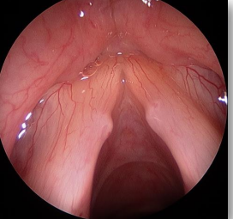

3- which of the following is wrong?

Maxillary polyp grow anteriorly

4- mx ? Systemic steroid then topical 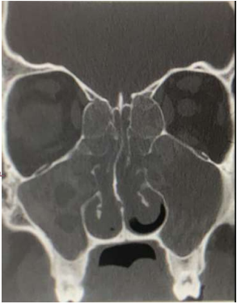

5- what is the name of test? Dix hallpike (image for dix hallpike)

6- if it was +ve, what is next? Canalith repositioning manuver

7- perforated ear)من الصورة تحدد انها يمين مش مكتوبة) one is true?

righ rinne negative left positive weber to right

8- which is true?

Tympanogram type B with high volume

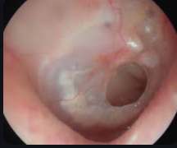

9- dx? quinsy

10- what is the most likely causative agent?

mixed flora

11- mx except ? Tonsillectomy

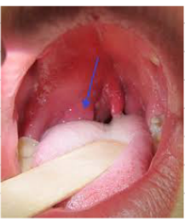

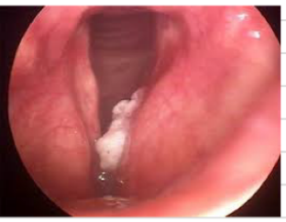

12 - laryngeal cancer for definitive dx? direct laryngeo + biopsy

13- Lc type is SCC

14- pure tone audiometry pic bilateral sensorineural HL

15- case of presbycusis so answer is 70 yo female

16- TYMPANO : Bilateral Type A

17- tx by hearing aid 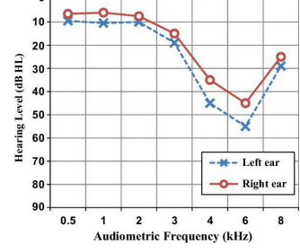

18- all are true about tracheostomy except ? Remove next day after surgery

19- bulge TM what is the mx : systemic anti biotic anti pyretic with analgesic with myringitomy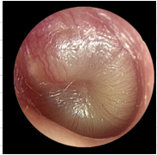

20-on tympanometry? air abnormal, bone normal ,with air bone gap