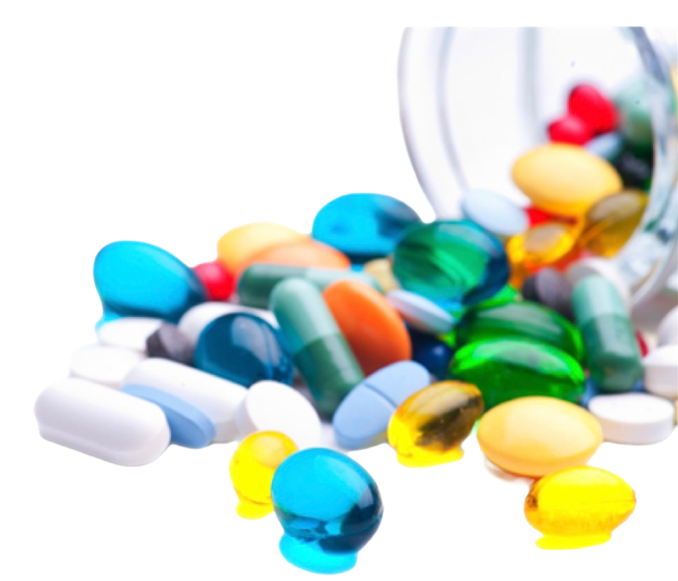

**pharmacology sheet**

**DONE BY:**

**Doctor 2020 - wateen - medicine - MU**

**No.**

**corrected BY:**

**Doctor :**