Experiment 1
Basic Laboratory Operations
I. Safety Rules: (page 33)
1. Safety glasses (goggles) or face shield must be worn in the laboratory
all the time. Contact lenses are not allowed, they must be replaced with
eyeglasses together with safety glasses.
2. Liquid-proof shoes must be worn in the lab., Sandals, canvas or high-heel
shoes are strictly prohibited.
3. The clothing must be long-sleeve, cotton-made, and covers skin from the
neck to below the knee. Synthetic clothing (like nylon) is sticky to the
skin and not safe in the lab. especially in the case of fire.
4. Laboratory coat or apron must be worn to protect the outer clothing.
5. Never taste, smell or touch a liquid unless you are specifically allowed
to do this. (chemicals may be poisonous or may cause sensitivity.
6. Gloves must be worn specially when transferring corrosive chemicals.
7. Smoking, drinking, eating, and chewing are not permitted at any time
in the laboratory.
8. In the case of accident (like chemical spill, breaking of glass, injury,
fire, …), never panic, and immediately report it to your instructor even
with small accidents.
9. In the case of chemical spill on hands, wash them immediately with
plenty of water.
10. In case of fire, do not discharge fire extinguisher when a person's clothes
are on fire. Use SAFETY SHOWER.
11. Never heat flammable liquids on a direct flame. Ask your instructor
how to do this.
12. Do not work alone in the lab. For any reason. Always you should work
with, at least, one person near to you.
13. Be aware of the mistakes of your neighbor in the laboratory, you may
be a victim of his (her) mistakes.
II. Bunsen Burner:
▪ How to lit and adjust the Bunsen burner.
▪ Gas mixture of hydrocarbons, mainly methane CH4 gas.
▪ Insufficient oxygen results in yellow luminous flame, carbon particles
(smoke), water, and poisonous carbon monoxide gas (CO) are produced.
6CH4 (g) + 9O2 (g) → 2CO2 (g) + 12H2O(g) + 2C(s) + 2CO(g)

▪ With sufficient amount of oxygen, gaseous CO2 and water are produced
according to the following reaction:
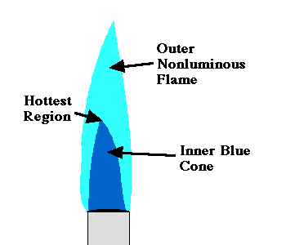 | ▪ Three regions  ▪ Outer nonluminus flame  ▪ Hottest region, bright blue, top of the inner  cone, 1500 Co  ▪ Do the temperature test with a wire gauze
CH4 (g) + 2O2 (g) → CO2 (g) + H2O(g)

Bunsen burner in the Lab:

III. Laboratory Balance:
Choice of balance depends on the accuracy and precision required.
Top loading Balance:
Triple beam Balance:

IV. Laboratory equipment and glassware (use the internet)
Introduction to Glassware and Apparatus

List of Some Laboratory glassware and equipment:
1. Funnel | 13. Iron Ring
2. Erlenmeyer Flask | 14. Stand
3. Beaker | 15. Clamp
4. Graduated Cylinder | 16. Pipette Filler or rubber Bulb
5. Pipette | 17. Tongs/Crucible Tongs
6. Test Tube | 18. Clay Triangle
7. Burette | 19. Crucible and Lid
8. Test Tube Rack | 20. Glass Rod
9. Wire Gauze | 21. Test Tube Brush
10. Medicine Dropper | 22. Goggles
11. Wash Bottle | 23. Spatula
12. Bunsen Burner
V. Use of Pipette (safety bulb) (Technique 16b)
Use of Pipette filler
VI. Determination of Density of a Solid:
▪ Intensive property and extensive property.
▪ At a given temperature.
▪ SI units: g/cm³ for solids; g/mL for liquids and g/L for gases.

The Experiment: finding the density of an irregular object.
VII. The Report:
▪ Prelab. Report (before the lab.)
▪ The report sheet (during the lab period)
▪ Post-lab report (after the lab period)

Lab Quiz (Look at this link)

Funnel  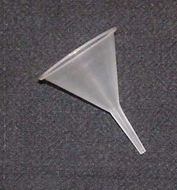 | Erlenmeyer Flask  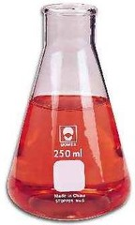 | Beaker  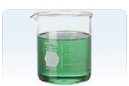
Graduated Cylinder  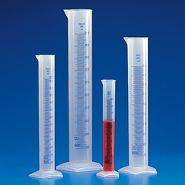 | Burette | Pipette  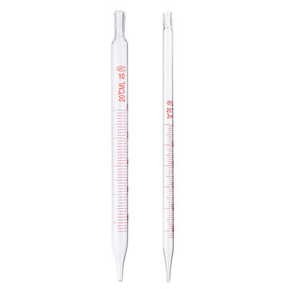

Test Tube  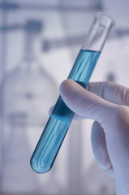 | Test Tube Rack  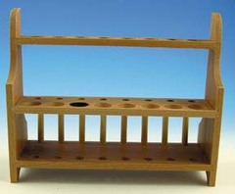 | Bunsen Burner  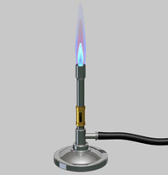
Wire Gauze  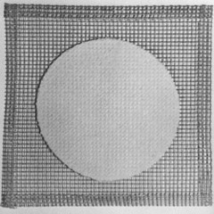 | Medicine Dropper  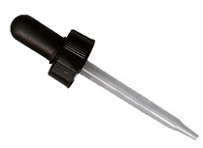 | Wash Bottle  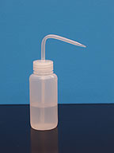
Utility Clamp  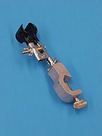 | Iron Ring  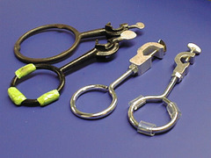 | Stand (with ring)

Pipette Filler or rubber Bulb  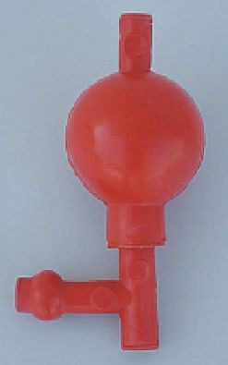 | Goggles  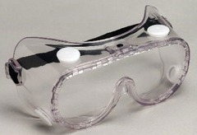 | Tongs/Crucible Tongs  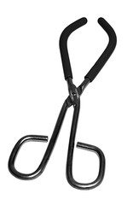
Clay Triangle  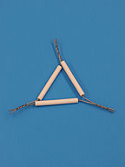 | Crucible and Lid  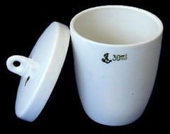 | Crucible in Triangle  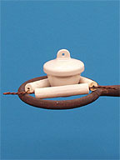
Spatula | Glass Rod | Test Tube Brush  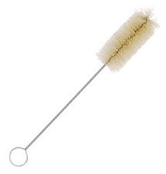

VIII. Techniques: (Summarized on pages 7 & 8 in your lab. manual.)
Some of these techniques are listed below:
Technique # | Name | Technique # | Name
1. | ----- | 10. | Transferring Liquids & Solutions
2. | Cleaning Glassware | 11. | Decantation, G. Filtration
3. | Handling Chemicals | 12. | -----
4. | Disposing of Chemicals | 13. | Heating Liquids & Solutions  (Over Hot Plate or Water Bath)
5. | Preparing Solutions | 14. | Evaporating Liquids  (Flammable & None-Flammable)
6. | Measuring Mass | 15. | Using a Crucible  (Drying, firing, ignition, …)
7. | ------- | 16. | Measuring Volume  (Reading a meniscus, Using and preparing Pipet & Buret, Pipet Filler)
8. | -------- | 17. | ▪ Testing for Odor  ▪ Testing for Acidity & Basicity
9. | Transferring Solids

Important:
See the laboratory assignment on the laboratory techniques, page 31-32.

Technique 14:
Heating volatile or flammable liquids in the laboratory in a water bath

The End

2014
Modified: 2019, 2020, 2021

