Pathology lecture 5
3 CHRONIC INFLAMMATORY DERMATOSES
- The skin surface in some chronic inflammatory dermatoses is roughened as a result of excessive or abnormal scale formation and shedding (desquamation).
- Psoriasis
- Lichen Planus
All related to autoimmune response
- Lichen Simplex Chronicus

psoriasis

-a T cell-mediated inflammatory disease
- autoimmune in origin
-most common location is the skin of elbow and knees along with gluteal
-symmetrical
-prominent parakeratotic scale with infiltrating neutrophils
- Erythematous plaque salmon like covered by loosely adherent silver-white scale
-no granular layer

Lichen Planus
- Autoimmune disease
- symmetrically distributed
- particularly on the extremities.
- Approximately 70% of cases also involve the oral mucosa
- result from a CD8+ T cell–mediated cytotoxic response against antigens in the basal cell layer and the dermoepidermal junction that are produced by unknown mechanisms.
- lichen means : bandlike infiltrate of lymphocytes along the dermoepidermal junction
- “Pruritic, purple, polygonal, planar papules, and plaques”

Lichen Simplex Chronicus
-response to local repetitive trauma
-induces epithelial hyperplasia and eventual dermal scarring

BLISTERING (BULLOUS) DISORDERS
- Blistering in these diseases tends to occur at specific levels within the skin, a morphologic distinction
1-Pemphigus (Vulgaris and Foliaceus)
-an uncommon autoimmune blistering disorder resulting from loss of normal intercellular attachments within the epidermis and the squamous mucosal epithelium
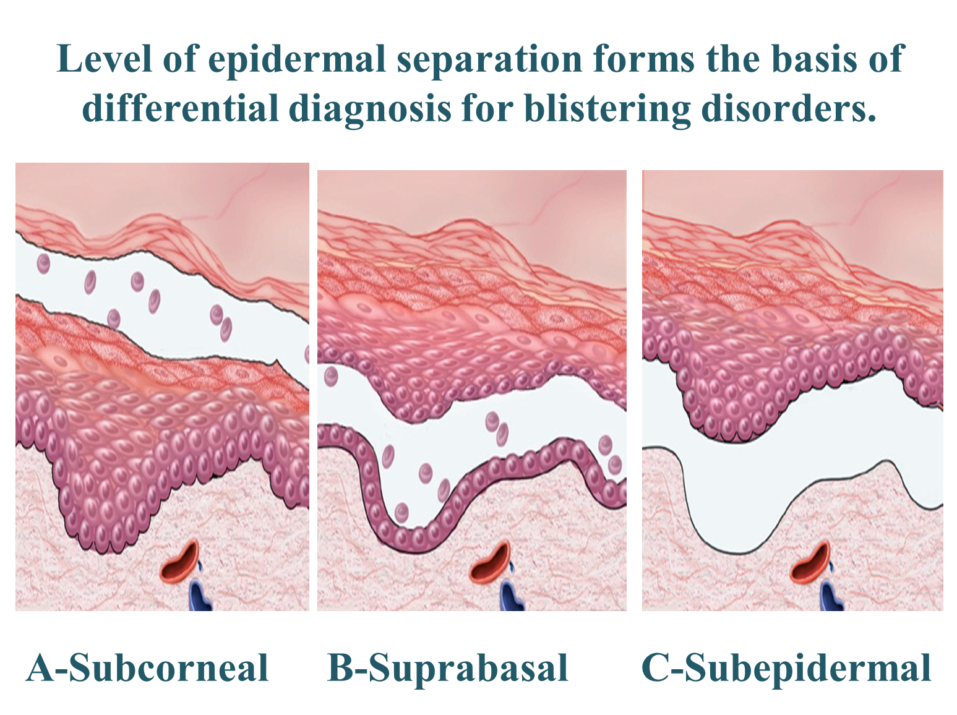
-Autoimmune diseases caused by: Antibody mediated hypersensitivity reactions. (Type II)
-IgG autoantibodies: Bind to intercellular desmosomal proteins of skin
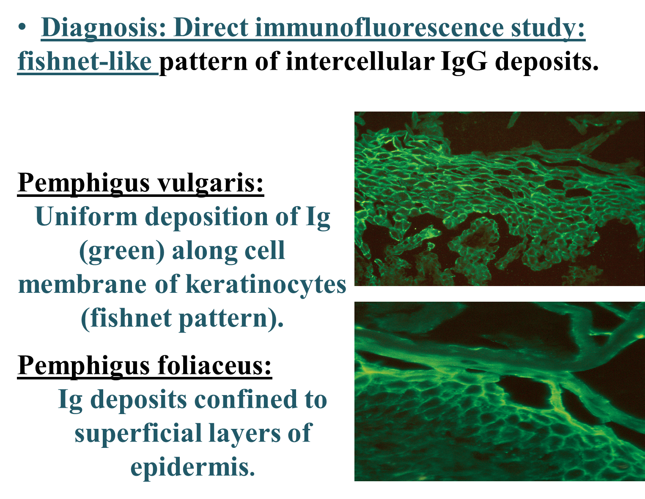
-Acantholysis (separation)
-Pemphigus vulgaris: Suprabasal blister.
-Pemphigus foliaceus: Subcorneal
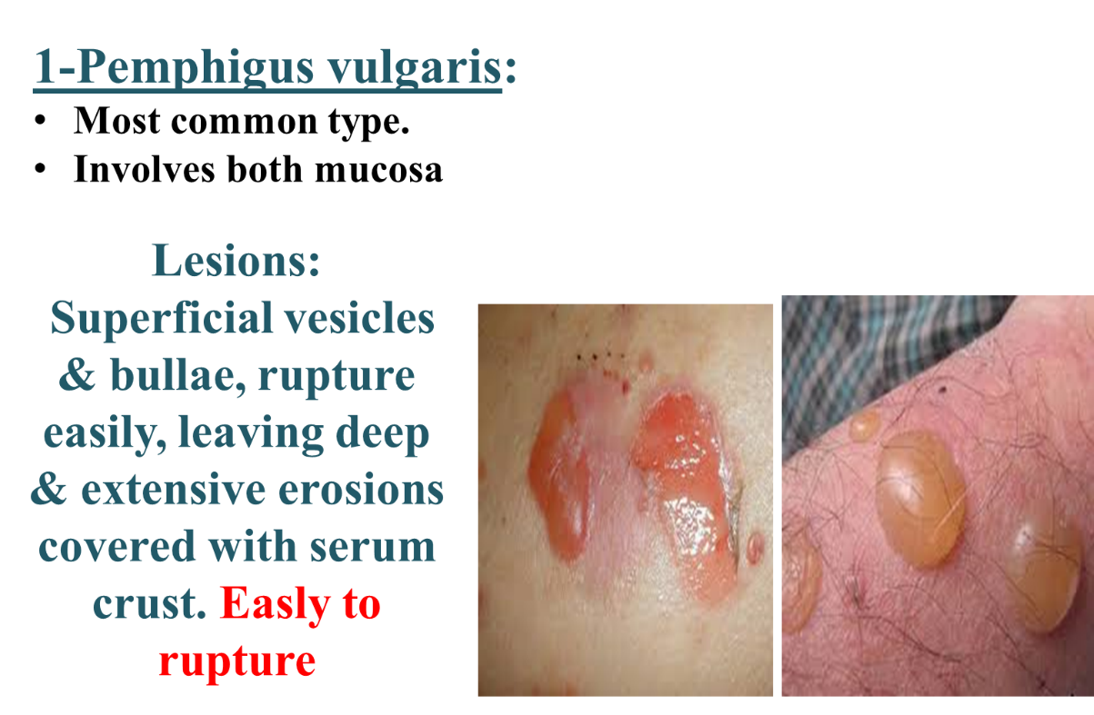
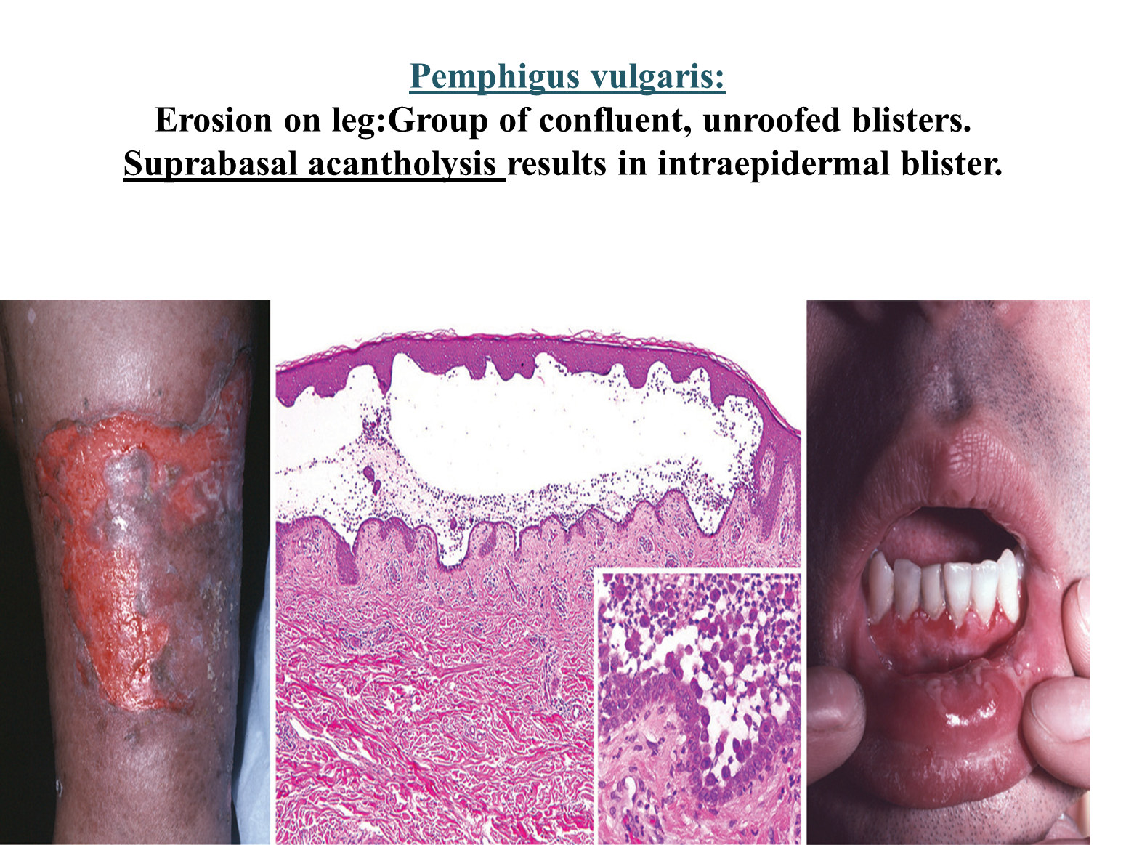
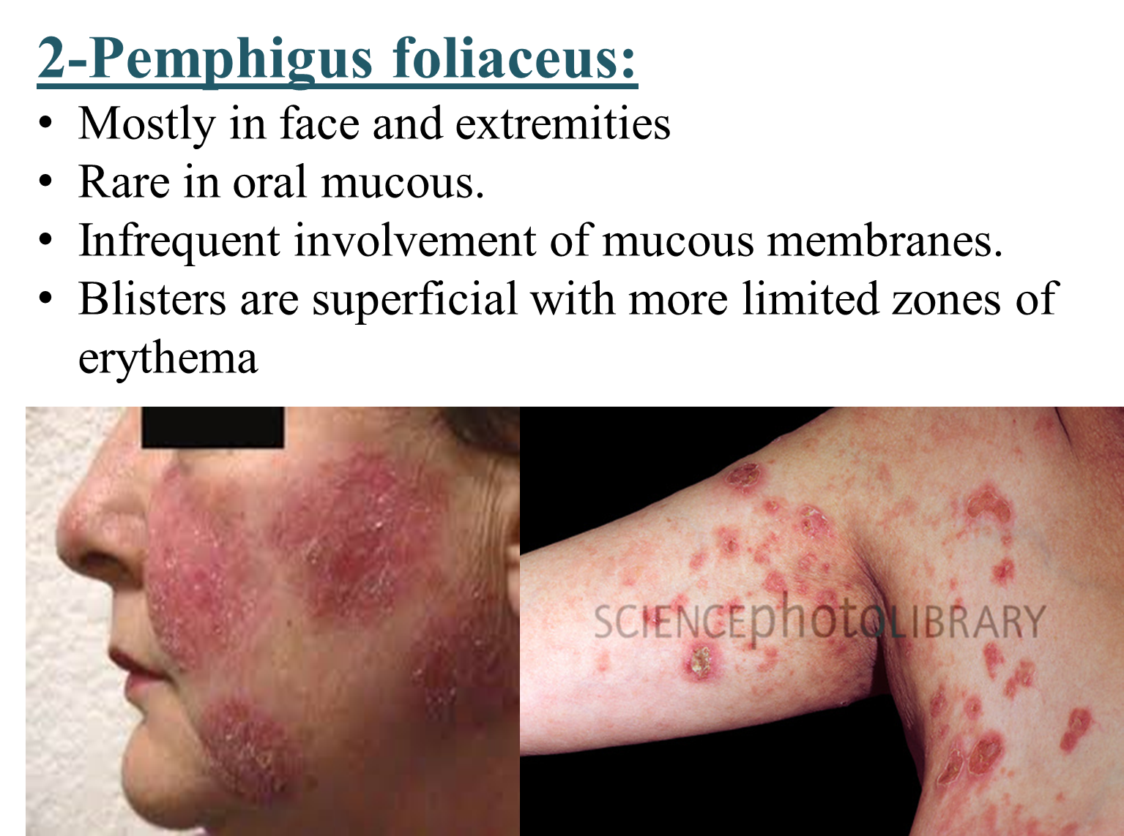

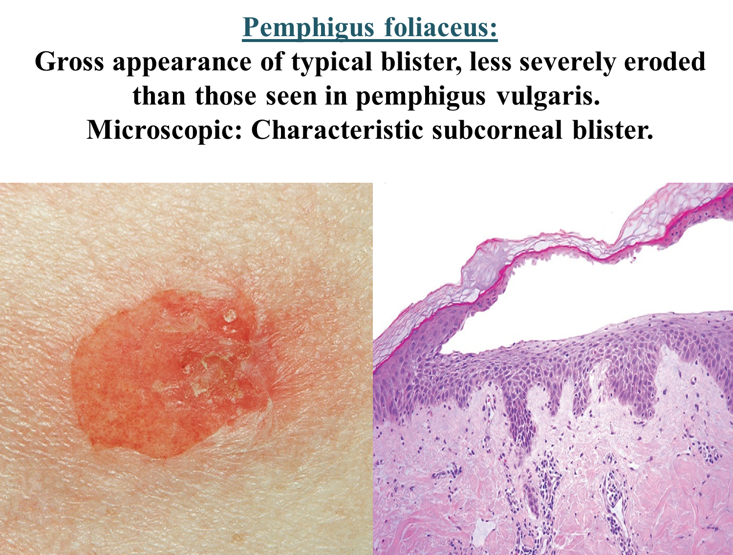
2-Bullous pemphigoid:
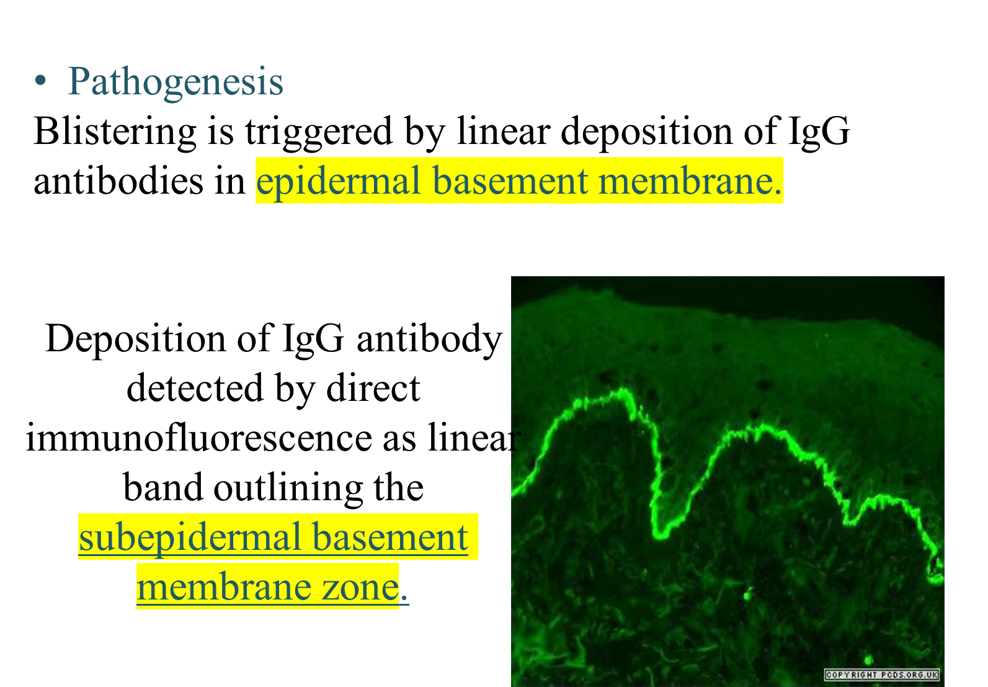
Morphology: Grossly:
- Tense bullae filled with clear fluid.
- Subepidermal nonacantholytic blisters. 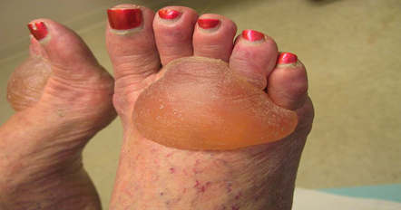
- Perivascular infiltrate of lymphocytes & eosinophils.
- Superficial dermal edema.
- Basal cell vacuolization gives rise to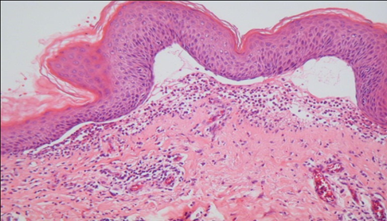
fluid-filled blister.
- Blister roof consists of full thickness with intact intercellular junctions so epidermis not rupture easily.
(Key distinction from blisters in pemphigus)

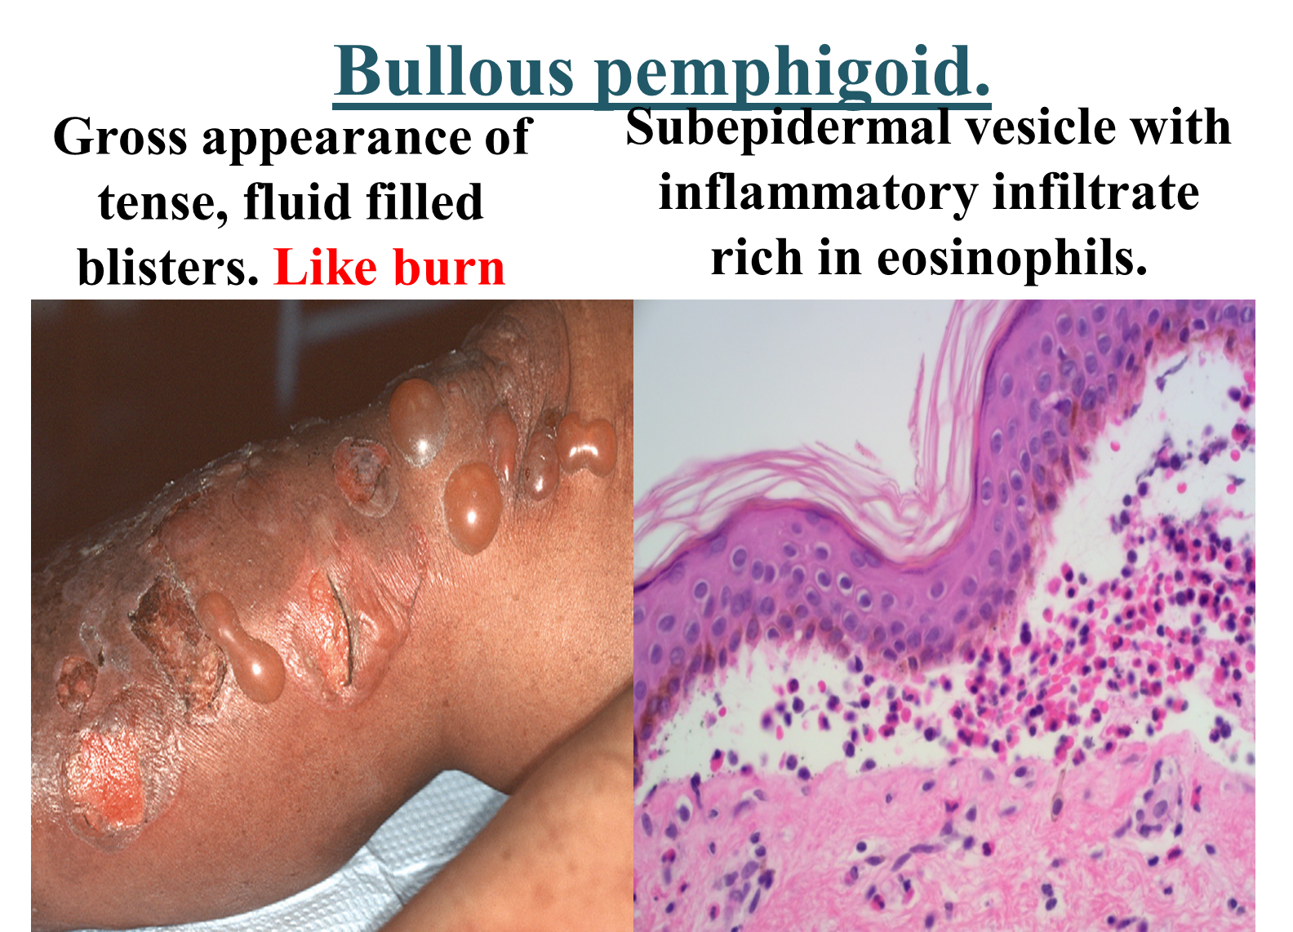
SKIN TUMORS
1- Squamous Cell Carcinoma
-common tumor
-arises on sun-exposed sites in older adult
-mainly caused by UV light exposure, which leads to widespread DNA damage and extremely high mutational loads
-arising at internal sites (oropharynx, lung, esophagus, anus).
2- Basal Cell Carcinoma
-common slow-growing cancer that rarely metastasizes
- loss-of function mutations in PTCH1
- composed of nests of basaloid cells in the periphrey.
-The cleft between the tumor cells and the stroma is a highly characteristic artifact of sectioning
Melanocytic nevi
-benign neoplasms
-caused by somatic gain-of-function mutations in BRAF or RAS.
junctional nevi :epidermis
compound nevi: epidermis +dermis
intradermal nevi: deep dermis
-brownish in color
-uniformly pigmented
-uniform border
- Early lesions are composed of round to oval cells that grow in “nests” along the dermoepidermal junction
-Nuclei are uniform and round, and contain inconspicuous nucleoli with little or no mitotic activity
3-Melanoma
-less common
-more aggressive in the skin
- caused by UV light–induced DNA damage that leads to the stepwise acquisition of driver mutations
- initiating event appears to be an activating mutation in BRAF or (less commonly) RAS
-lymphocytic infiltrate
-The main clinical warning signs are as follows:
1. Rapid enlargement of a preexisting nevus
2. Itching or pain in a lesion
3. Development of a new pigmented lesion during adult life
4. Irregularity of the borders of a pigmented lesion
5. Variegation of color within a pigmented lesion

لجنة الطب والجراحة
#الفريق_الأكاديمي

