بسم الله الرحمن الرحيم
ENT notes 2017
Dr .Osama btoush
- High frequency SNHL with unilateral tinnitus in young age group (acoustic neuroma ,vestibuler shwanoma).
- Bilateral high frequency SNHL in young is ( NIHL)
- Bilateral high frequency SNHL in older age (presbycusis)
- Most common benign tumor ( vestibuler shwanoma ) ,
** 1% of sudden hearing loss caused by vestibuler shwanoma BUT 10% of vestibuler shwanoma presented by sudden hearing loss.
**Vestibuler shwanoma presented 85% by unilateral high frequency progresive SNHL ,65% tinnitus.
**Investigations :CPAngle MRI / tympanometry :type A normal( because it disese of inner ear)/Rinne positive / webers latralise to normal ear .
** The first nerve affected by this tumor is “ trigeminal nerve “. The second one is “ sensory facial nerve (post auricular anesthesia )
** Treatment : Observation .
- Difference between Rt &Lt tympanic membrane on pictures ( direction of light )
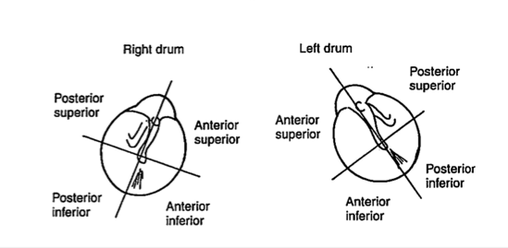

- Picture of tympanic membrane perforation
Q: treatment : myringoplasty or tympanoplasty
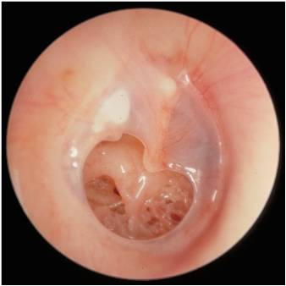
- Q1: Name the procedure : myringotomy with grommet .
Q2: complication of it : *infection
*permenant perforation
* bleeding
* damage to external canal
* damage to facial nerve
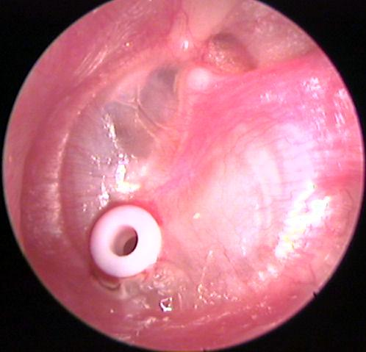
- Ear drop with antibiotic given only if pus ,discharge from ear.

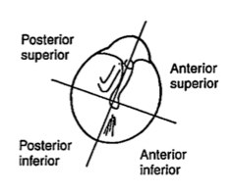
pressure is high in post. Sup >post.inf>ant.inf>ant.sup.
*in middle ear effusion ,we do myringotmy in ANT.INF Part ( this part is least healing area and pressure ,and we need to keep the perforation open for longer time ).
*in acute otitis media complication : we drain the pus ANT.INF because the pressure is high in POST.SUP. which prevent pus from drain.
- Facial palsy or sudden hearing loss ,always give steroid( patient should take it from 5:00AM to 7:00AM) .
- OM with effusion >>may be silent OM (if there is no pain )
- Adenoid hypertrophy >> the most common cause of OME in children
- Nasopharyngeal tumor can cause OME , so do X-ray (don`t forget)
- In OM >> conductive hearing loss
- Most common cause of chronic cough >> adenoid , while the second cause is >> sinusitis
- The carotid artery is far from bed of tonsils >> 1.5 cm (for written exam)
- Defferntial diagnosis of abdominal pain , N+V >> OM
- In case of severe itching + discharge >> think of otitis externa
- In case of severe itching + discharge + intact TM >> fungal otomycosis (Aspergelosis)
- Treatment of this fungal infection >>keep dry , toilet , topical anti-fungal
- Central TM perforation >> tubotempanic , marginal TM perforation >> atticoantral
- Cone of light position : in right ear >> 5 o`clock , in left ear >> 7 o`clock
- Two specific indication for tonsillectomy :
1- recurrent infection 2- sleep apnea
**symptom and indication for tonsillectomy : febrile convulsion
** 70% of tonsillitis >> viral cause
- Facial palsy :
**upper motor N lesion :wrinkles spared
lower motor N lesion: wrinkles involved
** deviation is to the normal side
**example : Rt upper neuron lesion affect Lt Lower part of face .
** 90% of patient recover without treatment in 3 months .
**most common cause :
- Bells palsy
- Ramsay –hunt syndrome :it has vesicles , 63%recovery , caused by>> Herps Zoster Virus
Facial palsy +herpes vesicles on auricle
** treatment : steroid
hydration
topical ointment “isoteres”
B- complex injection
Anti viral “acyclovire”
** Common question : terminal branches of facial nerve?? Temporal ,buccal,zygomatic,marginal mandibuler ,cervical .

- Neoplasm of nose and sinus :
** most common in : maxillary sinus 55%
** 1% sphenoid +frontal
**Most common site for Adenocarcinoma is ethmoidal .
** on axial CT of sinus :if unilateral mass in sinus : tumor
If Bilateral : polyps (pale in color)
CT image of sinus is important in OSCE
The mass will be between nasal septum and turbinate in both cases.
**surgery for septal deviation : septoplasty
**best surgery for nasal polyp : Functional Endoscopic Sinus Surgery (FESS)
**adult with OM with effusion we suspect >> nasopharyngeal neoplasm .
- ohngren’s line (مهم جدا)
Q1- connect what ?medial canthus of eye to
Angle of mandible .
Q2- indicate what ? above =bad prognosis
Below=good prognosis.
- Papilloma
**most common benign tumor of larynx .
** premalignant /unilateral /originate from lateral wall .
**cause destruction of bone .
**to differentiate it from polyps ( originate from ethmoids / bilateral /opacification on x-ray/ no destruction of bone.
**only antrochoanal polyp from maxillary sinus
- Angiofibroma
**affect MALE ONLY
**severe epistaxis
** unilateral nasal obstruction
** no biopsy taken .
- TTT for any sinus tumors(MCQ ):
Surgery or radiation o chemical ? ALL .
- Tumor investigation :
MRI /CT /Nasal endoscopy /biopsy.
(( all investigation write in exam)).
- Stridor …(steeple sign )
**treatment steps :
Ensure Airway is patent
Steroid
Nebulizer epinephrine
Oxygenation
Tracheostomy sometime
No need for Antibiotic “ viral” unless there are complications.
- In case of forign body inhalation , what type of x-ray do you request??
AP and lateral
-Complications include : airway obstruction and perforation of esophagus
- Retropharyngeal abscess on examination of throat ?
Bulging of posterior pharyngeal wall.
- Indication of tonsillectomy in peritonsiller abccess ?
(( second attack of quinsy))
- Most important symptom for peritonsilar abcess :drooling of saliva+ trismus
** in adult its treated by incision and drainage but in children give antibiotic for 48 hours then incision and drainage
- Epiglottitis
** thumb sign (مهمه)
**ttt :1- airway
- third generation cephalosporine
- Laryngomalacia
** congenital causes .
** bilateral vocal cord palsy
**most common cause of stridor in the neonatal period and early infancy
**6-9 months (حتى يبين stridorعالطفل )
** surgery ( supraglottoplasty)
** Omega sign/shape on inspiration .
** aggravating factor ( supine,flexion of neck, GERD)
**give (antiacide)even if the patient don’t have GERD.
- Subglottic stenosis
** normal glottis diameter in child 6mm
Borderline 5mm
Stenosis 4mm
Grade 1>> 50% stenosis : no need TTT
Grade 2 >> 50-70% : need TTT.
- Vocal cord
** RT recurrent laryngeal nerve palsy : adduction to medial side( because cricothyroid muscle not affected). Normal respiration and voice.
** bilateral recurrent laryngeal palsy : adduction +inspiratory stridor .
**unilateral superior and recurrent laryngeal : abduction ,cadaveric paramedian position of left side , Rt side cross medline . Normal respiration and voice
** bilateral superior and recurrent : bilateral ( cadaveric ) , aphonia , normal respiration.
- Cricothyroid muscle is supplied by superior laryngeal nerve
- Most important artery for embolization in case of epistaxis >> Sphenopalatine
- Most important cause for toxic shock syndrome is : nasal packing
- Cautery is contraindicated in epistaxis when : the bleeding is bilateral , the area is wide and there is infection .
- Congenital cause for epistaxis >> Heridetary Hemorrhagic Telangiectasia HTT
** treated by : septodermoplasty
- Topical steroid is given with head down (to avoid the septum ), while the vasoconstrictor is given with head elevated .
- Types of nasal polyps :
1-Ethmoidal >> bilateral , in adult , benign , in ethmoid sinus , treated by topical and systemic steroids
2-Antrochoanal >> single , unilateral , usually in children , in maxillary sinus , low recurrence
- Samter`s triad : Nasal polyp + Intrinsic asthma + Aspirin allergy
- Laryngeal cyst :
DDX: tumor ,polyps .
- Choanal atresia ( مهمه )
** emergency respiratory distress in infant **
** part of CHARGE syndrome
** on CT complete obstruction of posterior nasal space
- Recurrenr laryngeal nerve palsy:
Second step after examination : CT from skull base to lung or chest .
- Hoarsness of the voice ,, when you need to investigate ??? if the hoarsness > 3 weeks .
- Laryngeal polyps : unilateral >3mm
- Vocal cord cyst : reactive ( compensatory) lesion on other side .
- Laryngeal nodule <3 mm , bilateral ,in male child and female adult ,in junction of anterior third and posterior two thirds , mostly seen in teachers and singers .
- Polypoid cordites (Reinks cordites) :
**TTT : lateral cordotomy
** aka smoker corditis
**bilateral 65%
**mostly old age
- Most common cause of chronic cough :
Post nasal drip , asthma , GERD بالترتيب
- Hot potato voice : acute epiglottitis
- Leukoplakia : DDX: tumor ,fungal infection , papillomatosis .
- Glottic carcinoma : most common laryngeal CA , good prognosis , early presentation by Hoarseness , no lymph drainage , no mets , dysphagia .
- Granuloma : aka intubational granuloma , hx is important
- Supraglottic carcinoma : bad prognosis , aggressive , presented by delayed symptom>> dysphagia .
- CA Larynx investigation (( common Q))
- Nasopharyngeal tumor (مهم)
** most common symptoms :
- 50% unilateral huge neck mass
- 30% nasal symptoms eg : epistaxis
-20% era symptoms :
40- ويكون عنده ممكن يجي صورة tympanic membrane
Secrotory OM :
If adult : 25 years RT SOM
- Rinne‘s: negative
- Audiogram: conductive HL
-Weber‘s : lateralize to Rt ( abnormal ear)
-Investigation : tympano , audiometry ,,CTand MRI to post nasal space
-Examination of post nasal space + biopsy ((fibrooptic endoscope or rigid )) ؛ because we suspect tumor in adult with SOM.
- Most common cause of SOM in children “ adenoid “
- TTT of nasopharyngeal tumor :
**very sensitive to Radiation
** grade 1 ,2 = radiation
**grade 3,4 = chemo ,radio ,surgical
- Trotters Triad of naso pharyngeal tumor (( ipsilateral CHL , ipsilateral ear pain + facial pain , ipsilateral paralysis of soft palate.))
- Most common paranasal sinus malignancy in children < 5 years : Rhabdomyosarcoma
- Non hodgken lymphoma >> most common >> most aggressive >> chemotherapy
- Hodgken lymphoma >> less common >> less aggressive >> radiotherapy .
- The best investigation for sinusitis : CT , and the best for fungal sinusitis :MRI (on CT you will see calcification so request MRI to make sure )
- Axial CT for congenital anomalies
- On CT if :
Opacification is complete : chronic sinusitis
Air fluid level : acute sinusitis
Opacification in sinus and nasal cavity and bilateral : polyp
Dr.Harazneh

- Normal color of nasal mucosa >> pink
** if its pale >> viral infection or allergic rhinitis
** if its red >> bacterial infection
- Watery rhinorrhea >> allergic or viral
** if chronic >> its allergic
** if acute and short duration >> viral infection
- Anterior rhinoscopy >> anterior 2/3 of nose
* posterior rhinoscopy (nasopharyngolaryngeoscopy)>> posterior 1/3 + nasopharynx
- In case of nasal polyp or severe allergy >> systemic steroid
- Signs of fungal ear infection >> wet paper appearance + cheesy material
- otitis external (pruritis , pain , discharge):
1- fungal in origin: “wet paper “ appearance + cheese material ,,, rarely cause stenosis of external ear canal ,,, Tx by antifungal locally at least 3 weeks .
2- bacterial: may cause stenosis need Aural toilet “antibiotic + ear drop”
3- Malignant otitis external: Admission + IV antibiotic + surgical debridement .
#If ear wax is smooth: Suction , syringing direction ->>posteriorly superiorly .
#contraindication of syringing and cold caloric test :
1- OM 2- otitis external 3- tympanic membrane perforation .4- organic fb
- Case : A 3-year-old child came to ER complaining of unilateral , foul smelling , nasal discharge since 2 weeks , what is the most likely diagnosis ( what diagnosis you should rule out )?
**answer >> foreign body
- Case : A 15-year-old male patient complains of severe recurrent unilateral epistaxis , with nasal obstruction what is the most likely diagnosis ( what diagnosis you should rule out )?
**answer >> Juvenile nasopharyngeal angiofibroma

- Management of nasal trauma : (hx of falling down on face ) >>
1-ensure airway is patent
2- give adequate ventilation
3- stabilize patient
4-If its open wound and contaminated with foreign matter, copious irrigation will be required or sometimes, Some debridement may be needed
5-pretreatment with anxiolytic and pain medications should be considered
6- lateral nasal bone X ray .
7-Reduction of acute nasal fractures (open or closed) to realign cartilaginous and bony structures to their locations before the injury, to decrease discomfort and maximize airway patency
8-do incision (horizontal )and drainage+ I.V antibiotic if there is septal hematoma+ bilateral swelling (to prevent septal abccess and septal perforation )
9-final external and internal (endoscopic, if possible) examination before releasing a patient who has undergone manipulation and reduction of a nasal fracture
10-prophylactic antibiotics may be prescribed when indicated, such as in a grossly contaminated open fracture
11-an external splint or cast should be applied to the nasal dorsum for about one week.
12-nasal packing if required
**Done by :
Tamara Tarawneh
Noor Daher Alhijjaj

