Resonance and curved arrow formalism

NO₃⁻¹

In order the resonance to occur it should be:
- Charged center carrying, negative or positive charge or radical.
- This charged center should be conjucated to double or triple bond(s)
- Double or triple bond conjucated with another

Formal Charges

- Sometimes it is necessary to have structures with formal charges on individual atoms
- We compare the bonding of the atom in the molecule to the valence electron structure
- If the atom has one more electron in the molecule, it is shown with a “-” charge
- If the atom has one less electron, it is shown with a “+” charge
- Neutral molecules with both a “+” and a “-” are dipolar
- In order to calculate formal charge, you should be able to draw the Lewis structure first.
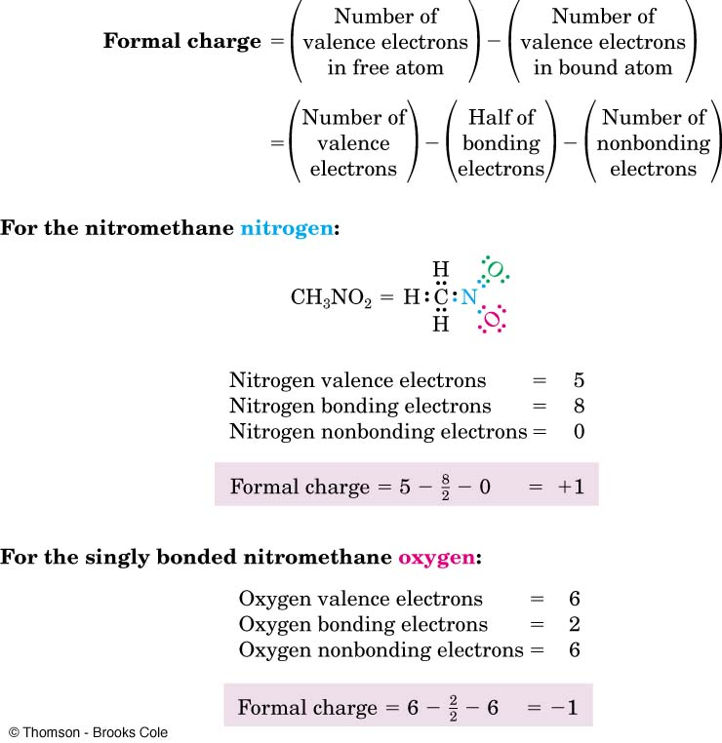
Example: calculate the formal charge for each atom in CO₃⁻²
- Draw its lewis structure.

- Then calculate the formal charge for each atom

Formal charge of O1 = 6 – 0.5(2) – 6 = -1
Formal charge of O2 = 6 – 0.5(2) – 6 = -1
Formal charge of O3 = 6 – 0.5(4) – 4 = 0.0
Formal charge of C = 4 – 0.5(8) – 0.0= 0.0

Questions: calculate the formal charge for the following
NO₃⁻¹

NH4⁺¹

