1-The confrontation test used for assess of : A. Visual acuity .
- Visual color .
- Ophthalmoplegia
- Visual field .
- Accommodation reflex .

2-Which is damaged cranial nerve A. Right hypoglossal nerve .
- Left vagus nerve .
- Right vagus nerve .
- Left hypoglossal nerve .
- Left trigeminal nerve .

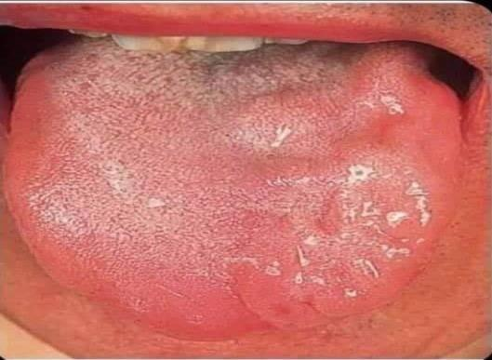

3-Which is damaged nerve ? A. Left trochlear nerve .
- Left oculomotor nerve .
- Left optic nerve .
- Left abducent nerve .
- Right abducent nerve .

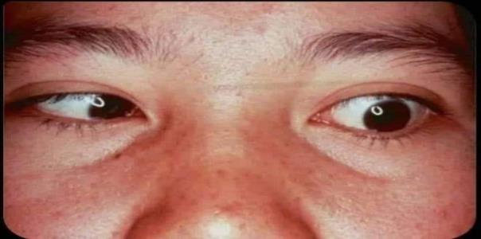

4- All of following are dxx for this sign except ?
A- Right ventricular failure . B. Acute bronchitis .
- Mitral stenosis .
- Acute thrombophelibitis .
E.Idiopathic pulmonary fibrosis .

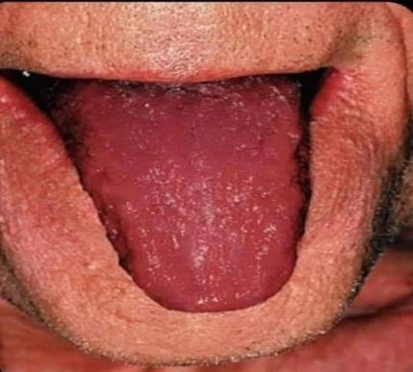

5-This patient has which of the following : A. Hypoglycemia .
- Hypocalcemia .
- Hypercalcemia .
- Hyponatremia .
- Hypernatremia .

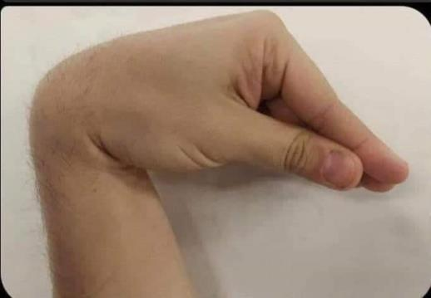

6-This examination occur for assess : A. Chest expansion .
- Vocal resonance .
- Tactile fremitus .
- Cardiac index .
- Cardiothoractic ratio .

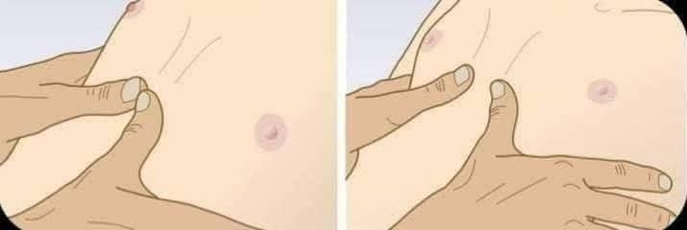

7-Which of the following is ddx for this condition ? A. Nephrotic syndrome .
- Liver cirrhosis .
- Heart failure .
- DVT .
- Lymphedema .

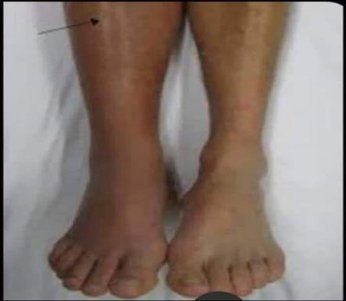

8-Which is damaged cranial nerve A. Right hypoglossal nerve .
- Left vagus nerve .
- Right trigeminal nerve .
- Left hypoglossal nerve .
- Left trigeminal nerve .

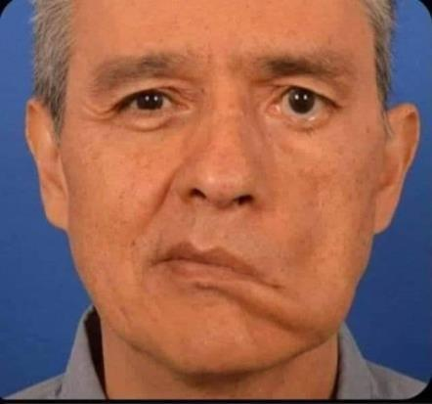

9-Which is damage nerve for this patient ? A. Spinal root of accessory nerve .
- Thoracodorsal nerve .
- Long thoracic nerve .
- Axillary nerve .
- Glossopharyngeal nerve
.
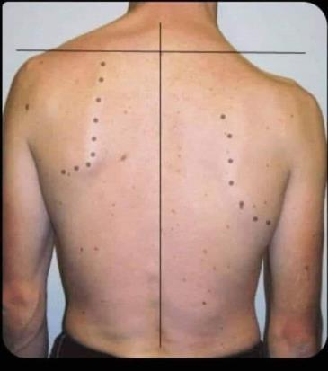

10-Which is damaged cranial nerve A. Right oculomotor nerve .
- Left trochlear nerve .
- Right trochlear nerve .
- Left abducent nerve .
- Left trigeminal nerve .

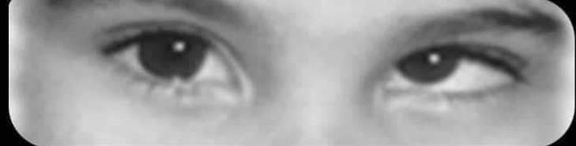
11-is a sign of . … ..................?
A- rheumatoid fever .
- - tricuspid valve reguirgitation .
- - infective endocarditis .
- - acute pericarditis .
- - aortic stenosis

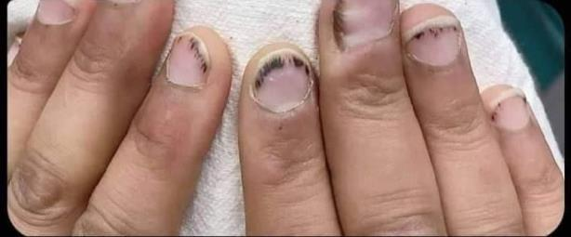

12-30 years old patient admitted to surgical clinic with neck enlargement , after eye examination shows as in picture : Which wrong about this condition ?

- Diarrhea is the common bowel habit for this patient .
- The face is wet and sweaty .
- Goiter indicated for hyperthyroidism condition .
- after treatment , exophthalmus not removed .
- hyperthyroidism associated with arrhythmia , atrial fibrillation or tremor .

13-Which is damage nerve for this patient ? A. Spinal root of accessory nerve .
- Thoracodorsal nerve .
- Long thoracic nerve .
- Axillary nerve .
- Glossopharyngeal nerve .

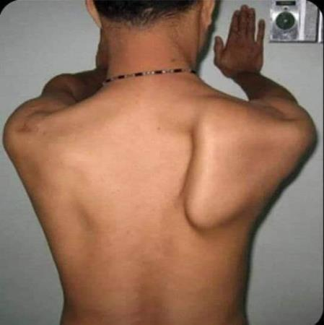

14- Which is damaged cranial nerve A. Right hypoglossal nerve .
  - Left vagus nerve .
  - Right vagus nerve .
  - Left hypoglossal nerve .
  - Left trigeminal nerve .

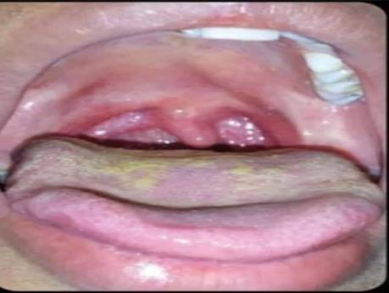

15-All of the following are ddx for this condition except ? A. Nephrotic syndrome .
  - Liver cirrhosis .
  - Heart failure .
  - DVT .
  - Lymphedema
. 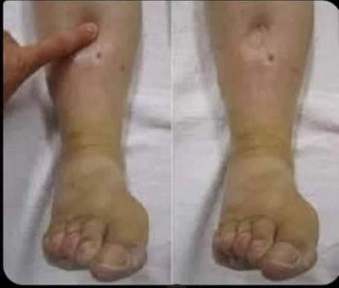

16-Which of the following findings is typically found on percussion over the area of the chest with massive pleural effusion ?
A. Resonant percussion .
B. Dull percussion .
C. Hyper – resonant percussion .
D. Normal percussion .
E. Stony dull percussion .
Answer:E

17-Kussumaul’s means ?
- Increases respiratory rate .
- Increases respiratory rate with sever acidosis .
C – increases respiratory rate and depth with sever acidosis .
- Increases respiratory depth with sever acidosis .
E – increases respiratory rate and depth with sever alkalosis .
Answer :C

18-Type of tremor of hyperthyroid patient ?
A. Resting tremor .
B. Action tremor .
C. Intention tremor .
D. Physiological tremor .
E. Essential tremor .
Answer :d

19-All of the following associated with liver cirrhosis except ?
A. Testicular atrophy .
B. Gynecomastia .
C. Spider nevae .
D. Breast atrophy .
E. Resting tremor .
Answer : e

20-Freely mobile mass like mouse in right upper quadrant breast of 25 year old female , The most Dx ? A. Fibrocystic change .
B. Fibroadenoma .
C. Ductal infiltrating carcinoma .
D. Carcinoma in situ .
E. Lymph node enlargement .

21-What is “ secondary amenorrhea “ ?
- Cessation of menstrual cycle for two months but it was normal previously .
- Cessation of menstrual cycle for three months but it was normal previously .
- Cessation of menstrual cycle for six months but it was normal previously .
- For 16 years , but she is not menses .
E – vaginal bleeding after twelfth months from last menses .

22-The wrong about this patient ?
A. Associated with limb edema with exudate .
B. Sloping edges .
C. Sever painful .
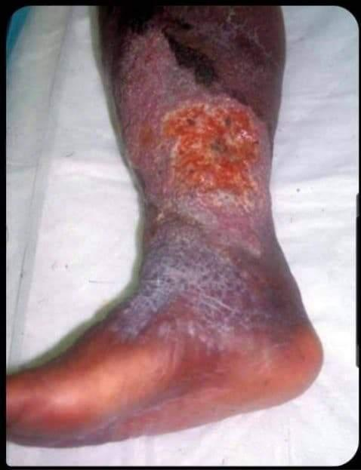
D. Relieved by leg elevation . E. Lipodermatosclerosis ; hemosiderosis with blanche atrophie .

23-The most Dxx for this patient :
A. Deep venous thrombosis . B. Hypothyroidism .
C. Nephrotic syndrome .
D. Graves disease .
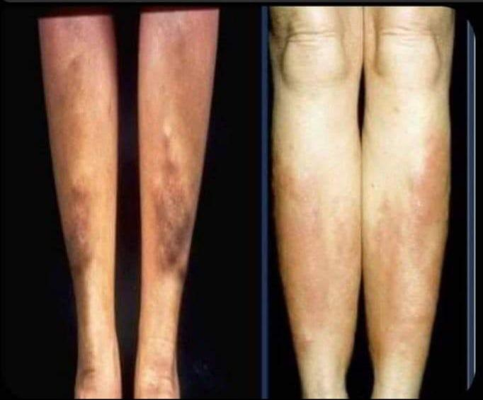
E. Liver cirrhosis

24-This sign indicates elevation of which in blood ?
A. HDL .
B. LDL .
C. Lactic acid .
D. Cholesterol .
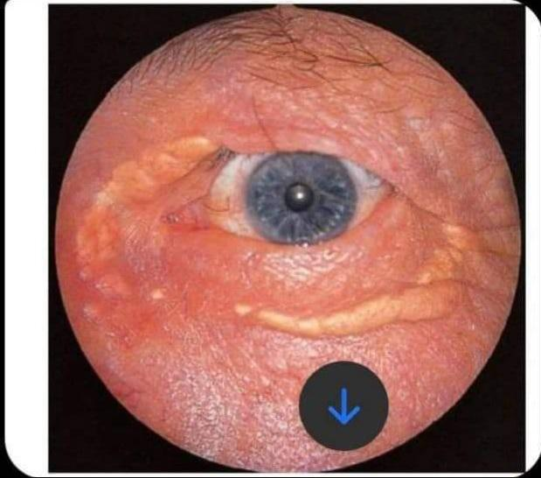
E. Oxidative agents .

25-The most dx for this patient : A. Portal hypertension .
B. Inferior venacava obstruction
C. Superior venacava obstruction
D. Thromboephelibitis .
E. Caput medusa
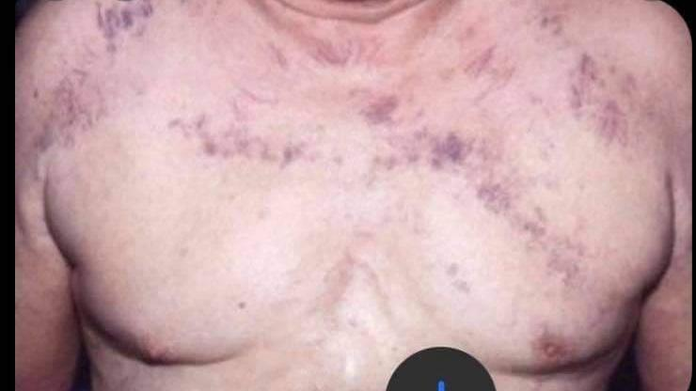
.

26-All of the following are associated with sever ascites examination except ?
A. Increased distance btw xisosternum and umbilicus . B. Distended flank .
C. Everted umblicus .
D. Caput medusa .
E. Positive fluid thrill .
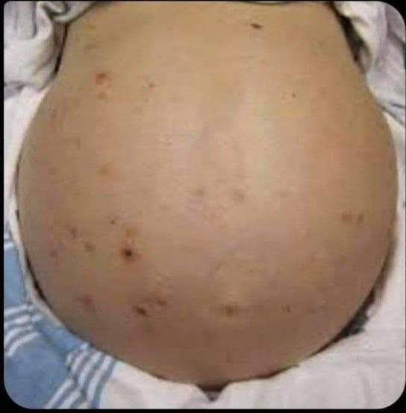
27-Which indicates ?
- Inflammatory breast carcinoma .
B – lobar infiltrating carcinoma .
C- ductal infiltrating carcinoma .
D. Pagets disease of breast .
E. Fibroadenoma .

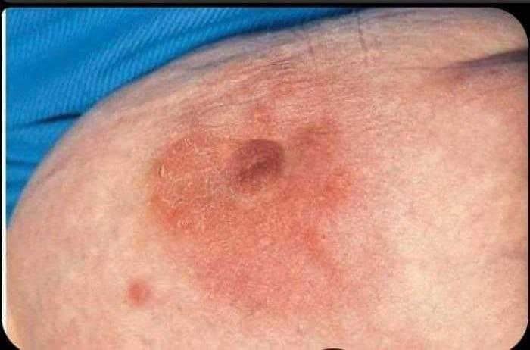
28-Which correct about this test ?
- Indicated lower neuron lesion
B – associated with sensory ataxia
- Indicated upper neuron lesion
- Indicated polyneuropathy .
- Abnormal in neonate .
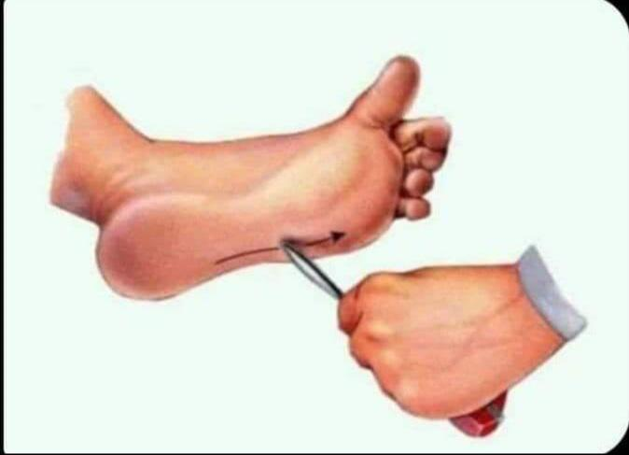
29-This sign is associated with :
- Irritable bowel diseases . B- perihepatitis .
C – inflammatory bowel diseases
- Ulcerative colitis .
E – pneumothorax .

