1)Identily the specimen?
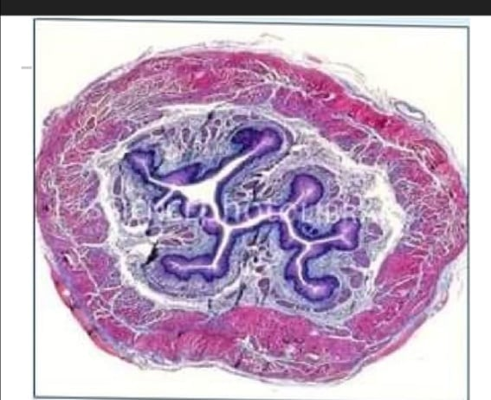
a.Esophagus xxx
b.Appendix
c.leum
d.Gall bladder
e.Duodenum
2)One of the following cames the most important nisk for the development of this tumor?
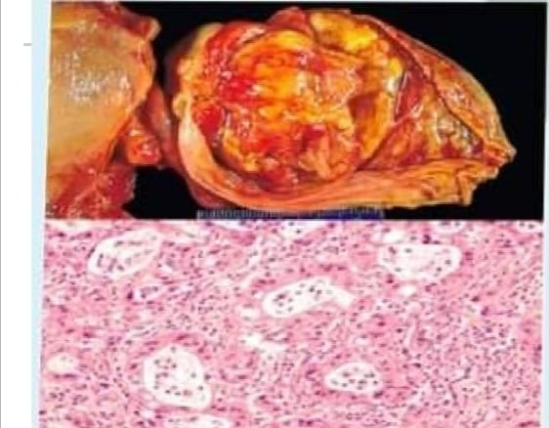
a.Cholelthiasis xxx
b.Hepatitis B infection
C. Primary billary cholangitis
d.Pregnancy
e.Infestation by liver flukes
3)What is the labelled structure?
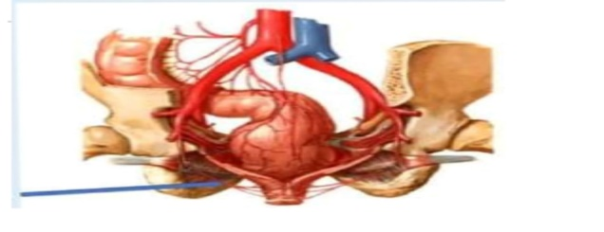
a. Common illac artery
b.Middle rectal anery
Extenal iac artery
d.Infenor rectal artery xxx
e.Intemal mac artery
4) One of the following is incorrect about the disease in this picture?
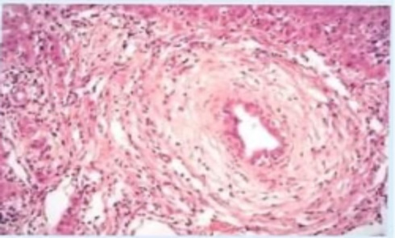
a.70% of individuals with ulcerative colitis present with this disease xxx
b.it has charactenstic sting of beads sign on biliary tree seen by MRI
c Il has 2.1 male predominance.
d.Pernuclear anti-neutrophil cytoptasmic antibodies(pANCA)are found in most cases
e.infiammation is assocatiated with obliterative fibrosis which dilate the preserved segments
5)A 20 year-old male has complained from abdominal pain for the past 5 years.Lower gastraintestinal endoscopy showed polypoid lesions in the colon. What is best management for the following microscopic and macroscopic appearances shown in the nigures?
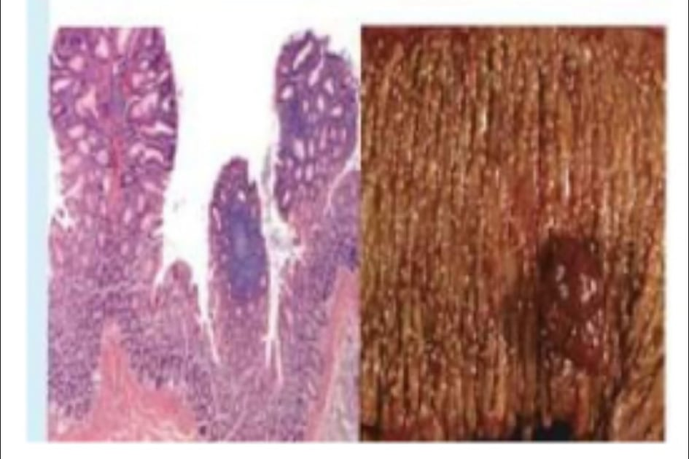
a.Total colectomy.
b.Regular endoscopic follow-up
c.Fiber-rich food
d.Total colectomy and an endoscopy for the other tamily members xxx
e.long term of corticosteroid and NSAID
6)this picture?
One of the following has the highest association with the tumor in 29 years old
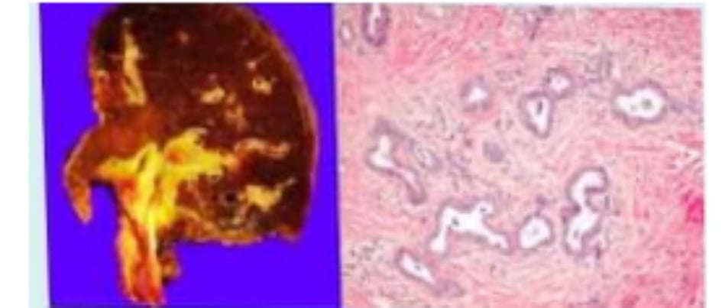
a.Alcohol addiction
b.Chronic hepatitis B infection
c.Aflatoxin ingestion
d.Non-alcoholic tatty liver disease
e.Opisthorchis infection xxx
7) this picture?
A 29-year-old woman sees her physician because she has had abdominal cramps and diarhea for the past years.She is pale and her anemia is confirmed by laboratory test. An endoscopy is performed and tandom biopsy are taken from the small intestine.The microscopic findings shown in this figure.Which of the following statement is true regarding the diagnosis of this case ? 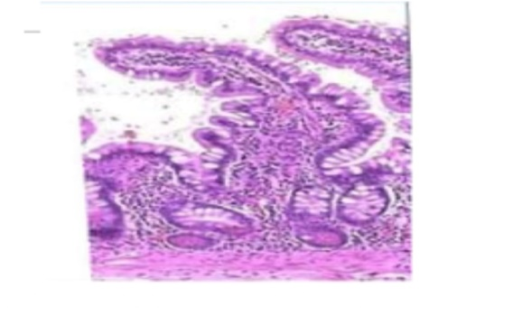
a,Need further investigation to contirm her diagnosis
b.She must follow gluten-free diet xxx
c.Atotal colectomy is advised for her case to prevent the prognosis of cancer
d.She does not need any further investigation.
e.An antibiotic is advised
8) A67-year-old woman has experienced severe nausea,vomiting.
early satiety,and a 9-kg weight loss over the past 4months.On physical examination,she has mild muscle wasting The most specitic endoscopic ninding for this patent is involving all the following,except?
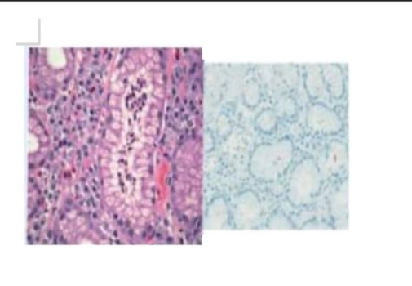
a.Erythematous mucosa
b.Polypoid lesions xxx
c.Ulceration
d.Thick gastric wall
e.Antral involvement
9) Identity the cells type?
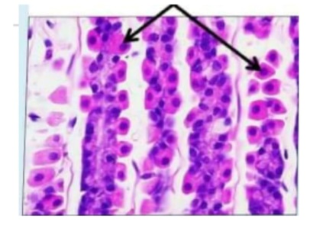
a Paneth cells
b.Enterocytes
c Chief cells
d.Hepalocytes
e. Parietal cells xxx
10) identity the section?
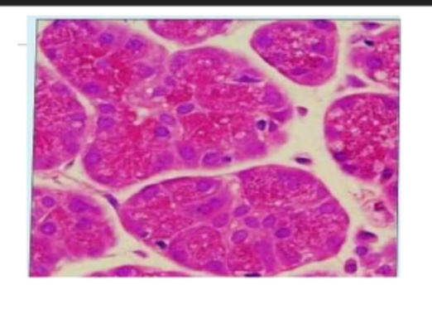
a.Serous demliune
b.Brunner's glands
c.Serous acinl xxx
d.Islets of Langerhans
e.Stnated duct
11) The image belongs to?
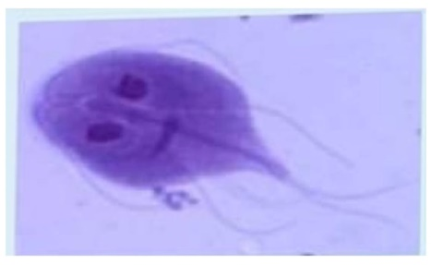
a Balantdium coll
b.G.lamblia xxx
c.Cryptosporidium parvum
d.S.mansoni
e.Ascaris lumbricolde
12) What is the labelled structures?
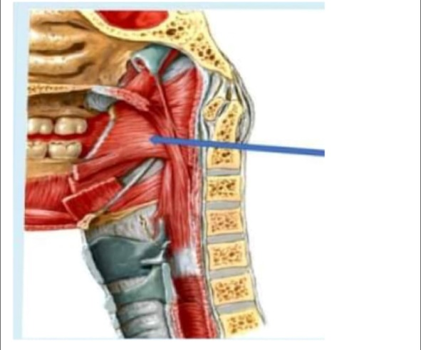

a.Superior constrictor muscle of pharynx xxx
b.Palatopharyngeal muscle
c.Middle constrictor muscle of pharynx
d.Stylopharyngeal muscle
e.Inferior constrictor muscle of pharynx
13) This stnuctune seem to be
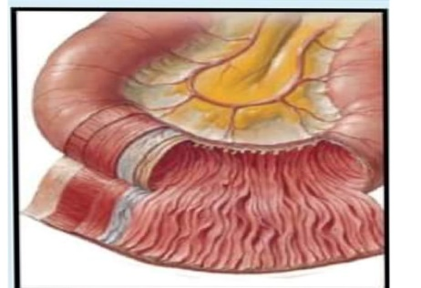
a .Transvarse colon
b.Jajunum xxx
c.Duodenum
d.Sigmold
14) This pattem of growth is related to?
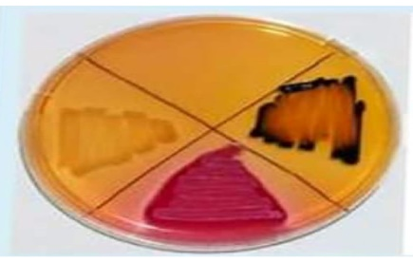

a.V.cholera
b.V parahemolyticus
c.E coli
d.Salmonella xxx
e.Shigella
15) The histological section is
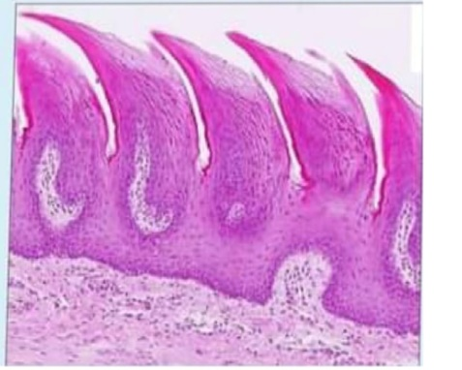
a Intestinal vill
b.Filliform papillae xxx
c.Foliate papillae
dCircumvallate papilae
e.Fungiform papillae
16) Which of the following is the function of the human GALL BLADDER?
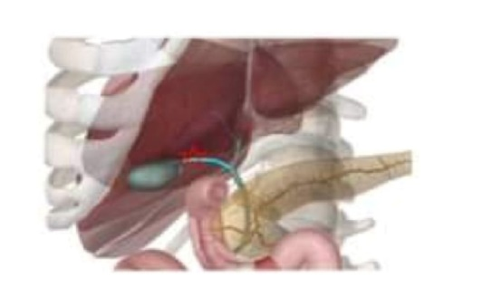
A. Production of bile
b.Storing the bile
c.Producing an insulin
d.Aand B xxx
e.Aand C

17) This worm belongs to?
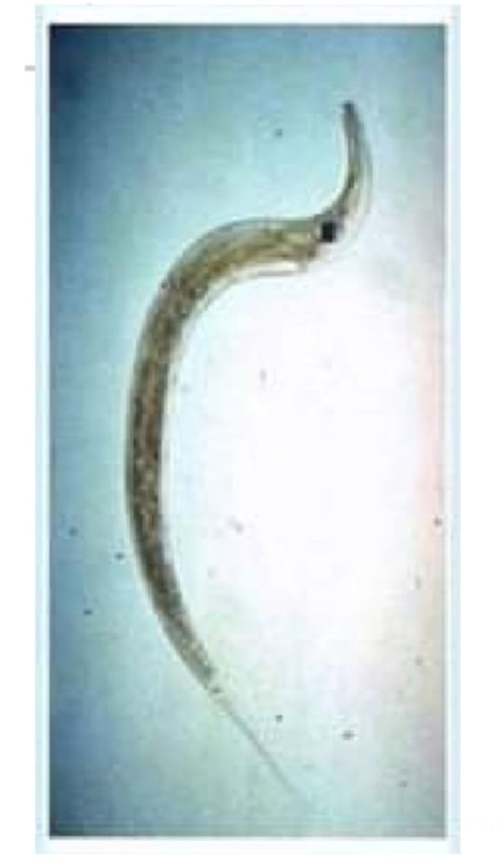
a Ancylostoma habditiform tarva.
b.Ancylostoma tilarform larva
c.Enterobius vermiculars female xxx
d.Ascaris lumbricoides
e Enterobius vermiculars male

18) Arrows point to
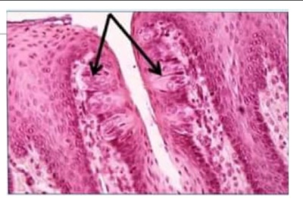
a.Exocrine glands
b.Neuroepithelium
c.Goblet cells
d.Taste buds xxx
e.Paneth ceils
19) This method of diagnosis is used with?
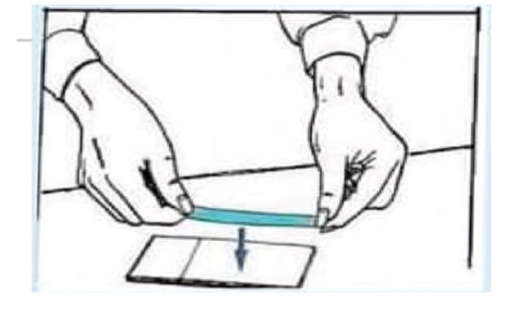
a Enterobius vermiculars xxx
b.Ancylostoma
O c.Trichinella spiralis
d.Ascars lumbricoides.
e.Ancylostoma duodenale
20)What is the labelled structure?
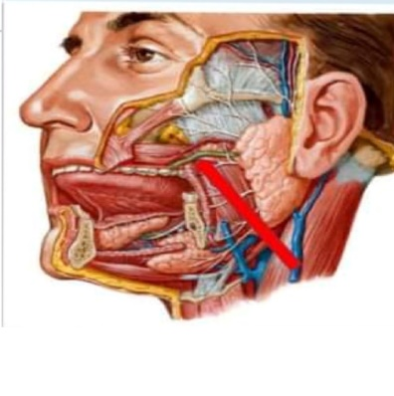
a.Superficial temporal vein
b.Auriculotemporal nerve
c.Maxillary artery
d.Temporal nerve
e.Parotid duc xxx

21) Concerning the blood supply to the gastrointestinal tract.which of the follawing has The superor pancreaticoduodenal artery as a branch
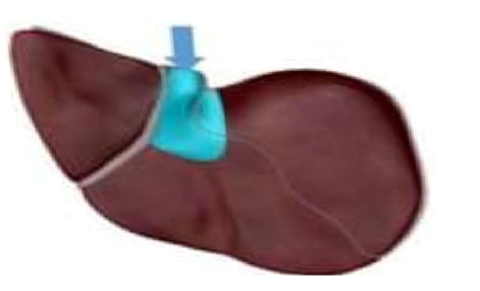
a Right colic artery
b.Gastroduodenal artery xxx
c.Left gastroepiploic artery
d.Left colic artery
e. Right gastroepiploic artery
22) What is the material accumulated in the hepatocytes in this picture?
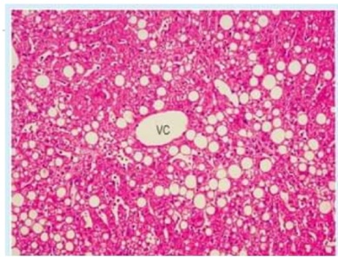
a tron
b.Cholersterol
C.Ble
d.Triglycendes xxx
e.Aflatoxin

23) The pointed structure is.
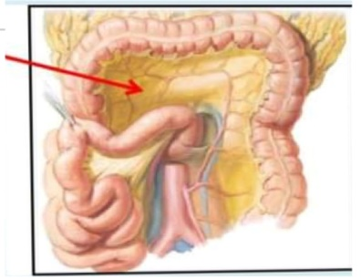
a.Mesentery of transverse colon xxx
b.Greater omentum
cPosterior abdominal wall
d.Mesentery of small intestine
e.Sigmoid mesocolon
24) Identity the specimen?
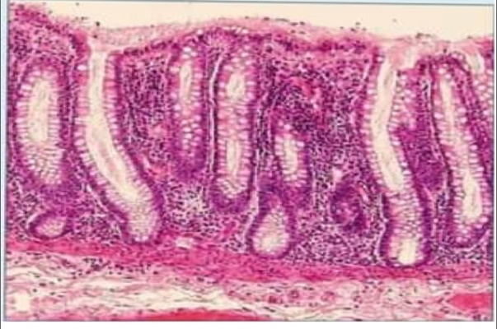
a.Intestinal vil
b.Mucosa of the colon xxx
c.Gastric glands
d Strated ducts
eFoliale papillae

25)This ovum belongs to?
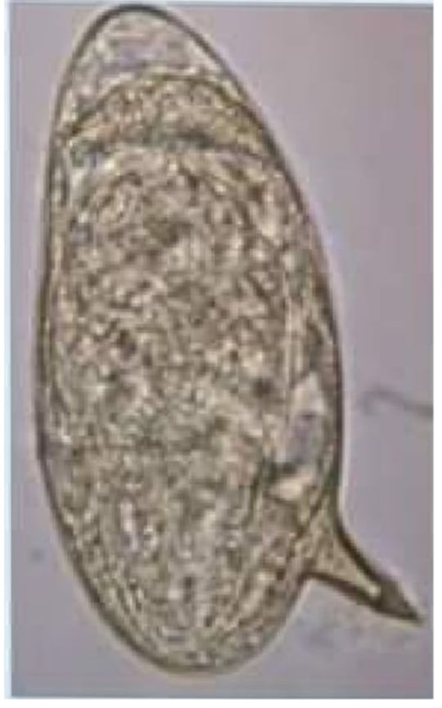
a.Ancylostoma duodenale
b.Trichuris
c.Ancyiostoma
d.S.mansoni xxx
e.Ascans lumbncoldes
26) The image belongs to?
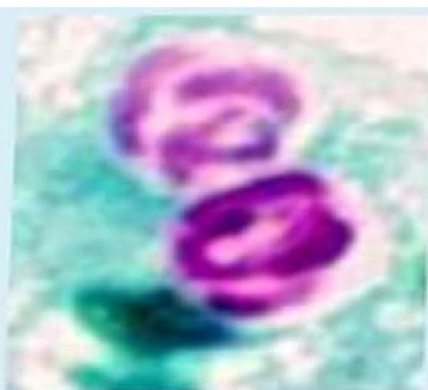
a.Balantidium coll
b.G lamblia
c.Cryptosporidium parvum xxx
d.S.mansoni
e.Trichurs
27) This worm belongs to?
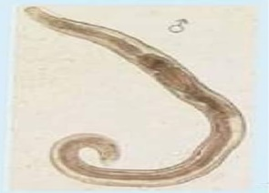
a.Ancylostoma rhabditifonm larva.
b:Ancylostoma flariform larva,
c.Enterobius vermiculars female.
d.Ascans lumbricoldes
e.Enterobius vermiculars male. Xxx
28) A49-year-old woman sees her physician because she has had abdominal cramps and dianhea with six stools per day for the past two years.Findings on physical examination are unremarkable, but a stool sample is positive for occull blood,however,no ova or parasites in the stoal Colonoscopic findings are showing in this figure in different areas of the colon.Colonic blopsy specimens trom these areas revealed active inflammation The patient is at high risk of developing which of the fallowing complications?
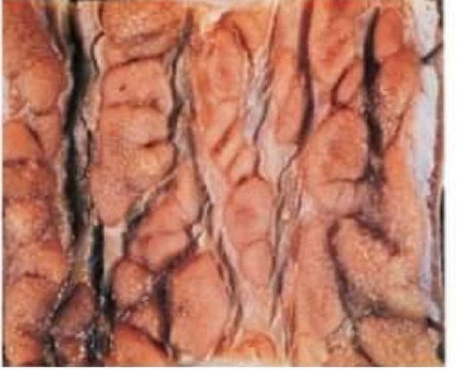
a. Adenocarcinoma of the stomach
b. Diverticulitis
c.Primary billary cirrhosis
d.Celiac disease
e Perirectal fistula formation Xxx

29) 41-year-old man has experienced pain when swallowing. He has had no episodes of hematemesis and no nausea or vomiting There are no remarkable findings on physical examination.An endoscopy is performed and random biopsy are taken The microscopic tindings shown in this figure.Which of the following statement is true regarding the diagnosis of this case?
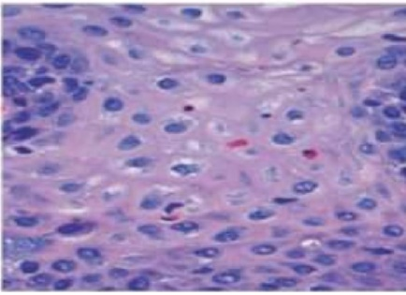
a.Baratt esophagus with low grade dysplasia.
b.Nomal gastroeasophageal junction
c.Rellux esophagitis
d.Barratt esophagus without dysplasia
e.Nomal esophageal mucos Xxx

30) This pattern of growth is related to?
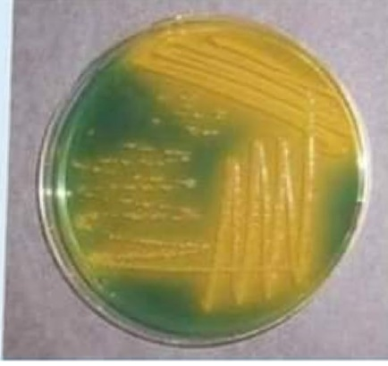
a V.cholera Xxx
b.V parahemolyticus
C E coll
d.Salmonella
e.Shigella
31) A59-year-old man has had constipation for the past 6 months. There are no significant tindings on prysical examination Lower gastrointestinal endoscopy shows a polypoid lesion in the descending colon.After excision,the microscopic and macroscopic appearances shown in the figures.What is the proper diagnosis?
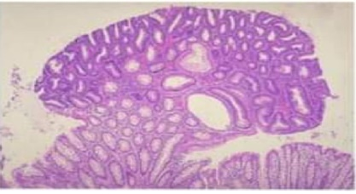
a. Tubutar adenoma with low grade dysplasta
b. Tubular adenoma with high grade dysplasia Xxx
C.Hyperplastic polyp
d.Villous adenoma with low.grade dysplasia
e.Tubulovillous adenoama
32) The histological section is
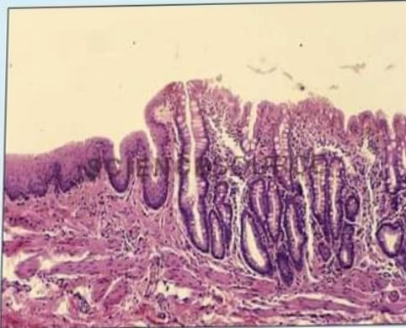
a.Pyloro-duodenal junction
b.Gastro-esophageal junction
c.Junction of excretory duct of salivary gland with oral cavity
d.Recto-anal junction Xxx
e.Junction of main pancreatic duct with duodenum

32)The pointed structure is
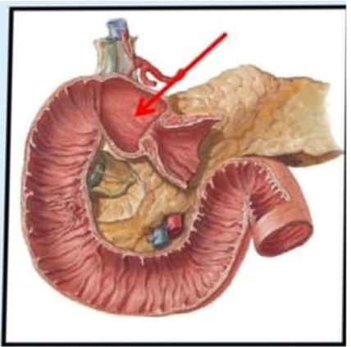
a.At L3 vertebra level
b.Common site for peptic ulcer Xxx
C.Pylorus
d.Totally retroperitoneal
e.Second part of duodenum
33) Which of the following statements is true about the weight of the
human liver?
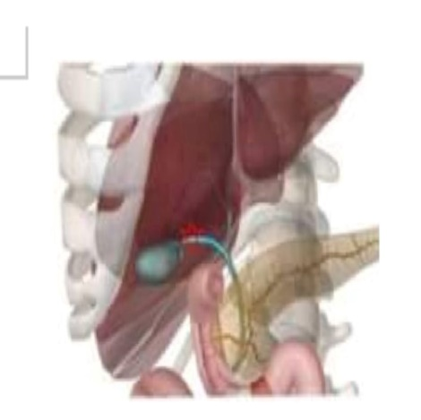
a.31b Xxx
b.14b
C.16Ib
d.1.5lb0
e.4.1b
34) A 68-year-old woman has had substemal pain atter meals for many years For the past year,she has had increased difficulty swallowing liquids and sollds. On physical examination,there are noremarkable findings Upper gastrointestinal endoscopy shows a lower esophageal mass that nearty occludes the lumen of theesophagus.A biopsy specimen of this mass is most lkely to show which of the following neoplasms?
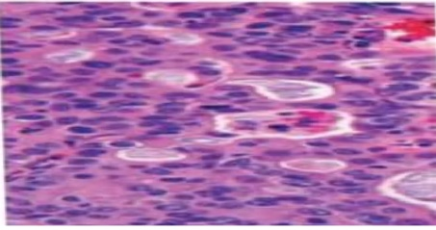
a.Adenocarcinoma Xxx
b.Leiomyoma
c. Squamous cell carcinoma
d.Non-Hodgkin lymphoma
e.Barrett esophagus
35) The definitive diagnosis for this stomach lesion is?
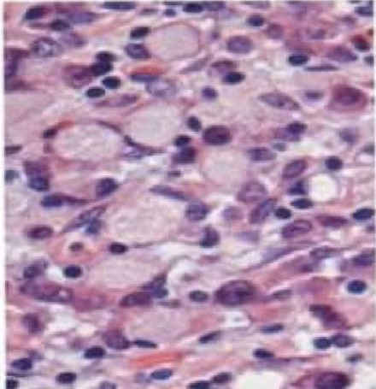
a.Gastric Intestinal type adenocarcinoma
b.Lymphoma
c.Gastric Diffuse type adenocarcinoma Xxx
d.Gastrointestinal Stromal Tumor
e.Gastnc carcinoid tumor

36) What is the tabelled structure?
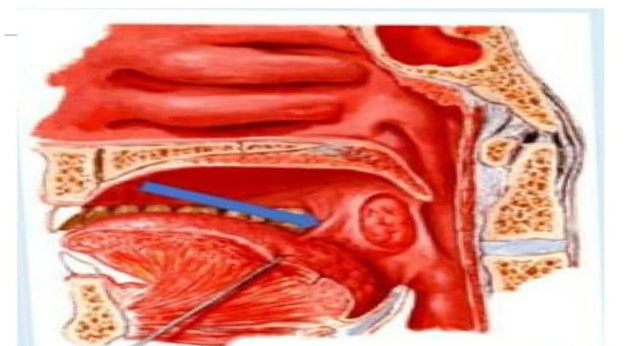
a.Palatoglossus muscle Xxx
b.Palatopharyngeal muscle
c Geniohyoid muscle
d.Mylotryoid muscle
e.Geninglossus muscle
This pattern of growth is related to?
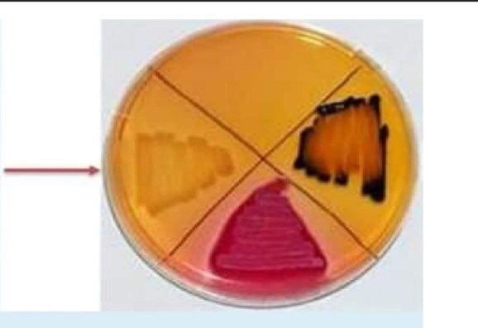
a.V cholera
b.V parahemolyticus
d.Salmonella
e.Shigella Xxx

