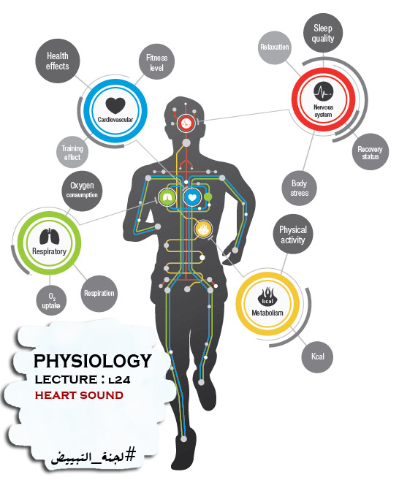

HEART SOUNDS
- Heart sounds are made by the closure of the heart valves
- the acceleration and deceleration or vibration of valves due to blood flow in the cardiac chambers.
*Heart sounds are heard by a stethoscope.
*There are different types of stethoscopes depending on the frequency that the stethoscopes are used at.
*deoxygenated blood comes from the peripheral (systemic) circulation to the RT ventricle.
-From there it will go to the lungs be the pulmonary artery (RT and LT) to be oxygenated.
-Then the blood will go from the lungs to the LT atrium through RT and LT pulmonary veins.
Then it will go to the RT ventricle , after that it will go to the aorta to reach the peripheral circulation again.
_______________________________________________________________
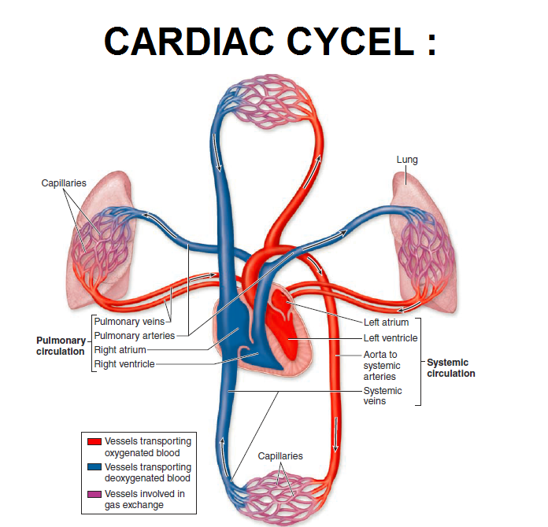
*Positioning of stethoscope

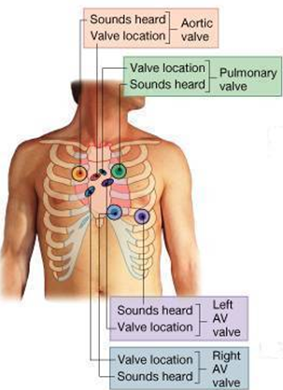
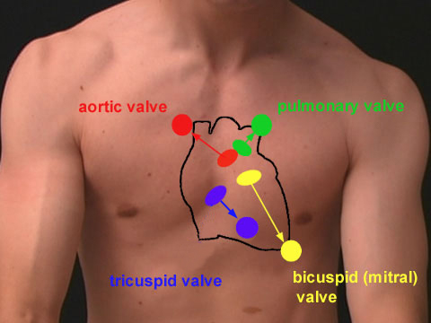

*At physical examination of the patient , we must listen to all the sounds of the valves (4sounds = 4valves) , to make sure that there is no any abnormal heart sounds, because this indicates a problem at the valves.
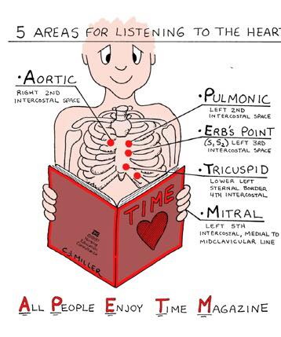
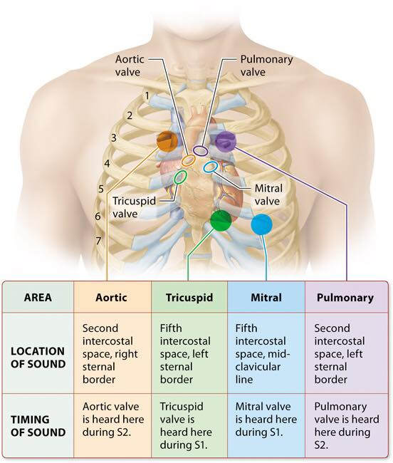
CARDIAC CYCLE: ASSOCIATION WITH HEART SOUNDS.
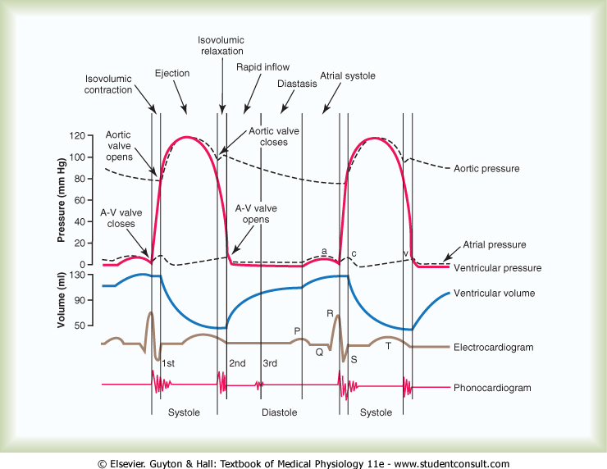
-Isovolumic contraction: at the end of ventricle diastole.
FIRST HEART SOUND (S1)
- First heart sound is produced due to the closure of Atrio-ventricular valves (Tricuspid and Mitral).
- It happens at isovolumic contraction.
- It occurs at the beginning of the systole
- When listening by stethoscope.
- Sounds like LUB
- If the frequency is higher the intensity will be higher.
- Frequency: 25-45 CPS (cycles per second) or Hz.
- Gives us the intensity of the sound and the pitch of the sounds.
- Soft when the heart rate is slow because ventricles are well filled with blood and the leaflets of the A-V valves float together before systole begins.
- Time: 0.14 sec.
- The ECG pattern formed is PQRS .
- First component due to turbulent rushing of blood towards A-V valves
- 2nd component occurs due to the closure of the A-V valves
- 3rd component is produced when semi-lunar valves open
- Ejection of blood from the ventricle to the pulmonary artery and aorta.
- 4th component produced due to turbulent blood flow into large arteries
- Vibration
- The mitral component heard at the apex beat area [left 5th intercostal space at midclavicular line].
- The tricuspid component is best heard in the 4th intercostal space at the left sternal border
NOTE (FROM SLIDE) :
Laminar Flow: the flow of a fluid when each particle of the fluid follows a smooth path, paths which never interfere with one another. One result of laminar flow is that the velocity of the fluid is constant at any point in the fluid.
Turbulent Flow: irregular flow that is characterized by tiny whirlpool regions. The velocity of this fluid is definitely not constant at every point.

SECOND HEART SOUND (S2)
- This sound is produced by the vibration associated with the closure of the semilunar valves (aortic and pulmonary) at the end of ventricular systole.(isovolumic relaxation)
- ECG relationship: The second heart sound occur soon after the T-wave of ECG.(PQRST ---- at ECG)
- Duration: 0. 11 sec
- Frequency: 50 Hz or CPS.----more intense than S1
- This sound is sharp and loud and described as “DUB.”
- Two sub components
- Pulmonary component heard at the level of 2nd left intercostal space.
- Aortic component is heard at the level of the 2nd right interscostal space near the right border of the sternum.
- The second heart sound, or S2, forms the "dub" of "lub-dub" and is composed of components A2 (aortic valve closure) and P2 (pulmonary valve closure).
NOTES:
1-when listening to the heart sounds we must listen carefully .
2- if there is a sound heard before T at ECG , we must know that sound is not made by the closure of the semilunar valves.
3-heart sounds are heard at specific ECG patterns.
*A split means that we can hear the sound twice.
Normally A2 precedes P2 especially during inspiration where a split of S2 can be heard. It is caused by the closure of the semilunar valves (the aortic valve and pulmonary valve) at the end of ventricular systole and the beginning of ventricular diastole
*closing of valve (semilunar) occurs when the pressure after the valve in artery is higher than the pressure before it.
*the aorta is not effected with the – of intra thoracic pressure.
- Splitting of S2, also known as physiological split, normally occurs during inhalation because the decrease in intrathoracic pressure increases the time needed for pulmonary pressure to exceed that of the right ventricular pressure. A widely split S2 can be associated with several different cardiovascular conditions such as, pulmonary stenosis.
*So, at inhalation the intra thoracic pressure is low so the pressure at the pulmonary artery will be low too. This will cause a delay in the closure of pulmonary valves and that gine us the split.

- The S2 duration is 0.11 Sec and S1 is about 0.14 second
The reason for the shorter S2 is that semilunar valves are more tight than A-V valves, so they vibrate for a shorter time than A-V valve
- The S2 has higher frequency than the S1
The greater elastic coefficient of the taut arterial walls that provide the principal vibrating chambers for the S2.
*the elastic coefficient of semilunar valves is higher than AV valves.
*When the wall of the artery is thicker or stronger it’s Elastic co efficient is higher.
*So, when semilunar valves close they will produce a sharp sounds.
_______________________________________________________________

THIRD HEART SOUND (S3)
► Ventricular dilation will make us hear S3 because the ventricles get larger and that will cause higher vibration when blood moves from the atrium to the ventricle.
- Occurs at the beginning of middle third of Diastole(ventricle).
- Rush of blood from Atria to Ventricle during rapid filling phase of Cardiac Cycle. (passively).
- It causes vibration in the blood
- Frequency:20-30 Htz. Because it is the vibration that happens when blood movement occurs to the ventricles from atrium.
- Time: 0.1 sec
- We can't normally hear S3 even if we used special kinds of stethoscope like (pill stethoscope) , but we can hear it in children or young adults (less than 45 years)

FOURTH HEART SOUND (S4) OR ATRIAL SOUND
- Occurs at the last one third of Diastole [Just before S1].
- -After P wave.
- -Beginning of atrial systole.
- Produced due to Atrial contraction which causes rapid flow of blood from Atria to Ventricle and vibration in the blood.
- Frequency: 20 cycles / sec or less [Htz]
- Third and Fourth heart sound are low pitched sounds therefore not easily audible normally with stethoscope
- S3 may be heard in children and young adults
_______________________________________________________________
SUMMARY OF HEART SOUND
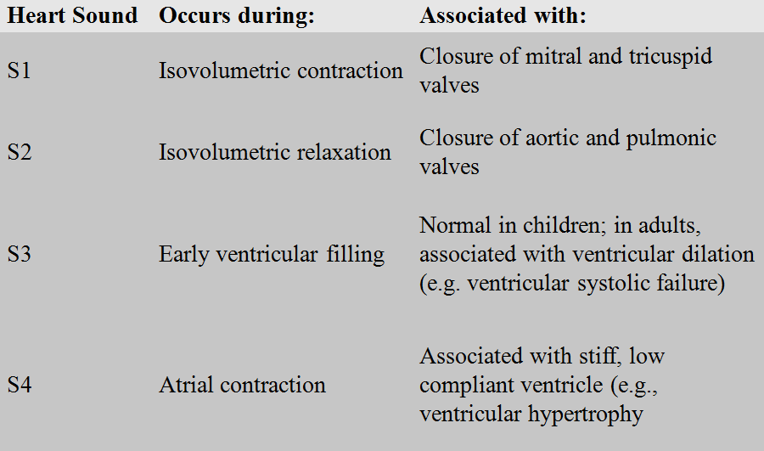

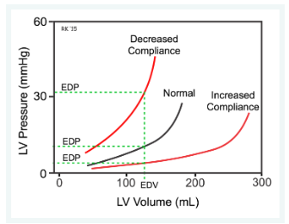
Ventricular Compliance

NOTE ABOUT THE LAST DIAGRAM…
(NOTE from slide)
*As the ventricle fills with blood, the pressure and volume that result from filling are determined by the compliance of the ventricle. Normally, compliance curves are plotted as the change in volume (ΔV) over the change in pressure (ΔP). Therefore, the slope of the relationship is the reciprocal of the compliance, which is sometimes referred to as ventricular "stiffness.“
As the ventricle fills with blood and its volume increases, the pressure within the ventricular chamber passively increases (see the Normal filling curve in the figure). The relationship is not linear, particularly at higher volumes, because the compliance of the ventricular wall decreases ("stiffness" increases) the more the ventricular wall is stretched. This occurs in most biological tissues.
in ventricular hypertrophy the ventricular compliance is decreased (i.e., the ventricle is "stiffer") because the thickness of the ventricular wall increases; therefore, ventricular end-diastolic pressure (EDP) is higher at any given end-diastolic volume (EDV)
In a disease state such as dilated cardiomyopathy, the ventricle becomes very dilated without appreciable thickening of the wall. This dilated ventricle will have increased compliance as shown in the figure; therefore, although the EDV may be very high, the EDP may not be greatly elevated.
HEART SOUNDS: ASSOCIATION WITH
CARDIAC CYCLE
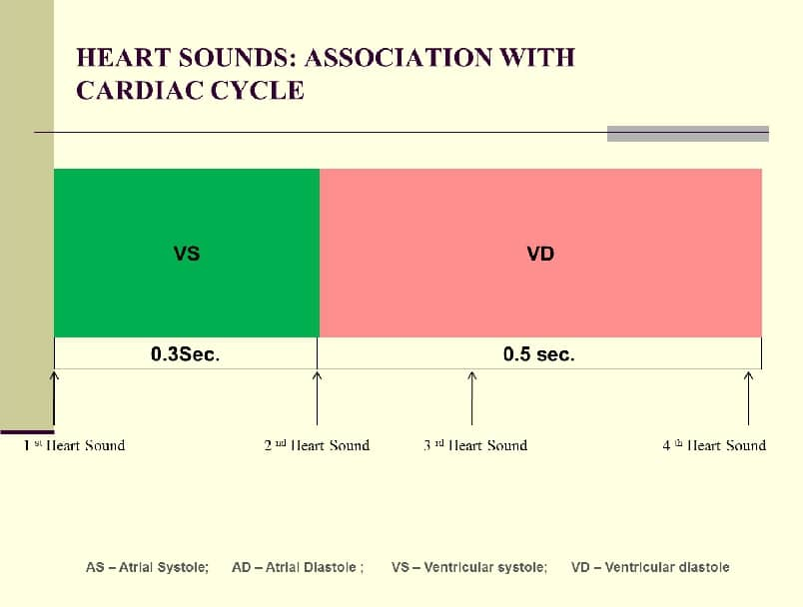
_________________________________________________________________
MURMURS
- abnormal heart sounds, produced with excessive degree of turbulence of blood flow in the heart chambers. Murmurs occurs when there is an abnormality of the cardiac valves (stenosis and incompetence). –Not normal (strong vibration) = high pitch sound.
- Murmurs of aortic stenosis and mitral regurgitation occur only during systole.
- -means back flow of blood
- -most common murmurs.
Murmurs of aortic regurgitation and mitral stenosis occur only during diastole

- كان معكم زملائكم : Yousef Tarawneh , Rand Bumadian & Feras Ahmad
# لجنة_ التبييض

