Endocrine lab exam
دفعة نبض 2019

1)A 72-year-old woman with presents with abdominal pain. Physical examination reveals neuromuscular weakness and hypertension. Laboratory studies show markedly elevated levels of PTH and Ca. A surgical exploration of the patient's neck demonstrates four symmetrically enlarged parathyroid glands. This patient's endocrinopathy caused by which of the following underlying disorders
- Chronic liver disease

- Parathyroid hyperplasia
- Insulin deficiency

- Renal insufficiency

- Parathyroid adenoma
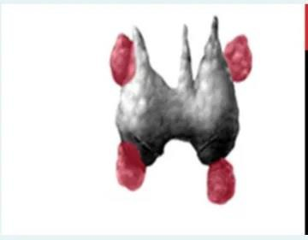

Question 2 : What do you call the material deposited on the islets of Langerhans in this section from the pancreas?
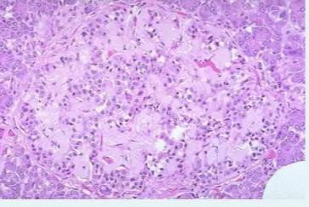
:Select one

A. Atherosclerosis

b. Hyaline

C. Dystrophic calcification
d. Amyloid

e. Microorganisms

quastion 3: What is the labelled structure

- Left posterior division of superior thyroid artery

- Left anterior division of superior thyroid artery

- Right posterior division of superior thyroid artery
- Right anterior division of superior thyroid artery

- Thyroid gland
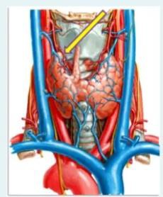

Quastion 4:A 32-year-old woman presents with a solitary, nontender, firm nodule on the left side of her neck. Thyroid function tests are within normal limits. A fine-needle biopsy reveals malignant cells. The tumor is excised and examined by light microscopy (shown in the image). What is the appropriate management for this lesions
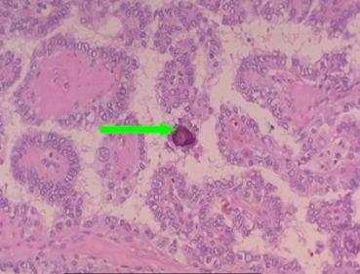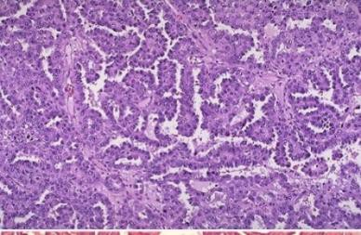
- Total thyroidectomy:

- Radiological investigation for bone and lung metastasis

- Lobectomy
- Only lymph node dissection

- Hemithyroidectomy

Quation 5: The pointed structure present in
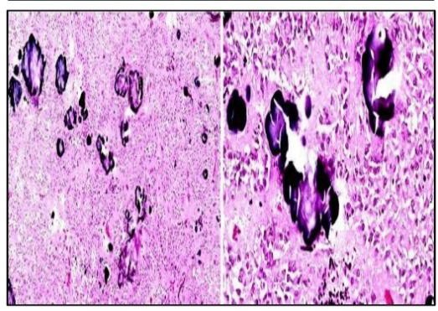

- Pituitary gland

- Suprarenal gland
- Parathyroid gland

- Pineal body e.cerebral cortex
Quastion 6:what is the medication responsible for these spherical eosinophilic cytoplasmic
:inclusions seen commonly in this tumor
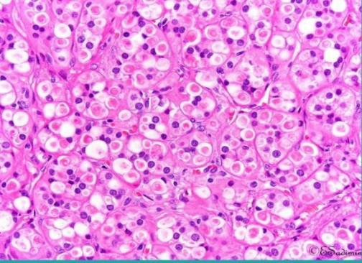
- Spironolactone

- Propranolol

- Furosemide

- Dexamethasone
- Aspirin

Quastion 7: The TRUE statement for the pointed cell is
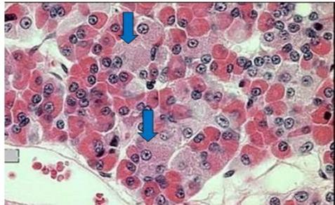
- Constitute 37%

- Secrete ACTH
- Secrete prolactin

- Secrete growth hormone

- Small in size

Question8: identify the tissue?
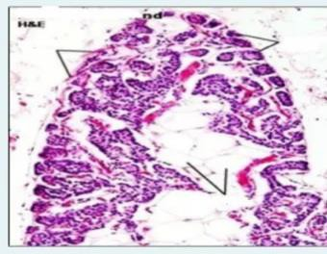

a.Yellow bone marrow

- Pineal gland in old age
- Parathyroid in young

- Parathyroid in old age

- Thymus in old age

Quastion9:The TRUE statement for the cell present in the pointed are
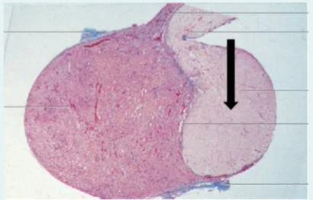
:
a.small glial cells of posterior pituitary

- Secretory cells present in pars nervosa

- Called astrocytes .a
- Multipolar nerve cells
- Modified neuronsquestion

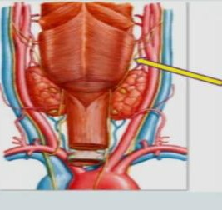
:Quastion 10 What is the labelled structure

- Inferior constrictor muscles of pharynx

- Superior laryngeal nerve
- Internal laryngeal nerve

- External laryngeal nerve

- Superior thyroid artery

?quastion 11 :What is the labelled structure?
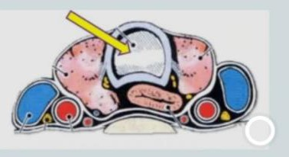

- Isthmus of thyroid gland
- Esophagus

- Lobe of thyroid gland

- Larynx

- Trachea

quation 12 What is the labelled muscle
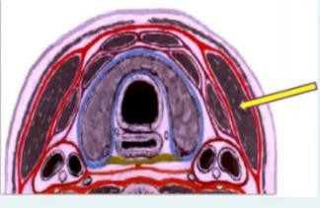
- Omohyoid
- Sternohyoid

- Sternomastoid

- Platysma

- Sternothyroid

.

:What is the material responsible for the usual yellowish color of these tumor
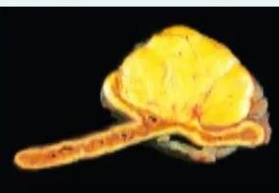
- Uric acid
- Bilirubin

- Lipid
- Dystrophic calcification

- Protein

question 14:One of the following is not usually associated with this morphologic change in the
:adrenal gland?
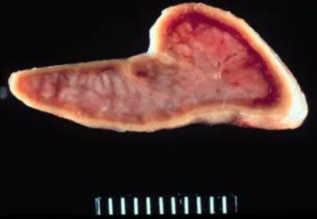
- Cushing disease

- Contralateral adrenal carcinoma
- latrogenic administration of high dose corticosteroids

- Contralateral adrenal carcinoma

- Contralateral adrenal hyperplasia

Quastion 15: the pointed area secrete?
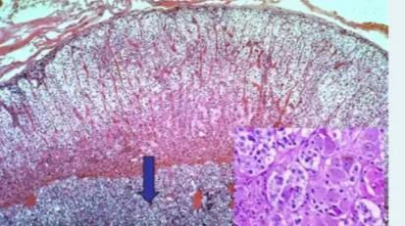
- Adrenaline and noradrenaline

- Melatonin

- Parathyroid hormone
- Melanocyte stimulating hormone

- Glucagon

:Quation 16 : the FALSE statement concerning the cell number (1) is
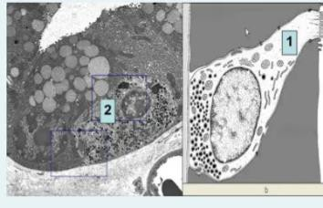
- They might show apical microvilli

- They have paracrine or endocrine action
- They have basal secretory granules

- Their apices do not reach the lumen of viscera

- They commonly present in the GIT
Quastion 17: what is the main inflammatory cell type mainly involved in the insult you see in this photo
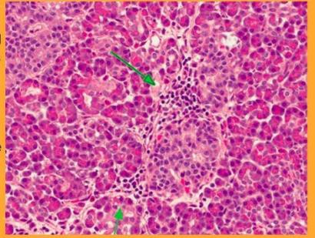
- Neutophiles

- Eosinophiles
- Macrophages

- B-Lymphocytes

- T-Lymphocyte

:Quastion 18:!what is the labelled structure?
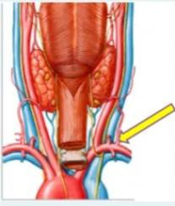
- Thyrocervical trunk

- Subclavian artery

- Recurrent laryngeal nerve

- Inferior thyroid artery
- Inferior thyroid vein

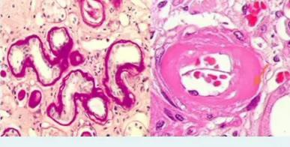
:?Quastion 19:!One of the following is incorrect about these lesions
- These lesions are characteristic and specific for long standing diabetes mellitus
- Diffuse thickening of basement membranes also involves renal tubules and nerves

- Plasma proteins are deposited in the walls of injured arterioles thickening them

- Microangiopathy is diffuse thickening of basement membranes of capillaries
- Microangiopathy underlies the development of diabetic nephropathy and retinopathy

:Quastion 20:what is the main cell component of this tumor
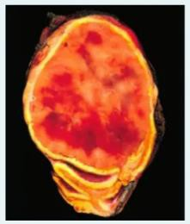
- Sustentacular cells
- Glomerulosa cells

- Fasciculata cells

- Reticularis cells
- Chromaffin cells

:Quastion 21: The vein of the labelled structure drains into
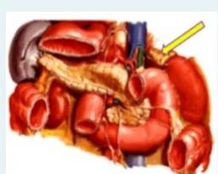
- Splenic vein

- Inferior vena cava

- Portal vein
- Left renal vein

- Right renal vein

Quastion 22: A 9-month-old female shown in this picture, born with severe mental impairment
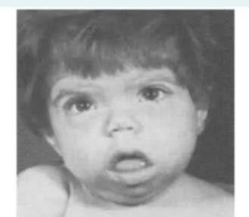
?along with umbilical hernia. What is most likely to produce these findings
- Mutation in the RET proto-oncogene
- Dietary deficiency of iodine

- Antibodies against TSH receptor

- Maternal deficiency in T4 in early pregnancy

- Irradiation of the neck

Quastion 23:A 45-year-old man presents with swelling in the anterior portion of his neck. Physical examination reveals an enlarged nodular thyroid. Thyroid function tests are within normal limits. A biopsy of this nodule shown in this image. X-rays demonstrate distant bony metastases. What is the most likely diagnosis
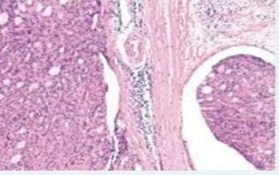
- Metastatic carcinoma

- Anaplastic carcinoma
- Follicular carcinoma

- Medullary carcinoma

- B-cell lymphoma

:Quastion 24 :what is the labelled structure?
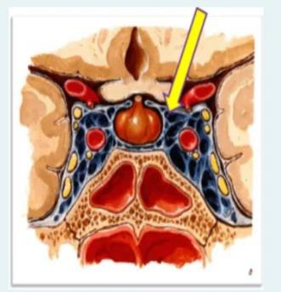
- Diaphragma sellae

- Base of the skull
- Hypothalamus

- Sella turcica

- Pituitary

Quastion 25:Which of the following diseases commonly present with this finding?
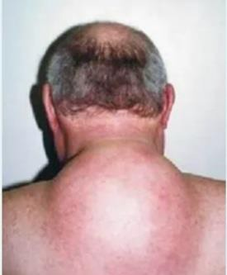

- Waterhouse Friderichsen syndrome

- Addison disease
- Cushing disease

- Diabetes mellitus

- Adrenal crisis

Quastin 26:A 33-year-old woman complains of swelling in the anterior portion of her neck, Physical examination reveals a stony, hard thyroid gland that is adherent to other neck structures. A thyroid
:?biopsy is shown in the image. What is the appropriate diagnosis?
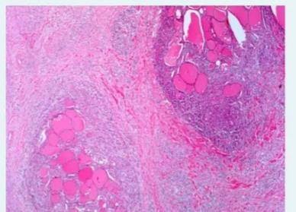

- Riedel thyroiditis
- Papillary thyroid carcinoma

- Multinodular goiter

- Graves hyperthyroidism
- Follicular adenoma

Quastion 27:A 35-year-old woman with a history of schizophrenia complains of headaches, visual disturbances, and irregular menses for 9. months. On physical examination the breasts are firm and tender. MRI shows enlargement of the anterior pituitary. A pituitary biopsy is shown in this picture.
:?Which of the following is true regarding the pituitary enlargement in this patient?
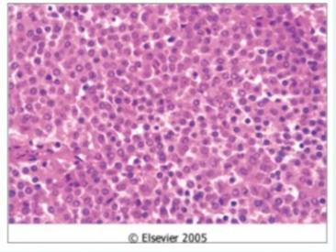
- The cut point between microadenoma and adenoma in size is metastases

- the least common type is lactotroph adenoma
- The cut point between microadenoma and adenoma in size is 1cm

- The most common type is somatotroph adenoma

- The cut point between microadenoma and adenoma in size is 1 mm

:Quastion 28:The anterior relation of the labelled structure is
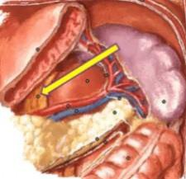
- Pyloric part of stomach
- Fundus of the stomach

- Body of stomach
- Left crus of diaphragm

- Head of pancreas

Quastion 29:the pointed structure secrete
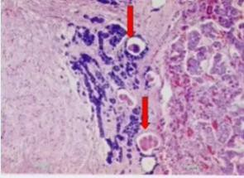
- Calcitonin hormone

- Melatonin hormone

- Melanocyte stimulating hormone
- T3 and T4

- Thyroid stimulating hormone

Quastion30:Which of the following are correct regarding the effects of increased levels of hormone
?regarding this macroscopic and clinical diagnosis
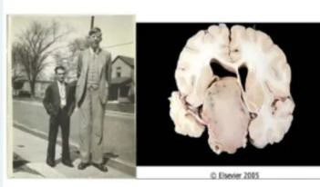
- Increased levels of growth hormone stimulate increased production of insulin like growth factor one (IGF1) from the liver
- Increased levels of growth hormone stimulate increased production of vasopressin from the adrenal glands
- A. Increased levels of growth hormone stimulate increased production of insulin like growth factor one (IGF1) from the pancreas
- Increased levels of growth hormone stimulate increased production of insulin like growth factor one (IGF1) from the adrenal glands
- Increased levels of growth hormone stimulate increased production of vasopressin from the liver

?Quastion 31:One of the following is correct about the attached photo and this patient disease?
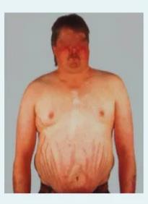
- Patients usually present with distal muscle weakness
- Moon facies is part of the characteristic centripetal redistribution of adipose tissue
- Collagen is a major component of the skin and responsible for its immunity

- Striae are formed because the skin is thick and hypertrophied due to scaring

- Anabolic effect effects of insulin resistance leads to loss of collagen

Quastion32:What is the labelled structure?
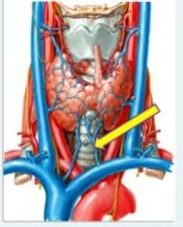
- Right superior thyroid vein
- Middle thyroid vein
C. Left superior thyroid vein

d. Right inferior thyroid vein

e. Left inferior thyroid vein

Quastion 33:A 43-year-old woman complains of low-grade fever and has a 3-day history of pain in her neck. Physical examination reveals slightly enlarged thyroid. A biopsy of the thyroid reveals the following microscopic picture (shown in the image). What is the causative agent for this diagnosis?
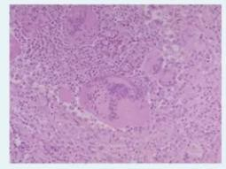
- Mutation in the RET proto-oncogene

- Maternal deficiency in T4
- Preceded by viral infection

- Dietary deficiency of iodine

- Irradiation of the neck

?Quastion 34:The least numerous cell type in this organ
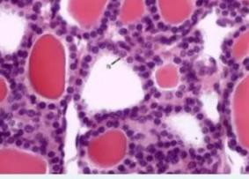
- Parathyroid cells

- Follicular cells
- Oxyphil cells

- Interfollicular cells

- Called clear cell

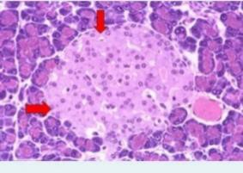
:Quastion 35:The cell in the pointed area which secrete insulin is
- Gamma cell

- Delta cell

- Parathyroid chief cells
- Beta cell

- Alpha cell

Quastiom 36:The FALSE statement concerning the pointed zone?
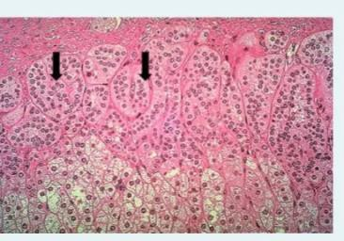
- The cells are columnar in shape
- The cells are steroid secreting cells

- Secrete aldosterone hormone

- Constitute 15%
- Also called spongiocytes

Quastion 37:What is the labelled structure?
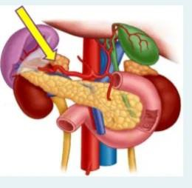
- Duodenum

- Right suprarenal gland

- Tail of pancreas
- Left suprarenal gland

- Lienorenal ligament

Quastion 38:A 32-year-old woman presents with a solitary, nontender, firm nodule on the left side of her neck. Thyroid function tests are within normal limits. A fine-needle biopsy reveals malignant cells as shown in this picture. Which of the following cytological feature is highlighted by the arrow
:and confirmed the diagnosis of this thyroid malignancy
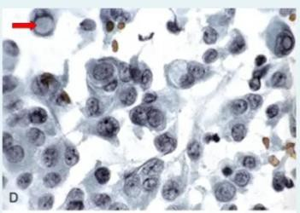
- Papillary thyroid carcinoma

- Nuclear clearing
- Nuclear grooving

- Nuclear inclusion

- Medullary carcinoma

Quastion 39:A 33-year-old woman presents with a swelling in her neck. Physical examination reveals a solitary, nontender nodule of the thyroid gland measuring 2 cm in diameter. Thyroid function tests are within normal limits. The nodule does not accumulate lodine on thyroid scintiscan. A biopsy of the nodule is shown in the image. Which of the following is true regarding
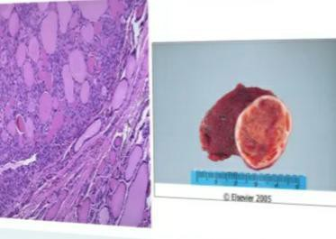
?this lesion
- Intact capsule

- Nuclear changes on FNA cytology
- Capsular or vascular invasion

- Evidence of lung metastases

- Capsular invasion

Qoastion40:One of the following is incorrect about the tumor seen in this photo ?
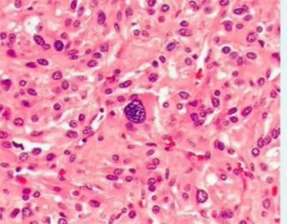
- 50% of them are paragangliomas

- Ventricular arrhythmias are one of the cardiac complications

- Multifocal lesions require long-term medical treatment for hypertension
- Tumor cells are compartmentalized into small nests by a rich vascular network

- 90% of patients present with hypertension

THE END

