E X E RC I S E

Handwashing
2
Handwashing is a simple and effective way to help prevent diseases, such as colds, flu, and food poisoning.

When to wash your hands
Washing hands:
- Before and after preparing food, eating, or feeding someone else
- After using the washroom or helping someone use the washroom
- Before and after changing diapers
- After sneezing, coughing, or using a tissue
- Before and after caring for someone who is sick
- After handling pets or other animals
- After handling animal waste
- After handling shared objects

Proper handwashing

Steps when using soap
- Wet your hands with warm water.
- Apply plain soap to your hands and rub together for 20 seconds
- Wash the front and back of your hands, as well as between your fingers and under your nails.
- Rinse your hands well for 10 seconds under warm running water, using a rubbing motion.
- Wipe and dry your hands gently with a paper towel or a clean towel. Drying them vigorously can damage the skin.
- Turn off the tap using the paper towel so that you do not re-contaminate your hands.
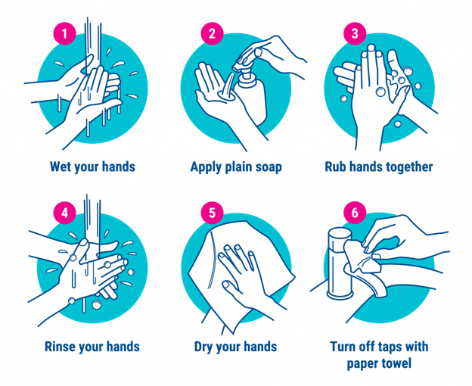

Steps when using alcohol-based hand rubs
- These products need to be at least 60% alcohol to be effective, so check the label.
- Alcohol-based hand rubs do not cause antibiotic resistance.
- Alcohol-based hand rubs do not work if your hands are greasy or visibly dirty. These products do not clean your hands and are not a substitute for handwashing. If your hands are visibly soiled, it is best to use soap and water.
- Rub your hands together until the product has evaporated.
- If dry skin is a problem, use a moisturizing lotion.
- Alcohol-based hand rubs are safe for children if used with supervision. Alcohol-based hand rubs are poisonous if ingested. Children should not put their hands in their mouths until the alcohol evaporates (about 15 seconds).
Hand washing laboratory
Aim
To demonstrate different organisms on our hands to increase awareness of hand washing importance in preventing health care-associated infections.

Objectives:
Screening hands for presence of organisms using nutrient agar plates.
Hands will be screened before and after washing.

Materials:
Nutrient agar plates.
Soap, alcohol gel and tissue paper.
37°C incubators.

Method:
Students will be divided into two groups, A and B.

For both groups:
Streak your fingers (as demonstrated) on the agar plate before washing your hands and label the plate appropriately.

Group A:
Wash your hands using soap and water, dry your hands then streak the fingers on a labeled plate as appropriate.

Group B:
Wash your hands using the provided alcohol gel until dry then streak your fingers on a labeled plate as appropriate.

For both groups:
Incubate all the plates at 37°C overnight.
Record your result the next day.

