Q1 : the study of biological molecules and the molecular basis of structure and function in living organisms . these definition refers to ??
A1 : molecular biology .
Q2 : what is the common problem the molecular biology work to solve it ??
A2 : the structure and function of the gene
Q3 : The goal of molecular biology is to understand what ??
A3 : The goal of molecular biology is to understand the five basic cell behaviour patterns (growth, division, specialization, movement, and interaction) in terms of various molecules that are responsible for them.

Q4 : It estimated that humans has ( ……… ) genes :
A ) 20000 B ) 30000 C ) 40000
A4 : B ( 30000 )
Q5 : the rapid advances in biological science brought about by the development and advancement of the ( …………… )
A5 : Watson-Crick model of DNA (deoxyribonucleic acid ) during the 1950s and 1960s

Q6 : It is estimated that each gene codes for at least ( …….. ) proteins which can be explained by splicing . what is the number ??
A6 : 4 genes
Q7 : what is the Genetic code ??
A7 : Genetic code is the sequence of nucleotides in DNA that determines the sequence of amino acids in proteins.
Q8 : what is the 5 models of biological system ??
A8 : viruses , bacteria , yeast m animal cells , plant cells .

Q9 : what is the most basic model ?? from what it composed and its anatomical structure ??
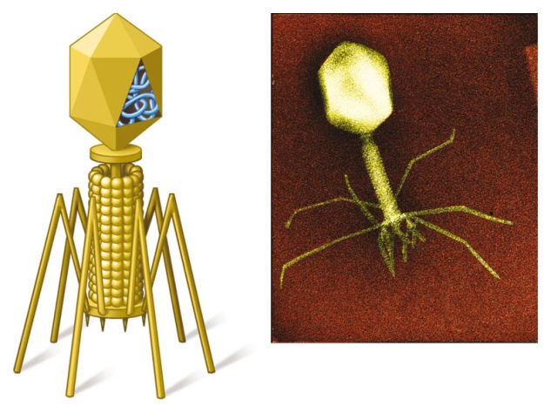
A9 : viruses , composed of protein envelope & DNA in it .
structure : head ( contain DNA , neck , tail fiber )
Head
tailTail
tail fiber er
DNA

Q10 : why we use viruses and what its function in molecular biology ??
A 10 : we use it to study DNA structure and component because it is the most basic biological models , and it work as gene transporter .
Q11 : what is the characteristics of bacteria ??
A11 : prokaryote, agar (Agar is a complex polysaccharide derived from red algae), cell division, prototroph, auxotroph
Q12 : when we use bacteria and why ??
A12 : we use it isolate it to study its therapy and effect in our body .
Q13 : yeast is ( prokaryote / eukaryote )
A13 : eukaryote
Q14 : when we use animal cell in microbiology ??
A14 : cell culture, cancer cell culture, stem cells
Q15 : if we put one cell of plant in the lab , we can grow whole plant , animal cells applied this too . ( true / false )
A15 : false , animal cells can’t grow from one cell in the lab as plant cells , it is completely different .
Q16 : we have three factors make cause diseases , environmental and genetic and interaction between each other . ( true , false )
A16 : true
Q17 : most diseases result from which factor from its in the last question ?? hive example .
A17 : Most disease result from environmental influences interacting with the individual genetic makeup {genetic predisposition (sometimes also called genetic susceptibility)}. e.g., high blood pressure, diabetes mellitus, psychiatric disorders
Q18 : complete with correct number :
- The total estimated frequency of genetically determined diseases of different categories in the general population is about (………. )
- More than ( ……….. ) defined human genetic diseases are known .
A18 : 1 ) 3.5 – 5.0 % 2 ) 3000
Q19 : is generally offered prior to marriage or conception, in order to predict the likelihood of conceiving an affected child, during pregnancy . who is that ??
A19 : Genetic counselling
Q20 : what is the :
1 ) genome 2 ) chromosome 3 ) DNA
4 ) gene
A20 :
1 ) The genome is the entire set of genetic instructions found in a cell. In humans, the genome consists of 23 pairs of chromosomes.
2 ) The human chromosomes consists of deoxyribonucleic acid (DNA) associated with proteins molecules organized into structures called chromosomes. The genome represented as chromosomes ..
3 ) DNA : it is the genetic material forms the chromosomes .
4 ) Genes are the basic physical and functional units of heredity that are made up of DNA and are parts of chromosomes. Each DNA molecule contains many genes. A gene is a specific sequence of DNA nucleotide bases, whose sequences carry the information required for constructing a specific polypeptide (protein, enzyme or hormones).
Q21 : describe the structure of DNA ??
بدي أحط الصورة للمساعدة ، أول مرة استعين بالصورة في الوصف عشان تتذكر وبعدين لقدام صير تخيل الصورة واوصف عشان تكون فاهم وتثبت المعلومات 100 %
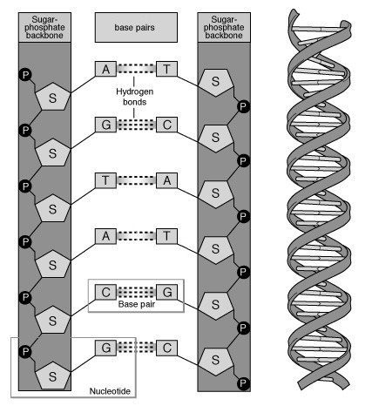
A21 : In humans, as in other higher organisms, a DNA molecule consists of two strands that wrap around each other to resemble a twisted ladder whose sides (backbone) made of sugar and phosphate molecules are connected to nitrogen-containing chemicals called nitrogenous bases. Each strand is a linear arrangement of repeating units called nucleotides. The particular order of the bases arranged along the sugar-phosphate backbone is called the DNA sequence; the sequence specifies the exact genetic instructions required to create a particular organism with its own unique traits.

In other letters :
The DNA is polymer of nucleotides , each nucleotide consist of nucleoside and phosphate , each nucleoside consist of deoxyribose
sugar and nitrogen base and these nitrogen bases twisted to each other.
Q22 : DNA is the molecule of heredity in all cells except some ( ……… ) where RNA is the molecule of heredity.
A22 : viruses
Q23 : where are RNA molecules synthesize and what its function ??
A23 : RNA molecules are synthesized on DNA templates and participate in protein synthesis in the cytoplasm
Q24 : ply peptide make by RNA maybe one of three things , what is it ??
A24 : protein , enzyme , hormone .
هذا السؤال بالذات بيوضحلنا شو أهمية الدي أن ايه ، الدكتور حكا انه مهمته الوحيدة انه يساوي آر أن ايه ، وهو راح يساوي بولي بيبتايد ، وهذا البولي بيبتايد حيساوي هرمون أو بروتين أو انزايم واللي احنا بنقدرش نعيش بدونهن ، فهيك هو حيتحكم بكل وظائف وأعمال الجسم .
Q25 : the DNA has two strands , what is the source of each strand ??
A25 : Each time a cell divides into two daughter cells, its full genome is duplicated; for humans and other complex organisms, this duplication occurs in the nucleus. Each daughter cell receives one old and one new DNA strand. The cell's adherence to these base-pairing rules ensures that the new strand is an exact copy of the old one. This minimizes the incidence of errors (mutations) that may greatly affect the resulting organism or its offspring.

Q26 : The chromosomes of prokaryotic microorganisms differ from eukaryotic microorganisms, in terms of two things , what is this two things and what is the diffrences ??
A26 : The chromosomes of prokaryotic microorganisms differ from eukaryotic microorganisms, in terms of shape and organization of genes. Prokaryotic genes are more closely packed and are usually is arranged along one circular chromosome.
Q27 : what is the fundamental control mechanism for growth and development in molecular biology ??
Or : what we mean by : transcription , translation in RNA ??

A27 : The central belief of molecular biology states that DNA is copied to make mRNA (messenger RNA), and mRNA is used as the template to make proteins. Formation of mRNA is called transcription and formation of protein is called translation. Transcription and translation processes are regulated at various stages and the regulation steps are unique to prokaryotes and eukaryotes. DNA regulation determines what type and amount of mRNA should be transcribed, and this subsequently determines the type and amount of protein. This process is the fundamental control mechanism for growth and development.

الجواب للسؤالين ، السؤالين لنفس الجواب .
**** note you have to understand All living organisms are composed largely of proteins, the end product of genes. Proteins are large, complex molecules made up of long chains of subunits called amino acids. The protein-coding instructions from the genes are transmitted indirectly through messenger ribonucleic acid (mRNA), a transient intermediary molecule similar to a single strand of DNA

Q28 : In eukaryotes, messenger RNA (mRNA) moves from the nucleus to the cellular cytoplasm, but in both eukaryotes and prokaryotes mRNA serves as the template for protein synthesis. ( true / false )
A28 : true

Q29 : hwo many amino acids you find in protein ??
A29 : Twenty different kinds of amino acids are usually found in proteins.
Q30 : there is not a unique codon sequence for every amino acid ( true / false ) .
A30 : true .
*** important note : Twenty different kinds of amino acids are usually found in proteins. Within the gene, sequences of three DNA bases serve as the template for the construction of mRNA with sequence complimentary codons that serve as the language to direct the cell's protein-synthesizing machinery. Codons specify the insertion of specific amino acids during the synthesis of protein. For example, the base sequence ATG codes for the amino acid methionine. Because more than one codon sequence can specify the same amino acid, the genetic code is termed a degenerate code (i.e., there is not a unique codon sequence for every amino acid).

Q31 : determine which of these subject pertaining to molecular biology and what pertaining to others :
1) DNA replication 2 ) mutation caused by UV
3 ) mechanisms of rearrangement and exchange of genetic materials.
4 ) DNA mutation

A31 : Areas of intense study by molecular biology include the processes of DNA replication, repair, and mutation. Other areas of study include the identification of agents that cause mutations (e.g., ultra-violet rays and some chemicals) and the mechanisms of rearrangement and exchange of genetic materials.

Q32 : describe the virus structure ??
A32 : are the simplest organisms. It is made up of DNA (in some cases RNA) surrounded by protein coat

Q33 : what is the key of virus simplicity ?? and from where it borrows its function ??
A33 : The key to the virus simplicity is its parasitic nature. It borrows functions from its host cells. The host include bacteria cells (bacteriophage is bacteria viruses), plant cells, and animal cells.

Q34 : Viruses helped in proving that protein and not DNA contain the genetic information ( true / false )
A34 : false , Viruses helped in proving that DNA and not protein contain the genetic information

Q35 : describe bacteria .
A35 : a unicellular cells that have a single chromosome, and they are simple in their organization. Bacteria lack a membrane-bounded nucleus (they are prokaryotes) and mitochondria, are surrounded by a cell wall, and divide by binary fission.

Q36 : how bacteria develop and growth ( divide ) ??
A36 : by binary fission

Q37 : in which processes we use bacteria to study and why ??
A37 : Bacteria are suitable object to study some process because they can grow easily and rapidly, they are simple in their need .

Q38 : what is the Escherichia coli (E. coli) and every how minutes it divides ??
A38 : it is a type of bacteria , and it is divide every 20 minutes at optimal conditions .

Q39 : in which surfaces or environments bacteria can grow ??
A39 : They can be grown in liquid (broth) and solid surface (agar)

Q40 : what is the difference between broth and minimal medium ??
A40 : If the liquid is complex extract of biological material it is called broth, if the growth medium is a simple mixture containing no organic compounds other than a carbon source such as sugar it is called a minimal medium .
Q41 : describe the typical minimal medium .
A41 : A typical minimal medium contain the ions and a source of carbon such as glucose, glycerol, or lactate

Q42 : what we mean by prototroph and auxotroph ??
A42 : If a bacterium can grow in a minimal medium it is called prototroph and if other substance has to be added for growth the bacterium is called auxotroph.

Q43 : where are bacteria is normally grown ??
A43 : Bacteria is normally grown on agar

Q44 : describe agar and its characteristics .
A44 : jellying agent obtained from seaweed. Agar is resistant to the action of bacterial enzyme.

**** note : Metabolism in bacteria is precisely regulated. They rarely synthesis substances that are not needed. For example if tryptophan is present in the growth medium bacteria will not make it but once used up the tryptophan synthesizing enzyme will be activated.

Q45 : describe the yeast .
A45 : it is eukaryotes .

Q46 : where we use yeast ??
A46 : mutant strains of yeast were often used to discover the genes that control growth, division, and cell behavior patterns. They also are used to produce large number of human genes.

Q47 : many animal cells can be grown and cultured in lab. ( true / false ) .
A47 : true .

Q48 : Fill in the blanks with true or false regarding animal cells :

1 ) Primary cell culture represent normal animal tissue ( )
2 ) Animal cells grow well initially and still growing . ( )
3 ) Tumor cells grow indefinitely and are easier to propagate in culture. ( )
4 ) molecular biologist has Fail in injecting foreign genes into animal eggs ( )

A48 :
1 ) true
2 ) false , Animal cells grow well initially but eventually die off.
3 ) true
4 ) false , has succeed

Q49 : what is the cell work as starting point for the production of tissues and organs as human replacement parts ??
A49 : Embryonal stem cells

Q50 : how molecular biologist succeeded in generating transgenic animals ??
A50 : molecular biologist has succeeded in injecting foreign genes into animal eggs and thus generating transgenic animals .

Q51 : explain about gene therapy .
A51 : Attempts will be made to inject foreign genes into humans cells to correct genetic defect .

انتهى الجزء الأول بحمد الله
بالتوفيق للجميع

