Tibia & Foot
The tibia:
Plural tibiae /ˈtɪbii/ or tibias
Also known as the shinbone or shankbone, it is:
- The larger,
- Stronger,
- And is the Anterior (frontal) of the two bones in the leg below the knee.
The tibia is found on the medial side of the leg next to the fibula and closer to the median plane or centre-line. The tibia is connected to the fibula by the interosseous membrane of the leg, forming a type of fibrous joint called a syndesmosis with very little movement. The tibia is named for the flute tibia. It is the second largest bone in the human body next to the femur. The leg bones are the strongest long bones as they support the rest of the body.
It is a component of the knee and ankle joints.
The ossification or formation of the bone starts from three centers; one in the shaft and one in each extremity.
The tibia is categorized as a long bone and is as such composed of a diaphysis and two epiphyses. The diaphysis is the midsection of the tibia, also known as the shaft or body. While the epiphyses are the two rounded extremities of the bone; an upper (also known as superior or proximal) closest to the thigh and a lower (also known as inferior or distal) closest to the foot. The tibia is most contracted in the lower third and the distal extremity is smaller than the proximal.
The proximal or upper extremity of the tibia is expanded in the transverse plane with a medial and lateral condyle, which are both flattened in the horizontal plane. The medial condyle is the larger of the two and is better supported over the shaft. The upper surfaces of the condyles articulate with the femur to form the tibiofemoral joint, the weight bearing part of the knee joint.
The medial and lateral condyles are separated by the inter- condylar area, where the cruciate ligaments and the menisci attach. Here the medial and lateral intercondylar tubercle forms the intercondylar eminence. Together with the medial and lateral condyle the intercondylar region forms the tibial plateau, which both articulates with and is anchored to the lower extremity of the femur. The intercondylar eminence divides the intercondylar area into an anterior and posterior part. The anterolateral region of the anterior intercondylar area is perforated by numerous small openings for nutrient arteries. The articular surfaces of both condyles are concave, particularly centrally. The flatter outer margins are in contact with the menisci. The medial condyles superior surface is oval in form and extends laterally onto the side of medial intercondylar tubercle. The lateral condyles superior surface is more circular in form and its medial edge extends onto the side of the lateral intercondylar tubercle. The posterior surface of the medial condyle bears a horizontal groove for part of the attachment of the semimembranosus muscle, whereas the lateral condyle has a circular facet for articulation with the head of the fibula.
Beneath the condyles is the tibial tuberosity which serves for attachment of the patellar ligament, a continuation of the quadriceps femoris muscle.

The Facets
The superior articular surface presents two smooth articular facets.
The medial facet:
It is oval in shape, slightly concave from side to side, and from before backward.
The lateral facet:
It is nearly circular, concave from side to side, but slightly convex from before backward, especially at its posterior part, where it is prolonged on to the posterior surface for a short distance.
The central portions of these facets articulate with the condyles of the femur, while their peripheral portions support the menisci of the knee joint. In this position the menisci intervene between the two bones.

Intercondyloid eminence
Between the articular facets in the intercondylar area, but nearer the posterior than the anterior aspect of the bone, is the intercondyloid eminence (spines of tibia), surmounted on either side by a prominent tubercle, on to the sides of which the articular facets are prolonged; in front of and behind the intercondyloid eminence are rough depressions for the attachment of the anterior and posterior cruciate ligaments and the crura of the menisci.

Surfaces
The Anterior Surfaces of the Condyles are continuous with one another, forming a large somewhat flattened area; this area is triangular, broad above, & perforated by large vascular foramina; narrow below where it ends in a large oblong elevation, the Tuberosity of the Tibia, which gives attachment to the patellar ligament; a bursa intervenes between the deep surface of the ligament and the part of the bone immediately above the tuberosity.
Posteriorly, the condyles are separated from each other by a shallow depression, the Posterior Intercondyloid Fossa, which gives attachment to part of the posterior cruciate ligament of the knee-joint. The medial condyle presents posteriorly a deep transverse groove, for the insertion of the tendon of the Semimembranosus.
Its medial surface is convex, rough, and prominent; it gives attachment to the Medial Collateral Ligament.
The lateral condyle presents posteriorly a flat articular facet, nearly circular in form, directed downward, backward, and lateralward, for articulation with the head of the fibula. Its lateral surface is convex, rough, and prominent in front: on it is an eminence, situated on a level with the upper border of the tuberosity and at the junction of its anterior and lateral surfaces, for the attachment of the iliotibial band or iliotibial tract, it could be regarded a ligament or a tendon . Just below this a part of the extensor digitorum longus takes origin and a slip from the tendon of the biceps femoris is inserted.

The Shaft or Body of the Tibia:
It is triangular in cross-section, having three borders:
An anterior, medial & lateral or interosseous border. These three borders form the boundary of three surfaces:
- Medial
- Lateral
- Posterior
The forward flat part of the tibia is called the fibia, often confused with the fibula.

Borders
The anterior crest or border, the most prominent of the three, commences above at the tuberosity, and ends below at the anterior margin of the medial malleolus. It is sinuous and prominent in the upper two-thirds of its extent, but smooth and rounded below; it gives attachment to the deep fascia of the leg.
The medial border is smooth and rounded above and below, but more prominent in the center; it begins at the back part of the medial condyle, and ends at the posterior border of the medial malleolus; its upper part gives attachment to the Tibial Collateral Ligament of the knee-joint to the extent of about 5 cm., & gives insertion to some fibers of the popliteus muscle; from its middle third some fibers of the soleus & flexor digitorum longus muscles take origin. Along most of its extent it is related to the Great Saphenous vein which is embedded in the deep fascia attached to this border.
The Interosseous Crest or lateral border is thin & prominent, especially its central part, and gives attachment to the interosseous membrane; it commences above in front of the fibular articular facet, and bifurcates below, to form the boundaries of a triangular rough surface, for the attachment of the interosseous ligament connecting the tibia and fibula.

Surfaces:
The medial surface:
It is smooth, convex, broader above than below; its upper third, directed forward and medialward, is covered by the aponeurosis derived from the tendon of the sartorius, and by the tendons of the Gracilis & Semitendinosus, all of which are inserted nearly as far forward as the anterior crest; in the rest of its extent it is subcutaneous.
The lateral surface: is narrower than the medial; its upper two-thirds present a shallow groove for the origin of the Tibialis anterior; its lower third is smooth, convex, curves gradually forward to the anterior aspect of the bone, and is covered by the tendons of the:
- Tibialis anterior
- Extensor hallucis longus
- Extensor digitorum longus
arranged in this order from the medial side.
The posterior surface:
presents, at its upper part, a prominent ridge, the popliteal line, which extends obliquely downward from the back part of the articular facet for the fibula to the medial border, at the junction of its upper and middle thirds; it marks the lower limit of the insertion of the Popliteus, serves for the attachment of the fascia covering this muscle, & gives origin to part of the Soleus, Flexor digitorum longus, & Tibialis posterior. The triangular area, above this line, gives insertion to the Popliteus. The middle third of the posterior surface is divided by a vertical ridge into two parts; the ridge begins at the popliteal line and is well-marked above, but indistinct below; the medial & broader portion gives origin to the Flexor digitorum longus, the lateral and narrower to part of the Tibialis posterior. The remaining part of the posterior surface is smooth and covered by the Tibialis posterior, Flexor digitorum longus, and Flexor hallucis longus. Immediately below the popliteal line is the nutrient foramen, which is large and directed obliquely downward.

Lower extremity
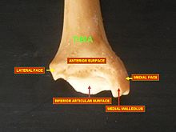
Lower extremity of tibia seen from the front
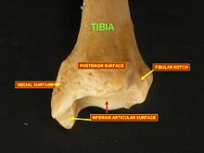
Lower extremity of tibia seen from the back
The distal end of the tibia is much smaller than the proximal end and presents five surfaces; it is prolonged downward on its medial side as a strong pyramidal process, the medial malleolus.
- The Lower Extremity of the Tibia together with
- The Fibula &
- The Talus form the Ankle Joint.

Surfaces
The inferior articular surface is quadrilateral, and smooth for articulation with the talus. It is concave from before backward, broader in front than behind, & traversed from before backward by a slight elevation, separating two depressions. It is continuous with that on the medial malleolus.
The anterior surface of the lower extremity is smooth and rounded above, and covered by the tendons of the Extensor muscles; its lower margin presents a rough transverse depression for the attachment of the articular capsule of the ankle-joint.
The posterior surface is traversed by a shallow groove directed obliquely downward and medialward, continuous with a similar groove on the posterior surface of the talus and serving for the passage of the tendon of the Flexor hallucis longus.
The lateral surface presents a triangular rough depression for the attachment of the inferior interosseous ligament connecting it with the fibula; the lower part of this depression is smooth, covered with cartilage in the fresh state, & articulates with the fibula. The surface is bounded by two prominent borders (the anterior and posterior colliculi), continuous above with the interosseous crest; they afford attachment to the anterior and posterior ligaments of the lateral malleolus.
The medial surface -- see medial malleolus for details.

Fractures غير مطلوب
Ankle fractures of the tibia have several classification systems based on location or mechanism:
- Medial malleolus - Herscovici classification
- Posterior malleolus - Haruguchi classification
- Mechanism - Lauge-Hansen classification

Blood supply
The tibia is supplied with blood from two sources: A Nutrient Artery, as the main source, and Periosteal Vessels derived from the anterior tibial artery.

Joints:
The tibia is a part of four joints:
- Knee,
- Ankle,
- Superior tibiofibular
- Inferior tibiofibular
In the knee the tibia forms one of the two articulations with the femur, often referred to as the tibiofemoral components of the knee joint.^{[5][6]} This is the weight bearing part of the knee joint.^{[2]} The tibiofibular joints are the articulations between the tibia and fibula which allows very little movement. The proximal tibiofibular joint is a small plane joint. The joint is formed between the undersurface of the lateral tibial condyle and the head of fibula. The joint capsule is reinforced by anterior and posterior ligament of the head of the fibula.^{[2]} The distal tibiofibular joint (tibiofibular syndesmosis) is formed by the rough, convex surface of the medial side of the distal end of the fibula, and a rough concave surface on the lateral side of the tibia.
The part of the ankle joint known as the talocrural joint, is a Synovial Hinge joint that connects the distal ends of the tibia and fibula in the lower limb with the proximal end of the talus (Trochlea of the talus). The articulation between the tibia and the talus bears more weight than between the smaller fibula and the talus.

The skeleton of the foot three segments:
The Tarsus

Seven Tarsal Bones
- Five metatarsals
- Skeleton of the toes; 14 phalanges
The tarsal bones are short bones which collectively create the Tarsus. These are arranged in 3 rows:
(a) Proximal row includes talus and calcaneus.
(b) Middle row is made of navicular.
(c) Distal row is composed of 3 cuneiforms (medial, intermediate, and lateral) and cuboid.

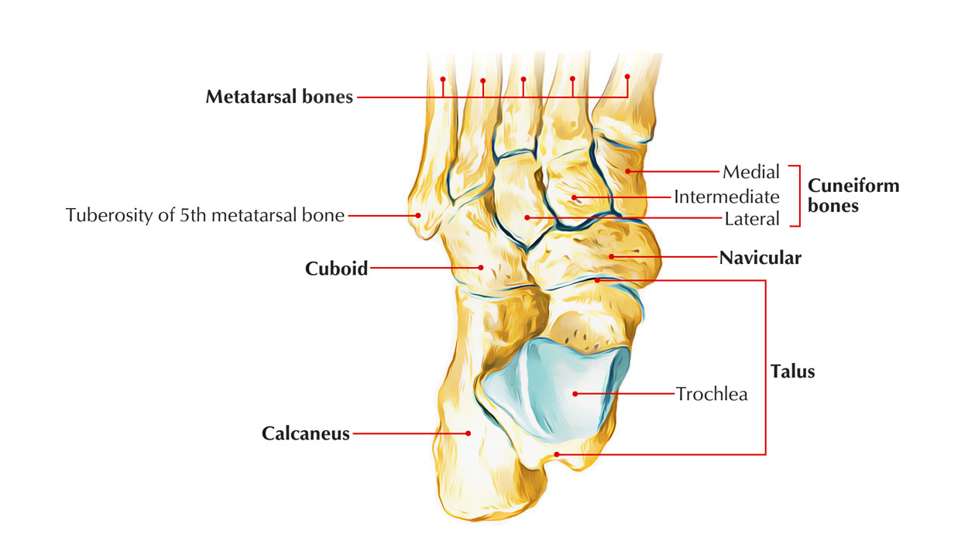

Identification of bones in the skeleton of the foot:
- Calcaneus (heel bone) is the largest and most proximal bone.
- Talus is the 2nd largest bone and is located above the calcaneus like a rider, therefore maximum bone in the skeleton of foot.
- Navicular is boat-shaped and is located in front of the head of talus.
- Cuboid is cubical in shape in front of the lateral part of calcaneus.
- Cuneiforms are small wedge shaped bones and ordered from side to side in front of navicular.

METATARSAL BONES
All these are 5 tiny long bones. The 5 metatarsal bones collectively make up the Metatarsus. They can be numbered from medial to lateral sides as first, second, third, fourth, and fifth.

Skeleton of the Foot: Metatarsal Bones

IDENTIFICATION

FIRST METATARSAL
- It’s the shortest, thickest, and most powerful, and is accommodated for weight transmission.
- Proximal surface of its base presents a kidney shaped articular surface.

SECOND METATARSAL
- It’s the longest metatarsal bone.
- Proximal surface of its base has a triangular concave articular surface.

THIRD METATARSAL
- Proximal surface of its base has a flat triangular articular facet.
- The lateral side of its base has 2 facets while the medial side has 1 facet.

FOURTH METATARSAL
- The proximal surface of its base has a quadrilateral facet, which articulates with the cuboid.
- The lateral side of base has 1 facet while its medial side has 1 facet split into 2 parts- proximal and distal.

FIFTH METATARSAL
The lateral side of its base projects proximally and somewhat laterally to create a large tuberosity (styloid process).

PHALANGEAL BONES
The phalangeal bones are tiny long bones. They’re 14 in number in every foot- 2 for the great toe and 3 for every of the other 4 toes. The phalanges in the great toe are proximal and distal, and phalanges in other toes are proximal, middle, and distal.

Skeleton of the Foot: Phalangeal Bones

- The base of the proximal phalanx presents a concave facet which joint together with the head of metatarsal bone to create the metacarpophalangeal joint.
- The distal end of the proximal phalanx presents a pulley like articular surface and articulates with the middlephalanx in the lateral 4 toes and with terminal phalanx of first toe. So, lateral 4 toes possess 2 interphalangeal (IP) joints, proximal and distal, and the great toe possesses only 1 IP joint.
- Both, proximal and distal articular surfaces of the middle phalanx are pulley-shaped.
- The distal phalanx of every toe bears a rough tuberosity on plantar aspect of its distal end.

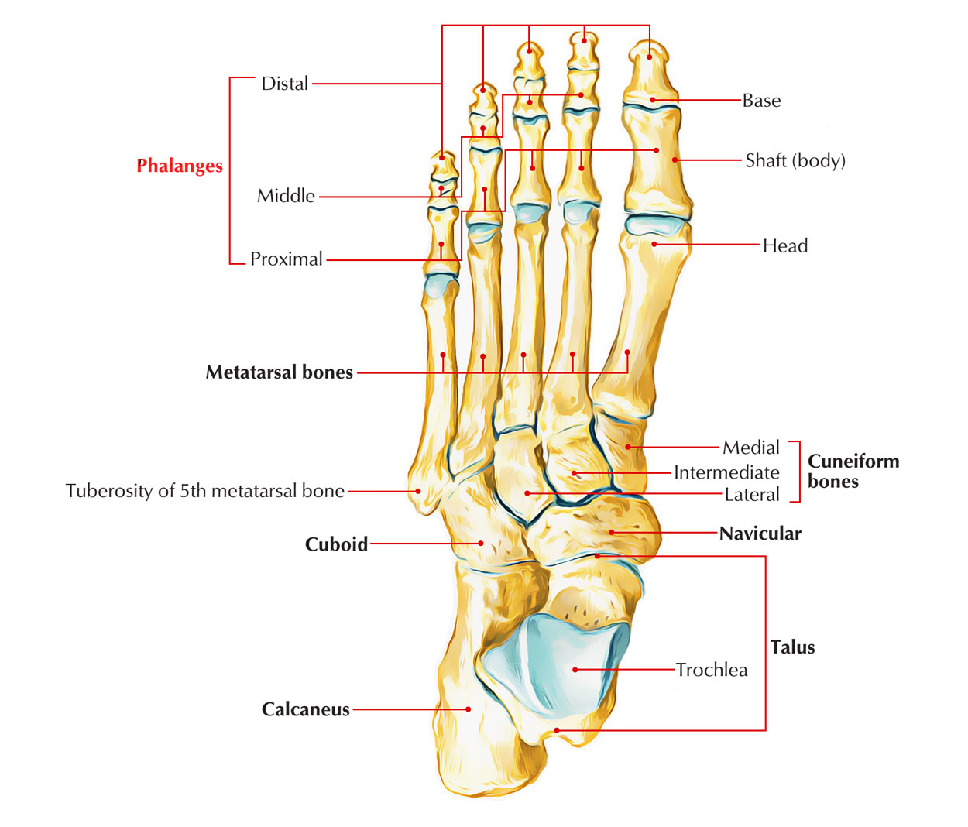

OSSIFICATION
- Every phalanx ossifies from 2 centers: a primary center for the shaft and a secondary center for the base.
- The period of appearance of primary centers is as follows:
(a) For proximal phalanges: 12th week of IUL (Intrauterine Life).
(b) For middle phalanges: 15th week of IUL.
(c) For distal phalanges: 9th week of IUL.
- The period of appearance of secondary centers is as follows:
(a) For proximal phalanges: 2 years.
(b) For middle phalanges: 4 years.
(c) For distal phalanges: 8 years.
- The fusion of epiphysis (base) with diaphysis (shaft) takes place in about the 18th year.

