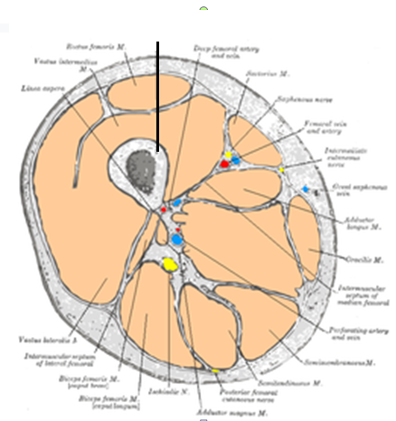

Anterior Femoral
Muscles

The anterior compartment of
The thigh contains muscles which extend the knee and flex the hip.
Structure
The anterior compartment is one of the fascial compartments of the thigh that contains groups of muscles together with their nerves and blood supply.
The anterior compartment contains:
- The Sartorius (the longest muscle in the body &
- the Quadriceps Femoris, which consists of:
- Rectus Femoris
2. Three Vasti:
- Vastus Lateralis,
- Vastus Intermedius,
- Vastus Medialis
In addition:
- The Iliopsoas is sometimes considered a member of the anterior compartment muscles, or related to the iliac group comprising psoas major, psoas minor & iliacus
- The Articularis Genu which is a femoral muscle proper
Thus a total of nine muscles, if the pectineus is included then a total of ten muscles.
The anterior compartment is separated from the Posterior Compartment by the lateral intermuscular septum and from the Medial Compartment by the medial intermuscular septum.
Nerve Supply
The nerve of the anterior compartment of thigh is the femoral nerve.
Innervation for the quadriceps muscles come from the Posterior Division of the femoral nerve.
The Anterior Division (which contains cutaneous as well as muscular components) gives a lateral & a medial branch, the second being responsible for the innervation of the sartorius muscle.
The iliacus and the psoas major and psoas minor muscles, sometimes considered part of the anterior compartment, do not share the same innervation. Whereas the iliacus is innervated by the femoral nerve, the psoas is innervated by ventral rami of L1-L3.
Blood Supply
When the External Iliac Artery descends behind the inguinal ligament, it becomes the femoral artery as it enters the femoral triangle. It supplies blood to the anterior compartment and is the largest blood artery in this region.
Function[edit] 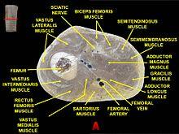

Cross-section of the upper right thigh
The anterior compartment of thigh contains muscles which are extensors of the knee and flexors of the hip joints.
Clinical significance
The anterior compartment may be affected as part of a compartment syndrome.
The musculature of the thigh can be split into three sections:

- Anterior
- Medial
- Posterior

Each compartment has a distinct innervation and function.
The muscles in the anterior compartment of the thigh are innervated by the femoral nerve (L2-L4), and as a general rule, act to extend the leg at the knee joint.
There are three major muscles in the anterior thigh:

- Pectineus
- Sartorius
- Quadriceps femoris

In addition to these, the end of the iliopsoas muscle passes into the anterior compartment.
This article will cover the attachments, actions, innervations and clinical correlations of these muscles.
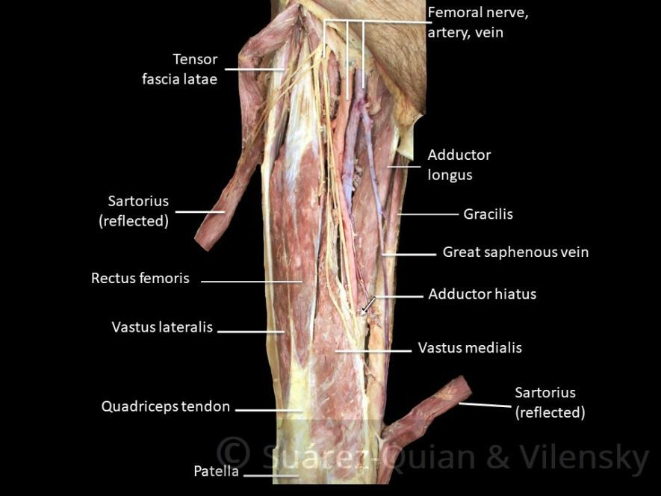

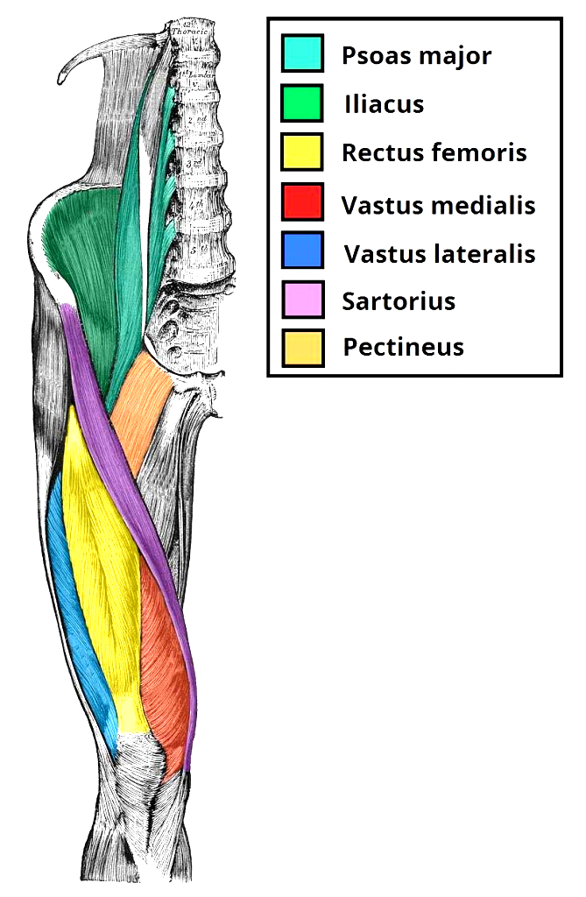

Quadriceps Femoris
The quadriceps femoris consists of Four Individual Muscles; three Vastus Muscles and the Rectus Femoris. They form the main bulk of the thigh, and collectively are one of the most powerful muscles in the body.
The muscles that form the quadriceps femoris unite proximal to the knee and attach to the patella via the quadriceps tendon. In turn, the patella is attached to the tibia by the patella ligament. The quadriceps femoris is the main extensor of the knee.
Vastus Lateralis

- Proximal attachment: Originates from the Greater Trochanter and the Lateral Lip of Linea Aspera.
- Actions: Knee Extensor & patellar stabilizer, through its fibers that converge on the lateral patellar border & others attaching to the lateral patellar retinacula.
- Innervation: Femoral nerve.

Vastus Intermedius
- Proximal attachment: Anterior & Lateral Surfaces of the femoral shaft.
- Actions: Knee Extensor & Patellar Stabilizer.
- Innervation: Femoral nerve.

Vastus Medialis
- Proximal attachment: The intertrochanteric line and medial lip of the linea aspera.
- Actions: Extends the knee joint and stabilizes the patella, particularly due to its horizontal fibers at the distal end.
- Innervation: Femoral nerve.

Rectus Femoris
- Attachments: Originates from the ilium, just superior to the acetabulum. It runs straight down the leg (the Latin for straight is rectus), and attaches to the patella by the quadriceps femoris tendon.
- Actions: The only muscle of the quadriceps to cross both the hip and knee joints. It flexes the thigh at the hip joint, and extends at the knee joint.
- Innervation: Femoral nerve.
By TeachMeSeries Ltd (2020)
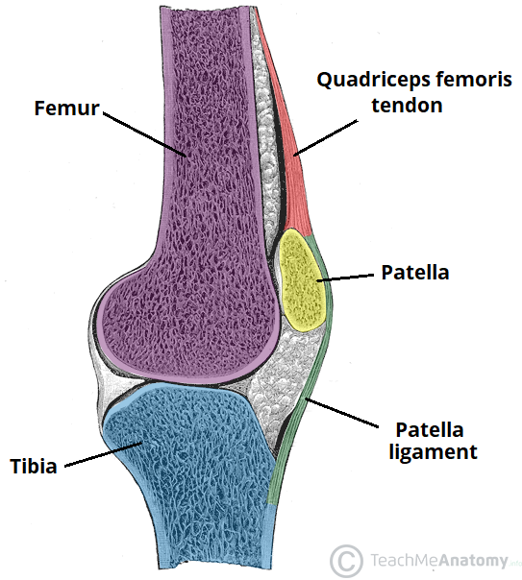
Fig 2 – The femur, tibia and patella of the knee joint.

Sartorius

The sartorius is the longest muscle in the body. It is long & thin, running across the thigh in an inferomedial direction. The sartorius is positioned more superficially than the other muscles in the thigh.
- Attachments: Originates from the Anterior Superior Iliac Spine, and attaches to the superior, medial surface of the tibia.
- Actions: At the hip joint, it is a flexor, abductor and lateral rotator. At the knee joint, it is also a flexor and medialrotator.
- Innervation: Femoral nerve.

Fig 3 – Cross section of the distal thigh. The iliopsoas and pectineus muscles originate and attach in the proximal thigh, and hence are not included in this diagram.

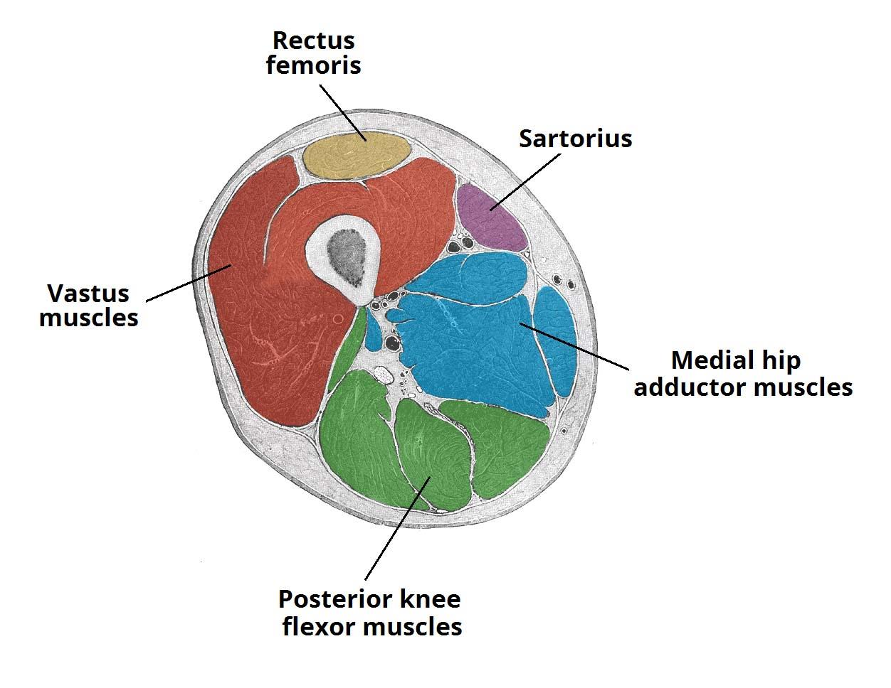

Pectineus

The pectineus muscle is a flat muscle situated in the floor of the femoral triangle. It has a dual innervation, and thus can be considered a transitional muscle between the anterior & medial thigh compartments.
- Attachments: It originates from the pectineal line on the anterior surface of the pelvis, and descends to the pectineal line on the posterior surface of the upper third of the femur, just inferior to the lesser trochanter.
- Actions: Adduction and flexion of the hip joint.
- Innervation: Femoral nerve. May also receive a branch from the obturator nerve.

Clinical Relevance: Testing the Quadriceps Femoris
The quadriceps femoris muscle can be used to test the femoral nerve in cases of suspected nerve palsy.
This is performed by positioning the patient supine, with the knee slightly flexed. The patient is asked to extend the leg (at the knee) against resistance. If the femoral nerve is damaged, contraction of the quadriceps femoris will be absent.

