MSS Lab Exam
دفعة نبض 2019

Mss lab archive

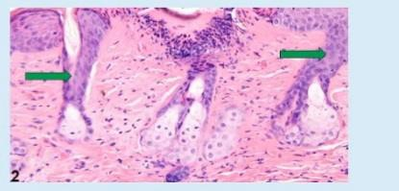
- Identify the following structure:

  - Sweat gland
  - Sebaceous gland
  - Hair follicle
  - Keratin
  - Papillary dermis

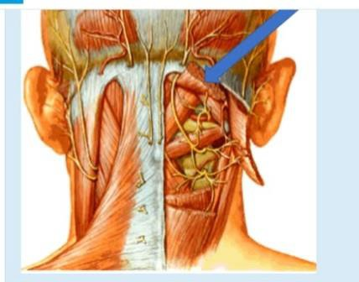
- Identify the following structure: Select one:

- Splenius capitis
- Semispinalis capitis muscles
- Oblique capitis superior
- Rectus capitis posterior major
- Rectus capitis posterior minor

- Chose one True statement about this lesion
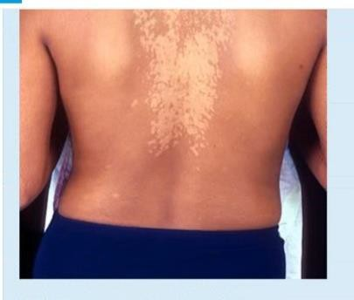

- Itchy
- Commonly superinfected by bacterial infection
C. The causative yeast has thick pseudo hyphae
d. Miconazoles usually used in treatment
e. Highly contagious

- Identify the histological feature
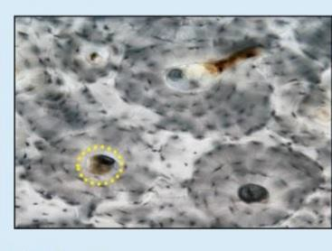

- Central canal
- Osteon
- Volkman's canal
- Canaliculi
- Lacunae

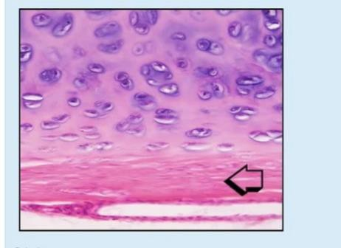
- Identify the histological feature

- Nest Cell
- Perichondrium
C. Lacunae
d. Territorial Matrix
e. Articular Cartilage

- What is the labeled structure:
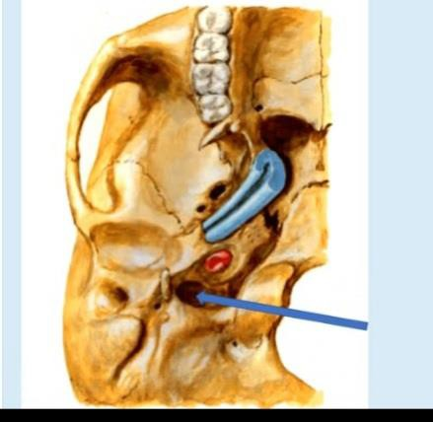

- Foramen lacerum
- Foramen jugular
C. Foramen ovale
d. Carotid canal
e. Foramen spinosum

- What is the labeled structure
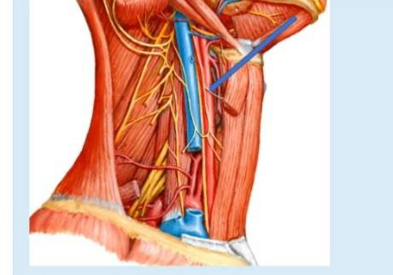

Select one:
- Nerve to omohyoid
- Nerve to thyrohyoid
C. Nerve to sternothyroid
d. Lower limb of ansa cervicalis
e. Nerve to sternothyroid

- Identify the following structure:
Select one
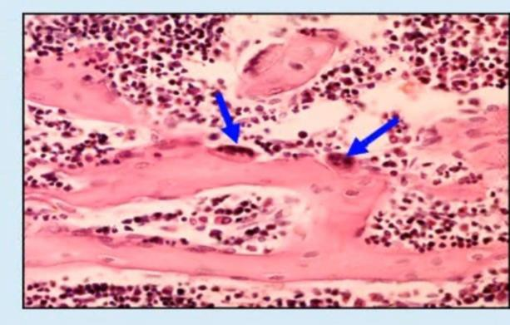
a Osteocyte
b. Osteoclast
C. Chondrocyte
d. Osteoblast
e. Osteoprogenitor Cell

- What is the labeled structure
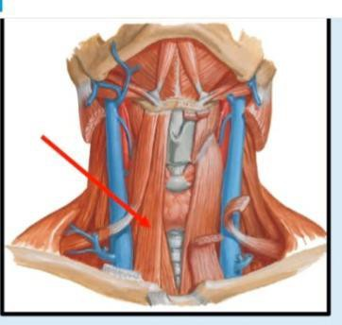

- Thyrohyoid
- Omohyoid
- Geniohyoid
- Innervated by Ansa cervicalis; C1, 2, and 3
- Sternothyroid
- identify the histological feature
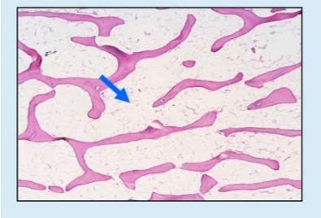

a. Hyaline cartilage b. Trabecular bone C. Bone marrow d. Articular cartilage

- Identify the histological feature:
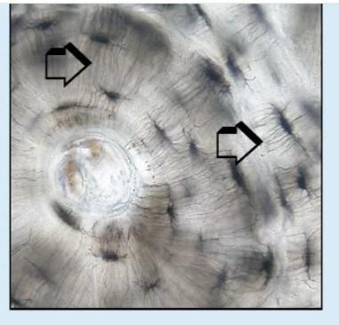
- Central canal
- Osteon
- Volkman's canal
- Canaliculi
- Lacunae
- Identify the histological feature:
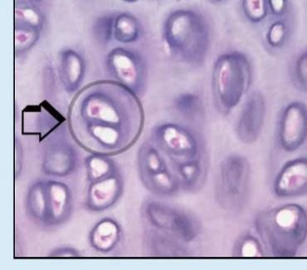
- Canalicul
- Perichondrium
C. Periosteum
d. Isogenous Group
e. Chondrogenic Cells

- Which of the following histopathologic finding would be most likely found when examining the patient's skin under the microscope?

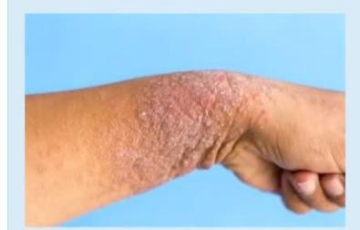
- Hyperkeratosis and acanthosis.
- Lymphocytes along the dermoepidermal with apoptotic keratinocytes
- Confluent zones of basal epidermal necrosis
- Minimal spongiotic dematitis
- A sparse superficial perivenular infitrate of mononuclear cells

- A 25-year-old male, who is a known case of sickle cell anemia, has had pain in the area of the right leg for the past 3 weeks. On physical examination, his temperature is 38.2°C. There is swelling with marked tendeness to palpation in the area of the right leg, pain, and reduced range of motion. Which organism is most likely to produce these pictures findings?
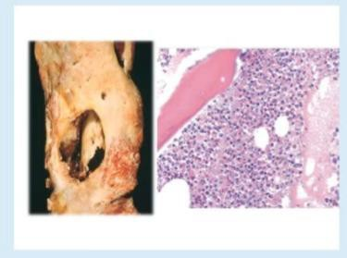
- Staphylococcus epidermidis.
- Salmonella species
- Tuberculosis.
- Staphylococcus aureus.
- Pseudomonas

- Which of the following best describe the pathogenesis leading to the change in this photo:
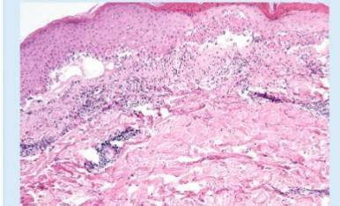

a Exacerbation reaction due to scratching of the lesion
b. Mast cell degranulation
C. Abnomal reaction to UV light
d. keratinocyte injury mediated by CD8+ cytotoxicT lymphocytes.
e. CD4+ Tlymphocytes type IV hypersensitivity

- A 42-year-old man has recently had muscle weakness. On physical examination without muscle pain or loss of joint mobility. A chest radiograph shows cardiomegaly with pulmonary edema and pleural effusions. A muscle biopsy specimen is examined. The figure shows the immunohistochemical staining pattern with antibody to dystrophin (A, normal; B, patient) What is the most likely diagnosis?

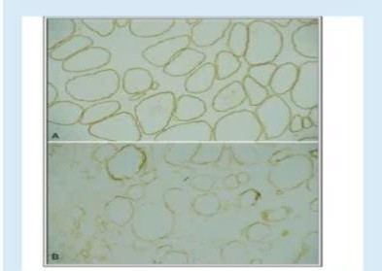
- Polymyositis
- Becker muscular dystrophy
C. Amyotrophic lateral sclerosis
d. Myasthenia gravis
e. Myotonic dystrophy

- A 30-year-old man complains of eruptions of blisters on inner surface of the groin and in his mouth. The blisters rupture easily and leave large crusted areas. Histologically, the lesions show separation of the stratum spinosum from the basal layer. The results of direct immunoflorescence microscopy for IgG are shown in this picture. Which of the following proteins is targeted by IgG autoantibody in the skin of this patient?

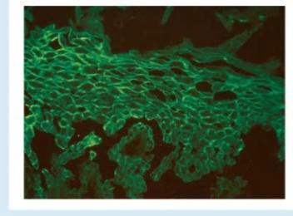
- Collagen type IV
- Desmosome
C. E-cadherin
d. Fibronectin
e. L-selectin

- Identify the histological feature
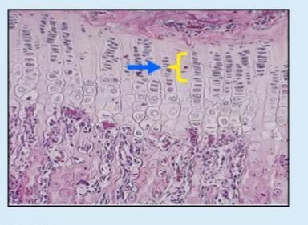
a. Hypertrophy
D. Proliferation
C Resting
d. Calcification
e. Ossification

- One is wrong:
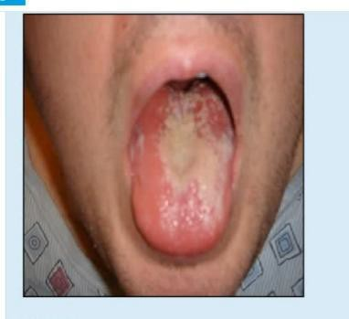
- Moniliasis
- Predisposed by bad mouth hygiene
- Usually treated by nystatin
- Caused by T. mentagrophytes
- The causative organism reproduces by budding

- The mentioned bone is:
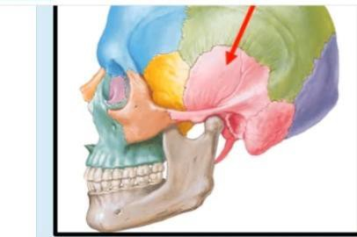

- Mastoid process of the temporal bone
- The petrous part of the temporal bone
C The squamous part of the temporal bone
d. Tympanic part of the temporal bone
e. Styloid process of the temporal bone

- What is the labeled structure

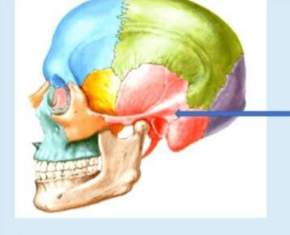
- Mastoid process
- Styloid process
C. Supramental triangle
d. External auditory meatus
e. Zygomatic arch

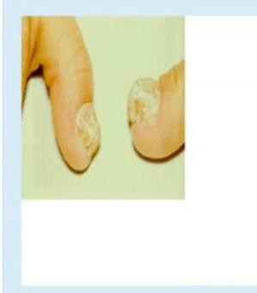
- This is describe as:

a Paronychia
- Tinea unguinum
- Moniliasis
- Fingers thrush
- Nail thrush

- A 65-year-old woman complains of having an itchy rash for the past few months. She said the lesions first appeared as red swollen plaques on her forearms. Physical examination reveals urticarial plaques, as well as large bullae on her foreams. A skin biopsy reveals a positive direct immunofluorescence test for IgG(shown in the image). Which of the following is the appropriate diagnosis?
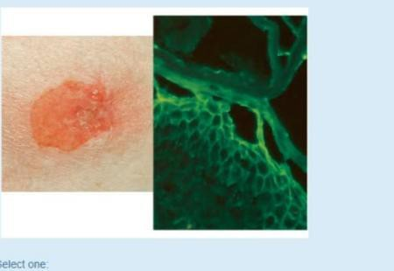

- Pemphigus foliaceus.
- Bullous pemphigoid.
- Dermatitis herpetiformis.
- Lichen planuus.
- Pemphigus vulgaris.

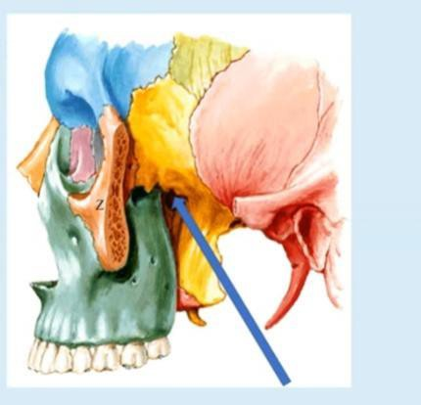
- The labeled structure is:
a Origin of lower head of lateral pterygoid muscies
- Origin of deep head of medial pterygoid muscles
- Orgin of upper head of lateral pterygoid muscles
- Origin of pterygomandibular ligament
- Origin of superficial head of medial pterygoid muscles

- What is the labeled structure

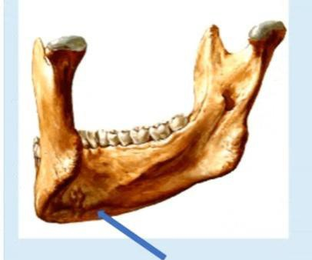
Select one:
a Origin of anterior belly of digastric
b Insertion of platysma
c. Origin of mylohyoid
d. Origin of geniohyoid e Origin of genioglossus

- What is the labeled structure:
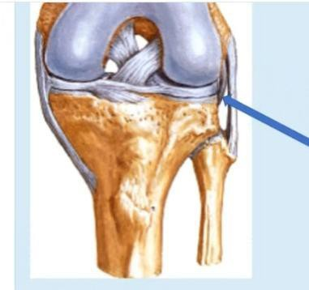
Select one:
A Lateral meniscus
b. Anterior cruciate ligament C Posterior cruciate ligament
d. Popliteus muscies
e. Medial meniscus

- What is Wrong about this
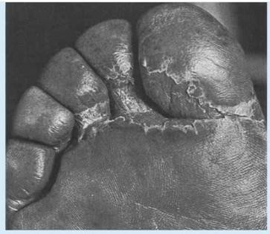
Select one:
- Tinea pedis
- b itchy
- c. Contagious
- d. Commonly caused by microsporum dermatophytes
- e. Known also as athlete's foot

- The following image is
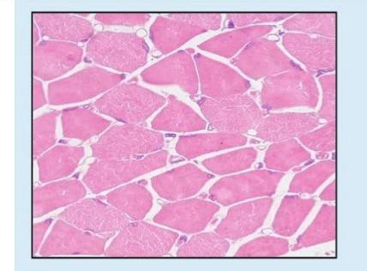
Select one:
a LS skeletal Muscle
b. Territorial Matrix
C. Lacunae
d. Articular Cartilage
e. T.S skeletal Muscle

- All the following are features of this tumor, except
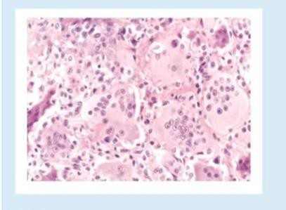

a lit has the synonym of osteoclastoma.
b.it is a relatively common benign but locally aggressive bone tumor.
C.A majority of this tumor arise in the diaphysis of long bones around the knee.
- Most are solitary tumors
- About 2% of this tumor spreads to the lungs.

- The indicated structure is
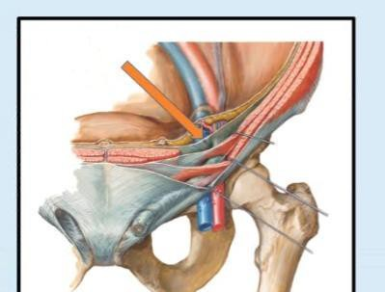
Select one:
a The transverslis fascia
b.The transversus abdominis muscle
c . The aponeurosis of the internal abdominal d The transverses aponeuroses
- Thoracolumbar fascia

- In this image one structure is not seen
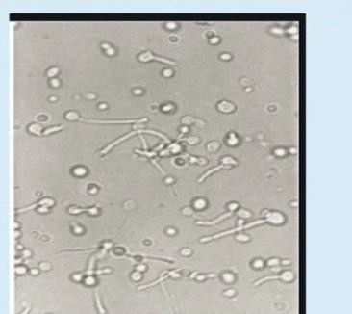

a Germ tube
b. Thin septated hyphae
C. Budding
d. Terminal spores
e. Oval yeast

- The indicated artery is
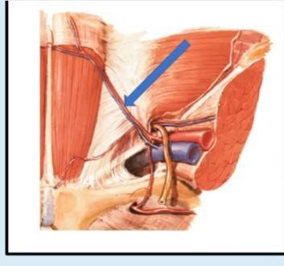
Select one:
a Subcostal artery
- Inferior epigastric artery
- Deep circumflex illac artery
- Superficial epigastric artery
e Superficial circumflex iliac artery

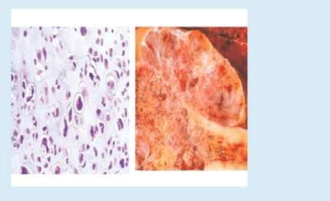
- All the following are features of this tumor, except Select one:

a lt commonly involves the small bone of the distal extremities.
- It typically manifests as painful, progressively enlarging masses.
- Chondrosarcomas metastasize hematogenously, preferentially to the lungs
- Most patients are age 40 or older, with men affected twice as frequently as women
- Conventional variant is the most common type.

- A 70-year-old man complains of right hip and thigh pain of several months' duration. On physical examination, he has reduced range of motion in both hips. Laboratory studies show eleveated a serum alkaline phosphatase level and a normal range of calcium and phosphorus. A bone biopsy is done; the figure shows the microscopic appearance of the specimen. What condition is most likely to produce these findings?
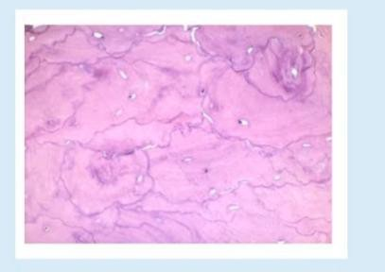

a Osteochondroma
B. Mixed phase of Paget disease of bone
c Sclerotic phase of Paget disease of bone
d. Osteoporosis.
e. Lytic phase of Paget disease of bone.

- The labeled structure is
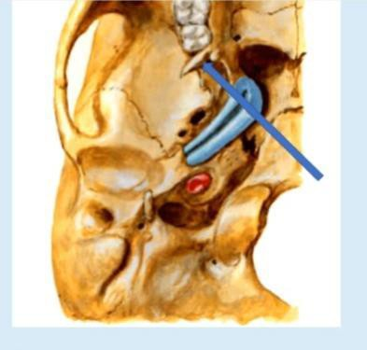
Select one:
a Origin of lower head of lateral pterygoid muscles
b. Origin of deep head of medial pterygoid muscles
c. Origin of upper head of lateral pterygoid muscies d Ongin of pterygomandibular ligament
e. Origin of superficial head of medial pterygoid muscles

- The labeled structure is
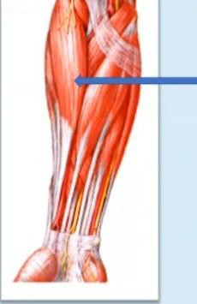
- Pronator teres
- Brachioradialis
C. Flexor carpi radialis
d. Flexor carpi ulnaris
e. Flexpr digitorum superficialis

- What is the labeled muscle
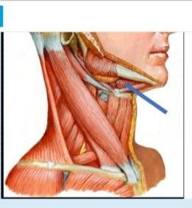
Select one:
a Anterior belly of digastric b Platysma
C. Mylohyoid
d. Posterior belly of digastric e Genioglossus

- Identify the histological feature
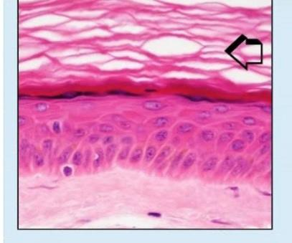
- Thin skin
- Stratum spinosum
C Stratum corneum
d. Stratum iucidum
e. Stratum granuiosum

- The identified tendon is

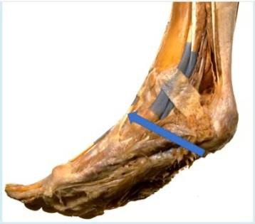
a. Tibialis posterior
D. Flexor hallucis longus C Flexor digitorum longus
d. Tibialis anterior
e Extensor halucis longus

THE END

