Physiology of menstrual cycle
- menstrual cycle :
  - Series of changes a woman's body goes through to prepare for a pregnancy.
  - About once a month, the uterus grows a new lining (endometrium) to get ready for implantation of fertilized egg.
  - When there is no fertilized egg to start a pregnancy, the uterus sheds its lining and the next cycle starts .
  - It is from Day 1 of bleeding to Day 1 of the next time of bleeding (bleeding days and off bleeding days .
  - Although the average cycle is 28 days, it is normal to have a cycle that is shorter or longer.
  - If a woman bleeds for 4 days is clean for 25 days >> her cycle is 29 days “ this is called 4 over 29 “ which means she bleeds 4 days every 29 days .
- Normal menstrual cycle :
  - mean duration of the MC :
Mean 28 days (only 15% of ♀)
Range 21-36 (3-5 weeks , below or above is abnormal )
  - average duration of menses : 3-7days
  - normal estimated blood loss : Approximately 20 – 80 ml
  - When does ovulation occur ?
Usually day 14 (in 28 days cycle )
10-12 hrs after the onset of mid-cycle LH surge
LH surge occurs 24-36 hr before ovulation, it triggers ovulation .
  - How many cycles can a woman have during life time? 300—400 cycle
  - How many oocyte at birth female has ? 2 million
- What controls the menstrual cycle?
  - Hypothalamus produces gonadotropin releasing hormone , it will go to anterior pituitary and stimulate the release of FSH and LH , FSH will go to ovaries and stimulate the growth of the follicle (from primary oocyte into mature graafian follicle ) and LH triggers ovulation .
  - The hormones estrogen and progesterone play the biggest roles in how the uterus changes during each cycle.
  - Estrogen is the predominant hormone in 1st half of cycle , it is produced from granulose cells , and it builds up the lining of the uterus from the basal layer .(there is few progesterone in 1st half of cycle )
  - Progesterone is the predominant hormone in 2nd half of cycle , produced by corpus luteum (which is formed after ovulation), increases after an ovary releases an egg (ovulation) .(there is few estrogen in 2nd half of cycle ) . corpus luteum = yellow body .
- Symptoms of painful periods :
  - Pains in the abdomen
  - Pain in the vagina
  - Feeling nauseous and generally unwell
  - Diarrhoea
  - Sweating
  - Fatigue
- Related Terms :
  - Oligomenorrhoea : Irregular, infrequent periods (5 weeks – 3 months if the period is regular OR 5 weeks – 6 months if the period is irregular )
  - Menarche: is the age of the first menstrual cycle and culminates at the age of Puberty.
  - Dysmenorrhea - painful menstruation , Possible cause >> prostaglandins
  - Amenorrhea - absence of menstruation ( >3 months if regular period OR >6 months if irregular period)
  - Mittelschmerz - middle pain; cramping in lower abdomen that occurs during ovulation “release of egg” , sometimes associated with few blood spots (good sign , indicates that lady is ovulating) .
  - Menopause is cessation of regular menstrual cycle for at least 1 year .
- Menstrual Cycle Consists of:
  - Ovarian Cycle
  - Endometrial Cycle
- The Phases of the Ovarian Cycle :
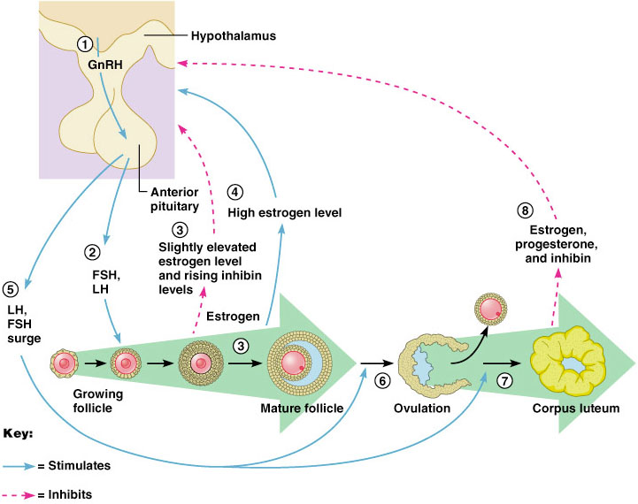
  - Follicular phase - proliferative phase or Pre ovulatory phase :
    - Starts from day 1 until ovulation day 14 .
    - high levels of FSH secreted from anterior pituitary .
    - Function is to stimulate follicles in the ovaries (from primary oocyte into mature Graafian follicle)
    - Only One follicle begins to mature and brings an egg to maturity 1- 14 days (As the follicle mature estrogen FSH “-ve feed back on the pituitary” the follicle with the highest number of FSH receptors will continue to thrive, The other follicles “that were recruited” will become atretic .
    - granulosa cells of the Follicle secrete estrogen
    - Increase level of estrogen secreted by maturating follicle that leads to endometrial proliferation and increase thickness.
  - Ovulation :
    - Follicle ruptures open and releases the mature egg at day 14 , triggered by LH surge (LH surge occurs 24-36 hours before ovulation)
    - Decrease level of estrogen
    - Life span of ovum is 24 hrs in fallopian tubes , if not fertilized within 24 hrs it’ll die .
  - Luteal phase - secretory phase or post-ovulatory phase :
    - Starts from ovulation day 14 to the end of the cycle .
    - after releasing an egg, the follicle turns into the corpus luteum 15 -28day (corpus luteum = mature graafian follicle – egg ) . egg is surrounded by cells “cumulous oophorus”
    - The corpus luteum starts to secret progesterone (predominantly) 2-3 days after ovulation to Prepare endometruim for implantation and to secret glycogen and mucus , it also secrets estrogen to a lesser level.
    - If pregnancy occurs >> the corpus luteum will not fade away and secrete progesterone until 12 weeks of gestation until the placenta is formed and it starts to produce progesterone instead .
    - Progesterone maintains pregnancy by relaxing uterine muscles and increasing sphinctric action of internal Os .
    - If pregnancy doesn’t occur >> the corpus luteum begins to degenerate and fade away and become fibrous tissue , that will lead to Estrogen and Progesterone decrease.
    - Sudden drop of Estrogen and Progesterone will lead to start of next cycle .
  - Menstruation :
    - Shedding of the inner lining of the endomertium at day 28(start of a new cycle) .
    - Just before menses the endometrium is infiltrated with leucocytes
    - Prostaglandins are maximal in the endometrium just before menses
    - Prostaglandins constriction of the spiral arterioles ischemia & desquamation Followed by arteriolar relaxation, bleeding & tissue breakdown
- The Phases of the Endometrial Cycle :
  - Proliferative phase
    - Start in day 5
    - Start endometrial proliferates in response of estrogen
    - Increase thickness dramatically from 0.5 – 5mm (at end of cycle it becomes 5 mm).
    - Cervical mucus becomes thin , clear , watery more alkaline near ovulation .
  - Secretory phase :
    - begins at ovulation
    - Progesterone secreted by the corpus luteum stimulates the glands of the endometrium to start secreting the nourishing substances preparation of implantation.
  - Ischemic phase
    - If fertilization does not occur, the ischemic phase begins.
    - Estrogens and progesterone level drop
    - Corpus luteum degenerate.
    - Spasm of spiral arterioles and lead of shedding of the endometrium.
  - menstrual phase :
    - Rupture of spiral arteries
    - The beginning of menstrual flow marks the end of one menstrual cycle

Done by : Noor Daher Al-hijjaj

