Psychiatry miniOSCE
Nabed
2-Aug-2023
1- Irritability , poor concentration , sleep problems , All of the following should be considered in the differential diagnosis , EXCEPT ?
A- PTSD
B- Premenstrual dysphoric disorder
C- GAD
D- Social anxiety disorder
E- Depressive disorders
Ans:D
2-case of female fears of social situational including contact with strangers?
*Social phobia
3-cocaine Mechanism of action :
*Dopamine release
4--Which of these is not a side effect of lithium?
A-Nephrogenic DM
B-thyroid enlargement
C-benign leukocytosis
D-weigh loss
Ans: D
5-alcohol is: GABA agonist
6-benzodazepines : GABA agonist
7-lorazepam: GABA A
8-not poor prognosis in OCD? Episodic symptoms
9-case of person belief that he owned the world what is youre diagnosis :grandeur delusion
10- The period requires to diagnosis of illness anxiety disorder : 6 months
11-true about history of eating disorder : 50% of bulimia nervosa have history of anorexia nervosa
12-A patient presented to clinic that has Russel sign, normal weight, what is the most likely diagnosis?
*bulimia nervosa
13-One is find in anorexia nervosa:increse BUN
14--70-year-old male in the ICU due to multiple MI and stroke, on EEG there is a low wave in the background, he is confused and disoriented but he is not agitated, what is the diagnosis? Delirium
15-case of a female patient that likes to cross-dress and wants to undergo sex-change surgery claiming that “she is in the wrong body”
a-transgender
b-gender dysphoria
c-transvestic fetishism
d-frotterurism
e-necrophilia
Ans: B
16- A patient on antipsychotic started to experience restlessness and he says he is unable to set still?
A- Rigidity
B- Akathisia
C- Dystonia
D- Bradykinesia
E- Ataxia
Ans: B
17- Good prognostic factor for MDD:Severe depression
18- which of these is not a side effect of carbamezapine ? hypernatremia
19- Difficulty recognizing words with slow inaccurate reading is called:Dyslexia
20- In DSM-V criteria for enuresis, what is the duration needed for diagnosis? 2 times a week for 3 Months
21-Patient brought by his brother to the ER, he had a broad-based gate , on examination he was confused, ocular examination showed nystagmus , what should you ask about? Alcoholاشي زي هيك
22-not present ofl lewy body dementia:blindness
23-all of the following Risk factors for depression in women except:
A-3 or more children under the age of 14 at home
B-Low socioeconomic state
C-Not working outside home
D-Lack of confiding relationships
E-Loss of mother by death or separation before the age of 11 years
Ans: B

24-In which of the following disorders does the individual have the motivation to assume the sick role in the absence of any secondary gain? Factitious disorder
25- The criminal act should be preceded with which of the following to be considered as a crime? Mens rea
26-the most common presentation of affective disorders among patient with epilepsy: interictal depression
27- sleep complex and K spindle with which stage of sleep? N2
28-differece between PTSD and acute stress disorder: time
29- which of these is not a side effect of valporic acid ?
30_case of male excessive sleepiness in a day time and sleep in office during do tasks : narcolepsy
31- sleep walking stage is: stage 3&4
32-17 years old male,2 years of isolation and hates eating with his family because he believes they put poisen on it and associated with deterioration of function:
- Schizophrenia
- Delusional disorder
- Major depressive disorder
Ans: A
33-a case of borderline personality disorder what is the effective therapy: DBT
34-the difference between illness anxiety disorder and somatic symptom disorder: somatic need treatment to pain relief
35-the percentage for depression occurrence in epilepsy patient with more than one seizures per month: 21%
36-postpartum psychosis strongly related to: bipolar disorder
37-percentage for postpartum depression is : 10%
38- one of the following is not a PTSD criteria
39-wrong about methylphenidate: weight gain
40-all of the following are characteristics of hypomania except: delusion

August archive
Done by:

Shahd muhaisen
Sondos AlQatawneh
Rama Hreseh

1)Insight meaning?
A)the relationship between the patient and the doctor.
B)Patient knowledge that he has illness.
C)patient behavior
D) abstract thinking

2)how to differentiate between deliruim and dementia?
A) Consciousness
B) age
C) behavior

3)one of the following is wrong about deliruim?
A) Chronic
B) acute
C) more in old
D) also known as ICU psycosis

4) affect is type of the following?
A) Thought
B) Cognition
C) Mood
D) behavior

5) Alexithymia meaning?
A) Inability or difficulty in describing or being aware of one’s emotions or mood
B) Unable to read
C) motor disability

6)somatic symptoms duration?
A)1 month
B)3month
C)6month
D) 1 year

7)patient who has a negative body image and occupied with their weight , she regularly engages in eating binges followed by self inducing vomiting her weight is 48kg and height is 1.70 cm .what is the diagnosis:-
A- Anorexia nervosa restricting type
B- Anorexia nervosa binge eating/purging type
C- Bulimia nervosa
D- Binge eating disorder

8)timing for bulimia diagnosis?
A)2 times /w for one month
B)1 time/w every month for 3 months
C)1time/w for one month

9)Russell sign is diagnostic for?
A) anorexia nervosa
B) Binge eating
C) bulimia

10) best description for OCD?
A) decrease eye contact
B) Elevated mood
C) Recurrent repetitive behaviors to reduce stress
مش نفس الصيغة*
D) Sterotype

11)in which stage sleep walking and talking occur?
A) n1
B) N2
C) N3&4
D) rem

12)k complex and spindles?
A) n1
B) N2
C) N3&4
D) rem

13)in which stage ejaculation occur?
A) n1
B) n2
C)n2&3
D) rem

14) patient complains of 3 aliens following him,whichpart of the brain is affected?
A) Frontotemporal
B) Cortex
C) Prefrontal cortex
D) mesolimbic

15) poor prognosis of schizophrenia:
A) Gradual
B) Marred
C) Older age
D). Female

16) Person with odd behavior and magical thinking , lack of close friends believes in superstitions, what is his diagnosis?
A) Schizoid
B) Schizotypal
C) Anti social
D) border line

17)which of the following is not lithium side effect?
A) Constibation
B) Sedation
C) Polyureia/polydepsia
D) Hypothyroidism

18)which of the following is not VA side effect?
A) Nystigmus
B) Diplopia
C) hirsutism
D) Pancreatitis

19)Which of the following is not carbamazipine side effect?
A) Nystigmus
B) Hepatotoxicity
C) Aplastic anemia
D) CYP 450 inhibition

20) one of the following best discribtion for lithium?
A) works immediately
B) narrow therapeutic index
C) dose not need CBC and hepatic Monitoring
D) safe for breastfeeding

21)which of the following is typical antipsycotic?
A)haloperedol
B)olanzapine
C)atmoxitine
D) TCA

22)SSRIs is safer than TCA and MOAI due to:مش*متأكدين من الاجابة
A) cause less sexual dysfunction
B) work by inhibition of noradrenaline reuptake
C) less potential for seretonin syndrome
D) best choice for bipolar
E) less sleep disturbance

23)wrong choice for social phopia treatment:
A) methylphenidate
B) ssri
C) propranolol
D) CBT

24)we do thyroid exam for which patients?
A) depression
B) mania
C) panic attack
D) OCD

25)most common disorder in women?
A) OCD
B) schizophrenia
C) depression
D) phopia

26)which postpartum disorder has 70% prevalence ? A) maternal blue
B) depression
C) postpartum psychosis

27)child came to the ER with his parents complaining of loss of vision, the parents said that this happened after they had an argument, the child doesn't seem to be scared, what is the most likely diagnosis?
A) conduct disorder
B) selective mutism
C) malingring
D) convertion disorder

28) in which cycle Premature ejaculation occur?
A) desire
B) araousal
C) orgasm
D) refractory

29)which of the following is considered adjustment disorder?
A) psychosis
B) mixed depression and anxity
C) intermittent explosive
D) bipolar

30)avoidance occur in which disorder
A) PTSD
B) depression
C) Schizoaffictive
D) OCD

31)9 year old Patient with loss of bladder and bowel control, decrease Cognitive function?
A) heller
B) asperger syndrome
C) rett syndrome

32)which of the following is not ASD criteria?
A) marked impairment in nonverbal behaviors.
B) stereotyped and repetitive motor mannerisms.C) persistent preoccupation with parts of objectsD) answer without permission

33)which of the following is not Atmoxitine side effect:
A) hepatic Toxicity
B) insomnia
C) weight loss
D) suicidal ideation

34)what is the first sign in alcohol Toxicity?
A) delirium
B) convulsions
C) nausea and vomiting
D) itching

35)what is the most illisit substance world wide?
A) cnnapis
B) nicotine
C) benzodiazipne
D) opioid

36)what is an example of hallucinogen?
A) opoid
B) LSD
C) barbiturate
D) heroine

37)Not included in the 4D's of Negligence in clinical malpractice?
A) Duty
B) Damage
C) Deviation
D) Direct causation
E) Discovery

38)patient who has fear of leaving home and being left alone?
a- social anxiety disorder
b- agoraphobia
c- generalized anxiety disorder
d- specific phobia

39)age for enuresis diagnosis?
A) 5 years
B) 3 years
C) 4 years
D) 7 years
40)asking the patient to tell proverbs is a test for?
A) insight
B) abstract thinking
C) Cognitive
D) thought content

Group 3
Done by ; omyma Anwar , kozama saadeh

1) withdrawal of one of these substances can lead to a potential death?
A. Alcohol B. Cocaine C. Heroin D. Cannabis

2) all of the following are side effects of (Strattera) Atomoxetine except?
A. weight loss B. poor appetite C. Insomnia D. Hepatic toxicity E. Suicidal ideation

3) all of the following are present in DSM5 criteria of encopresis except?
A. Chronological age >4 years

B. Event occur at least once a month for 3 months
C. Repeated passage of feces in inappropriate places
D. The condition is not attributable to medical condition or substance E. it occur only during sleep

4) alcohol withdrawal is related to one of these neurotransmitters?
A. Dopamine B. Norepinephrine C. GABA D. Acetylcholine

5) a 22 years old patient have got abroad job opportunities know he Can't sleep well, feeling worried a but travelling to a new country without knowing its language and circumstances, feeling on edge.. Since 2 months.. His probably suffering from?
- Generalized anxiety disorder
- Adjustment disorder with depression
- Adjustment disorder with anxiety
- Phobia

6) all of the following are side effects of lithium except?
A. Constipation B. Benign leukocytosis
C. Sedation D. Weight gain E. Thyroid enlargement

7) all of the following are side effects of Carbamazepine except?
- Leukopenia B. Microsomal enzyme inhibition C. aplastic anemia
D. thrombocytopenia, E. Agranulocytosis

8) what neurotransmitters antidepressant agents work mainly on?
A. Serotonin and dopamine B. Norepinephrine
C. dopamine and ach D. adrenaline and dopamine

9)all of the following are present in ASD except?
A. lack of social or emotional reciprocity
B. stereotyped and idiosyncratic language
C. stereotyped and repetitive motor mannerisms
D. marked impairment in nonverbal behaviors
E. Blurts out answers before questions have been completed

- 10) a child presented at age of 9- 10 after normal development with lose of motor skills and bowel and bladder control, marked loss of cognitive functions, abnormalities of social behavior and communication ?
A. Heller's syndrome B. Rett syndrome C. ASD D. ADHD
11) a pregnant women suffering from depression with suicidal ideation what's the treatment of choice ? A. ECT B. lithium C.valporic acid

12) the most common Psychiatric disorder in female population?
A. Phobia B. GAD C. anxiety disorder D. somatization

13) all of the following are true about illness anxiety disorder except?
A. More common in female than male
B. preoccupied of acquired a serious illness
C. high level of anxiety about health
D. somatic symptom are not present
E. persist at least 6 month

14) False about Factitious Disorder :
A. more common in men
B. it can be intentional
C. the gain is primary gain
D. Fagin symptoms such as hyperthermia
E. falsification of injury or disease

15) defention concrete thinking : abstract thought and its type of thought prossing

16) loose of association is present most commonly in :
A. Schizophrenia
B. Bipolar
C depression with psychotic feature
- Mania

17) not paraphilia :
A. homosexual
B. Pedophilia
C. Exhibitionism
D. Voyeurism
E. Fetishism

18) pyromania categorized in DSM5 criteria of :
A. impulse control, conduct
B.GAD
C. phobia
D. panic attack
E. anxiety disorder

19) bulimia nervosa treatment :
A. fluoxetine
B. antidepressant
C. just CBT
20) case of female Patient with binge eating and inappropriate compensatory mechanism to prevent weight gain, weight 45, height 170, diagnosis?
- Anorexia Bulimia
- Anorexia nervosa
- Somatic disease
- Bing - eating disorder

21) all of the following are used in treatment of social phobia except :?
A. Methylphenidate B. SSRI C. CBT D. Beta blockers E. lorazepam

22) delirium :
A. Sudden onset
B. Brief an fluctuant course
C. Resolve immediately after defining the underlying cause and treating it
D. Domiprazole is the first line treatment

23) duration to diagnose schizophrenia :
A. 6 months
B. 1 month
C. less than 6 month
D. 3 month with symptom

24) duration to diagnose delirium : 1 month

25) true about sleep hygiene :
A. sleep daily at the same specific time
B. Take daily naps as needed
C. Eat large meals at bedtime
D. Exercise right before bedtime

26) definitive treatment of obstructive sleep apnea :
A. nasal continuous positive airway pressure
B. Weight loss
C. theophylline

27) hypocretin insufficiency contributes in the pathophysiology of? Narcolepsy

28) A 10 years old male child presented to the hospital with his parents complaining of blindness after a conflict, diagnosis? A. Conversion

29) tactile hallucinations are most common with?
A. alcohol withdrawal B. Bipolar disorder C. Schizophrenia D. drug toxication
E. drug with drawal
30) Gender identity ?
A. the sense of self as being male or female
B. the expression of one’s gender in society.
31) emotions are examined under this category? A. Thought B. Behavior C. Perception D. Affect E. Memory

32) one of the following is not a side effect of Benzodiazepines?
A. Impairment of intellectual function
B. Reduced motor coordination
C. Drug tolerance
D. Drowsiness, sleepiness, or dizziness
E. Acute dystonia

33)which of the following is not VA side effect? A. Nystagmus
B. Diplopia
C. hirsutism
D. Pancreatitis
E. Fulminant hepatic toxicity

34) antidote for Benzodiazepines A. Flumazenil

35)one of the following is adjustment disorder? A. Job loss
B. Relative death
C. rape
D . none of above
- All of above

36) one of these is not found in schizoid personality disorder?
A. detachment from social relationships
B. restricted range of expression of emotions
C. emotional coldness, detachment
D. Recurrent and intense mood swings

37) a child with dyscalculia find difficulty in?
A. Reading
B. Writing
C. Mathematics *****
D. intellectual function
E . memory

38) a negative sign of schizophrenia?
A. Delusion
B. Hallucinations C. Alogia D. Disorganized speech E. Disorganized behavior

39) pervasive pattern of symptoms **** case مكرر ارشيف
40) ECT not consider treatment in social phobia مش متذكرين السؤال ولا الخيارات**

Psychiatry
Mini-OSCE Archive
sara saraireh , rahma saraireh , ebthal al qudah , juman riyad

Sexual:
1 - All sexual disorders except drug-induced, criteria for duration should at least be? A- 1 month
B- 3 months
C- 6 months **
D- 8 months
E- 1 year

2- A case about a male that obtains sexual pleasure by rubbing his genital area on the body of the opposite sex female
a ) sadism.
b) frotteurism. ***
c) fetishism
d) exhibitionism

3 - Non-modifiable suicidal risk factor?
A- PTSD
B- Impulsivity
C- Cancer
D- Homosexuality**
Reaction to stress and Adjustment disorder :

4- The key difference between panic attack and panic disorder?
A- Panic attack is characterized by spontaneous, recurrent panic attacks.
B- Panic attacks can be experienced with other psychiatric disorders and medical conditions*
C- Panic disorder cannot occur multiple times per day

5- one of the following is adjustment disorder?
A. Job loss*
B. Relative death
C. rape
D . None of above
E- All of above

6- a 22 years old patient have got abroad job opportunities know he Can't sleep well, feeling worried a but travelling to a new country without knowing its language and circumstances, feeling on edge.. Since 2 months.. His probably suffering from?
A. Generalized anxiety disorder
B. Adjustment disorder with depression
C. Adjustment disorder with anxiety**
D. Phobia
Personality disorder :
7- schizoid personality disorder:
a- Limited emotion and indifference to social relationships**
b- failure to confirm social norms
c- failure social rejection
d- delusion of grandiosity
forensic psychiatry:
8 - Not included in the 4D's of Negligence in clinical malpractice?
a- Duty
b- Damage
c- Deviation
d- Direct causation
e- Discovery**
impulse control disorder :
9- patient have impulsive and aggressive outbursts that cause damage?
1. Intermittent explosive disorder**
2. pyromania
3. kleptomaniac
4. general anxiety disorder
Delusion disorder
10- duration of delusion?
a- 1month**
b- 2 m
c- 6m
d- 2weeks
Somatic disorder
11- 23. 65 years old female came to the clinic that reported she has skin cancer and the doctor make all test &labs to confirm but the result have no abnormal findings which type of disease that the patient suffer from?
A- Adjustment disorder with anxiety
B- Conversion disorder
C- Delusional disorder (somatic subtype)
D- Factitious disorder
E- Generalized anxiety disorder
F- Illness anxiety disorder**
Schizophrenia
12- all of the following consider negative symptoms of schizophrenia except?
1. Anhedonia
2. affective mood
3. improvement of Thought process**
4. lack of motivation

13- combination of symptoms of criteria A if occur for 1 month can diagnosed with schizophrenia:
a- Prominent visual and auditory hallucination
b- perceptual and grandiose delusion
c- disorganized speech and emotional difference **
Schizoaffective
14- to differentiate Schizoaffective from mood disorder with psychotic features patient must have 2 week of symptoms without manic or depressed episodes which is :
a- hallucination and delusion**
b- anhedonia and poverty of speech
c- disorganized speech and behavior
Mood disorders :
15- good prognostic factor for MDD
a-Double depression
b-Co-morbid physical disease, personality disorders or alcohol dependence
c-Chronic ongoing stress
d-Poor drug compliance
e-acute and severe depression **

16- the percentage of patients with MDD eventually commit suicide:
a- 50
b- 10
c- 15 **
d- 5

37 – not in DSM5 criteria for depression:
a- Amenorrhea**
b- anhedonia
c- change in appetite
alcohol and substance use :
18- all of that are CNS depressant except :
a- alcohol
b-cocaine**
c- Hallucinogen
d- Marijuana

19- reemergence of symptoms when the medication is discontinued :
a- dependence
b- withdrawal **
c- intoxication
d- tolerance

20 – Teens try to substance
a- Past emotional or physical trauma
b-To feel older
c-Relief anxiety
d-All above**
e-Not above
postpartum disorder
21- Most common postpartum disorder?
1.postpartum depression
2.postpartum psychosis
3.postpartum blue**

22- the management of postpartum depression and postpartum psychosis?
1.isolation &avoiding
2.request consult from professionals
3.know the cause and she go away
4.SSRI*?
5- seek therapy *?
Sleep disorder :
23- true about sleep hygiene :
A. sleep daily at the same specific time**
B. Take daily naps as needed
C. Eat large meals at bedtime
D. Exercise right before bedtime

24- definitive treatment of obstructive sleep apnea :
A. nasal continuous positive airway pressure**
B. Weight loss
C. theophylline

25- hypocretin insufficiency contributes in the pathophysiology of? Narcolepsy
Delirium
26- wrong about delirium :
A. Sudden onset
B. Brief an fluctuant course
C. Resolve immediately after defining the underlying cause and treating it
D. Domiprazole is the first line treatment**

Psychotherapy:
27- Projection of unconscious feelings regarding important figures in the patient’s life onto the therapist
- A) Transference **
- b. Countertransference
Learning disorder :
28- deficits in counting and calculations and solving math problems >>Dyscalculia
Phobia :
29-the main cause of fear in social phobia:
a- Embarrassment**
b- social and occupational impairment

30- case of girl feel fear when she in a public area , she fall 2 month before and say she fear that no one can help her in public area as she didn’t have children ……….
a- agoraphobia ***?
b- specific phobia ( كان مكتوب نوع )**?
c- social phobia
Elimination disorder :
Case about encopresisبالتفصيل مش متذكرينها
31 – case of child feel anxiety …retentive:
a- intestine immobility
b-toilet training resistance مش اكيد **
Mood stabilizer + psychotherapy + antidepressant
32- one of the following are Atypical: quetiapine

33- which of the following is not lithium side effect?
A) Constibation**
B) Sedation
C) Polyuria/polydipsia
D) Hypothyroidism

34- which of the following is not VA side effect?
A) Nystagmus
B) Diplopia
C) hirsutism**
D) Pancreatitis

35- all of the following are side effects of Carbamazepine except?
A. Leukopenia
B. Microsomal enzyme inhibition**
C. aplastic anemia
D. thrombocytopenia,
E. Agranulocytosis

36- Case with the following symptoms( dietary reaction severe headache palpitation hypertensive crisis ) what is the SE: tyramine reaction
Epilepsy
37-all true about Geschwind syndrome except :
a- hypersexuality
b- hyper- religiosity
c- circumstantiality
d- Hypergraphia
e- bizarre delusion **

sign and symptoms
38- Which of the following represents Relation + environment aware of the examiner and surroundings :
a- Insight**
b- Judgment
eating disorder :
39 – anorexia nervosa :
a- Restriction of energy relative to requirement , intense fear of becoming fat , distortion in a perception of body weight and shape**
b- low self steam _being fat -distortion
others :
40 - 50 year old man who has schizophrenia and he is alcoholism, came with hallucinations and delusion, what should not be included in the differential diagnosis?
A- Schizophrenia
B- Alcohol dependence
C- Substance induced psychotic features
D- Border line personality disorder with psychotic features**

1- What neurotransmitter does vortioxetine workon :
- serotonin receptor modulator
- serotonin and noradrenaline reuptake inhibitor
- monoamine oxidase inhibitor
- noradrenaline

2 - adjustment disorder:
- should remit within 6 months
- is often inappropriately diagnosed/overdiagnosed by psychiatrists,
- often involves daily life activities not rarecatastrophic events
- could lower the subthreshold for other disorders
- all of the above

3- 48 y/o woman presented to the psych withrepetitive , undesired thoughts of harming her 7month old baby even tho she doesn’t intend to,she hides all the kitchen supplies leavingnothing to cook with , case of :
- OCD
- OCPD
- schizophrenia

4- 80 yo in the ICU for hip fracture surgerysuddenly developed *presentation of delirium *ultimate management would be:
identify and treat underlying condition
(​I​1​5 aI Lull​L )

5- 25 y/o guy is on antipsychotics and feels restless: akathisia

6- most persistent risk factor in postpartumdepression : ( primiparity ) first pregnancy .
7- antipsychotic causes weight gain : olanzapine8- propranolol used fortreatment of :
- akathisia
- social phobia
- tremor
- all of above

9- one of the following wrong:
Ailurophobia - fear of germs

10 - case of female complain of * health problem* and the doctor treat her , came againin the next day complaining of high fever ,while doing the investigations all Q x!I​IUI I ¿JIC ¿ . , case of :
- factitious disorder
- malingering

11- meaning of egodystonic
is the opposite of thoughts and behaviors that are conflicting with the needs and goals of the ego,or further, in conflict with a person's ideal self-image. ( II​\a​é Q​!l​)
12- how to differentiate between delirium anddementia:
fluctuating of consucness

13- difference between binge eating and bulimiaNervosa:
absence of compensatory behaviors in bingeeating

14​•- The key difference between panic attack andpanic disorder?
A- Panic attack is characterized by spontaneous,recurrent panic attacks.
B- Panic attacks can be experienced with otherpsychiatric disorders and medical conditions”/
C- Panic disorder cannot occur multiple times perday

15-

5- one of the following is adjustment disorders'
A. Job loss”

B. Relative death

D . None of above
E- All of above

16- what neurotransmitter pathway responsibleof addiction:
- GABA
- dopamine
- serotonin
- glutamate

17 - meaning of tolerance
Markedly diminished effect with continued use of thesame amount of the substance

18- good prognosis for OCD late onset

19- good prognosis for psychosisassociated withmood disorder

20 - all of below associated with Geschwindsyndrome, except:
- circumstantiality
- hypergraphia
- hypersexuality
- intense mental life
- viscosity

21- meaning of sleep latency
time from turning off the lights till N2 stage

22- one of the following right about sleep hygiene: arise every dayat the same time

23- all of the following are Schneider first ranksymptoms, except:
- audible thoughts
- visual hallucinations
- thought withdrawal
- thought insertion
- 3 person audible hallucinations

24- the technique of DPT that deals withinterpersonal effectiveness, tolerate stress , and regulate emotions:
- mindfulness
- interpersonal effectiveness
- tolerate stress
- regulate emotions
- radical

25 - what is the forenuresis​VIII​9 alarm enuresis alarm

26- in MSE , the domain in cognition that deals withexecutive function:
- problem solving
- perception

27- intent to do crime : mens rea

28- most frequent symptom associated with withdrawalof opioids:
- seizures
- insomnia
- diarrhea

29- incorrect thing about schizophrenia:
- equal male to female ratio
- delusions necessary for diagnosis
- lack of insight
- antipsychotics are the main treatment
- auditory hallucinations are the most common type ofhallucinations

30 - all of the following symptoms of narcolepsy,except:
- catalepsy
- cataplexy

31- male to female ratio in schizophrenia:

-2:3

32- child has difficulties with understanding spokenand written:​y1​!
- dysgraphia
- dyspraxia
- nonverbal learning disorder
- phonological processing disorder
- expressive language disorder

33- all of the following are drugs of dementia ,except:
- donepezil
- rivastigmine
- guanfacine
- galantamine
- meantime

34- all of the following about delerium true ,except:
chronic

35- sleep disturbance role in postpartumdepression:
one of the diagnostic criteria

36- all of the following are DSM5 diagnosticcriteria of specific phobia , except:
- symptoms persist for at least 3 months

37 - age for diagnosis of intermittent explosivedisorder
- childhood.
- adolescents
- middle age
- early adulthood

- late adulthood

38- 49 yo banker is referred by her internist ... 2 months of believing that she's in a relationshipwith a famous singer with no otherhallucinations or disorganized speech , case of: delusional disorder

39- drug that cause kidney stones ,hypochloremic metabolic acidosi stopiramate

40- definition of persecutory delusions.

Psychiatry archive
Malak hamasha
Rand smadi
1.In Dialectical behavior therapy (DBT) what mean “ wise mind “ ?
I think it was balance between rational and emotional

2. What tolerance mean ?
Need large dose to achieve same effect

3. Case of 6 months of anxiety , followed by fear of meet stranger and talk to them ?
Social anxiety disorder ?

4. Which of these is not a side effect of lithium?
Weight loss

5. Good prognosis of OCD ?
Late onset
6. Good prognosis of SCHIZOPHRENIA ?
Family history of mood disorder

7. Child believe that he has power to control people ?
Grandiose delusion

8. True about eating disorder ?
50% of bulimia nervosa have history of anorexia nervosa

9. Wrong about delirium ?
It is chronic

10. FDA drug approved of delirium ?
Haloperidol
11. All these symptoms occur in Traumatic brain injury except ?
Hyperkinesia

12. A patient on aripiprazole started to experience restlessness and he says he is unable to set still?
Akathisia

13. Which of theses NMDA receptor antagonist drugs ?
Memantine

14. What are characteristic of difficulty in written expression ?
Poor handwriting

15. All are true about phobia except ?
3 month
16. A pervasive pattern of instability of interpersonal relationships, self-image, and affects, and marked impulsivity ?
Borderline personality disorder

17. Common side effect of SSRI ?
Dry mouth

18. First line treatment in moderate to sever post partum depression ?
SSRI

19. How to differentiate between paranoid personality disorder and paranoid schizophrenia delusional disorder?
Pervasive pattern of symptom ?

20. Sleep latency?
Turn off light to n2 stage

21. What is true about Adjustment disorder ?
A.Remit within 6 month after end of stimulus
B.Occur with daily events not rare events
C.Excessively diagnosis by doctor
D.All of above

22. Which one is adjustment?
e.Job loss
f.Rabe
g.Plane crash
h.All of above

23. The criminal act should be preceded with which of the following to be considered as a crime? Mens rea
24. A child is quiet in school for a few months, parents say that in the house, he is quite talkative, diagnosis?
Selective mutism

25. Duration of illness anxiety?
6 months

26. A man pretend sickness intentionally without secondary gain ?
Factitious disorder

27. How to differentiate between pp blues and pp depression ?
Severity and duration of symptoms

28. Good sleep hygiene measure?
Wake up at the same time

29. Side effect of opioid withdrawal?
Diarrhea

30. FDA drug of Rett syndrome ?
Trofinetide

31. False about Asperger ?
Impaired language and intelligence

32. Mismatched pairs ?
Ailurophobia fear of heights
33. Occur with Narcolepsy… all except?
Catalepsy

34. Voices commenting on patients actions ?
Third person hallucination

35. Which of the following represents perception and environment aware of the examiner and surroundings ?
Insight

36. Child voluntary hold his stool ? Something like that
retentive encopresis
37. Failure to resist uncontrollable urges to steal objects that are not needed for personal use or monetary value ?
Kleptomania

38.

1- In mental state examination, what is concerned with speed and coherency of thought?
Thought form
2- The criminal act should be preceded with which of the following to be considered as a crime?
Mens rea
3- A 32 year old female is incapacitated by recurrent panic attacks, she feels low and doesn't leave her home, she lost pleasure in leisure activities and feels guilty about not being a good mother to her 12 y.o son, what is the most likely diagnosis?
- depressive disorder
- agoraphobia
- panic disorder
- generalised anxiety disorder
4-Incorrect match:
Ailurophobia: fear from germ
Acrophobia: fear of heights
Xenophobia: fear of strangers
Agoraphobia: fear of open spaces
5- *One of the following not meet criteria for specific phobia?
-3 months duration of symptoms
6- Which of the following does not occur in PTSD?
- Hypervigilance
- avoidance of triggers
- nightmares
- flashbacks
- compulsions
7- Sign in child with PTSD:
bed wetting
8- One of the following is not subtypes of adjustment disorder?
-adjustment disorder with depressed mood
-adjustment disorder with bipolar features
-adjustment disorder with anxiety
-adjustment disorder with dissociation
-None of the above
9- Treatment for adjustment disorder?
- supportive counseling and psychotherapy
10- What is the method in psychoanalysis that involves redirecting feelings about a significant figure in the patient's life to the therapist?
Transference
11- Which of the following correctly describes difference between somatic symptoms disorder and illness anxiety disorder?
- somatic disorder patients request treatment and symptomatic relief
12- A woman is recently diagnosed with schizophrenia after suffering from hallucinations and persecutory delusions after her mother's death, from history there is 3 year history of negative symptoms and bizarre behavior, and her father has history of major depression, in her case what is a poor prognostic factor?
- insidious onset of symptoms
- family history of affective disorder
- precipitating event
13- A 27 y.o. male believes he is being spyed on by his work colleagues, other than that he has normal functioning, he has no substance abuse or other medical condition, what is the diagnosis?
Delusional disorder
14- What is a poor prognostic factor for schizophrenia?
Long first episode
15- Regarding females and males affected by schizophrenia, what is correct?
Females have later onset and better prognosis
16- What is a good prognostic factor for OCD?
Late onset
17- Patient has schizotypal personality disorder, what other feature does he have?
- Odd belief and magical thinking
- need admiration
- avoidance of socializing
18- Appearance of symptoms after stopping chronic use of substance is called?
Withdrawal
19- All of the following are cns depressants except?
- cocaine
- sleeping pills
- tranquillizer
20- Neurotransmitter involved in benzodiazepine withdrawal :
GABA
21- One of the following is key diagnostic criteria of DSM-V for Encopresis?
- Impaired Social interaction
-occurs one time per week for 3 month
22- Learning disorders can affect academic performance, give an example of a specific learning disorder associated with reading?
Dyslexia
23- Which of the following is incorrect about asperger syndrome?
- marked impairment in language and intelligence
- repetitive behavior
24- not a side effect of methylphenidate:
Weight gain
25- 82 years old pt come with confusion, agitated , restlessness in evening . One of the following is not an appropriate in treatment?
- calendar on the wall
-haloperidol
-support from family
-diazepam at night
-bright light
26- Which of the following is specific about delirium?
Acute onset
27- One of the following is not in traumatic brain injury?
- Hyperkinetic
- insomnia
-memory loss
28- In kleptomania, a person feels tension that is only relieved after stealing, what is this called psychologically?
Aversive conditioning
Behavioural desensitisation
Classic conditioning
29- Which of the following is an NMDA antagonist?
Memantine
30- Which disorder has Male to female ratio is 1:10 ?
Eating disorders
Personality disorders
31- what is true regarding eating disorders?
50% of patients with bulimia had history of anorexia
32- A 24 y.o male likes to cross-dress and gets sexual pleasure from it, his relationship with his girlfriend is otherwise normal, what is the type of disorder?
- sexual preference disorder
- sexual orientation disorder
- sexual dysfunction in arousal
33- longest stage of sleep
Stage 2
34- What neurotransmitter released from hypothalamus regulates sleep-wake cycle?
- Acetylcholine??
- melatonin
- serotonin
- dopamine
35- most common psychiatric condition after giving birth?
Postpartum blues
36- best step for Postpartum depression and Postpartum psychosis?
Seek professional help
37- SSRIs are different than other antidepressants in the way they affect the platelets, what is their effect on platelets?
Decrease serotonin levels in platelets
38- not a side effect of lithium
Weight loss
39- probable contraindication of propranolol in anxiety treatment
- cardiac arrhythmia
- allergy
- asthma
40- among these side effects which is the first to appear after taking antipsychotics
Hypothyroidism
Parkinsonism
Tardive dyskinesia
Akathisia

- the most common learning disability:
- Dyslexia *
- dyscalculia

2- What is the intent to commit a crime or a guilty mind called?
- Mens rea *
- Actus rea

- all true about Geschwind syndrome except:
- hypo-religiosity.*
- Hyposexuality.
- Circumstantiality.

- all these anti-epileptic drugs cause depression except?
- Valproate*

- The key difference between panic attack and panic disorder?

B- Panic attacks can be experienced with other psychiatric disorders and medical conditions.

- Difference between delirium and dementia:
a-fluctuation of consciousness

- Postpartum woman with thoughts of hurting her baby and she knows it is wrong so remove every harmful object from her kitchen ( so she couldn’t cook)and start ordering fast food
What is the diagnosis:
- OCD.*
- OCPD
- Delusion

- Drug lead to Wight gain:
a. olanzapine.*
b. haloperidol.
- Treatment of Acute stress: PSYCOTHERAPY

- Least recognized encopresis chronic constipation type:
a.Retentive encopresis*
b- functional encopresis

- Case of fire-worker after 2 years of his colleague’s death :
a.PTSD *
b. adjustment disorder
c. depression

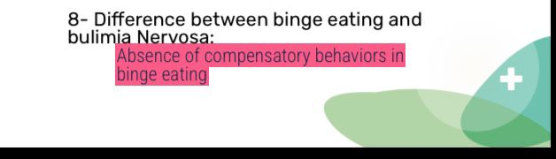
- 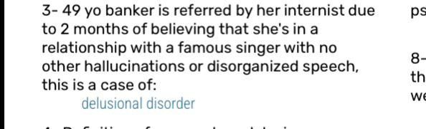

- 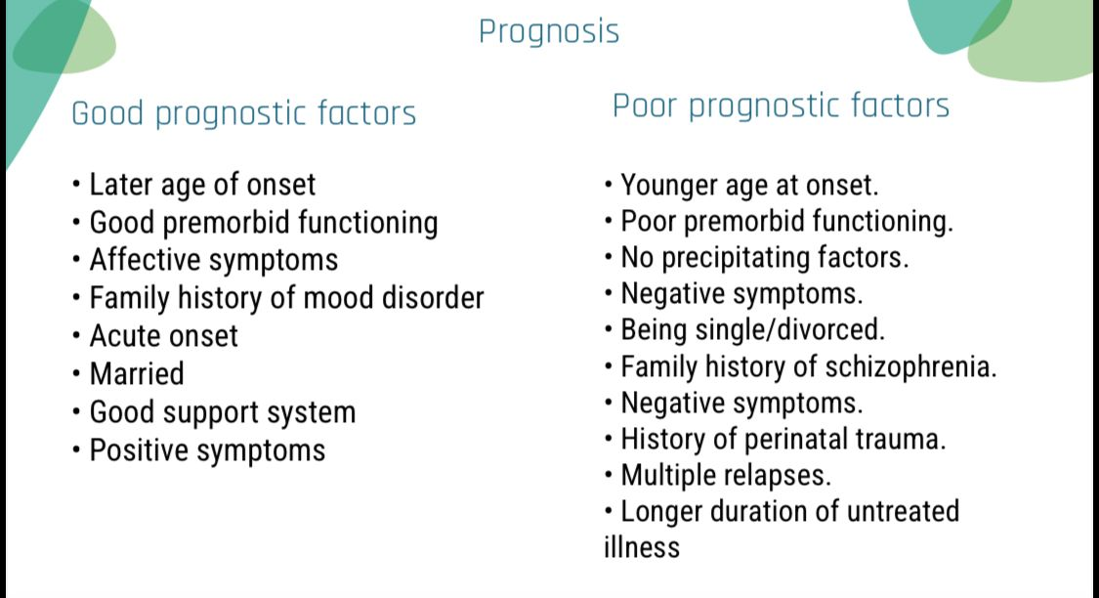
The prevalence of schizophrenia

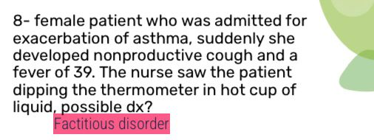
Correct match :
- 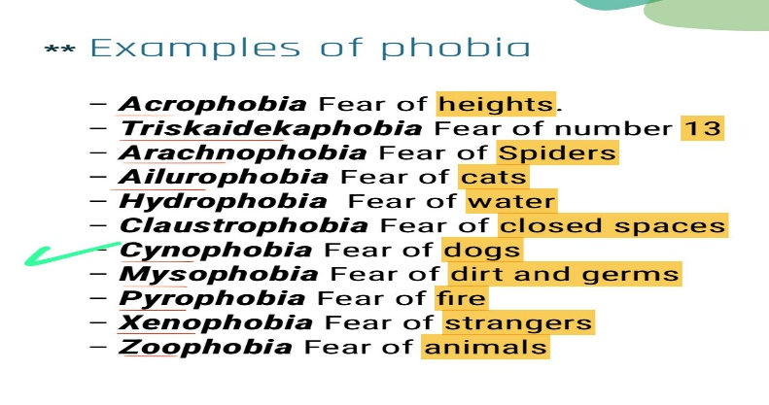

All the following of DSM5 criteria for agoraphobia is true except:

- 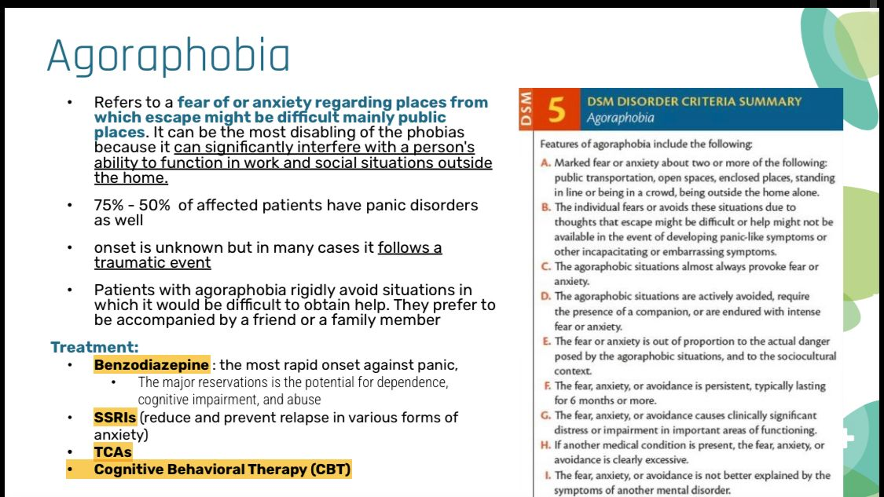

- 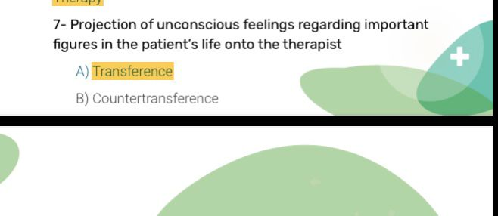

- All of the following can’t be the underlying cause of Abuse except :
- Stress*
- Good family support

- sundowning syndrome all are true except: lethargy
- Can’t be a SE of lithium :
a. muscle rigidity*
b. vomiting
c. diarrhea

- Beta blocker use for:
- Phobia
- Anxiety
- all of the mentioned above*

- Case of ICU PATIENT what the diagnosis :
a. Delirium

- Walking during sleep:
a-stage 4*
B-REM
C- STAGE 3

- RF OF POSTPARTUM DEPPRESSION:
A-previous history of depression *
B- Good family support

- Prevalence POSTPARTUM DEPRESSION
a-10-25%

- Postpartum depression: lack of bonding

- 2 sounds discussion his action: 3rd person hallucinations

- narcolepsy:

- sleep paralysis.
- Cataplexy.
- all of above.*

- Schizophrenia except:
a-delusions necessary for diagnosis.
- ⁠definition of tolerance
- ⁠tyramine hypersensitivity: MAOIs side effects

ناسية السؤال
- avoidant disorder question
- impulse criteria
- وحدة بتنام ع ١٠ وبتصحى ع ٢ : depression

Psychiatry
Mini-OSCE Archive
3-April-2024
Salma almawajdeh
Shahd abdallat

1.somatic symptoms duration?
-6month

2.Not included in the mental state examination:
-IQ

3.All sexual disorders except drug induced, criteria for duration should at least be?
- 6 months

4. a male comes to the office due to concerns about having pancreatic cancer after a coworker died of the disease 6 months ago. The patient has no epigastric pain, jaundice, or weight loss. However, he worries constantly because in researching the illness he read that it may not have obvious symptoms in early stages and can be rapidly fatal. The patient saw another physician 2 months ago, who performed a physical examination, laboratory evaluation, and abdominal CT scan. The results were normal and the physician reassured the patient that he did not have cancer. However, the patient reports that he has noticed occasional stomach noises after eating and would like to have additional testing done. Which of the following is the most likely diagnosis?
- Illness anxiety disorder

5.All sexual disorders share the same duration to be diagnosed,except
-Substance/Medication-Induced Sexual Dysfunction

6.A person had an RTA 3 weeks ago, that caused death of his friend, the patient is feeling sad, anhedonia and started having nightmares & flashbacks about the accident, Your Diagnosis?
-Adjustment Disorder
-Post-traumatic stress disorder
-Acute Stress Disorder

7.how to differentiate between delirium and dementia?
-Consciousness

8. Female patient says she is depressed and plays the sick role without any secondary gain?
-Factious disorder

9. 72-year-old male in the ICU due to multiple MI and stroke, on EEG there is a low wave in the background, he is confused and disoriented but he is not agitated, what is the diagnosis?
- Delirium

10. What is the method in psychoanalysis that involves redirecting feelings about a significant figure in the patient's life to the therapist?
-Transference

11.Can’t be a SE of lithium:
-muscle rigidity

12.case of a female who fears social situations including contact with strangers?
-Social phobia

13. Treatment for adjustment disorder?
- supportive counseling and psychotherapy

14. a symptom in a child with PTSD:
-bed wetting

15. Which of the following does not occur in PTSD?
- compulsions

16.all these anti-epileptic drugs cause depression except?
-Valproate

17.Brief Psychotic Disorder duration?
- Less than 1 month

18.the most common learning disability:
-Dyslexia

19. not associated with Geschwind syndrome
-Hyporeligiousity

20.Case with the following symptoms (dietary reaction severe headache palpitation hypertensive crisis) what is the SE:
-tyramine reaction

21. longest stage of sleep
-Stage 2

22.Whichof the following disorders has a Male to female ratio of 1:10?
-Eating disorders

23. Failure to resist uncontrollable urges to steal objects that are not needed for personal use or monetary value?
-Kleptomania

24.Two voices or more talk to another referring to the patient as “he” or “she" and may give a running commentary on the patients action or intention
-Third person hallucination

25. A woman is recently diagnosed with schizophrenia after suffering from hallucinations and persecutory delusions after her mother's death, from history there is 3-year history of negative symptoms and bizarre behavior, and her father has history of major depression, in her case what is a poor prognostic factor?
- insidious onset of symptoms

26.All the following of DSM5 criteria for agoraphobia is true except:
-Less than 3 months duration

27.One of the following isn’t at the DSM-5 Diagnostic Criteriasymptoms of the Persistent Depressive Disorder
-Psychomotor retardation

28.A true match
-Cynophobia= Fear of dogs

29.A case of female patient who wants to have sexual activity,but there are failure of genital organs swelling and lubrication along with the Absence of sexual excitement and pleasure during sexual activity
- Female sexual interest arousal disorder

30.The main hormone that’s responsible for the postpartum depression is
-estrogen
-Oxytocin
-testosterone
-cortisole
-Progesterone (we are not sure about this answer because in postpartum seminar, both of estrogen and progesterone were mentioned as the major contributing factors for the
postpartum depression)

31.One of the following is true about delusional disorder
-Daily functioning is not significantly impaired

32.Increasing the dosage to re-amplify the drug's effects is called
-Drug tolerance

33.True about substance use disorder
-Liver cirrhosis

34.the intent to commit a crime or a guilty mind called?
-Mens resa

35.schizoid personality disorder:
- Limited emotion and indifference to social relationships

36.FDA approved medication for Bulimia Nervosa:
- Fluoxetine

37.The key differentiating characteristic between binge eating and bulimia nervosa is?
-Lack of Inappropriate compensatory behavior

38.A Child with a voluntary holding his stool?
-retentive encopresis

39.not a postpartum depression symptom:
-Joyful feelings

40.not a symptom of sundowning syndrome
-lethargy

Psychiatry archieve

1.cogntive behaviour therapy means?
Change and challenge distored toughts

2. Intent before criminal act? Mens rea
3. Major depression disorder among epilepsy pt? 11-80%
4. Most common presentation of affective disorders among pt with epilepsy? Interictal depression
5. The precentage for depression occurnce in epilepsy pt ? 21%
6. Pt came to the psychiatrist recently complains of worrying of everything, her kids, her husband, even his husband, her sleeping is ok? Generlized anxiety disorder
7. Case about acute stress disorder best mangment? Psycotherapy
8. Case before one week went to hospital had a complications she felt she is dying now she had symptoms and does not want to go to hospital because what happened to her before? Acute stress disorder
9. A child quiet for few months in school only, but in the house talkative? Selective mutism
10. Fear of stranger? Social anxiety
11. Fireman has nightmares when his collegue died before 2 years? PTSD
12. Difference betweeen ilness anxiety and somatic ? Somatic need treatment and symptoms relif
13. Good prognostic factor of ocd? Episodic
14. Precentage of shizophrenia? 1%
15. Incorredt about schoizoeffective ? Femal more early
16. About borderline? Impulsive and risky behaviors
17. Not risk factor of substance use?high socioeconmic statuse
18. About opiods withdrawal in infatnt? (Poor feeding, hypotonia, sedation, insomnia,increase response for stimul)??

19. Pyromania criteria? Not for mentory gain
20. Encopresis criteria? Cause distress and impairment
21. Correct About specific learning disorders? not related Intelligence skills
22. Delirium different from demntia ?Delerium acute
23. Case pt in icu , agitated , removed iv line by her self tt?Treat the cause
24. Binge different from bulimia by?Binge no compensating
25. Pt went to psychiatrist complains of her partner recently has sexual pleasure by hurt him and pain ? Sadism
26. K-Spindle in what stage of sleep?N2
27. Not disorders of sleep ?Epilepsy
28. Moderate post partum depression treatment?Anti depression drug
29. Female born her baby before 3 weeks, she complains of change apeptie, and sleep , she hears her baby crying but he is sleeping? major depression disorder with psychosis
30. Better drug for smooking?Buprobion
31. Restlessness and unable to sit?Akathesia
32. Wrong about side effect of valporic acid?
Mycosomial enzyme inducer??

33. Not side effect of lithium?Weight loss
34. Not good prognosis of schizophrenia? Long episod

35. Female call she suffer depression not for external reward?Factitious disorder
36. Correct about schizophrenia?Equally in male and female
37. Which of the following is not carbamazepine side effect?Hypernatremia
38. Affect substance abuse in pregnant women?Miscarriage
39. Nihilistic delusion: false feeling that self,?the body is nonexistent or ending).
40. most common complication of postpartum depression?Suicide

