Pelvic organ prolapse POP
- A prolapse is a protrusion or herniation (not true hernia) of an organ or structure beyond its normal anatomical site.
- It is classified according to its location and the organ contained within it .
- Most important risk factors : multiparity and old age .
- More common in multiparous 12 – 30 % , and less common in nulliparous 2% .
- Extremely common problem. About 11 % of women will have one kind of the operation for prolapse during their life ,incidence increases with age .
- Factors that support uterus in its anatomical position :
- Uterine axis (mechanical support) >> It is anteflexed (angle between cervix and uterus) , anteverted (angle between cervix and vagina), so retroverted uterus is at high risk for prolapse .
- delancey support >> 3 levels of support :
  - 1st level of support is suspension :
    - (uterus , cervix and upper one third of vagina are suspended from above by parametrium and paracolpium which are the same but surround different organs , and they contain uterosacral ligament and cardinal ligament , these ligaments are cut in hysterectomy )
    - Parametrium is surrounding uterus and cervix , Paracolpium is surrounding vagina .
  - 2nd level of support is attachment :
    - it involves middle third of vagina , vagina is attached to pelvic side wall by endopelvic fascia .
  - 3rd level of support is fusion :
    - It involves distal third of vagina (2-3 cm above hymen) , vagina fuses anteriorly with urethra , posteriorly with perineal body and urogenital diaphragm “superficial and deep transverse perineal muscles” , and laterally with levator ani muscles .
- Classification :
I- Vaginal wall prolapse:
A- Anterior vaginal wall prolapse (Antrior compartment prolpase):
      - Cystocele “most common”
      - urethrocele.
      - cystourethrocele.
B- Posterior vaginal wall prolapse (Postrior compartment prolapse):
      - Rectocele “ most common”
      - Enterocele “ the only true hernia in POP” , could occur as vault prolapse in case of hysterectomy .
C- Apical vaginal wall prolapse: (Apical compartment prolapse)
      - Vault prolapse (after hysterectomy).
II- Uterine prolapse: Of 3 grades:
    - Grade 1: descent within the vagina.
    - Grade 2: Descent of the cervix outside the introitus but not the body of the uterus.
    - Grade 3: Descent of the whole uterus outside the introitus (Procidentia).
III- Combined type.
- We have 2 grading systems (both use hymen as landmark , how far is the prolapse from the hymen) :
  - The Baden and Walker Grading System (1968)
  - Pelvic Organ Prolapse Quantitative (POP-Q) (1996) “most commonly used “
- Vagina is 9-11 cm in length (total vaginal length TVL)
- Risk is higher in assisted vaginal delivery then spontaneous vaginal delivery then CS .

- The Baden and Walker Grading System :
  - Grade 1 prolapse halfway to the hymen(>5cm above hymen)
  - Grade 2 prolapse to the introitus (<5cm above hymen)
  - Grade 3 prolapse halfway beyond the hymen (<5cm below hymen)
  - Grade 4 complete prolapse (Procidentia)(>5cm below hymen)

- POP-Q grading system : “Gold standard”
  - Uses 9 points (six points on vagina: 2 on anterior vaginal wall, 2 on the
superior vagina, 2 on the posterior vaginal wall). In addition to other 3 points.
  - Ask patient to strain then see :
  - Stage I: the most distal portion of the prolapse is > 1cm
above the level of the hymen
  - Stage II: the most distal portion of the prolapse is ≤ 1cm
Above or below the hymen
  - Stage III: the most distal portion of the prolapse is > 1cm below the plane of the hymen.
  - Stage IV: complete eversion of the total length of the vagina.
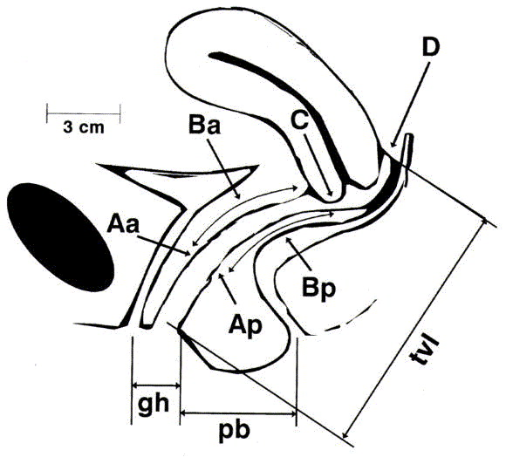
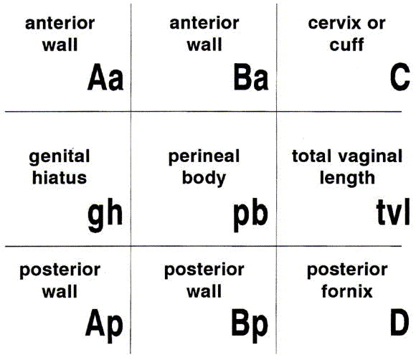

- In normal female without prolapse :
  - Aa : 3cm above hymen on anterior vaginal wall .
  - Ba : 6cm above hymen on anterior vaginal wall (most distant point on anterior vaginal wall, between Aa and C) .
  - Ap : 3cm above hymen on posterior vaginal wall .
  - Bp : 6cm above hymen on posterior vaginal wall (most distant point on posterior vaginal wall, between Ap and D)
  - C : anterior lip of cervix ( 7cm above hymen ).
  - D : posterior fornix ( 8cm above hymen) .
  - gh : distance between mid point on external urethral sphincter and posterior fourchette of introitus (2-3cm).
  - pb : distance between posterior fourchette of introitus and mid point on external anal sphincter (3-4cm) .
  - tvl : 9-11 cm .
- Anything above hymen Is given (-) and anything below hymen is given (+), so normal values are :
  - Aa & Ap = -3
  - Ba & Bp = -6
  - C = -7
  - D = -8
- All of these measurements should be taken while patient is straining EXCEPT TVL is taken at rest .
  - If Aa and Ap are (-) while Ba and Bp are (+) >> this is posterior vaginal wall prolapse .
  - If Aa and Ap are (+) while Ba and Bp are (-) >> this is anterior vaginal wall prolapse .
  - If Aa , Ap , Ba and Bp are (+) >> this is Procidentia (complete prolapse )
- Etiology of Prolapse :
  - Congenital (genetic factor):
    - Prolapse may occur in nulliparous (collagen disorder like marfan , Ehlers-Danlos or spina bifida).
    - More common in cretin races (hypothyroidism , it will cause constipation and increased intraabdominal pressure ) than others.
    - It is familial.
  - Childbirth:
    - Multiparity (pelvic floor muscles are weak).
    - Prolonged labor (due to compression on muscles and blood supply).
    - Difficult vaginal delivery (foreceps or vacuum) .
    - Macrosomic baby.
  - After hysterectomy (vault prolapse) .
  - Raised intra-abdominal pressure:
    - Chronic cough.
    - Chronic constipation.
    - Pregnancy, labor and delivery.
    - Large pelvic and abdominal tumor (large ovarian cyst , fibroid).
    - Ascitis.
  - Ageing: common in post menopausal women.
  - Obesity (BMI >25), and smoking .
- Clinical features :
  - History :
    - Lump protruding from the vagina either on straining or even at rest. ”most common symptom”
    - Lower abdominal discomfort and back pain.
    - In anterior compartment prolapse: urinary frequency, urgency, voiding difficulty, urinary tract infections and stress incontinence.
    - Posterior compartment prolapse: incomplete bowel emptying, constipation.
    - Sexual dysfunction , dyspareunia , fecal or urine incontinence during intercourse so they avoid it .
    - splinting (patient reduces the prolapsed organ in order to void ) and digitations (patient reduces the prolapsed organ in order to defecate).
    - Decubitus ulcer (in Procidentia there will be venous congestion and ischemia , so the prolapsed tissue will become ulcerated and infected specially the most dependent part of prolpase).
  - questionnaires:
    - POPDI-6: Pelvic organ prolapse distress inventory 6 : consists of 6 questions , the higher the score , the more severe the condition .
    - PISQ-12: Pelvic organ prolapse/urinary incontinence sexual function questionnaire : consists of 12 questions , the lower the score , the more severe the condition.
  - Abdominal examination: to exclude tumors, organomegaly and ascitis.
  - Vaginal examination:
    - On dorsal position, the prolapse could be seen protruding through the introitus. If not, the patient should be asked to push down or cough.

    - Steps for examination :
      - Empty bladder .
      - Any ulceration should be detected.
      - Bimanual exam to exclude pelvic tumors.
      - By Sim’s speculum (univalve) and the patient in the left lateral position or semi supine position on gynecological bed , the type of prolapse should be identified (compress the speculum against anterior vaginal wall and ask her to strain >> if there is prolapse this is posterior wall prolapse , then do the same on the posterior wall ).
      - Use bivalve speculum to examine apical prolapse (compress against anterior and posterior wall and ask patient to strain at the same time you withdraw speculum )
      - By combined rectal and vaginal digital exam (finger in vagina and finger in rectum , the aim is to differentiate between rectocele and enterocele ) , bowels easily reduced and have boggy feeling , peristalisis , but best method to differentiate is MRI.
- Differential diagnosis :
  - Congenital or inclusion vaginal cysts.
  - Urethral diverticulum.
  - Large uterine polyp.
  - Pedunculated fibroid.
- Investigations :
  - In case of urinary symptoms, GUE, urine culture, cystometry, and cystoscopy may be considered to exclude local causes in the bladder.
  - In major degree of prolonged uterine prolapse, renal function should be studied to exclude renal failure(and hydrnephrosis) due to kinking of the ureters.
  - Stage 3 and 4 prolapse >> there is obstruction in urine outflow , so patient will complain of urine retention and difficulty voiding , weak stream , splinting , high residual urine (increase risk for UTI ).
  - Urinalysis and urine culture .
  - Urodynamics and cystoscopy if we suspect other diagnosis (Urethral diverticulum).
  - Imaging study: MRI. U/S to see if there are mases or fibroid .
- Treatment :
  - The choice of treatment depends on:
    - The patient wish.
    - Age of patient and parity.
    - Preservation of sexual function.
  - The treatment is conservative and/or surgical.
  - Conservative treatment : (needs long time to start improving , up to 3 months )
    - Attempt should be made to correct obesity, chronic cough and constipation (increase fiber and fluid intake), stop smoking .
    - If decubitus ulcer is found, then local estrogen for 7 days should be used.
    - Pelvic floor muscle exercises (levator ani muscle , difficult for some patients ).
    - Pessary:
      - Support Pessary: ( Ring Pessary) A silicon rubber-based ring pessaries are most popular for conservative therapy. Used for all grades of prolapse .
Easily folded , Can be used during intercourse .
      - Space- Filling Pessary: Donut, Gellhorn.
Only used in grade 3 and 4 prolapse , can’t be kept during intercourse .
      - Each patient have different size of pessary , patients should remove them and clean them regularly then put them back (to avoid infection ).
      - They are inserted in the vagina, but should be changed at regular intervals.
      - The use of ring pessaries my be complicated by vaginal ulceration and infection.
    - Indications of pessaries:
      - As a therapeutic test (to see if patient will benefit from surgery or not ).
      - Medically unfit for surgery or refused surgery (cardiac disease , uncontrolled DM).
      - During and after pregnancy.
      - While awaiting for surgery.
  - Surgical treatment:
    - If patient old age , completed family , medically fit .
    - Two types of surgery :
      - Obliterative>> close the vagina , no further intercourse (widow)
      - Reconstructive
        - Patient with uterus (uterine sparing or hysterectomy >> here we should support vaginal vault by doing sacrospinous ligament fixation )
        - Patient without uterus

  - If anterior vaginal wall prolapse >> Anterior colporrhaphy operation.
  - If posterior vaginal wall prolapse >> Posterior colpo-perinorrhaphy .
  - If Enterocele: Posterior colporrhaphy with excision of the peritoneal sac .
  - If uterine prolapse >> Vaginal hysterectomy: in elderly patients and those who completed the family or with other uterine or cervical pathology, Adequate vault support of the utero-sacral ligement or the sacrospinous ligament (SSL fixation) is needed .
  - Uterine sparing >>
    - Manchester operation: amputation of the cervix (we recreate cervical canal so patient can get pregnant), bringing of the cardinal ligaments and uterosacral ligaments anterior to the lower uterine segment followed by vaginal repair. these patient are at increased risk of miscarriage due to cervical incompetence .
    - Sacrohysteropexy: this is an abdominal operation. It involves attachment of a synthetic mesh from the uterocervical junction to the anterior longitudinal ligament of the sacrum (fixate uterus to sacrum).
    - Trans-vaginal mesh (TVM): perigee (only for anterior vaginal wall prolapse ) or elevate-A (anterior vaginal wall and vault prolapse ).not commonly used because they may extrude and cause infection and bleeding .
  - If vault prolapse after hysterectomy >>
    - Abdominal approach :
      - Sacrocolpopexy: The vaginal vault is attached to the sacrum by synthetic mesh.but have complications like inflammation so not preferred .
      - Sling operation: The vaginal vault is slinged to the anterior abdominal wall by two strips of anterior rectus sheath.
    - Vaginal procedures:
      - Sacrospinous ligament fixation (SSLF), Uteroscaral ligament suspension, ileococcygeous suspension, Vaginal mesh kits (elevate-A)
Check pictures in the slide
Done by : Noor Daher Al-hijjaj

