Neuromedicine Archive (Group C+D)

Q1: when inspecting the hand: (except)

1. Scars ,
2. Wasting of muscles ,
3. Involuntary movements ,
4. fibrillation
5. Tremor.

Q2: one of the following is not seen in multiple sclerosis:

Hypotonia

كان في خيار ثاني brisk reflexes

Q3: all the following are optic nerve examinations except:  
corneal reflex

Q4: A question about (myasthenic crisis and cholinergic crisis), a sign that is in myasthenic crisis but not in cholinergic crisis:   
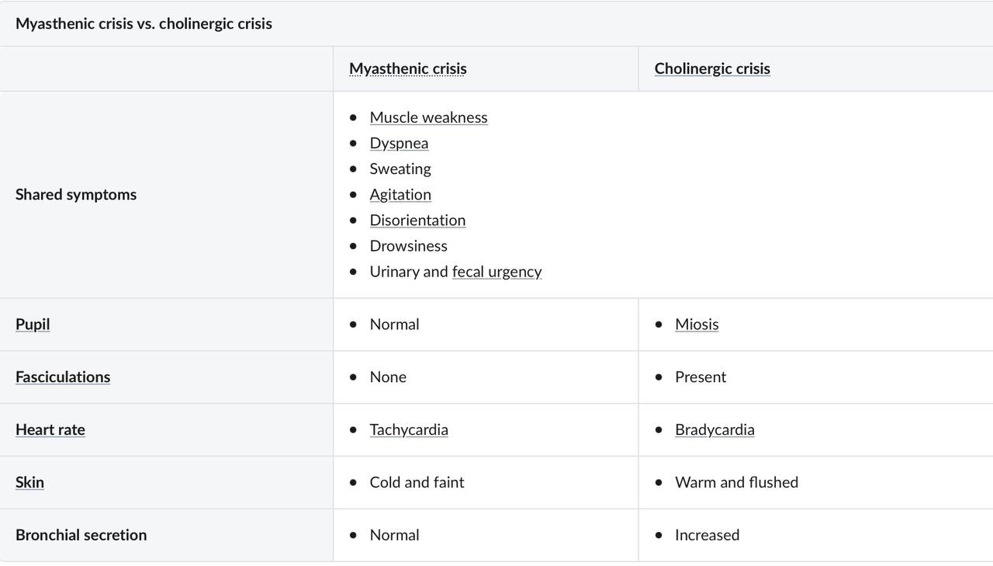

Q5: Encephalitis most common causative organism:   
HSV-1

Q6: One of the following is wrong about Paroxysmal hemicrania:

1. Severe stabbing or sometimes throbbing headache
2. Perorbital or temporal area
3. Each attack lasts from 2 to 60 seconds. (it’s mins not secs)
4. May have upto 12 or 15 episodes per day
5. Strictly unilateral and always occurring on the same side

Q7: One of the following is not used as a treatment for cluster headache:

كان في بالخيارات lithium / steroids بس ناسيين باقي الخيارات.   
  
Q8: All the following are risk factors of Headache of intracranial hypertension except:   
Male sex

Q9: A patient’s symptom worsened after a hot bath this is called:   
 Uhthoff phenomenon.

Q10:Most common site of encephalitis

Q11:Mechanism of action of Carbidopa

Q12: One of the following is a sign of drug-induced Parkinsonism but not Parkinson’s disease

Q13: One of the following is not a Miller fisher syndrome symptom   
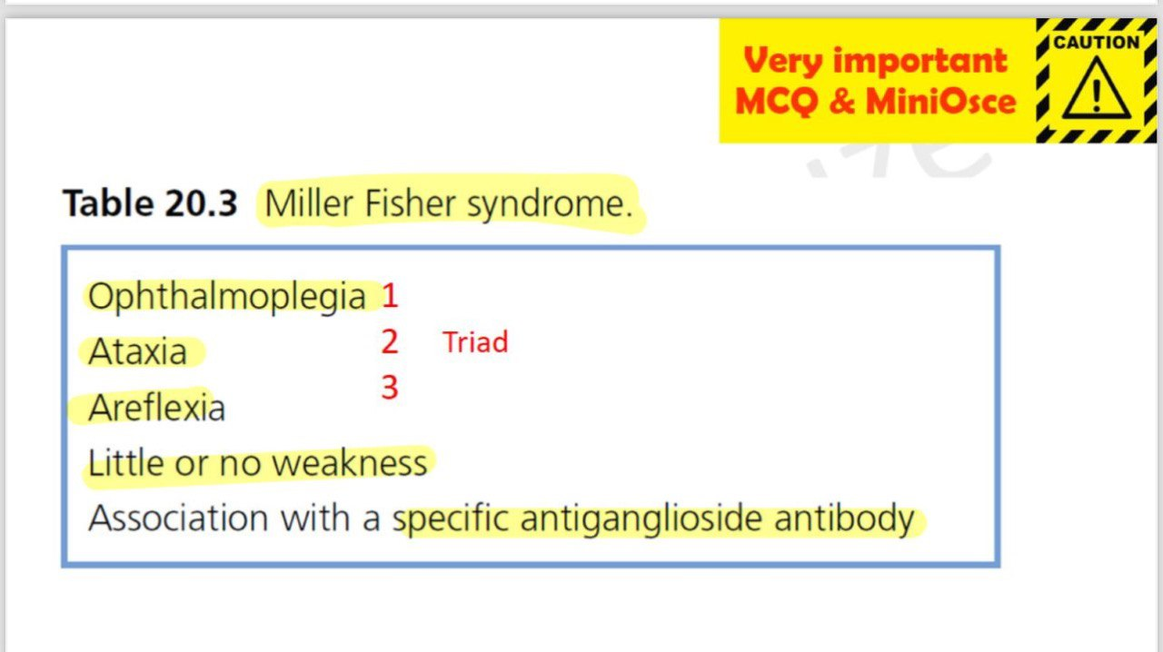  
  
Q14: Best diagnostic test for extradural hematoma   
Q15: Best diagnostic test for ischemic stroke   
Q16: Best diagnostic test for seizure

Q17: Indications for surgery for intracerebral hematoma

Q18: All of the following are acute management of ischemic stroke except

Q19:First Line drug for tonic-clonic seizure seizure

Q20: Myasthenia gravis complications  
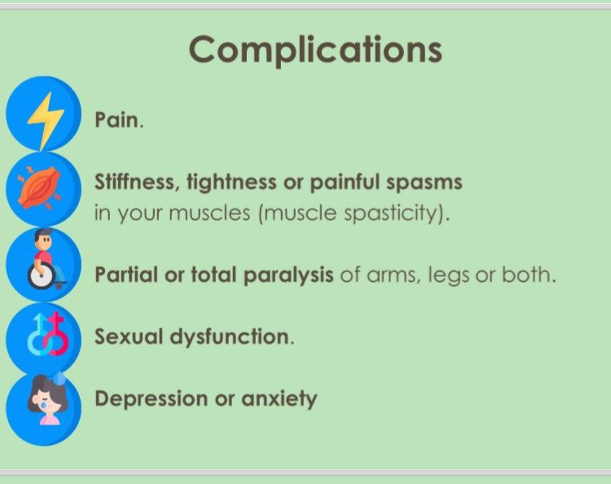  
  
Q21: Management of Viral meningitis

Q22:All of the following are examples of generalized seizures except:   
Automatisms

Q23: The diagnosis of epilepsy depends on: (not sure of the answer)   
-EEG  
-History & Examination   
  
Q24: One of the following is not a management of GBS 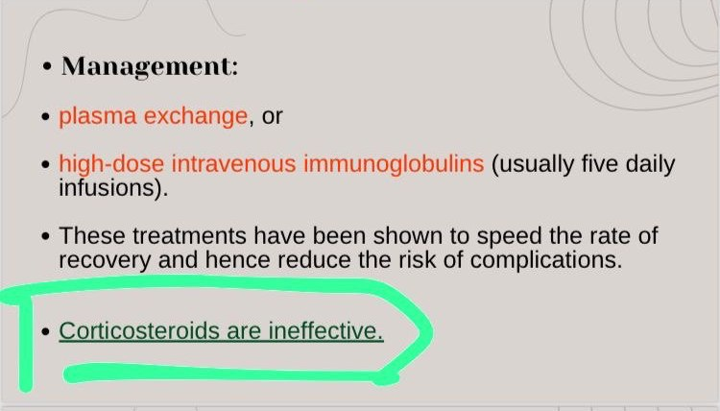

Q25:One of the following is not associated with GBS   
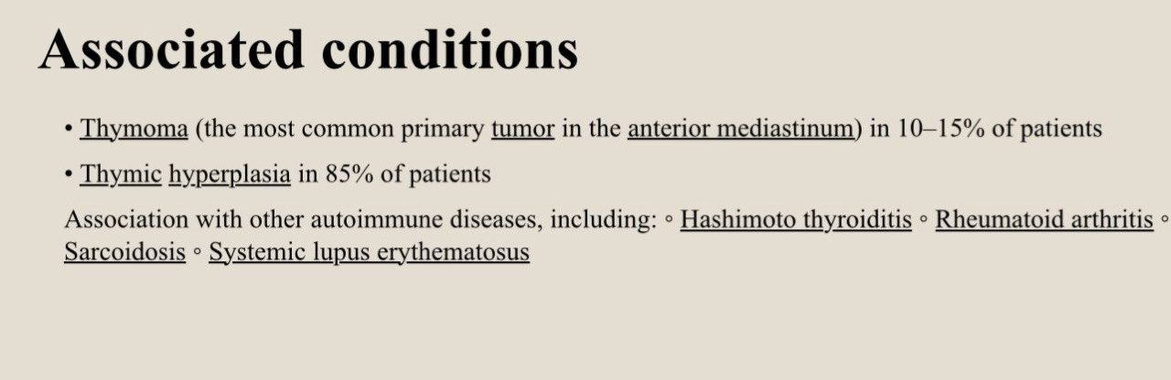

Q25: A CSF yellowish and viscous indicates   
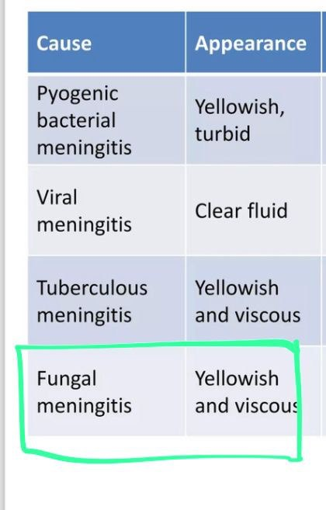

Q26:Paroxysmal hemicrania treatment:  
Endomethacin   
