**Introduction**

* **Definition:**

Respirationis the transport of O2 from atmosphere to the cells and CO2 and water from cells to atmosphere.

* **Functions of respiration:**

1. O2 Supply to tissues and removal of CO2 from them, as O2 is used in oxidation of food stuffs in the cells and release of energy.
2. Help venous return.
3. Regulation of body temperature through evaporation of water from the respiratory passages.
4. Regulation of the pH of the blood through adjusting the amount of CO2 eliminated from the body.

**Structure of the respiratory system**

1. **Physiological anatomy of the respiratory system:**

***The respiratory system consists of:-***

1- The air passages and lungs.

2- Respiratory muscles.

3- Nerve centers controlling respiration. **Discussed later**

**\* The air passages and lungs:-**

**They are divided into**

a- Conducting zone.

b- Respiratory zone.

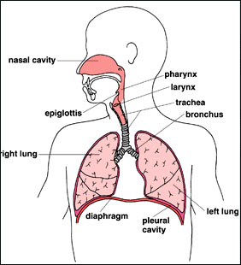

**Figure 1: Structure of the respiratory system**

***a- Conducting zone:-***

Includes (Nose, Nasopharynx, trachea, two main bronchi, and the smaller bronchioles till the respiratory bronchioles).

**Functions of the conducting zone:-**

1- **Air conduction** to the respiratory zone.

2- **Air filtration** i.e. it filters air from particles and bacteria as particles more than 6 microns are trapped by hairs at the entrance of the nose, while smaller particles are trapped by mucous secreted from the goblet cells in the epithelial lining of the air passages.

3- **Air Conditioning**

The mucosa of the nose, mouth, and pharynx has a large surface area and rich blood supply, this adds heat to cold air or remove heat from hot air, thus allow the inspired air to reach the respiratory zone at temperature of 37oc, to maintain a constant internal body temperature.

4- **Humidification**

As the air is saturated with water vapour to protect delicate lung tissue.

5- **Protective reflexes**

For removal of foreign bodies and irritant substances from the respiratory passage it includes.

a) Sneezing reflex.

b) Cough reflex.

6- **Smell** by olfactory epithelium of the nose.

7- **Phonation**

The vibrating element of the larynx is the vocal cords which vibrates when air passes through it producing sound.

***B-Respiratory zone:-***

* Composed of respiratory bronchioles.

* Each of respiratory bronchioles is subdivided into several alveolar ducts, each of which end by clusters of small thin walled air sacs called alveoli.

* Several alveoli open into common chamber called alveolar sac.



**Figure 2: Respiratory zone of the lung**

1. **From the physiological Point of view respiration can be divided into:**
2. ***External respiration***

**Which includes:-**

1. Pulmonary ventilation for renewal of air in the lungs from atmospheric air.
2. Exchange of gases between alveolar air and venous blood in the capillaries around the alveoli.
3. ***O2 and Co2 transport function of the blood.***
4. ***Internal respiration***

At the level of the cells in which there is utilization of O2 for oxidation of food stuffs and removal of Co2 that result from metabolic reactions.

**The respiratory cycle**

**It consists of:-**

**A)** **Inspiration**

***This is an active process during which:***

* The thoracic cavity increases.

* The lungs distend and air rushes into it.

* Its duration is 1.3 seconds.

**B- Expiration**

***This is a passive process during which:***

* The thoracic cavity decreases.

* The lungs recoil and air rushes out of the lungs.

* Its duration is 1.7 seconds.

***C- Expiratory pause:-***

* It is a period of rest after expiration.

* Its duration is about 0.7 second.

* It is absent in rapid respiration, as in muscular exercise.



**Figure 3: Respiratory cycle**

**Total duration of respiratory cycle**

Inspiration + Expiration + Expiratory pause

1.3 + 1.7 + 0.7 = 3.7 sec.

So respiratory rate/ min = 60/3.7 = 17 cycles/min.

**Mechanics of respiration**

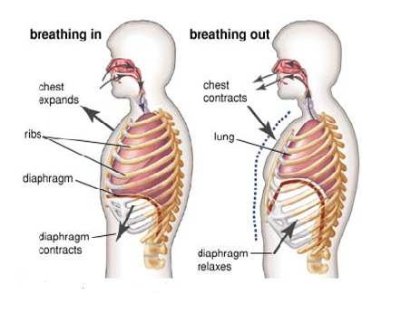

**Figure 4: Mechanics of respiration**

Breathing in = inspiration breathing out = expiration

**(A) Mechanics of inspiration:-**

Inspiration is an active process during which there is an increase in the length and diameter of the thorax.

1. ***The increase of length is due to contraction of the diaphragm.***

The increase in the length of the thorax is produced by contraction of the diaphragm which is dome shaped during rest ,but with inspiration it contracts and flatten leading to increased length of the thorax( the transverse diameter) , the diaphragm accounts to about 75% of the increase of the chest size. The diaphragm is supplied by the phrinic nerves which arise from the third to fifth cervical segments.

1. ***The increase in diameter (transverse and anteroposterior diameter) is due to contraction of external intercostal muscles.***

Contraction of the external intercostal muscles leads to elevation of ribs, as they are at rest inclined downward and forward, during inspiration and due to contraction of the external intercostal muscles, the ribs are elevated and the transverse and anteroposterior diameters of the thorax are increased. The external intercostal muscles are supplied by anterior horn cells of all thoracic segments.

**(B) Mechanics of expiration:-**

It is a passive process, that occurs by relaxation of the diaphragm and external intercostal muscles so all dimensions of the chest are decreased, leading to increased intrapulmonary pressure to about 1 mm Hg leading to air pumping out.

**(C)Forced inspiration:-**

During forced inspiration, other thoracic muscles are involved, to increase the thoracic volume; these muscles are called accessory muscles of respiration which includes.

* Sternocleidomastoid.

* Serratus anterior.

* Scaleni muscles.

* Pectoralis minor.

* latismus dorssi muscle.

The above muscles contract in addition to the contraction of the diaphragm and external intercostal muscles.

**(D) Forced expiration:-**

It is an active process, and occurs by contraction of.

* **Abdominal muscles** to increase the intra-abdominal pressure leading to elevation of the diaphragm upward so decreasing the vertical diameter of the chest.

* **Internal-intercostal muscles** which pulls the ribs downward and inward so reducing the transverse and antero-posterior diameters of the chest leading to more reduction in the thoracic cavity removing more air out of the lungs.

* It occurs during straining as during deification and labor.

**Summary of normal quite ventilation and forced ventilation is shown in the following table:-**

|  |  |  |
| --- | --- | --- |
|  | **Inspiration** | **Expiration** |
| 1  2  3  4  5 | Active process  Caused by contraction of diaphragm and external intercostal muscular.  The intra pulmonary pressure decrease to-1mm Hg.  The thoracic cavity is increased in all dimensions  Air rush inside the lungs. | Passive process  Caused by relaxation of the diaphragm and external intercostal muscles.  The intrapulmonary pressure increase to about +1 mmHg.  The thoracic cavity is decreased in all dimensions.  Air rush outside the lungs. |
|  | **Forced inspiration** | **Forced expiration** |
| 1  2 | Contraction of accessory muscles.  The intrapulmonary pressure decrease to about-20 mmHg. | Contraction of abdominal and internal intercostal muscles.  The intrapulmonary pressure increases to about + 30 mmHg. |