ECG

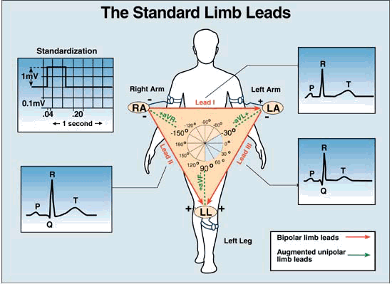**Look carefully at this picture:**

The heart electricity has a pattern that could be drawn , it’s called ***NORMAL PATTERN OF ECG*** .

The shape of the ECG diagram (مخطط) result from the specific location of the electrodes in the body to draw the electricity of the heart by anodes (قطب موجب)and cathodes .

* lead 1: the potential difference between an cathodes situated at the Right arm and the anode situated at the left arm **perpendicular** to the heart

يسجل جزء معين من كهرباء القلب ويترك الباقي

* lead 2: the potential difference between an cathodes situated at the Right arm (-) and the (+) at the left leg.

*Lead 3: uses left arm ( - pole) and left leg ( + pole)

***So: to know the shape of ECG u have to know what kind of system is used : lead 1,lead 2,lead 3***

In this lecture we will only learn about lead2 so the diagram used is the one I put a star on in this picture

كل شي لهلا مرسوم بالرسمة ولتفهم الرسمة اكتر في فيديو باخر صفحة برضو عليه نجمة

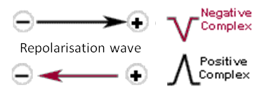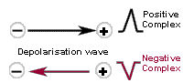

*If a wavefront(impulse) of depolarization travels towards the electrode attached to the + input terminal of the ECG amplifier and away from the electrode attached to the - terminal, a **positive deflection** will result.

: باختصار يعني لو الموجة راحت عالقطب الموجب يعني انتقلت من القطب السالب للموجب حيصير عنا

POSITIVE DEFLECTION

*If the waveform travels away from the + terminal lead towards the - terminal, a **negative going deflection** will result.

*If the waveform is travelling in a direction perpendicular to the line joining the sites where the two leads are placed, no deflection or a **biphasic deflection** will be produced.

***WHAT do we mean by positive and negative deflection?***

+ deflection: arrow above zero

- deflection: the arrow is up then goes to 0 and then below the zero

***Sinoatrial (SA) node***

is normally the pacemaker of the heart.

has an unstable resting potential.

Found in the RIGHT ATRIUM

begins the conduction of signals that causes the cell to contract then goes to AV Node , which is found in the border between the RV and RA

***AV node***

known as the gate keeper of the heart cuz it gets to decides whether what imports to get through!!!

Conteaction slows in it cuz if its small diameter which increase resistence to electric flow & its slow opening ion channels

It is very important to give time for ventricles to fill

It is the point which allows the flow of electricity from ATRIA to VENTICULAR

depolarization of the heart begins at the SA Node (0.3 sec) AV Node (1.6-1.7 sec) common bundle ( bundle of His ) bundle branch( .21-.22) right and left bundle branches Purkinje Fibers that causes depolarization of ventricular muscle .

الصورة الي تحت ممكن تساعد بالفهم

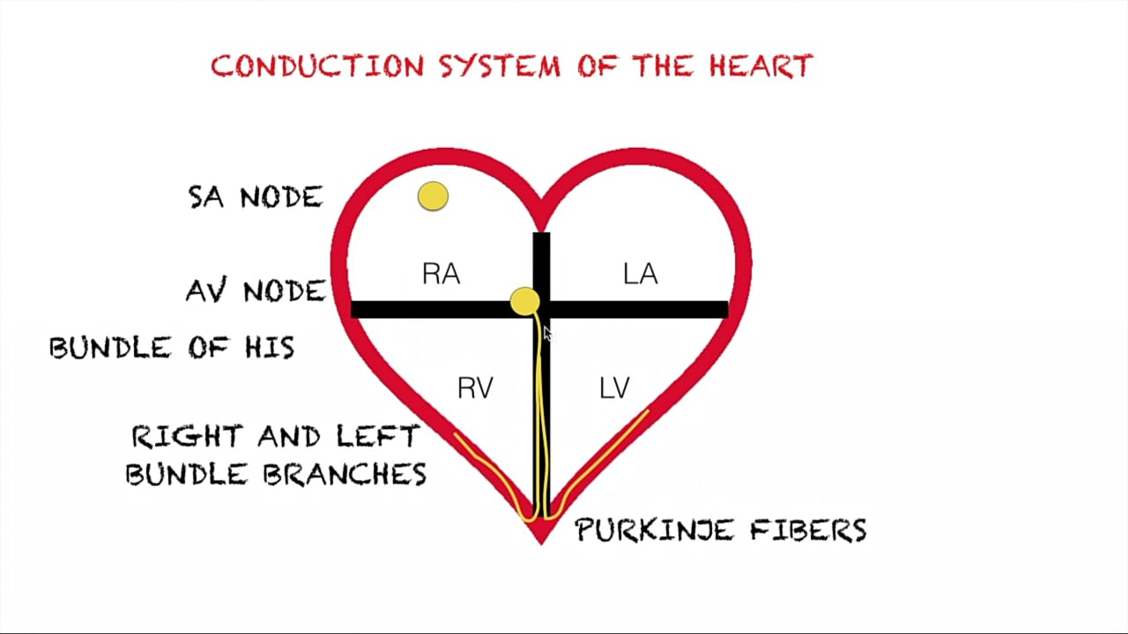

* AV Node is the site of delay OF depolarization .

* the variety of all of the nodes electricity gives us the ECG diagram .

*Purkinge fibers are so fast in conducting but SA node is faster , so fast contraction occurs

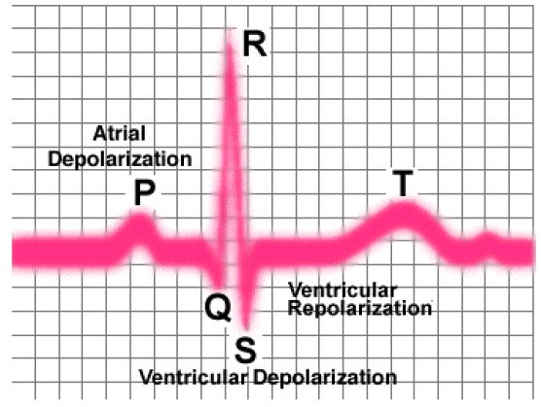

**P waves :** atrial depolarization and the 2 atria are contracting

**QRS complex:** ventricular depolarization and the 2 ventricular are contracting

**T wave :** ventricular repolarization so the 2 ventricular are relaxing

Now the question is : where does ATRIAL REPOLARAZATION occurs ?

The doctor will answer it laterجاوبته من بي ار اس من باب الحيطة لو ما جاوبته هي بعدين

it is “buried” in the QRS complex

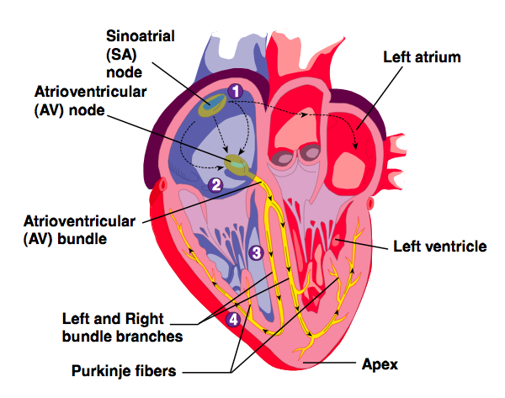look at these 2 pictures carefully and the one from the previous paper to recognize the charges(-or+)

(First, atria contract to fill ventricles.

Then, ventricles contract to send blood to the lungs and peripheral circulation).

*S-A node generates the signal.

*Signal travels through internodal pathways and atrial muscle (atria contract).

*when the impulse moves from 1 to 2:

depolarization occurs ,**1**- it moves from – to +

and then reaches the region of common bundles,so positive deflection will occur (**p wave**)

**2**- ***A-V node and bundle delay*** the signal and send it to the ventricles(1.6-1.7 sec), this small delay causes a negative deflection **(q wave**),the impulse didn’t reach the Purkinje fibers yet

***ائا معك نسخة ورقية افتح وشوف الصور ملونة عشان تفهم \****

**3**-the impulse moves from –to + which causes + deflection (**QR=R wave)**

**4**-A.P moved from the apex to the opposite direction to make a strong contraction from + to – which causes – deflection **(RS =S wave)**

**S is a small negative deflection cuz there was a small delay before repolarization**

Purkinje fibers rapidly carry the signal throughout the ventricles, where it then spreads, causing contraction

*QRS formed : ventricles contract

**NOW:** blood pumping happened cuz of **depolarization** and it’s time for relaxation by **repolarization**

**5**-repolarazation occurs ,+ to – charge,+ deflection**(T wave)**

**\*\*ventricles contract: when the purkinge fiber conducts the signals to it**

**\*\*Atria contracts after the signals are conducted through the internodal tracts to Bachman’s bundle**

**\*\*how does cardiac muscle differ from skeletal muscle?**

IN CADIAC MUSCLE: ventricle muscle is the last muscle that depolarizes and then repolarization begins with last muscle

IN SKELTAL MUSCLE: the first muscle depolarizes and its first to repolarize

why it differs ? cuz of function of myocardiac muscle, nature of muscle, contraction

HEART CIRCUlATION

* The two atria contract at the same time, then they relax while the two ventricles simultaneouslyمتزامن لا يسبق واحدة الأخرى) ) contract.
* The contraction phase of the ventricle chambers is called systole.
* The relaxation phase is called diastole.
* At a normal heart rate(no exercise) , one cardiac cycle last for *0.8 seconds*!
* **When heart rate increases (exercise) : all phases of cardiac cycle shorten, particularly diastole cuz I need to maintain the pumping of blood to the body**

فيتوافق مع عملية الأيض والجهد العضلي الي أنا بدي أعمله

* **Cardiac Cycle** = “events of one complete heart beat”
* Mid-to-late diastole (relaxation) = blood flows into ventricles
* Ventricular systole (contraction) = blood pressure builds before ventricles contract pushing blood out
* Early diastole = atria finish re-filling; ventricular pressure is low

بهمنا نعرف متى ال الصمامات مفتوحة او مسكرة ومتى الأذين والبطين في مرحلة راحة او انقباض وحكت هذول بنفهمهم بعدين

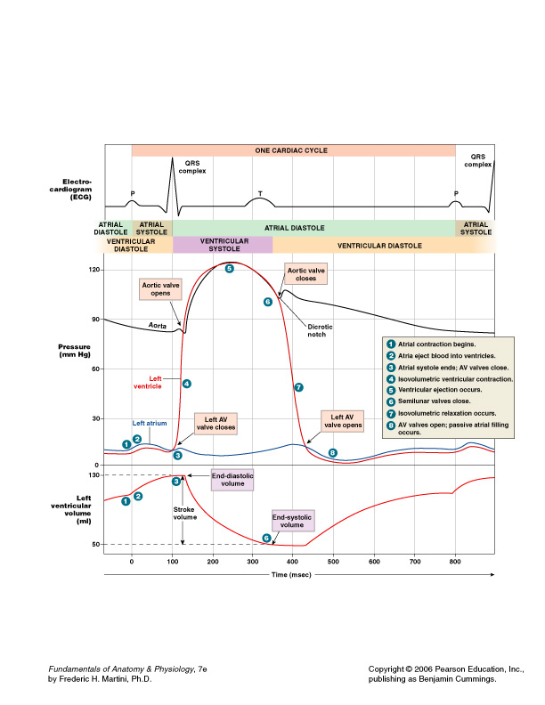

**Look at the picture carefully**:

**كل الكلام الي كاتبته تحت مكتوب في الرسمة هاي الي فوق والي بعدها ويفضل تسمع ريكورد عند هاي الجزآية بتفهم بشكل كتيير أفضل وعادي ما بتنعجق**

* These curvatures show how pressure affects the 2 values found on chambers
* The left side of the heart: Aortic value,L.AV
* The right side of the heat: Rt.AV , pulmonary valve

1. Beginning of cardiac cycle , relaxation of 2 chambers the atrium and ventricle (**ATRIAL DIASTOLE**)
2. beginning of **ATRIAL SYSTOSOLE** (atrial contract so blood transports from Atrium to ventricle, AV value open, semilunar valve closed.)
3. enough pressure which closes the AV valve to prevent any backflow of the blood to the atrium ,end of arterial systole and beginning of **early of ventricle systole**(ATRIA relaxes ,VENTRICLES contract, AV valves forced close, semilunar valves still closed cuz there is still not enough pressure to make it open)
4. enough pressure to open semilunar valve , in this case the aortic valve opens

انتبهواااا لكل شي ايش بقابله ب ال اي سي جي باتيرن وفي سؤال تحت

* step 3 when closing the left AV valve I comes across with the ECG pattern in the half of QRS ,the QS segment (**positive deflection**),the electricity goes from the base to the apex, but the ventricle still didn’t contract
* The ventricle contracts when the aortic value opens which comes across with the ECG pattern with the RS segment (**negative deflection)**
* At the point where the aortic value contracts **late ventricular systole** or the second phase occurs(contraction of ventricle, relaxation of atrium, AV value remains closed, semilunar value forced open)

1. **The end of ventricle systole**, pressure in ventricular champers decrease doe to blood pumping from the ventricle to Aorta which leads to very low pressure and then closing the semilunar valve in step 6
2. **The beginning of the early ventricular diastole** (atria and ventricle relaxation ,ATRIA begins passively filling with blood as AV values open,semilunar valves are closed)
3. &8 step : Pressure decreases so much in the ventricular & atrium so the left AV opens ,**late ventricular diastole** occurs(artia and ventricle relax ,valves are closed,ATRIA begins passively filling with blood) and the cycle begins again !!!

|  |  |
| --- | --- |
| Step 4:isovolumeric ventricular contraction | Step 7: isovolumeric relaxation |
| The Highest pressure | The lowest pressure |

When all valves are closed , ventricular volume is constant , and the phase is called isovolemeric

Opening and closing of valves cause the heart sounds

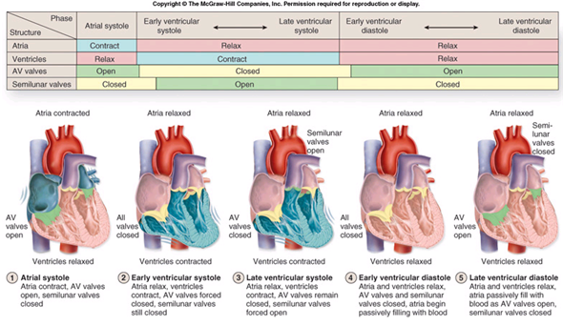

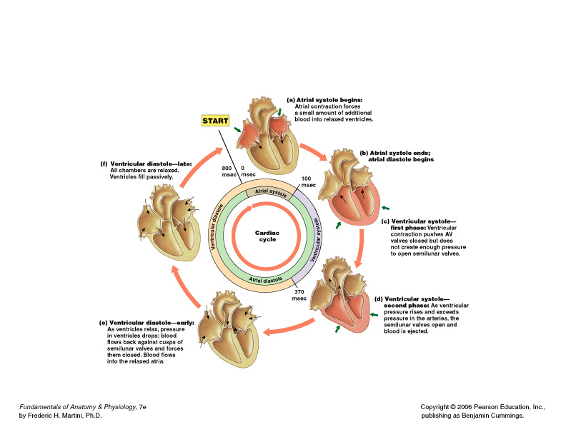

MSQ

**صيغة الأسئلة**

1-in **isovoumloutric contraction** -**what is the pattern of EcG?**

A-p

B-PQ

C-pQRS

D-pQRST

الاجابة c

2-**in isovoumloutric relaxation?** -**what is the pattern of EcG?**

A-p

B-PQ

C-pQRS

D-pQRST

الاجابة D

**3-before closing of AV Valve the pattern of EcG is:-**

A- p

B-PQ

C-QRS

D- a+b

الاجابة D لانه الدكتورة حكت انه لو كنت كاتبه الكم p او pQ فالثنتين صح

**4-after closing AV Valve and opening semilunar valve the pattern of ECG is:-**

A- p

B-Q

C-QRS

D-pQ

الاجابة c

**What kind of valves is closed or open?**

**The pressure in atrial or ventricular decrease or increase**

**In this step what exactly happens in ECG**

**What does this step or number resemble?**

vidios that help in understanding the ECG

https://youtu.be/xIZQRjkwV9Q

https://youtu.be/HDyqXNHLjug

the first 7 min of :

https://youtu.be/FThXJUFWUrw

لجنة الطب والجراحة

عمل :

المبيضة المبدعة : دانيا جعفر الطراونة

تدقيق:تسنيم الرواشدة

إشراف وحوسبة : لينا محمود

كل التوفيق

***وما بعد الهم إلا الفرج..أليس الله بكاف عبده !!***