**2016 mini OSCE**

1. **CT scan kidney stone ..treatment**

treatment

1. Medical ( NSAIDs > opioid >>Ca CHANNEL ANTAGOINST >> antiemetic >> ALPH BLOCKER IN LOWER )



1. Shock-wave lithotripsy (SWL)
2. Ureteroscopy.
3. Percutaneous nephrolithotomy (PCNL).
4. Open Stone surgery

1. **Hypospadia..type?..embryology**

Glandular …proximal penile …mid shaft … distal penile , scrotal …perineal

The end of 3rd month ,(incomplete closure of urethral folds on the underside of the penis during

embryological development) endoderm

1. **Ultra sound filling defect 5 DDX ,,,Bladder cancer surgery for T2**

Ddx … neoplasm

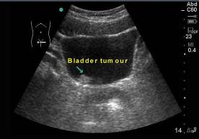

stone

blood clot

enlargement prostate gland

fungal ball

focal cystitis

-Radical cystectomy

1. **Pic of Folyes catheter?**

-indication of catheterization>>

1.Urinary retention

2.Obstruction of the urethra prostate cancer**)**

3.Collection of a sterile urine specimen for diagnostic purposes

4.After surgery.

5.Intra operative

6.Uorodynamic study

-indication for 3 ways catheter :

1. after bladder/ prostate surgery (to wash-out blood and clots that block the

catheter)

2. Cases of gross hematuria

3. Bladder infections

-Name the absolute contraindications for the insertion of these tools >>

1- urethral tear

2- pelvic fracture

3- urethral trauma

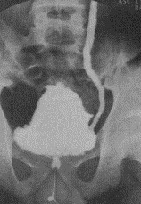

1. **Pic of vesico uretric reflux ? Indication for surgery**

1-If it is not possible to keep the urine sterile and **reflux persists**.

2-If **acute pyelonephritis** not responding to treatment

3-If **increased renal damage**

4-**High grade reflux** (grade IV or V - not an absolute indication)

1. **PSA defintion and function**

is a glycoprotein enzyme produced by prostatic epithelial cells. and its function is to liquefy the ejaculate, enabling fertilization

1. **Complete the blanks :**

The most common location for undesecended testis is (1) Prepubic and the age at which the operation should be performed is (2) 1 year

In the prostate gland, the most common location of BPH is (3) Transitional zone And the most common location for a prostatic cancer is (4) Peripheral zone

In UTI: Infection by a different baceteria is termed (5) Reinfection while

infection by the same organism from a focus within the urinary tract is termed (6) Bacterial persistence . Compliance describes the relationship

between (7) volume & (8) pressure . The spinal shock following severe injury to the spinal cord lasts (9) 3 months During this period, the bladder is

(10)hypoactive(flaccid)

1. **Definition of each type of stone**

**Calcium** Stones (most common ) Composed of either Calcium oxalate or phosphate Radio-dense (i.e. visible of abdominal radiograph) Occurs secondary to hypercalcuria (more common) and hyperoxaluria

**Uric Acid** Stones (2nd most common) Radiolucent (cannot be seen on abdominal radiograph) Causes Associated with Hyperuricemia.(gout)

**Struvite** Stones (Staghorn stones ) Radio-dense (magnesium ammonium phosphate) Causes Often seen in patients with recurrent UTI’s due to urease producing organisms (such as Proteus and Klebsieilla)

**Cystine** stones (rare) radio-lucent Seen in patients with Cystinuria (autosomal recessive)

1. **KUB picture**

- identify the pictures >> KUB

- differences between KUB and abdominal X-ray >> 1- from xiphoid to suprapubic

2- psoas shadow is seen 3- needs preparation 4- Usually supine 5- hyper exposure

- most common type of renal stones >> **Calcium oxalate**

1. **picture of urethral stricture**

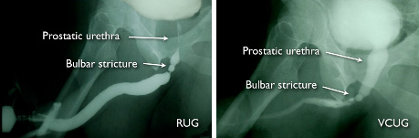

- identify the part of the urethra shown : bulbar

- diagnosis : urethral stricture

- causes : iatrogenic , tumor , stone , trauma

1. **Matching**

- patient with prostate size 40g and bothersome symptoms Tx is>> alpha blocker

- patient with prostate size 100g and large bladder stone >>tranvesical prostatectomy

- patient with localized prostate CA>> Radical prostatectomy

- patient with metastatic prostate CA>> molecular therapy

- patient with prostate size 80g without symptom >> watchful waiting

1. **patient with car accident with incontinence:**

- type of incontinence >> overflow

- causes of it >> spinal cord injury

- bladder function after 3 months >> overfunction

1. **essay question**

- define the erectile dysfunction >> (is the inability to achieve and maintain an erection adequate for intercourse to the mutual satisfaction of the man and his partner.)

- differences between organic and psychological types >>

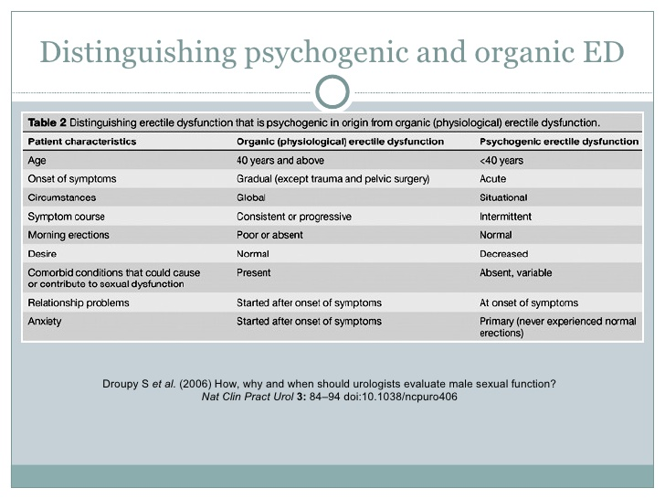

- mechanism of sildenafil function >> (Mechanism of Action: Viagra >> PDE inhibitor and increases the cGMP that promotes and sustains smooth muscle relaxation)

- Psychogenic Causes: Anxiety ,Depression, Fatigue ,Guilt, Stress, Marital Discord, Excessive alcohol consumption

1. **smoker patient with bladder mass**

- the first investigation of choice : cystoscopy

- most common cancer of the bladder is : TCC

- can you do suprapubic catheterization in this case and why ?

No , because this make the cancer to spread

1. **identify the picture** >> three way foley catheter

- why we use it in prostate cancer >> for irrigation ( in bleeding )

- the best solution to fill it in this catheter is >> sterile water or normal saline

1. **KUB with double J catheter**

- identify the pointed structure >> Double J catheter

- mention 3 indications>>

1- Relief of obstruction

2- Prevention of obstruction

3- after the ESWL

4-Post-renal transplantation

5- Malignancy

1. **VCUG showing bilateral VUR, the baby was diagnosed with antenatal hydronephrosis, what else should you suspect in him?**

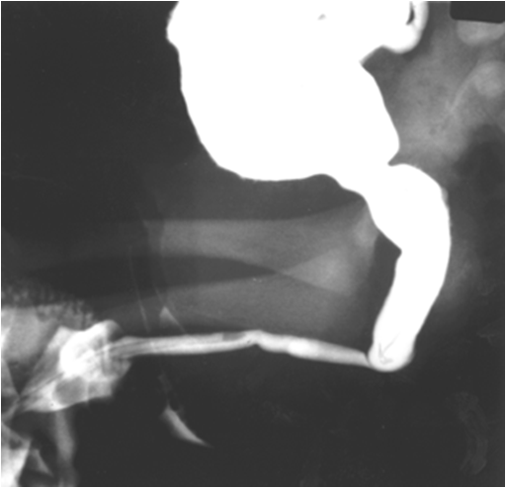

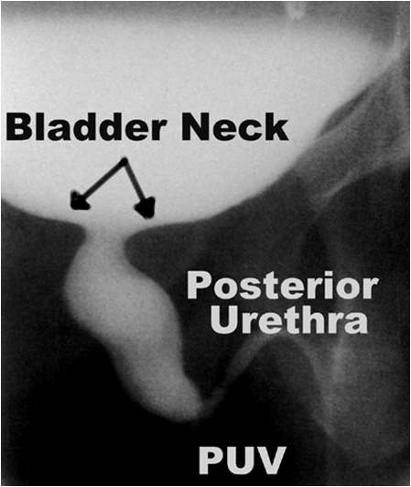

-HYPERTENSION , failure to grow .

1. **CT showing renal cancer, identify**

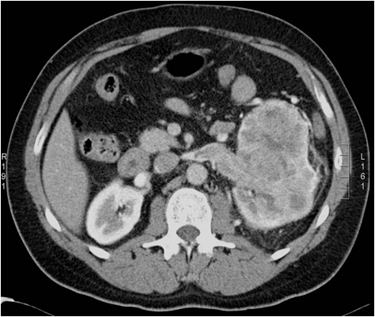

**left**



-Mention 3 clinical presentations>>

flank pain, palpable mass, gross hematuria

- mention investigations you should preform to check for mets >> cystoscope, bone scan, chest xray)

1. **Renal vascular trauma, which grade? Management? Indication for surgical exploration**

**Grade 1**: (most common): Renal contusion or bruising of the renal parenchyma.

**Grade 2**: Renal parenchymal laceration into the renal cortex.

**Grade 3**: Renal parenchymal laceration extending through the cortex and into renal medulla.

**Grade 4**: Renal parenchymal laceration extending into the renal collecting system, main renal artery thrombosis, segmental renal vein, artery , or both with contained bleeding.

**Grade 5**: Multiple deep parenchymal lacerations, renal pedicle avulsion, or main renal vein or artery injury( penetrating trauma).



1. **68 year old male patient with bph came to the ER with back pain, abdominal pain and he didn’t pass urine since morning , diagnosis? What exam do you do to support the diagnosis? What investigations? One important thing in the management**

-Exam >>palpate suprapubic area to determine if there is urine retention or anuria -investigation >>PSA ,urinanalysis ,creatinine

-management >>foleys catheteration

**Past questions**

1. **An IVP image showing a left non functioning kidney (no contrast excretion), right hydronephrosis and a filling defect in the bladder**

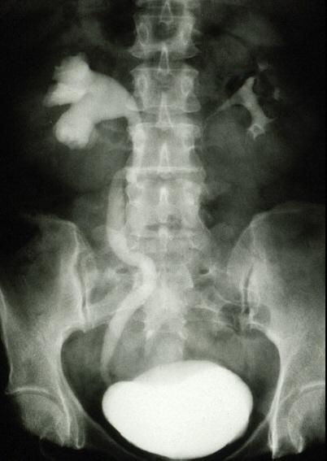

-Name 3 radiological abnormalities

1. **This is KUB of a 37 year old female patient with a history**

**of loin pain and recurrent UTI. This patients has 2 kids**

-what is the most probable etiology for her condition>>

Infection(proteus,pseudomonas, Klebsiella)

-What is the composition of this pathology>>

Magnesium ammonium phosphate

-What is the most appropriate method of management>>

PCNL (percutaneous nephrolithotomy)

1. **For each of the following conditions, write the most**

**appropriate method of diagnosis:**

-renal scar >> DMSA scan

- renal cyst >> US

- renal stone >> CT

- VUR >> voiding cystourethrogram

- pelviureteric junction obstruction >> CT

1. **For each of the following, write down the most appropriate method of treatment:**

A-8mm diameter mid ureteric stone >> eswl (shouck wave lithotripsy )

B- 13mm stone in the mid renal calyx.>> uretroscopy (intracorporal)

C- solitary, exophytic T1 transitional cell carcinoma of the bladder >>TURBT

D- BPH with bothersome urinary obstructive symptoms.>>alpha blocker

E- advanced prostatic adenocarcinoma with bony metastasis >> molecular therapy

1. **A 37 year old businessman presented with flank pain, high fever and chills. He has been started on gout medication since 2 months**

-what is the most probable diagnosis>> urinary tract stone ( uric acid )

-what investigations you would like to order >> raidiological (non contrast CT scan , IVP , Retrograde pyelography , Renal Ultrasound ) . Urinalysis . CBC . KFT.

-what is medical treatment >> hydration , urine alkalinization , Allopurinol , dietary manipulation

-if stone in bladder >> potassium citrate

1. **What is the name of this test >>** transillumination test

-What is the diagnosis >> hydrocele

-Management>> children >> resolve spontainuosly

In adult >> surgical excision

If secondary >> treat underlying cause

**Mini OSCE 2013**

1. **What is the name of this condition** >> Cryptorchidism ( undescended testis )

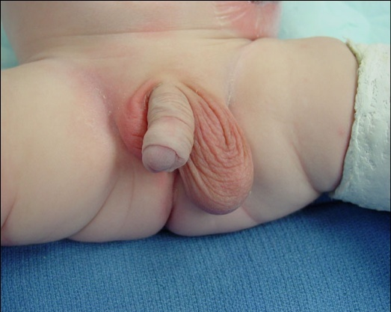

-What is the procedure performed, and when >> orchidopexy…..when>> after 1 year (6-18 months )

-List 5 complications associated with the condition >> hypoinfertility , cancer , torsion , trauma , inguinal hernia

-investigation >>chromosome analysis and hormone test

1. **What is the diagnosis** >> Torsion

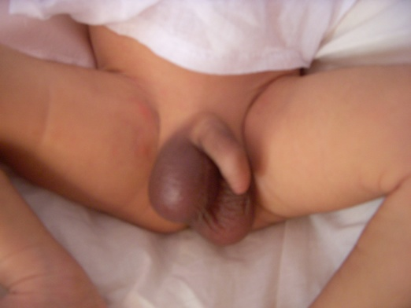

-What method of investigation is helpful in this situation >> color Doppler US

-What is the treatment >> surgical exploration , untwist testis and orchidopexy

1. **What is the name of this procedure**>> Transuretheral resection bladder (TURB)

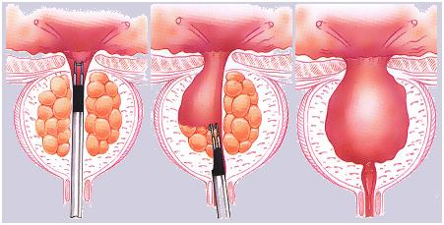

-What are the complications>> perforation of the bladder , sepsis, incontinence , ureteral stricture , hemorrhage , incomplete resection .

1. **Choose the correct answer :**

-Tumescence is mediated by>>

a. Thoracic sympathetic

b. Pelvic sympathetic

c. Lumbar parasympathetic

d. Pelvic parasympathetic (**Correct Answer**)

e. Sacral somatic

1. **What is the name of the radiological abnormality shown**? (Additional CT Image was present in the exam) >> Hydronephrosis

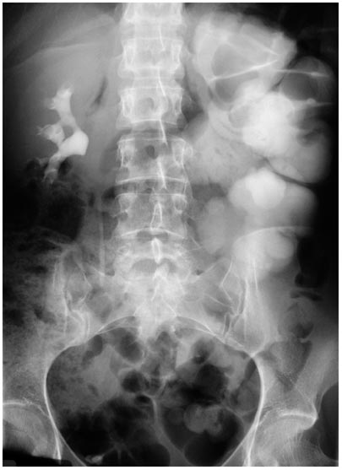

-List 5 causes >> Kidney stones , BPH , pregnancy ,

narrowing of the ureters , neurogenic bladder

1. **Describe the radiological abnormality seen**>> Bladder Filling Defect

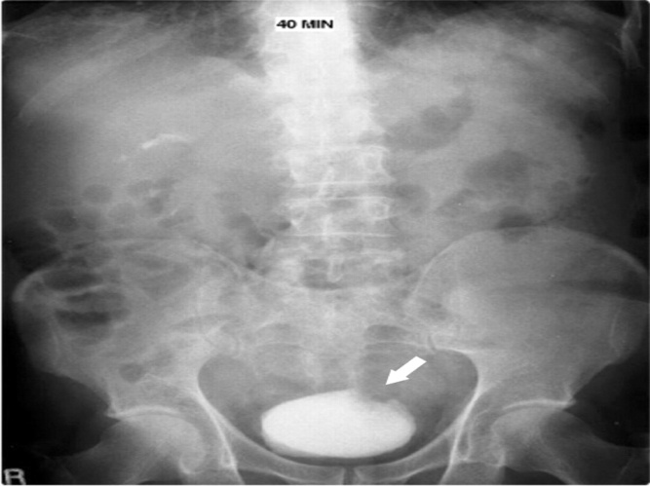

-List five differential diagnosis >> Blood clot , stone , Neoplasm , Polyp , Prostatic enlargement , focal cystitis

**Mini**

1. **Routine PSA examination yields PSA level of 8ng/ml**

-Causes of increased PSA>> benign prostatic hyperplasia, prostate cancer, acute prostatitis, UTI , ejaculation , DRE , biopsy , TURP

1. **Lady with loin pain & history of stone formation (has been removed)**

-Indications for admission>> intractable pain, toxemia suggesting infection, bilateral urine flow obstruction, single kidney & renal failure

1. **X-ray of staghorn stone**

-Diagnosis>> struvite stone (due to infection)

-Management>>PCNL (percutaneous nephrolithotomy)

1. **Newly married female with typical presentation of UTI: fever, frequency, urgency … etc**

-Simple diagnostic tests>> urine analysis, urine culture & sensitivity test & CBC

1. **Patient with spinal injury & quadriplegia cannot pass urine & has urinary incontinence**

Diagnosis>> spinal shock

-Type of incontinence>> overflow incontinence (bladder is hypoactive)

-Predict bladder & sphincter function after 3 months>> bladder becomes hyperactive + detrusor sphincter dyssynergia (DSD)

1. **A 65-year-old male patient presented to you complaining of red colored urine. What are the main questions in history that you will ask**

Timing of macroscopic hematuria in urinary stream

1. **While taking a shower, a 24-year-old male patient noticed a painless mass in his scortum. He is a smoker since 10 years. Answer the following questions:**

-What are the points in this history that goes with a diagnosis of testicular cancer>>Painless mass …smoker 10 years ………age 24

-Name the investigation**s** that will help you reach a diagnosis>> US , tumor markers (alpha fetoprotein, HCG , LDH and PLAP).

-What is the treatment >>1)Radical inguinal orchiectomy (Dx & local control)

2) radiotherapy

1. **A 50-year-old male patient presented with hematuria. He has been a worker in a chemical factory since 25 years. Answer the following questions**

-What is the main finding in this IVP>>Raidiolucent filling defect projecting in to the lumian ( bilateral hydronephrosis)

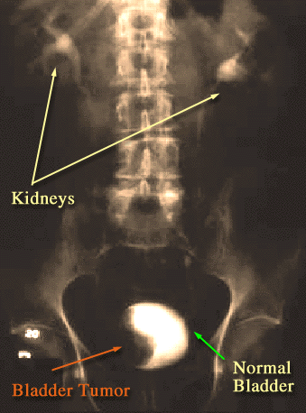

-If this patient was found to have a low grade bladder tumor,

what is the management>> TURBT ( transuratheral resection

of bladder tumor )

If invasive : radical cystectomy + pelvic lymphadenectomy

If metastatic : chemotherapy + radiation

1. **If a child has testicular torsion, name 3 signs that you will find during physical examination**

-ve Prehn’s sign, retracted testis, and absent cremasteric reflex

**2017 mini OSCE**

1. **What is the PSA**

- Function >> to liquefy the ejaculate, enabling fertilization

-Five thing lead it to increase >> benign prostatic hyperplasia, prostate cancer, acute prostatitis, UTI , ejaculation , DRE , biopsy , TURP

1. **KUB indicate a stone in the left ureter**

- what's the difference between the KUB and normal abdominal Xray>>

1- from xiphoid to suprapubic 2- psoas shadow is seen 3- needs preparation 4- Usually supine 5-hyper exposure

-What's the composition of the stone in pic>> calcium oxalate   
-What's the best management for it >> medical > I.V fluid , NSAIDs , alpha blocker

1. **CT scan show bladder cancer and history of gross hematuria**

- write the most likely diagnosis for it>>bladder CA  
-the most likely risk factor to get it >> smoking   
- The T stages for any bladder cancer in general>>

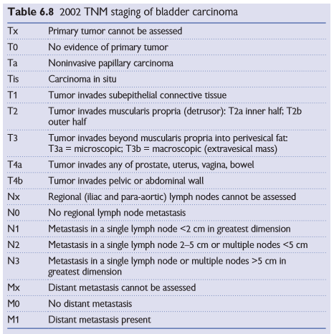

1. **define all the following**

- Radical cystectomy >>remove bladder + prostatic urethra + distal ureter + regional LN   
-Radical nephrectomy >> remove kidney +/- LN +/- perinephric fat + upper half of ipsilateral ureter  
-most common site for metastasis in testicular cancer >>para aortic lymph nodes , lung /prostatic tumor>>bone

1. **CT scan showing kidney tumour**

- Mention 5 symptom of disease and 2 name of syndrome the disease made>>

Haematuria , flank pain , mass , bone pain, night sweats

*Von Hippel–Lindau (VHL) syndrome* , Birt-Hogg-Dubé (BHD) syndrome   
-Your diagnose >> renal cell carcinoma

-what is gold standard investigation >> CT with contrast  
- What are the gold standard of management>> radical nephrectomy

1. **history of 65 year old man with long standing lower back pain and with no urine pass since morning**

- what are the clinical examination that you will perform and the finding that support your diagnosis >> palpate suprapubic area to determine if there is urine retention or anuria  
-what's the first line of management >> insert folyes catheter

1. **pic showing a black necrotic right testis**

- describe what you see >> swollen and black testis , pulled up testis  
-which age affect and what's the peak age >> (10-30 years ), (peak is 13-15 years)  
-mention 3 arteries supplying the tests >> testicular artery , cremastric artery , Artery of the ductus deferens   
-mention the thing that fixes the tests in it's position >> spermatic cord  
-What happen if untreated >> infarction and die

1. **true or false**

-Absorption of ca mainly in jejnium and proximal ileum >> F .. (duodenum)  
- the male to female ratio in bladder ca is 3:1 >> T  
- Stone formation may be a genetic cause >> T  
-gallbladder stone have an increased risk factor for renal stone >> T  
- The lymphatic spread of testicular cancer is mainly to iliac lymph node>>F

**The end**

Done by :

Noor Daher Alhijjaj ☺