Archive Wareed Final

2024

Done by:

Laith Najada

Monis Rashdan

Sondos Abbadi

**- امتحان الباطني لا تفوته معتمد على دراستك للسلايدات، ادرس من مصدر خارجي زي:**

**Medstudy books / Step-Up book / AMBOSS website**

**+ شوف الارشيف عشان تعرف توجه الدكاترة بالاسئلة بس لا تعتمد عليه بشكل اساسي، وشوف بعدين محاضرات الدكاترة اللي راح يكتبوا الاسئلة.**

**- طبعاً الحكي اللي فوق خلال الشهرين مش قبل الامتحان "_"**

**- في اكثر من سؤال لدكتور وليد وادي من ابحاث "_"**

**- في اسئلة مش متأكد من اجوبتها محطوط عندها علامة استفهام**

**1- Patient came with seizure, his Na level is 115, the best next step?**

A) 500cc 0.9% NS + D5W

B) 500 cc 0.9% NS

**C) 100 cc 3% NS**

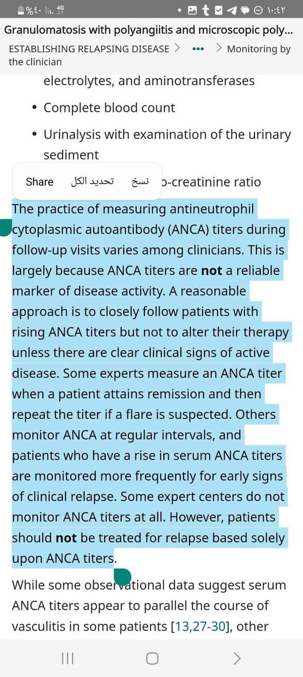D) 500 cc 3% NA

**2- Wrong about ANCA vasculitis?**

A) C-ANCA along with Pr3-ANCA both are highly positive

in Wegner granulomatosis

**B) ANCA correlate well with the severity of disease ??**

C) ANCA decreased with treatment

D) ANCA could be positive in some infections

E) ANCA could be positive in SLE

**3- Wrong about the following:**

A) JIA diagnosed in children before the age of 16

B) Disseminated gonococcal infection most commonly occurs in young male adults

**C) Osteoarthritis and RA of the hands most commonly occur in middle-age women**

**4- Patient with pancreatic cancer, came to the ER due to fever and altered mental status, there’s no neck stiffness, CBC shows low HB and platelets, KFT shows elevated Cr and BUN, the best next step is?**

A) Do lumper puncture to rule out meningitis

B) Give platelets before do LP

**C) Do blood film**

D) Observation

**Note: it’s mostly a case of TTP**

**5- Patient with chest pain and nonspecific anterolateral changes on ECG, what is the indication for giving clopidogrel?**

**A) If contraindicated to give aspirin**

B) For 6 months when the mortality is 5%

C) For 12 months when the mortality is 5%

**6- Patient on warfarin because he had DVT, his INR is 5.3, he is asymptomatic with no signs of bleeding, what is the next step?**

A) Give IV vitamin K

B) Give FFP and vitamin K

C) Stop treatment

**D) Skip the next dose, then decreasing the following doses**

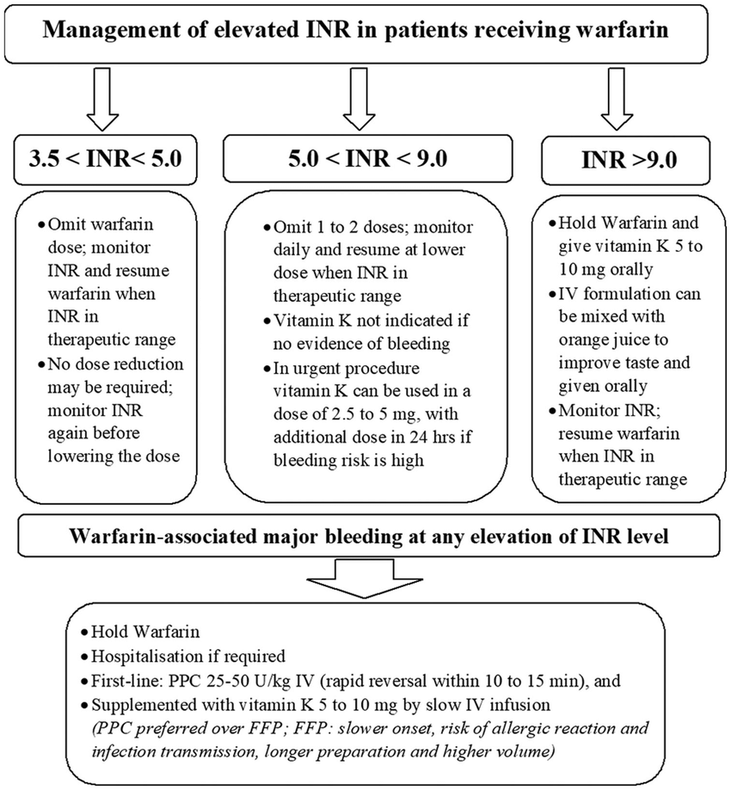

**7- After seven days of hospitalization for a patient who had a major surgery and taking heparin as prophylaxis, CBC is done for him shows low platelets 30,000 (baseline was 250,000), what is the best next step?**

A) Stop heparin and initiate LMWH

B) Stop heparin and initiate warfarin

C) Stop heparin with no other treatment

**D) Stop heparin and initiate fondaparinux**

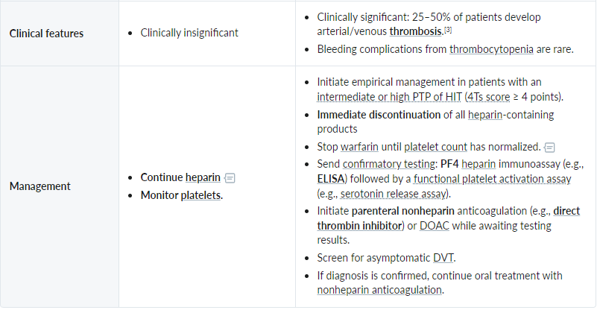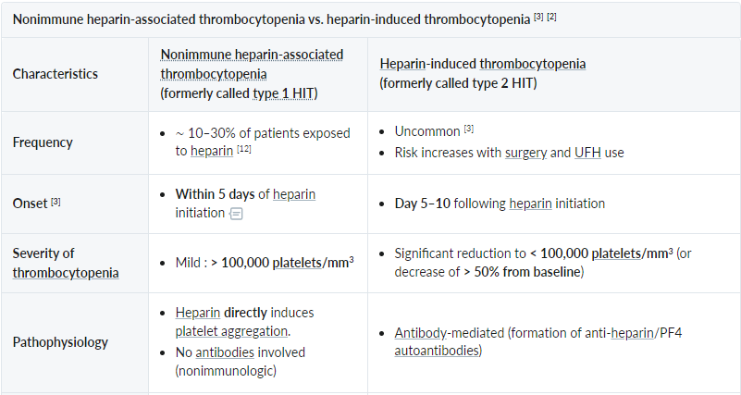

**(Except synthetic fondaparinux)**

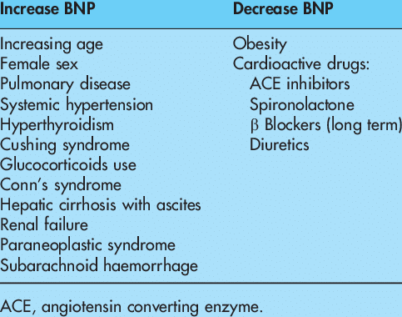**8- One of the following falsely elevate BNP:**

A) ACE inhibitor

B) Furosemide

**C) COPD**

D) Obesity

**9- Which type of nephrotic disease we don’t use corticosteroids?**

**A) Diabetic nephropathy**

B) FSGS

C) RPGN

D) DPGN

**10- Young male takes diclofenac for his arthralgia, developing an epigastric pain, his arthralgia has resolved, what is the best next step?**

A) Stop diclofenac and initiate ibuprofen with PPI

**B) Stop diclofenac and give PPI then follow-up after one week**

C) Urgent endoscopy

**11- All of the following cause secondary HTN EXCEPT?**

**A) PDA**

B) Liddle syndrome

C) 11 beta hydroxylase deficiency

D) OCPs

**12- HTN + DM, best antihypertensive drug?**

A) Nifedipine

**B) Ramipril**

C) Esmolol

**13- All of the following causing bronchial breath sounds EXCEPT?**

A) atelectasis with patent bronchi

B) Bronchigenic cancer

**C) Bronchial asthma ??**

D) Cavitation

**E) Superior border of pleural effusion ??**

**14- One of the following is long term side effect of steroid?**

A) Osteomalacia

**B) Avascular necrosis**

C) Thick skin

**15- Young female patient had a heart block on ECG, along with bilateral lung infiltration on chest X-ray, what is the diagnosis?**

**A) Sarcoidosis**

**16- A middle age man who works as a farmer came to the physician due to episodes of wheeze, cough, chest pain and dyspnea, spirometry shows elevated FEV1:FVC ratio, what is the most likely diagnosis?**

A) Asthma

B) COPD

**C) Hypersensitivity pneumonitis**

**17- 55-year-old man came to the ER due to one episode of hemoptysis, he is smoker, chest x ray is free, what is the best next step?**

A) Discharge and follow-up with x-ray annually

**B) Lung CT**

C) Bronchoscopy

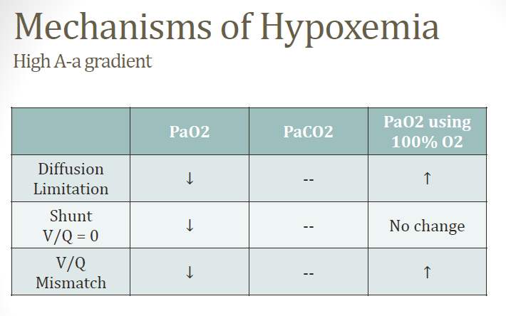**18- V/Q mismatch causes?**

A) Elevated PaO2 with decreased PCO2

B) Decreased PaO2 with elevated PCO2

**C) Decreased PaO2 with normal PCO2 ??**

C) Elevated both

D) Decreased both

**(Not sure about the answer, the table is from BNB)**

**19- 55-year-old smoker complaining of chronic cough with white to yellow sputum progressing for the last 3 years, chest x-ray is normal, spirometry is normal also, what is the most likely diagnosis?**

A) COPD

B) Asthma

**C) Chronic bronchitis**

D) Emphysema

E) Early cor pulmonale

**20- Best management for patient with inferior MI?**

**A) Aspirin, clopidogrel, heparin, statin, and urgent PCI**

B) Aspirin, clopidogrel, heparin, statin, and thrombolytic

**21- Best treatment for patient with Afib, bibasilar crackles, and free past medical history?**

A) Verapamil

B) Amiodarone

**C) Digoxin ?? (Best for patient with heart failure and Afib)**

**D) Bisoprolol ?? (Best as first line for rate control)**

**C or D not sure but mostly D**

**22- Young lady with RA wants to get pregnant, what is the best treatment for her?**

A) Methotrexate

B) Azathioprine

**Both B and C are safe during pregnancy, but according to the doctor it’s C**

**C) Sulfasalazine**

D) Leflunoamide

**23- Correct about hepatitis B virus?**

**A) Not contraindicated for lactation**

**24- 76 y female came with unilateral right eye sudden vision loss, carotid U/S shows 95% stenosis in the right carotid artery and 30% in the left, what is the best next step in management?**

A) Temporal artery biopsy

**B) Referred to surgery for carotid endarterectomy**

**25- Cushing disease, one is correct about diagnosis?**

**A) 24 hr urine cortisol**

**26- Not used in correction of K+ for the following case: K level is 6.5 and normal ECG?**

A) Insulin with dextrose

B) Sodium bicarb

C) Albuterol

**D) Calcium gluconate**

E) Dialysis

**27- Autoimmune hepatitis confirmatory test?**

A) ASMA

B) AMA

**C) Liver biopsy**

**28- Worst prognosis in infective endocarditis?**

A) Staph aureus

B) Strep viridians

**C) Prosthetic valve ??**

D) Low complements level

**29- Follow-up for treatment of HBV the best is?**

A) HbsAg

B) HBV genome

**C) Viral load**

**30- The most clinical sign that indicates isolated LV hypertrophy is?**

A) Tachycardia

**B) Rhythm gallop**

C) Cardiomyopathy

**31- Patient with sever pneumonia, his thyroid function test mostly shows:**

**A) Low to normal TSH, low T3, low T4**

B) High TSH, low T3, low T4

C) Low TSH, high T3, high T4

**(Euthyroid sick syndrome came with critical illness)**

**32- Specific for Graves’ disease of the following?**

A) Lid lag

B) Afib

**C) Pretibial myxedema**

**33- Young female develops sudden slurred speech after long flight from USA to Jordan, head CT shows no abnormality, what is the best test for the underlaying cause?**

**A) TEE**

B) TTE

C) Head MRI

D) Cerebral angiography

**(It’s mostly paradoxical emboli from DVT to the right heart —> PFO —> left heart —> to the brain)**

**34- A young male patient develops hyperthyroidism symptoms but without eye involvement, his TSH is slightly decreased with slightly T3 and T4 increased, also he has diffused painless goiter, what is the most likely diagnosis?**

A) Graves

**B) Toxic multinodular goiter ?? (Cause nodular goiter)**

C) Toxic adenoma

**D) Hashimoto thyroiditis ?? (Can cause transient hyperthyroidism initially)**

E) DeQuervian thyroiditis

**35- Best for COPD to prolong survival?**

A) Oxygen therapy

**B) Smoking cessation**

**“_” B الاثنين صح بس حسب الدكتور الاحسن**

**36- Patient with sickle his Hb is 5 and retic is 0.5% what is the most likely diagnosis?**

A) Hemolytic crisis

B) Splenic sequestration

**C) Viral infection**

**(Parvovirus B19 —> aplastic crisis —> low retic count)**

**(Splenic sequestration—> high retic count)**

**37- Patient develop heavy menorrhagia, PT normal but PTT is prolonged, mixing study show persistent prolongation of PTT, what is the diagnosis?**

A) Hemophilia A

B) Hemophilia B

C) Antiphospholipid syndrome

**D) Acquired factor 8 antibodies**

**38- Which one of the following cause bilateral bell’s palsy?**

A) Amyloidosis

B) Acoustic neuroma

**C) Sarcoidosis**

**39- Correct about DM?**

**A) Concordance of T2DM in twins is higher than T1DM**

B) It’s thought to be autosomal dominant

**40/41- Most common antibody seen in pernicious anemia is?** (تكرر مرتين للاسف

A) **Anti-parietal AB (More sensitive)**   
B) Intrinsic factor AB **(More specific)**

**42- One of the following not associated with “non-alcoholic fatty liver disease”?**

**A) T1DM**

B) Dyslipidemia  
C) Obesity  
D) Jejunoileal bypass  
E) Sudden weight loss and starvation  
  
**43- A patient with hematemesis, after resuscitation what is the treatment of choice while waiting for endoscopy?**

A) Octreotide **B) Terlipressin**

**44- Pregnant women with pleuritic chest pain, suspected to be PE, what is the diagnosis of choice?**

A) CT pulmonary angiography

B) Pulmonary angiography

C) D-dimer

**D) Radionucleotide isotope**

**45- All of the following cause ITP EXCEPT?**

A) Heparin

B) SLE

C) HIV

**D) Vitamin B12 deficiency**

**46- Diagnostic criteria of the ARDS include all the following EXCEPT?**

A) Non-cardiogenic cause

B) Acute insult within one week

**C) Respiratory rate more than 24**

**47- What is the mechanism of ketones production during DKA?**

A) Exchange with H+ **B) Lipolysis**

**48- Which of the following is suggestive of UC?**  
A) Multiple granuloma

**B) Goblet cell depletion**

C) Cobblestone appearance

**49) All of the following included in the management of nephrotic syndrome EXCEPT?**

A) ACEi, ARBs

**B) High sodium diet**

**50- Patient with mechanical mitral valve replacement, what you expect the drug that used by the patient?**

A) Not using any medication

**B) Warfarin**

C) Aspirin

D) DOAC

**51- A women came with excessive sweating, tremor, and nervousness, you inspect also a protruded eyes with lid retraction, what is the most likely diagnosis?**

**A) Graves’ disease**

**52- What is the cause of pulmonary edema in ARDS?**  
A) Increased hydrostatic pressure

B) Decreased oncotic pressure

**C) Increased capillary permeability**

D) Heart overload

**53- Patient with HIV, develops a dark red spot, diagnosed later with Kaposi sarcoma, what is the causative organism?**

A) HIV-2

**B) HHV-8**

C) HTLV 1

**54- 19-year-old female complain of sore throat, headache and fever, treated with amoxicillin for 2 days then she developed a rash, what is the most likely diagnosis?**

A) Penicillin allergy

**B) Infectious mononucleosis**

C) Kawasaki disease

**55- Screening for Celiac should be done in which one of the following scenarios?**

A) 60-year-old male with erythema nodosum

**B) 20-year-old male with anemia and fatigued all the time**

**56- Elderly man came with bone pain, multiple lytic lesions and elevated plasma cells on bone marrow, which of the following not associated with this case?**

A) Elevated total protein with normal to low albumin

B) Hypercalcemia

**C) Hyperkalemia**

D) Renal failure

**57- Which antibiotic of the following should be avoided in patient with long QT syndrome?**

A) Doxycycline

**B) Erythromycin**

C) Rifampin

**(Macrolides and fluroquinolones should be avoided)**

**58- One of the following is least associated with irritable bowel syndrome?**

A) Abdominal distension

**B) Waking at night from pain**

C) Mucus with stool

**59- Which part of ECG correspond to the closure of mitral valve?**

A) P wave

B) PR interval

**C) QRS complex**

D) ST segment

**60- One of the following is not a cause of iron deficiency anemia?**

A) Decreased oral intake of iron

B) Increased oral intake of iron absorption inhibitors

**C) Anemia of chronic disease**

D) Hookworm infestation

**61- One of the following is associated with anemia of chronic disease?**

A) Low ferritin

**B) High hepcidin**

C) High TIBC

**62- Which of the following indicates poor prognosis in cirrhosis?**

A) Caput medusa

**B) Ascites**

C) Gynecomastia

D) Splenomegaly

**63- Antiretroviral drug that cause pancreatitis?**

**A) Didanosine**

B) Indinavir

**64- 25-year-old male came to the ER due to cough, SOB, and fever; he is alert, his respiratory rate is 23, his BP is 120/78, his BUN is 13, what is his CURB-65 score?**

**A) 0**

B) 1

C) 2

D) 3

E) 4

**65- 70-year-old female, had a paroxysmal Afib, before 2 weeks she had a transient right sided weakness, she takes nifedipine for her hypertension, her BP is 124/83, calculate her CHADVASc score?**

A) 0  
B) 1  
C) 2  
D) 3  
**E) 4 (Age 1, TIA 2, HTN 1)**

**66- All of the following are indications for dialysis EXCEPT?**

A) Hyperkalaemia

**B) Hypomagnesemia**

C) Metabolic acidosis

D) Fluid overload

**67- Most common cause of non-iatrogenic cause of Cushing syndrome?**

A) Adrenal adenoma

**B) Pituitary tumor**

C) Ectopic ACTH secretion

**68- Young patient complains of epistaxis, her mother and sister also had similar symptoms, what is the most likely diagnosis?**

A) Haemophilia A

B) ITP  
**C) Von-Wilbrand disease**

D) Antiphospholipid syndrome

**69- Case of young female, not pregnant, urinalysis shows elevated WBCs in urine, urine culture positive for E. coli, she is asymptomatic, what is the best treatment for her?**

**A) No treatment is required**

B) Ceftriaxone

C) TMP-SMX

**70- Patient who became easily bruising with flank pain and oozing from site of catheter, lab investigations show low platelets, low fibrinogen, high D-dimer, high PT and PTT, he is diagnosed as a case of leukemia, which of the following is the most common type?**

A) M1

B) M2

**C) Acute promyelocytic leukemia**

D) Acute megakaryocytic leukemia

**71- A 55-year-old man is admitted to the Emergency Department with ‘tearing' chest pain radiating through to his back. A chest x -ray shows mediastinal widening. A CT shows dissection of the ascending aorta. What is the most suitable initial management?**

A) IV sodium nitroprusside

B) Oral verapamil

C) Observe only

**D) IV labetalol (The best initial)**

E) Surgical repair **(The definitive)**

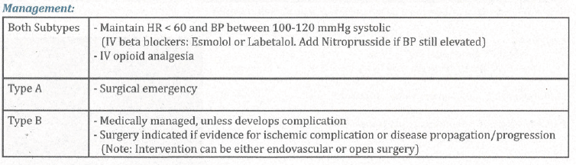

**72- A patient came to the ER after he loss his consciousness, ABGs and electrolytes show pH of 7.23, PCO2 of 35, HCO3 of 12, Na 145, Cl 103, what is the acid-base disorder?**

A) High anion-gap Metabolic acidosis with respiratory alkalosis

B) Normal anion-gap Metabolic acidosis with respiratory compensation

**C) High anion-gap Metabolic acidosis with respiratory acidosis**

D) Respiratory acidosis with metabolic compensated

E) High anion-gap Metabolic acidosis with respiratory compensated

**73- Patient came from India to UK, complains from cough, night sweat, fever, weight loss, and anorexia, sputum stain with acid-fast bacilli is positive, treatment regimen for this patient is?**

A) Rifampin, Isoniazid, Pyrazinamide, and Ethambutol for 6 months

**B) Rifampin and Isoniazid for 6 months, plus Pyrazinamide and Ethambutol for the first 2 months**

C) Rifampin and Isoniazid for 6 months, plus Pyrazinamide and Ethambutol for the first 4 months

**74- A patient with chronic myeloid leukemia, one of the following is associated with the disease?**

**A) Philadelphia chromosome**

B) TEL-AML translocation

**75- 35-year-old male ask you if he has a polycystic kidney disease like his father and his brother or not, what is the best screening test?**

A) KFT

**B) Ultrasound**

C) Genetic study

D) MRI

**76- Which of the following is diagnostic for DM?**

A) Asymptomatic patient with fasting blood glucose of 7.6 mmol/L for one occasion

B) Asymptomatic patient with fasting blood glucose of 6.3 mmol/L for two occasions

C) Asymptomatic patient with HbA1C of 6%

**D)** **Symptomatic patient with random blood glucose of 12 mmol/L for one occasion**

E) Symptomatic patient with normal blood glucose

**(To convert from mmol/L to mg/dL multiplied the value by 18)**

**77- A patient with fasting blood glucose of 6.5 mmol/L, what his FBG indicates?**

**A) Impaired fasting glycemia**

B) Suggest DM

C) Impaired glucose tolerance

D) Normal

**78- Young male with HOCM, which of the following drug should be avoided?**

**A) ACE inhibitor**

B) Atenolol

C) Amiodarone

D) Verapamil

**79- Which of the following impair glucose transport from blood to pleural fluid?**

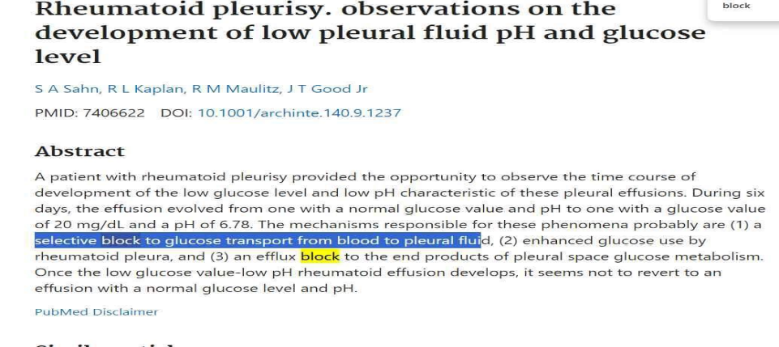A) Myxedema coma

B) Congestive heart failure

C) Liver cirrhosis

**D) Rheumatoid pleurisy ??**

E) TB

80- 40-year-old patient had productive cough, fever, and SOB, chest x-ray shows left lower lobe consolidation, treated as a case of pneumonia, after five days of antibiotics the patient still has persistent fever and cough, what is the most likely diagnosis?

A) Cancer

**B) Empyema**

**81- What of the following not considered in the management of CKD patient?**

**A) BP should be above 140/90 to ensure adequate blood flow to the kidneys**

B) Tight control of patient’s blood glucose

C) Give ACEi and SGLT-2 for the patients to delay the progression of disease

**82- Patient has hemoptysis, and red urine, kidney biopsy shows crescent formation in glomeruli, what is the most likely diagnosis?**

**A) Anti-GBM disease**

B) Wegner’s granulomatosis

C) Alport syndrome

**83- Patient with PH of 7.33, PCO2 47, HCO3 28, PaO2 87, he is on simple face mask, and O2 sat is 97%, what of the following statements is false about the case?**

A) He has COPD

**B) He needs ICU admission**

C) It’s chronic case, the patient is stable

D) He may needs NIV

**84- Young male patient who has lower back pain, associated with right knee pain and left ankle pain, he has also a morning stiffness, what is the most likely diagnosis?**

A) Rheumatoid arthritis

**B) Psoriatic arthritis**

C) Osteoarthritis

**85- Patient with negative HBsAg, negative anti-HBs, positive anti-HCV, what he has?**

A) Both HCV and HBV

B) HCV with immunization against HBV

**C) HCV only**

D) None of the above

**86- Wrong about seronegative arthritis?**

**A) Symmetrical polyarthritis**

B) Associated with IBD

**87- Patient after doing an ERCP develop an abdominal pain radiating to the back, his amylase level is 816, what is the best management for this patient?**

A) Surgery

B) Repeat ERCP

C) Antibiotics

**D) NPO with IV fluid and bed rest**

**88- Patient with SOB, ABGs show PH 7.48, PCO2 23, HCO3 21, his PaO2 is 66, what is the most likely cause of this case?**

A) Anxiety

**B) PE**

C) Salicylate toxicity

**89- Which of the following is not diagnostic for HHS?**

**A) Plasma osmolarity is 310**

B) +1 ketone in urine

C) Blood glucose is 800

D) HCO3 20

E) PH 7.34

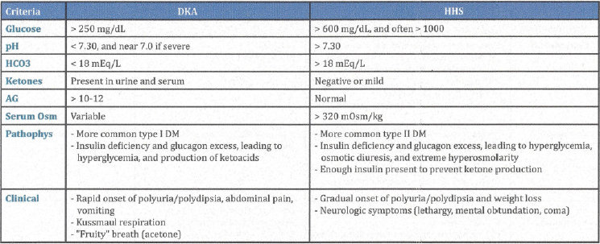

**90- Female patient presents with tremor, palpitation, diaphoresis, fatigue and confusion, she mentioned that she has increased in weight 20kg for the last month, her blood glucose is 2.1 mmol/L, what is the best next step?**

**A) Insulin and C-peptide levels during hypoglycemic episode**

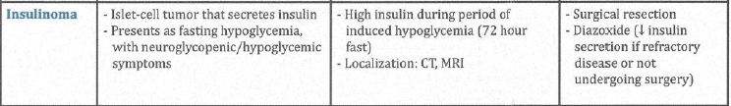B) Plasma glucagon level

**91- Female patient presents with SOB, hemoptysis, pleuritic chest pain, she is unstable with systolic BP of 80 mmHg, what is the best next step in management?**

A) LMWH

**B) Thrombolysis**

C) Warfarin