Family Medicine Archive (Group C+D)

1. Mention 4 skills a family medicine physician should have:
2. 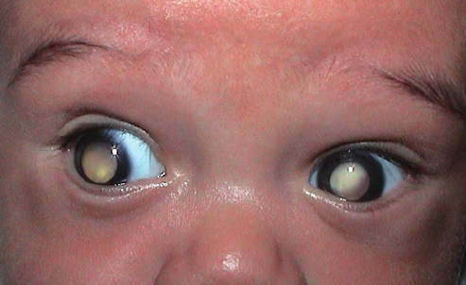

-What is this test called

-Mention 2 other screening tests for newborns

1. [a case of a man complaining of chest pain that is relieved with rest]

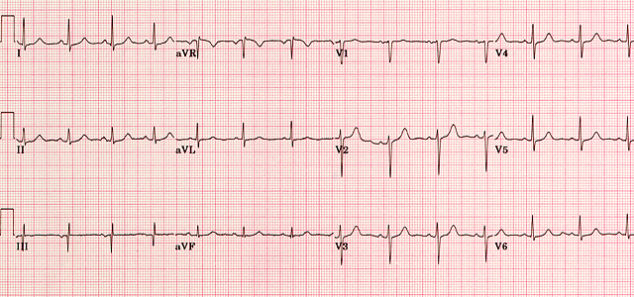

-what is your interpretation of the ECG: Normal ECG

-diagnosis: angina pectoris (stable angina)

1. [a case of a 52 year old man, diabetic, LDL 160, with CVSD risk 18%]

-Management: Moderate intensity statin + Lifestyle modifications

1. 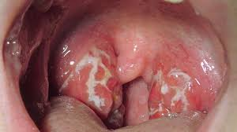

-Diagnosis ?

-Mention two indications for tonsillectomy?

1. [A case of diabetic patient with nephropathy and hypertension]

-Treatment?

-What is the antidiabetic medication that is safe to use with chronic kidney disease?

1. [a case of a woman with ovarian cysts, rebound tenderness, RLQ Pain..]

-Give four differential diagnoses.

1. [an elderly female with asthma and gout]

-Most suitable antihypertensive.

1. 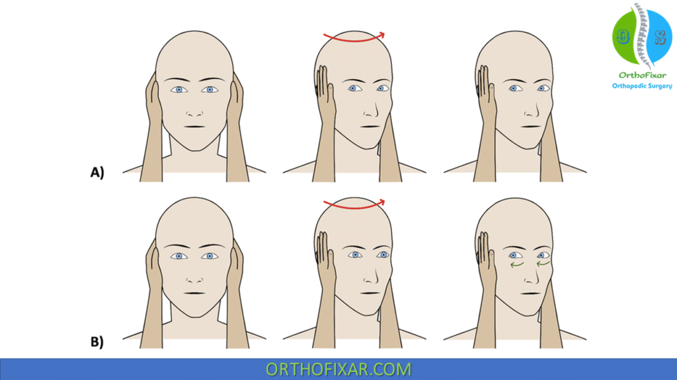

* Name of the test
* Diagnosis if the test is positive

1. -A Katz index score (can’t remember the score), your indication for this patient:

-Mention 4 Activities of daily living

1. [A typical case of migraine with prodroma]   
   -Diagnosis

-Do you use prophylactic treatment for this patient: yes

-Mention one prophylactic drug

1. Mention (3 or 4 ) initial investigations for a fatigued patient
2. Preventive measures for Osteoporosis