Microbiology
1)A granuloma is a complication of over-reaction of?
Select one:
a. TH1 cells
b. Antibody production
C. B cells.
d. TH2 cells.
e. Eosinophils.
2) After using a syringe to give intravenous drug, one of the following is TRUE?
Select one:
a. Give it to the nurse to recap the needle
b. Leave the syringe on the patient's bed wait an hour then recap the needle C. Swap the needle with alcohol and iodine then recap the needle.
d. Never recap the needle and discard the syringe in the yellow sharp pin.
e. Throw the syringe in the black plastic bag.
3) Mechanisms of antibacterial resistance include all of the followings EXCEPT?
Select one:
a. Decreased antibiotics uptake mediated by porins changes
b. Increased pumping out the antibiotic by efflux pumps
c. Production of enzymes called beta lactamases that destroy the beta lactam ring
d. Target bypass such as the production of PBP2 in MRSA
e. Mitochondrial cumulative point mutations
4) Which of the following processes the bacterial cell is forced in the lab to take an external segment of DNA?
Select one
a. Conjugation.
b. Cloning
c. Transduction
d. Bacteriophage infection.
e. Natural mutation
5) Biotype is an infra-subspecific designation according to?
Select one:
a. Pathogenic properties for certain hosts.
b. Ability to be lysed by certain bacteriophages.
C. Special biochemical and physiological properties.
d. Certain antigenic properties
e. Special morphological features
6) Which of the followings is an example on transmission by droplet nuclei (airbome)?
Select one:
a. E. coli.
b. Tuberculosis.
c. hepatitis C.
d. Cholera
e. Hepatitis A
7) One of the following antibiotics causes a reversible stop of bacterial growth (bacteriostatic)?
Select one:
a. Vancomycin.
b. Chloramphenicol.
C. Aminoglycosides.
d. Ciprofloxacin
e. Rifampicin
8) A blood in stool can be found in which of the following infections?
Select one:
a. The infection of certain strains of E coli.
b. The infection of certain strains of Vibrio cholera.
c. The infection of certain strains of Corynebacterium diphtheriae.
d. The infection of certain strains of Campylobacter
e. The infection of certain strains of Pseudomonads.
9) Which of the following tests is a serological test used in identification of bacteria?
Select one:
a. Restriction fragment length polymorphism.
b. Plasmid fingerprinting.
c. Polymerase chain reaction.
d. Enzyme linked immunosorbent assay.
e. Nucleic acid sequencing analysis
10) Viruses whose genomes have a messenger polarity are?
Select one
a. Adenoviruses
b. Papovaviruses
C. Paramyxoviruses.
d. Herpesviruses
e. Picornaviruses,
12) Sterilization using autoclave can be achieved ?
Select one:
a. At 134°C For 3 minutes.
b. At 63°C for 30 minutes
C. At 72°C for 15 seconds.
d. At 100°C for 15 minutes
e. At 121°C for 5 minutes.
13) Regarding the enriched media, all are false EXCEPT?
Select one:
a. It contains agents that inhibit the growth of all agents except that being sought b. It is used when specimen cannot be cultured soon after collection
c. It is used for storing the bacteria for a long period of time.
d. It is used for culture of fastidious organisms.
e. MacConkey agar considered an example for enriched media.
14) Disinfection of day care center play tables with 70% ethanol is UNLIKELY to affect the viability of?
Select one
a. Paramyxoviruses
b. Influenza virus
C. Herpesviruses.
d. Coronaviruses.
e. Rotavirus.
15) Which of the following is the most important structure related to microbial movement?
Select one:
a. Spores.
b. Pilus.
C. Capsule.
d. Fimbriae.
e. Flagella.
/16) Infection control measures include all of the followings EXCEPT?
Select one:
a. Bare above elbow.
b. Share thermometers between patients
C. No coats.
d. Cover open wounds with occlusive adhesive
e. Hand washing
/17) Slime layer is the part of?
Select one :
a. Glycocalyx
b Endoplasmic reticulum
C. Lysosomes.
d. Golgi
e Nucleus.
18) Integration of viral genetic material into the host DNA is seen in?
Select one
a. Reoviruses.
b. Rhabdoviruses
C. Hepatitis B virus.
d. Orthomyxoviruses.
e. Paramyxoviruses.
19) Which of the following are made up of Prokaryotic cells?
Select one.
a. Bacteria
b. Fungi
C. Protozoa
d. Viruses.
e. Parasite
20) One is WRONG regarding antibiotics?
Select one:
a. Minimum inhibitory concentration is a term used for bacteriostatic antibiotics
b. Synergism is when the effects of a combination of antibiotics is greater than the sum of the effects of the individual antibiotics
C. A bactericidal antibiotic is preferred in treating infection in an immunocompromised patient
d. On bacterial growth curve Bacterial control growth and bacterial growth with efficient antibiotic have the same curts
e. Always ask about antibiotic hypersensitivity (allergy) before prescnbing it to the patient
21) Nosocomial infection (NCI), one is WRONG?
Select one
a. Increases mortality and morbidity rates
b. Performance of an invasive procedure for a patient increases the risk of NCI
C. The patient can transmit such infection to doctors and nurses.
d. Endogenous NCI is s caused by patients own microorganisms
e. Hand washing is not an important measure to decrease NCI

22) Removing specific infection hazards in milk industry is best obtained by?
Select one
a. Autoclaving
b. UV light
C. Dry heat at 100
d. Flaming.
e. Pasteurization
23)Clostridium perfringens bacterium is?
Select one:
a. Spore-forming Gram positive bacillus
b. Spore-forming Gram negative bacillus.
C. Spore-forming Gram positive cocci
d. Non-spore forming Gram positive bacillus
e. Spore-forming intracellular bacteria
24) All the following DNA viruses replicate in the nucleus EXCEPT?
Select one:
a. Herpesviruses
b. Parvoviruses.
C. Poxviruses.
d. Hepadnaviruses.
e Adenoviruses.
25) The cell wall of gram-positive bacteria are mainly composed of?
Select one
a. Capsular protein
b. Lippolysacharide
c. Peptidoglycan
d. Phospholipid
e. lipoprotein.
26) Which of the following structure can help in plasmid transfer from one bacterium to another
Select one:
a. Spores.
b. Pilus
C. Capsule.
d. Fimbriae
e. Flagella
27) Who demonstrated that open tubes of broth remained free of bacteria when air was free of dust?
Select one
a Abbc Spallanzani
b. John Tyndall
C. Francisco Redi
d. Pasteur
e. Alexander Fleming
28) Which of the following bacteria can cause infection through consumption of contaminated mik?
Select one
a. Legionella pneumophila
b. Bordetella pertussis.
c. Haemophilus influenza
d. Brucella,
e. Yersinia enterolitica
29 ) Which of the followings has terminal spores?
Select one:
a. Corynbacterium diptheriae
b. Haemophilus influenzae.
C. Yersinia entercolitica.
d. Neisseria meningitides
e. Clostridium tetani.
30) Kuru is a fatal disease that is thought to be caused by?
Select one
a Slow viruses.
b. Defective virus.
c. Pseudovirion
d. Priors
e Viroid
31) Which of the followings is an example on transmission by respiratory droplet?
Select one
a. E. coli.
b. hepatitis C.
c. Hepatitis A.
d. Cholera
e. Pertusis
32) Which of the following structures is never present in a Eukaryotic cell?
Select one:
a. Spores.
b. Mitochondria.
C. Ribosome.
d. Membrane-bound nucleus.
e. Cell membrane
33) Which of the followings has centarl spore?
Select one
a. Bacillus anthracis
b. Clostridium tetani
c. Staphylococci aureus
d. H. pylori
e. Legionella pneumophila
34) Sterilizing an endoscope in gastrointestinal units is best achieved by?
Select one:
a. 76 % alcohol.
b. Tyndallisation
c. Inspissations
d. Ethylene oxide
e. 99% alcohol
35) The bacterial cells are at their metabolic peak during........phase?
Select one
a. Lag.
b. Log
C. Stationary
d Decline
e Eclipse
36) Modification of viral receptors on a eukaryotic host cell might affect which step in viral replication cycle
Select one:
a. It would facilitate the process of viral endocytosis.
b. It would result in the degeneration of the viral capsid.
c. It would enhance the process of viral apoptosis d. It would prevent the virus from attaching to the host cell.
e. It would prevent the viral assembly
37) One of the followings is Gram negative and intracellular bacteria?
Select one:
a. Chlamydia.
b. Clostridium difficile.
c. Legionella pneumophila
d. Bordetella pertussis
e. Proteus.
38) Which of the followings is INCORRECT regarding Blood and tissue nematodes?
Select one:
a. The infective stage of W. bancrofti is the L3 larva.
b. The Intermediate hosts of W. bancrofti is the Anopheles mosquitoes.
C. The eye worm is called Loa Loa.
d. The intermediate host of the eye worm is the horsefly
e. The adult worm of Trichinella Spiralis can be isolated from the striated muscle
39) Induction of passive-active immunity is useful in the prevention of which one of the following viral diseases?
Select one
a. Hepatitis A
b. Rabies.
c. Influenza.
d. Mumps
e. Measles
40) Which of the following vectors is INCORRECT?
Select one:
a. Culex: W. bancrofti.
b. black fly. Onchocerca volvulus
C. Chrysops: Loa loa.
d. Horsefly: Onchocerca volvulus.
e Culex: Brugia malayi.
41) A granuloma is a complication of over-reaction of
Select one
a TH1 cells
b. Antibody production
c. B cells
d. TH2 cells
e. Eosinophis
42) Which of the followings is INCORRECT regarding the diagnosis of parasitic infection?
Select one
a. The amoeba from the stored samples in the refrigerator can be seen by the wet mount preparation
b. Liquid and soft stool examined within 15 min.
c. Direct Smears of stool is used to assess the worm burden of a patient.
d. Sputum is dissolved before examination
e. Venous blood collected in EDTA anticoagulant is used to study blood parasites.
/43) Which of the followings is INCORRECT regarding the diagnosis of parasitic infection?
Select one
a. The amoeba from the stored samples in the refrigerator can be seen by the wet mount preparation
b. Liquid and soft stool examined within 15 min.
c. Direct Smears of stool is used to assess the worm burden of a patient.
d. Sputum is dissolved before examination
e. Venous blood collected in EDTA anticoagulant is used to study blood parasites.
**44) This figure represents?
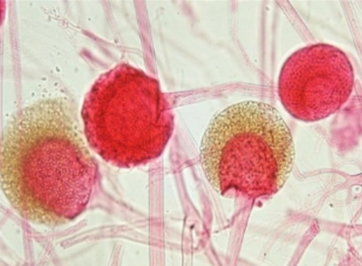
Select one
a. Arthrospores
b. Chlamydospores.
c. Basidiospores.
d. Blastospores.
e. Sporangiospores.
45) Habitat of Fasciolopsis buski is?
Select one:
a. The liver.
b. The lung
c. Large intestine.
d. Small intestine,
e. Muscles.
46) The role of antibody against Plasmodium is mainly to do all except?
Select one:
a. Act a direct damage by complement mediated.
b. Do ADCC.
c. Neutralization
d. Block attachment to host cells.
e enhance Phagocytosis
47) A cofactor in Burkitt's lymphoma is?
Select one
a. Hepatitis C virus infection
b. Hepatitis B virus infection
c. Human papillomavirus
d. Human T-Lymphotropic virus 1 infection
e. Epstein-Barr virus infection
48) The Main site of action of Formiversin is?
Select one
a. Attachment and penetration of virion
b. Viral MRNA
c. Viral protein synthesis
d. Viral genome DNA synthesis
e. Assembly and release of progeny virus

49) Which of the following features differentiates fungal cells from human cells?
Select one:
a. 80S ribosomes.
b. Presence of an endoplasmic reticulum,
C. Ergosterol as the major membrane sterol
d. Enzymes that allow them to use carbon dioxide as their sole carbon source,
e. Presence of chloroplasts
**50) All are correct regarding this test EXCEPT?
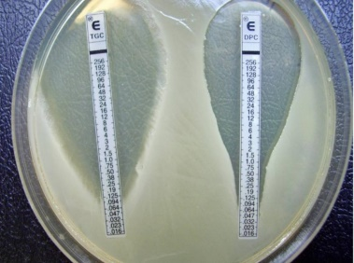
Select one:
a Called E-test
b. Is a substitution for MIC
C. Plastic strips with a gradient of one antibiotic
d. Storage at room temperature
e. Short shelf life expensive.
**51)The following life stage is belonging to which trematodes?
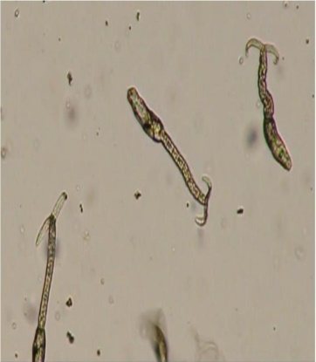
Select one:
a Fasciola spp.
b Heterophyes heterophyes.
C. Dendriticum Dicrocellum
d. Schistosoma spp.
e. Paragonimus westermani
52) Adhesive tape is used for the diagnosis of?
Select one:
a. Ancylostoma duodenale.
b. Trichuris trichiura.
C. Entrobius vermicularis.
d. Ascaris lumbricoides.
e. Capilaria philippinensis.
53) Seeing multinucleated giant cells in a cell culture can be used to make a presumptive diagnosis of infection by which one of the following viruses?
Select one
a. Adenovirus
b. Herpes simplex virus
C. Human papilloma virus
d. Parvovirus B19
e. Rubella virus
54) Each of the following statements concerning Diphyllobothrium latum is correct EXCEPT?
Select one
a. It is transmitted by undercooked fish.
b. It has operculated eggs.
c. it causes a megaloblastic anemia due to vitamin B12 deficiency
d. Its Gravid uterus forms a rosette
e. It is a tapeworm Nat has a scoleX with four sukers and a circle of hooks
55) Which of the following tapeworm is very short and called a dwarf tapeworm?
Select one:
a. Diphyllobothrium latum.
b. Echinococcus granulosus.
C. Taenia saginata.
d. Hymenolepis nana.
e. Taenia solium.
**56) This test is....... and the pH indicator is......?
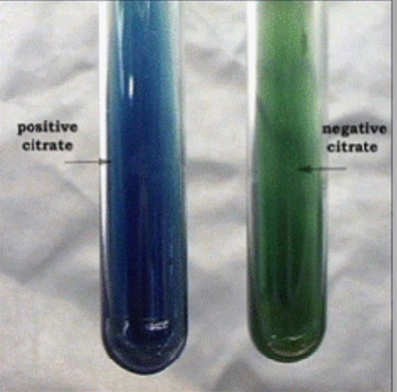
Select one:
a Citrate utilization test malachite green
b. Urease test, malachite green
C. Phenylalanine deaminase test bromothymol blue
d. Citrate utilization test bromothymol blue
e Indole test, Kovac's reagent
57) Entamoeba coli, one is WRONG?
Select one:
a. Usually discovered incidentally
b. its cyst may have more nuclei compared to E. histolytica.
C. Its trophozoites may appear with engulphed bacteria.
d. its trophozoite has a granular endoplasm
e. Has a spherical cyst with 1-8 nuclei.
58) The exchange of homologous segments of RNA between two different influenza type A virus is called?
Select one:
a. Complementation.
b. Genetic reassortment.
c. Phenotypic masking
d. Phenotypic mixing.
e. Recombination
59) The main immune response against Protozoa is mediated by?
Select one
a. TH1 cells.
b. Antibody production
c. TH17 cells
d. TH2 cells
e. Eosinophis
60) Man acting as a host for Toxocara canis is considered as?
Select one:
a. Definitive host.
b. Reservoir host.
C. Accidental host.
d. Intermediate host
e. Only in immunocompromised host.
/61) Which of the following most accurately describes a latent infection caused by a virus?
Select one
a. The virus replicates in the host cell that is usually killed by the release of the progeny viruses
b. The virus genome has integrated into the host cell transforming a into tumour cells
c. The vital genome is inside the cell but the genome is not repacating or the vitus is not going harm to me
d. The virus tepucates in the host cell and slowly releases virus progeny with very few of the infected cells
e. The virus infects the host cells produces a virus progeny tough the budding process
62) In the laboratory practical for hand washing, which was true?
Select one:
a. Hand washing with soap and water was the best in reducing bacteria.
b. Alcohol rub was the best in reducing bacteria
c. No alcohol and no hand washing was the best in reducing bacteria.
d. Alcohol rub and hand washing with soap and water had the same effect
e. Alcohol rub has same effect as not washing the hands or rubbing it with alcohol
63) What are the most common laboratory culture medium for fungal growth?
Select one:
a Sabouraud dextrose agar
b. Mannitol salt agar
C. Thayer Martin medium
d. Cornmeal agar
e XLD agar
64) Penicillin are bactericidal and act on?
Select one:
a. Cell wall
b. DNA
C. 30s ribosome.
d. 50s ribosome
e. messenger RNA
65) Which one of the following sequences is appropriate for testing a patient for antibody against the AIDS virus with the ELISA procedure as the assay is camied out in a plastic plate with an incubation and a wash step after each addition except the final one?
Select one
a. Patient's serum/enzyme substrate/HIV antigen/enzyme-labeled antibody against HIV
b Enzyme-labeled antibody against human gamma globulin patient's serum HIV antigen/enzyme substrate
c. HIV antigen patient's serum/enzyme labeled antibody against human gamma globulin enzyme substrate
d. Enzyme-labeled antibody against HIV/HIV antgenipabent's serum enzyme substrate
e. Enzyme substrate Patient's serum HIV antigervenzyme-labeled antibody against HIV
** 66) This mode of infection is related to?
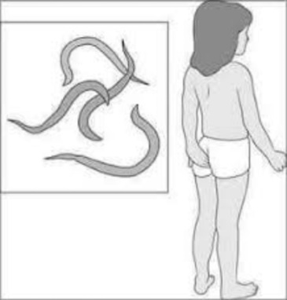
Select one:
a Ascaris lumbricoides.
b. Ancylostoma duodenale.
C. Necator americanus.
d. Enterobius vermiculars.
e. Trichuris trichiur.

67) Penicillin are bactericidal and act on?
a. Cell wall.
b. DNA
C. 30s ribosome.
d. 50s ribosome.
e messenger RNA
68) Which one of the following sequences is appropriate for testing a patient for antibody against the AIDS virus with the ELISA procedure as the assay is carried out in a plastic plate with an incubation and a wash step after each addition except the final one?
a. Patient's serum/enzyme substrate/HIV antigen/enzyme-labeled antibody against HIV
b. Enzyme-labeled antibody against human gamma globulin patient's serum HIV antigervenzyme substrate
C. HIV antigen patient's serumenzyme-labeled antibody against human gamma globulin enzyme substrate
d. Enzyme-labeled antibody against HIV/HIV antigen/patient serum enzyme substrate
e. Enzyme substrate Patient's seruit HIV antigen/enzyme-labeled antibody against HIV.

69) plate showing hemolytic colonies, the arrow pointed at?
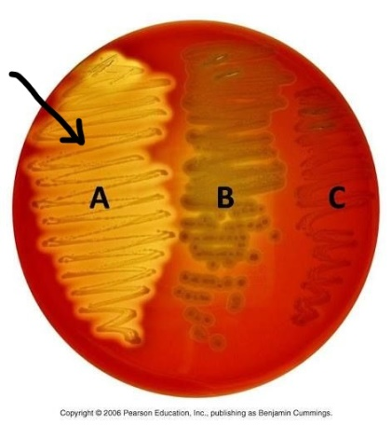
a. Alpha hemolytic growth in which complete hemolysis occurs
b. Beta hemolytic growth in which hemoglobin converted into methemoglobin
C. Samma hemolytic growth in which there is no change in the medium
d. Alpha hemolytic growth in which hemoglobin converted into meihemoglobin
e. Beta hemolytic growth in which complet hemolysis occurs

70) Immature larval form of the parasite occurs in the
a. Definitive host
b. Reservoir host
C. Accidental host
d. Intermediate host
e. Only in immunocompromised host

71) A parasite that passes through the human intestine without causing any disease and is detected in the stool is called
a. Facultative
b. Opportunistic
C. Obligatory
d. Spurious
e. Ectoparasite

72) A common place of amoebic flask shaped ulcer is?
a Duodenum
b Jejunum
C. slum
D. Vacuum
E. Pylorus

73) Negri bodies are ............. and associated with..........
a. Intra-nuclear basophilic inclusion bodies Cytomegalovirus infections.
b. Intra-cytoplasmic basophilic inclusion bodies. Herpes simplex virus infections
C. Intra-cytoplasmic eosinophilic inclusion bodies, Rabies virus infections
d. Intra-nuclear eosinophilic inclusion bodies. Cytomegalovirus infections
e Intra-cytoplasmic basophilic inclusion bodies Rabies mus infections

74) Which of the followings act by inhibition of folate synthess?
a Erythromycin
b Co-Trimoxazole
C Ritampin
a Cephalosporins
E. Polymyxin

75) Cleavage of antibody is an example of escape of?
a. Schistosoma.
b. Plasmodium.
C. Malaria.
d. Trypanosome.
e Ascaris

76) Influenza virus infection is?
a Inapparent infection
b. Acute infection
C. Persistent infection.
d. Latent infection
e. Slow infection.

77) Your patient is a 15-year-old girl with a 2-week history of headache and vomiting and a 3-day history of confusion and difficult speech MRI of the brain reveals multiple lesions bilaterally. The following day, she has a seizure and dies. On autopsy, the brain lesions consist of a cyst-like sac containing a larva. Of the following, which one is the most likely cause?
a. Diphyllobothrium latum.
b Echinococcus granulosus
C Taenia saginata.
d. Taenia solium
e EchinocoCcus multilocularis

78) This figure represents............. ?
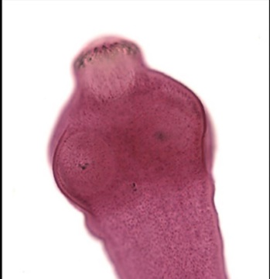
a Taenia solium Scolex.
b. Taenia saginata Scolex
c Scolex of Echinococcus granulosus.
d. Diphyllobothrium latum Scolex
e Mature proglottid of Dipylidium canine

79) following structure of Fasciola which indicated by arrow A?
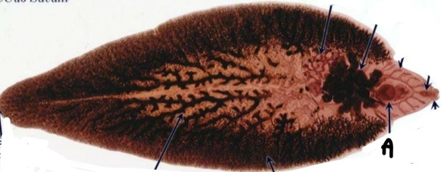
a. Testes
b Orai sucker
C. entral sucker
d Branched ovaries
E. uterus

80) Virus will contain?
a Cell membrane
b. Cell wall
C DNA
d DNA or RNA
e Ribosome

81) A........ is the larval stage of a fluke that is covered with cilia and swims about seeking out a snail to serve an intermediate host
a. Coracidium
b. Miracidium
C. Cercaria.
d. Metacercaria
e Redia

82) Characteristics of a bacterial capsule include?
a All bacteria have one
b. It is composed of peptidoglycan
C. It is an important mechanism for protecting a bacterium against ingestion by PMNs
d. It is what causes the gram stain reaction
e Food storage

83) Which of the following nematodes is an intestinal with a tissue stage?
a. Necator americanus
b. Loa loa
C. Onchiocesca volvulus
dracunculus medirensis
E. Enterobius vermiculars

84) This image is related to?
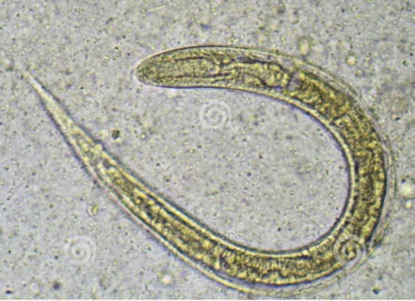
a Strongyloides stercoralis
b Loa loa
C Onchiocesca volvulus
dracunculus medirensis
Necator amencanus

85) The following EGG is belonging to which trematodes?
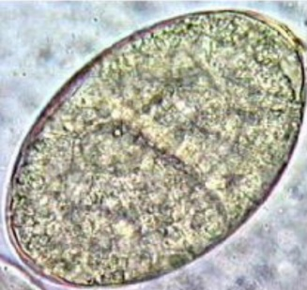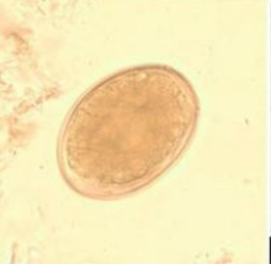
a Fasciola spp.
b Heterophives heterophyes.
c Dendriticum Dicrocelium
d. Schistosoma sp
E. Paragonimus westermani

86) This sneeze can transmit all of the followings except?
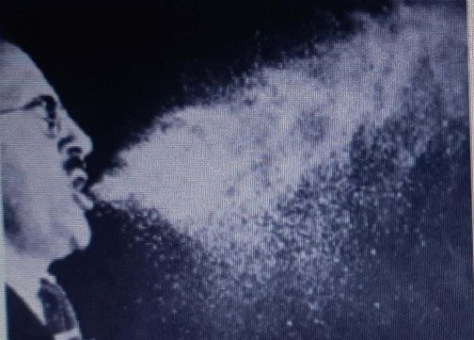
a Diphtheria
b. Pertussis.
C. Meningococcal meningitis
d. Hepatitis C
e. Coronavirus,

87) Which of the following is INCORREC regarding the sputum examination?
a. Sputum sample is added to an equal volume of HCL to dissolve the mucus
b. The sputum sample is centrifuged at 200xg for 5 minutes
C. Entamoeba histolytica can cause pathology in the lungs
d. The specimen can be preserved in 10% formalin
e Sputum sample is added to an equal volume of NaOH to dissolve the mucus

88) Water plant is the intermediate host for the?
a Schistosoma manson
b. Schistosoma japonicum
C. Clonorchis sinensis
d. Paragonimus westermani.
e Fasciolopsis buski

89) Pinocytosis is involved in which step of viral replication?
a. Attachment
b. Uncoating.
C. Penetration.
d. Nucleic acid and protein synthesis.
e. Release

90) Which of the followings is INCORRECT regarding this egg?
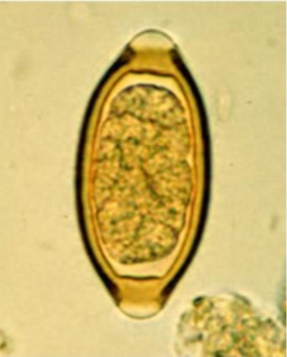
a. The egg of Trichuris trichiura
b. The posterior end of the adult female is straight and bunt
C. Posterior end of the adult male is curved and provided with 2 spicules
d. The egg is only found in the intestine
e. The egg is bile stained

91) The 9th step in hand washing is?
a. Rub each wrist with opposite hand
b. Rub hands palm to palm
C. Rub palm to palm with fingers interlaced
d. Rub tips of fingers in opposite palm in a circular motion
e. Use elbow to turn off tap

92) Nematodes have the following characteristics EXCEPT?
a. The Microfilariae of W bancroft can be isolated at night from lymphatic vess
b. It requires two hosts to complete its life cycle
C. Causes lymphatic filariasis and elephantiasis
d. human is the definitive host
e. Found usually in lymphatic of the upper limb

93) Regarding Echinococcus granulosus, which one of the following is most accurate?
a. The drug of choice for E granulosus infection is metronidazole
b. Dogs are a required part of the life cycle of the causative organism
C. Echinococcus granulosus is one of the longest tapeworms
d. Echinococcus granulosus larvae typically migrate to skeletal muscle where they cause an abscess
e. The main mode of transmission to humans is ingestion of eggs in food or water contaminated with hu

94) Which of the following combinations is INCORRECT?
a Trichuris trichiura Whipworm
b Eggs in the folds of the perianal region Pin Worm
C Barrel-shaped with mucus plug at each pole. The pinworm egg
E vermicularis Autoinfecáon
e Necatoramedcanus the infective stade Is he from arva

95) Cary-Blair medium is a(n)?
a Enriched medium
b. Differential medium
c. Selective medium
d. Inhibitory medium
e. Transport medium

96) The treatment of choice for asymptomatic E. histolytica is ?
a.Amoxicillin
b. Promomycin
c. Ceftriaxone
d Metronidazole
E. Coamoxiclav

97) Regarding Echinococcus granulosus, which one of the following is most accurate?
a. The drug of choice for E granulosus mtection is metronidazole
b. Dogs are a required part of the life cycle of the causative organism
C. Echinococcus granulosus is one of the longest tapeworms
d. Echinococcus granulosus larvae typically migrate to skeletal muscle where they caune an abscess
e The rain mode of transmission to humans is itigestion of eggs in food or water contaminated with human feces

98) Which of the following combinations is INCORRECT
a Trichuris trichiura whaledent
B. Eggs in the folds of The perianal region bin worm
C. Barrel shaped with much plug at each pole. The pin worm egg
D. E. Vermicularis autoinfecion
E.necator americanus the infected stage is the fiterform larva

99) What is this growth that the arrow pointed at?
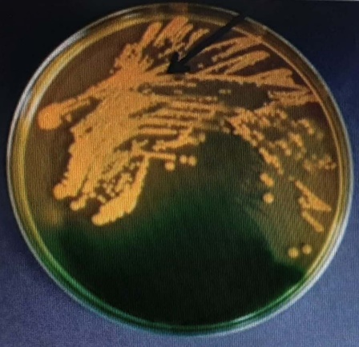
a E coli on MacConkey agar
b Vibrio parahaemolyticus on TCBS agar
C Salmonella on SS agar
D. Vibrio cholera on TBS agar
E. strentococcus pneumonia on Chocolate agar

100) Which of the following lead to anaphylactic shock?
a Leaking Hydatid cyst
b. Migrating larvae of ascarig
C. Cross reaction with malaria antigens
d Deposition of immune complexes
e. Cell mediated immunity against schistosoma eggs

101) Name this method?
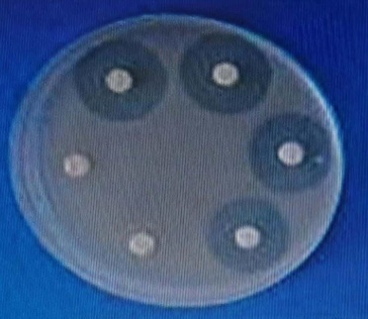
a Agar dilution method
b Kirby-Bauer method
c. Epsilometer test (E-test)
d. MIC
e MBC

102) The intermediate host for the Schistosoma japonicum is?
a. Sheep
b. Snail
C. Tapeworm.
d Ascaris
e Heterophyes heterophyes

103) in diagnosis of parasitic infections, which of the followings is least commonly requested
a History
B. Stool microscopic examination
C. Macroscopic examination ct the targeted sample
d. Serology
e. PCR

104) Entamoeba histolytica, one is wrong?
a Rhizopoda.
Endoparasite. b
C Unicellular
d. Has pseudopodia
e Cause infestation

105) When rod shaped bacteria appears in pairs, it is known as?!
a. Diplobacill
b Streptobaciti
C Diplococcus
d. Staphylococci
e. Staphobain

106) An organism capable of growth at full oxygen tension of 21% is?
a. Oxygenic
b. Microaerophilic
c. Aerobic
d. Anaerobic.
e Capnophilic

107) Regarding viruses that play a role in human carcinogenesis, which one of the following statements is the most accurate?
a. Epstein-Barr virus is implicated as the cause of nasopharyngeal Carcinoma. It is transmitted by mosquitoes
b. Evidence for hepatitis C virus as a cause of hepatocellular carcinoma and a DNA copy of the HCV genome found integrate into the DNA of hepatocytes
C. Hepatitis B virus is implicated as the cause of hepatocellular carcinoma and a DNA copy of the HBV genome found integrated into the DNA of hepatocytes
d. The viral oncogenes contain introns.
e Human Papillomavirus type 6 and 11 is associated with cervical cancer

108) The ethanol concentration that you used in the hand washing experiment was?
a 76%
b. 80%
c. 53%
d. 99%
e. 100%.

109) Regarding HTLV-1. all the following is false Except
a. It is associated with Hepatocellular carcinoma
B. It is a DNA tumor virus
C. is associated with Leukemia
D. lt carries latent membrane protein 1 oncogene
e. It synthesises early protein that interact with p53

110) Who was one of the first people to suspect bacteria as the cause of infection and use an antiseptic to prevent infection
a Lister
b. van Leeuwenhoek
C. Pasteur
D. Koch
e. Schleiden

111) All the following DNA viruses replicate in the nucleus EXCEL
Herpesvirus
Parvovirus
Pox viruses
Hepadnaviruses
Adenoviruses

112) An example for semi-continuous cell culture is?
a Hela cells
b Hep2 cells
c. Primary monkey kidney
d. Human diploid fibroblasts
e Vero cells

113) Which of the followings is INCORRECT regarding tissue and blood nematodes?
a. Microfilariae are ingested by arthropod vectors when feeding an interessos
B. Infective larvae is ready for transmission in 2-3 weeks
C. Larvae penetrale human skin pass to their habitat where they mature in almost 2 years ) and male
d. Blood and tissue nematodes need arthropod vector
C. No multiplication of larvae occur in the vector

114) Which of the followings is INCORRECT?
a. Brucellosis is due the ingestion of contaminated milk or cheese
b. The clinical manifestations of Brucellosis range from subclinical to acute with fever and chills
C. Humans acquire Legionella pneumophila by ingesting contaminated food
d. Chlamydia grow and multiply intracellularly.
e Rickettsias is transmitted via arthropod vectors

115) Cell walls of Viruses are made of a polymer called?
a Cellulose
B. Chitin
C. Peptidoglycan
D. The s layer
e. Viruses do not have cell walls

116) How would you describe an organism that grows aerobically with only 4% O2?
a Strict (Obligate) Aerobes
b. Microaerophilic.
C. Aerotolerant anaerobe.
d. Facultative anaerobe
e Capnophilic organism.

117) Which of the followings is INCORRECT?
a. Neisseria can hide in the immune cells
b. Neisseria can change their surface proteins
C. Special requirements for the growth of Haemophilus
d Treponema under light microscope shows tightly coiled shape
e Trachoma occur particularly in children

118) Which of the followings causes diarrhea due to antibiotic treatment?
a. C difficile.
b. H pylori
C. S. aureus
d C perfringens.
e Chlamydia
119) Preventing amino acid translocation at P site of the bacterial 50s ribosomal subunit is achieved by?
a. Erythromycin.
b. Clindamycin
C. Tetracycline.
d Chloramphenicol
e Gentamycin

120) A patient diagnosed of having cholera, which of the following bacteriophage is the source of the cholera toxin
a T12
b. CTX
C. d Lambda phage
Corynephage beta.
e Clostridial phages

121) In which phase of bacterial growth curve are the maximum of growth?
a Lag.
b Exponential
C. Stationary
d Death
e Eclipse
122) patient with measles, isolated in a single room, the following personal protective equipments are needed for infection prever A except?
a. Gown.
b. Surgical mask.
C. Hand hygiene
d. Gloves
e. Goggles

123) How would you describe an organism that grows aerobically with only 4% 02?
a Strict (Obligate) Aerobes
B.Microaerophilic.
Aerotolerant anaerobe
d Facultative anaerobe
E. Capnophilic organism

124) Which of the followings is INCORRECT?
a. Neisseria can hide in the immune cells.
b. Neisseria can change their surface proteins,
C. Special requirements for the growth of Haemophilus
d. Treponema under light microscope shows tightly coiled shape.
e. Trachoma occur particularly in children

125) Which statement regarding fungal growth and morphology is CORRECT?
a Pseudohyphae are produced by all yeasts
b. Molds produce hyphae that may or may not be partitioned with cross-walls or septa
c Conidia are produced by sexual reproduction
d Most yeasts reproduce by budding and lack cell walls
e. Most pathogenic dimorphic molds produce hyphae in the host and yeasts at 30*C.

126) Which of the following is a polyene antifungal agerit used for many life-threatening fungal infect
a Amphotericin B
Griseofulvin D
C Caspotungin
a Miconazole
e Nystatin

127) Which of the followings is INCORRECT?
a. Brucellosis is due the ingestion of contaminated milk or cheese
b. The pinical manifestations of Brucellosis range from subclinical to acute with fever and
C Humans acquire Legionella pneumophila by ingesting contaminated food
d. Chlamydia grow and multiply intracellular
e. Rickettsias is transmitted via arthropod vectors

128) The order of removing the personal protective equipment (PPE) is?
a. Gloves, gown, mask.
b. Mask, gloves, goen.
c. Mask gown, gloves.
d. Gloves, mask, gown.
e. Gown mask, gloves.

129) A 3 years child was seen by the pediatrician On examination, he suspected in meningitis. The CSF Gram staining showed a Gram negative diplococci bean shaped, Which of the followings you expect the causative agent?
a. Neisseria meningitides.
b. Haemophilus influenzae.
c. Bordetella pertussis
d. E coli.
e. Brucella

130) Microorganisms belonging to the same..... would be expected to have the most characteristics in comMON WIth each othe
a Family
B. Species
C. Order
d. Kingdom
e. Genus

131) A facultative anaerobic is?
a. Only grow anaerobically
b. Only grow in the presence of 02.
c. Ordinarily anaerobe but can grow with CO2
d Ordinarily anaerobe but can grow in presence or absence of 02.
e Only grow aerobically

132) Which of the following criteria is used to categorize viruses in Baltimore viral classification scheme"?
a. The kind of the natural host
b. The shape of the virus' capsid
C. The size of the virus particle.
d. The steps involved in the formation of viral mRNA after the virus has infected the cell
One The presence or absence of an envelope

133) Organism A has GC-content of 80% and organism B has GC-content of 20% Which of the following can be concluded with these data?
a The two organisms are related
b. The two organisms are unrelated
c. The organisms are Gram positive
d. Their nucleic acids will be hybridized.
e. Nothing can be concluded from GC content information

134) Sterilisation is best described as?
A. Killing all forms of microbial life, including bacterial spores
B. Using 70% alcohol or iodine to reduce the pathogenic organism on skin so they no longer cause
C. Subjecting living healthy tissue to ethylene oxide to kill spores
D. Killing viruses on living tissue by temperature
E. Using sodium hydrochloride to disinfect skin

135) All of the following are characteristic of bacterial spore except?
a Usually dehydrated.
b High resistant for heating
C. Dormant, tough, and temporarily non-reproductive structure
d. They consists of the bacterium's DNA and part of its cytoplasm surrounded by a very tough outer coating
e. Can I live in nutrent deficient environment

136) Which of the following is INCORRECT?
a. Pertussis progress through more than one stage
B. Pseudomonas causes secondary intections
c. Spirochetes move by corkscrew movement
D. Gamma hemolytic shows a clear zone around the bacteal growth
E. Chlamydia can't be grown on blood culture

137) Regarding the eclipse period, one is TRUE?
a Virus is infectious during eclipse period
b. It is the time from uptake of the virus to just before the assembly of the first intracellular Virus
c. Has a universal fixed time period among all viruses
d. Complete virus particle can be detected using electron microscope
e Virus grow in size during eclipse period.

138) Which statement(s) is/are not true of the organisms in the domain Prokaryotes?
a These organisms contain nucleus-bounded membrane
b. These organisms may contain peptidoglycan in the cell walls
C. These organisms have DNA and RNA polymerases
D. These organisins contain one single chromosome
e. These orgasms may transfer DNA y conjugation method

139) The concept of spontaneous generation is that life could arise from?
a. Bacteria
b. Viruses
C. Yeast
d. Fungi
e Non living things,

140) Which one of the following is TRUE concerning viral capsids?
a. Viruses acquire host proteins as their capsids
b. Capsids are virus-specific proteins, which provide shape to viruses.
C. Capsid protein subunits form a helix with core proteins to mainly provide cubic symmetry
d. Helical nucleocapsids are found with single-stranded DNA viruses.
e Capsids are lipid bilayer membranes containing proteins and/or glycoproteins

141)A definite sample of Gram positive bacilli was stained but the staining gave a Gram negative bacilli, where do you think the mistake mostly happened
a Fixation b Safranin
c. Mordant treatment
d. Acid alcohol e Crystal violet
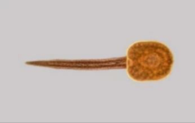
142)Define the following structure of Fasciola?
- Testes
- Eggs.
- Cercaria
- Metacercaria e Miracidium
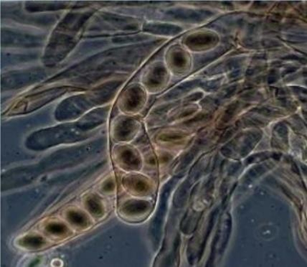
143)This figure represents?
- Arthrospores
- Zygospores
C. Basidiospores
d. Ascospores
e. Sporangiospores
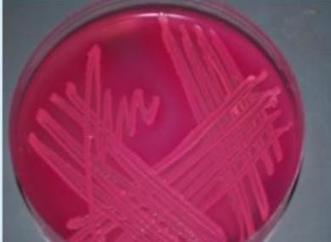
144)This MacConkey agar plate shows pink colonies of the indicator is ?
a E. coli, methyl red:
b E coli, neutral red.
c. Proteus, neutral red.
d. Klebsiella, methyl red.
e Enterobacter, phenol red.

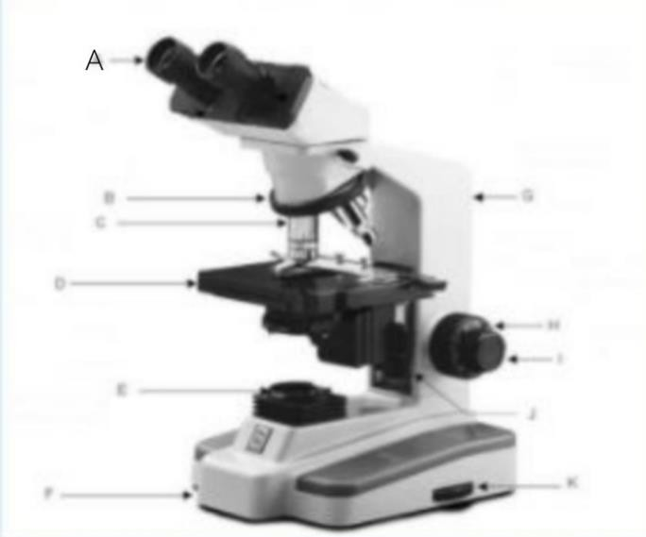
145)What is the part A in the microscope is called?
- clips.
- ocular lens.
C. stage.
d. adjustment.
e objective lenses
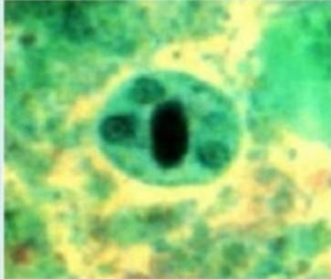
146)This quadrinucleate cyst (4 nuclei) was seen in stool sample from asymptomatic patient (patient with no symptoms, this is a cyst of?
a Entamoeba histolytica
- Entamoeba coli
- Toxoplasma gondii
- Balantidium coli e Giardia lamblia

147)This figure demonstrates pigments of?
- Pseudomonas aeroginosa,
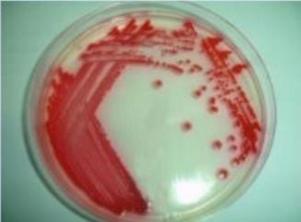
- E. coli.
- Serratia marcescens.
- S. aureus
- Salmonella typhi.

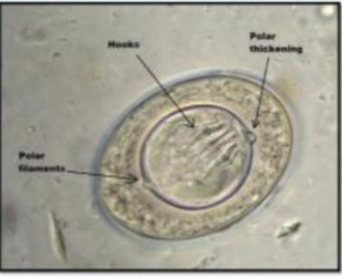
148)This figure represents?
- Egg of Diphyllobothrium latum
- Egg of T. saginata.
- T. solium Egg
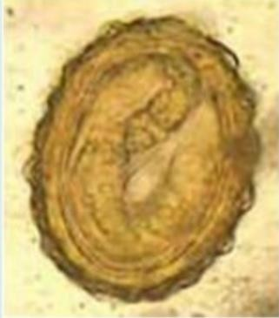
- Hymenolepis nana ova.
149)This egg belongs to?
- Loa loa
- Ascaris lumbricoides,
- Enterobius vermiculars.
- Dracunculus medinensis
- Necator americanus.

e Echinococcus granulosus egg
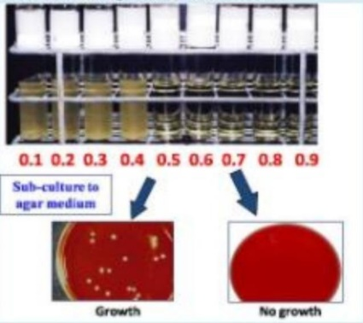
150)In the following test, the MIC is?
- 0.4 ug/ml.
- 0.6 pg/ml.
- 0.5 ug/ml.
- 0.7 pg/ml.
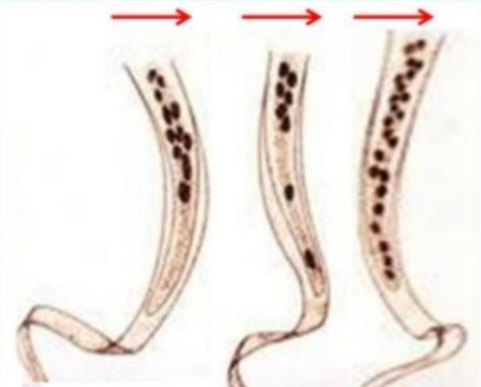
- 0.8 pg/ml.
151)Choose the correct arrangement form left to right?
- Wuchereria bancrofti, Brugia malayi, Loa loa.
- Loa loa, Wuchereria bancrofti, Brugia malayi.
- Loa loa, Enterobius vermiculars, Brugia malayi.
- Wuchereria bancrofti, Loa loa, Brugia malayi
- Ancylostoma duodenale, Loa loa, Brugia malayi.

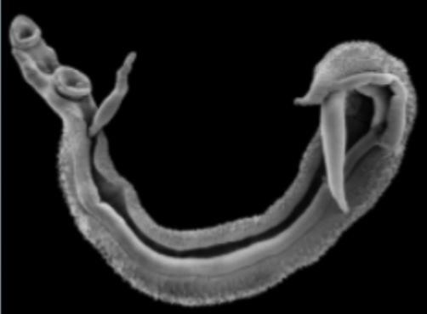

152)This couple is belonging to?
- Fasciola spp.
- Heterophyes heterophyes.
- Dendriticum Dicrocelium.
- Schistosoma spp.
- Paragonimus westermani.

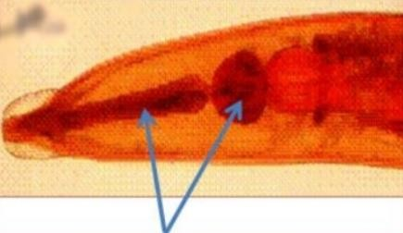
153)Arrows point to?
a Cellular oesophagus.
- Double bulbed oesophagus.
- Club shaped oesophagus
- Cylindrical oesophus
e Rhabditiform oesophagus

154)This action was wrong and it could transmit all of the following except
  - Hepatitis B
  - Hepatitis C.
  - HIV-1.
  - HIV-2
e Vibrio cholera.

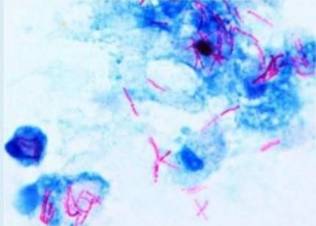
155)Which of the followings is correct regarding this sputum sample stained by acid fast staining?
a Carbolfuchsin: counter staining
- Crystal violet primary staining
- Methylene blue primary staining
d.Carbofuchsin Red color
e Acid alcohol: 30 drops.
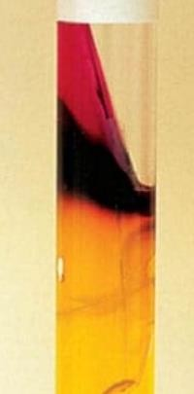
156)This is blackening in the media indicate?
  - Triple sugar iron agar, gas production
  - TCBS agar, H2S production.
  - Salmonella -Shigella agar, gas production.
  - Mannitol salt agar, sugar fermentation,
  - Triple sugar iron agar H2S production

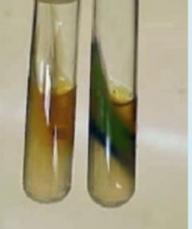
157)This test is?
a. Phenylalanine hydroxylase test.
- Lysine Decarboxylase Test
- Phenylalanine deaminase test.
- Arginine decarboxylase test e Citrate utilization test.

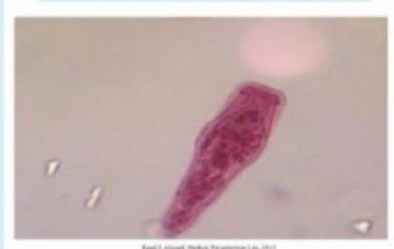
158)The following life stage is belonging to which trematodes?
a Fasciola hepatica
b. Heterophyes heterophyes c Dendriticum Dicrocelium
d. Schistosoma spp
e Paragonimus westermani
159)The main immune respons against Helminths is mediated by?
Select on :
a. TH1 cells
b. Antibody production
C. TH17 cells
d. TH2 cells
e. Macrophages

160)All trematodes are hermaphrodite except ?
Select one :
a. Fasciola spp
b. Heterophyes heterophyes
c. Dendriticum Dicrocelium
d. Schistosoma spp
One Paragonimus westermani.e

161)The medium that contains antibiotics is called a(n)?
Select one :
A. Enriched medium
b. Differential medium
C. Selective medium
d. Inhibitory medium
e. Basal medium

162)A granuloma is a complication of over-reaction against?
Select one :
A schistosoma eggs
b. Leaking Hydatid cyst
C. Migrating larvae of ascaris
d. Cross reaction with malaria antigens
e. Deposition of immune complexes

163) Which of the following drugs inhibits ergosterol synthesis, is important in treating systemic fungal infection?
Select one :
a. Amphotericin
b. Fluconazole
C. Griseofulvin
d. Echinocand
164)Which of the followings is mismatched?
Select one :
a. Skin penetration: Strongyloides Rhabditiform larvae
B. Larvae encyst in skeletal muscles Trichenill
c. Ingestion of infective larvae Trichenella
d. maturate i Trichuris n the intestine without migratory phase Enterobius
Eggs :Enterobius
e. Ingestion of embryonated

165) Antigen mimicry is an example of escape of?
Select one :
a. Schistosoma
b. Plasmodium
C. Malaria
d. Trypanosome
e. Ascaris
166)Entamoeba histolytica, one is wrong **
Select one :
A. Cyst is a diagnostic stage
b. Trophozoite has 1 nucleus
c. Cyst has 4-8 nuclei
d. Man is a definitive host
e. Pseudopodia are only seen in trophozoites not in cysts

167) Which is the oncoproteins of HHV-8 that impairs P53 and RB proteins?
Select one :
a. EBNA3C
b. HBx oncoprotein
C. Latency-associated nuclear antigen
d. Latent membrane protein 1

168)Which of the followings is CORRECT regarding the diagnosis of parasitic infection?
Select one :
a. The concentration methods is used if parasitic infection is heavy
b. The low specific gravity solutions are used in the floatation technique
C. The formol ether is used to harvest eggs from the surface of the fluid
d. Zinc sulphate is used for sedimentation
e. Eggs on surface when used saturated sodium chloride
169)A patient whose major source of protein is smoked and cooked fish develops what appears to be pernicious anemia What parasite is noted for causing a look-alike vitamin B12 anemia in certain infected individuals?
Select one :
a. Echinococcus granulosu
b. Diphyllobothrium latum
C. Hymenolepis nana
d. Dipylidum caninum
e. Taenia solium

170) Which of the followings is mismatched?
Select one :
A. Skin penetration: Strongyloides Rhabditiform larvae
b. Larvae encyst in skeletal muscles Trichenilla
c. Ingestion of infective larvae. Trichenella
d. maturate in the intestine without migratory phase Enterobius
E. Ingestion of emryonated eggs: Enterobius and Trichuris and Ascaris

171)Which of the followings is mismatched?
Select one :
a Skin penetration: Strongyloides Rhabditiform larvae.
b. Larvae encyst in skeletal muscles Trichenilla
C. Ingestion of emryonated eggs : Enterobius and Trichuris and Ascaris.
d. maturate in the intestine without migratory phase Enterobius

172)All are correct regarding Mycobacterium EXCEPT?
Select one :
a. Gram-negative irregular bacill
b. Acid-fast staining due to the presence of mycolic acids
c. Strict aerobes
d. Grow slowly in the lab
e. Virulence factors that prevent destruction by lysosomes or macrophages

173)The slow virus disease that MOST Clearly has immunosuppression as an important factor in its pathogenesis is?
Select one :
a. Subacute sclerosing panencephalitis
D. Creutzfeldt-Jakob disease
C. Kuru
d. Progressive multifocal leukoencephalopathy
e. Scrapie

174)Immune suppression is an example of escape?
Select one :
a. Schistosoma
b. Plasmodium
c M. ularia
D. Leishmania
e. Ascaris

175)All are correct EXCEPT? **
Select on :
Tissue nematodes as oviparous a.

176)Proof that a microorganism could cause a disease was provided by?
Select one :
Pasteur a.
b. Lister
C. Koch
d. Wasserman
e. Redi

177)Interaction between two viruses infecting the same cell at the functional level but not at the genom?
Select one :
- Complementatio
b. Genetic reassortment
C. Phenotypic masking
d. Phenotypic mixing
e. Recombination

178)Regarding Taenia solium, which one of the following is most accurate?
Select one :
a. The drug of choice for the adult worm in humans is metronidazole
b. The cysticercus of T. solium contains the mature eggs of the organism
c. In the laboratory, identification of adult worms is based on finding the typical
d. Ingestion of the terminal proglottids of T. solium by pigs results in mature tap
e. The scolex of T. solium has four suckers and a circle of hooklets

179)Chemical reaction that makes small particles to be more complex component?
Select one :
b. Oxidized
d. Anabolism

180)Wuchereria bancrofti infection occurs through?
Select one :
a. Blood transfusion
b. Autoinfection.
c. Ingestion of cyclop
d. Penetration of the skin by filariform larva through insect bite
e. Ingestion of undercooked meat

181)Viruses that grow at permissive temperature but not at restrictive temperature are called?
Select one :
Attenuated mutants a.
Conditional lethal mutants b.
Antigenic variamts c.
Defective interfering particles d.
Drug resistant mutants e.

182)Reproduction via binary fission leads to what type of growth under optimal conditions?
Select one :
a. linear
b. mixed
C. exponential
d. uptake-limited
e. iintermittent
183) of the following statements best describes the cytopathic effects of viruses on host cells?
Select one :
Usually morophology in nature a.
Often associated with changes in mitochondrial membranes b
C. Pathognomonic for an infecting virus
d. Rarely fatal to the host ccel
E. Can only be seen with an electron microscope
184)All of the followings characterize E. histolytica vegetative form except
Select one :
a. Pseudopodia
b. Ingested RBCS
c. One nucleus
d. Nucleoplasmm
e. Pangranular cytoplasm

185)Autoinfection occurs in infection with?
Diphyllobothrium latum a.
Echinococcus granulosus. b
Taenia solium c.
Hymenolepis nana d.

186)Halophiles can tolerate? **
Select one:
Temperatures above 100 C a.
A vitamin – depleted medium b.
c. 5%-10% NNac
D. pH & It ;5.5
e. tolerate high nitrogen environment

187)The arrangement of steps of viral replication is as follows?
Select one :
a Attachment, Uncoating, Penetration Nucleic acid and protein synthesis, Assembly and Release
B. Attachment, Penetration, Uncoating, Nucleic acid and protein synthesis. Assembly and Release.
C. Attachment, Penetration, Nucleic acid and protein synthesis, Uncoating, Assembly and Release
d. Attachment, Penetration, Uncoating, Nucleic acid and protein synthesis, Release and Assembly
e. Attachment, Penetration, Uncoating. Assembly. Nucleic acid and protein synthesis and Release

188)The 5th step in hand washing is?

Select one :
a. Rub hands palm to palm
b. Rub pater to palm with fingers interfaced
c Rub tips of fingers in opposite palim in a circular motion
d. Use elbow to turn off tap
e. Rub each wrist with opposite hand

189)Ribavirin is? **
MRNA inhibitor a.
B. . Protease inhibitor
c. Neuraminidase inhibitor
- Inhibitor of nucleic acid synthesi
190)Which of the followings is an example on transmission by fecal oral route?
Select one :
a. Tuberculosis
b. Pertussis (whoopoing cough)
Hepatitis A . c
d. Hepatitis C.
e. Hepatitis B
191)Which of the followings is INCORRECT regarding nematodes?
Select one :
  - The filariform larvae have cylindrical oesophagus
  - Lumbricoides is one of the commonest and most wide spread of all human parasites.

  - The filariform larvae of the pin worm Strongyloides stercoralis is the infective stage

192)Which of the followings settles in small intestine and has a tissue stage?
Select one :
A. Strongyloides stercoralis
b. Enterobius vermiculars
c. Trichuris trichiura
d. Loa loa
193)At a party, a student consumed sushi which contained fish from Canada. Ifa parasite becomes established from this raw fish consumption, which of the following is the most likely?
Select one :
A. The fish contain a procercoid larva
d. These students will act as intermediate host
c. Oocysts is formed
• d. The fish contain a plerocercoid larva

194)Which of the followings is INCORRECT ?
Select one :
a. Pertussis progress through three stages of disease
b. Pseudomonads cause opportunistic iinfection
C. Spirochetes move in a corkscrew fashion through its environment
d. Beta-hemolytic complete hemolysis of red blood cells
e. Chlamydia can be isolated using special agar medie
195)All are correct regarding Mycobacterium EXCEPT?
Select one :
Gram-negative irregular bbacill a.
b. Acid-fast staining due to the presence of mycolic acids
Strict aerobes c.
d. Grow slowly in the lab

196)Which of the following fungi produces poisonous substance mycotoxin called aflatoxin?
Select one :
Candida albicans a.
Mucor b.
Aspergillus flavus c.
Rhizopus d.
Amanita mashroom e.

197)The role of antibody against schistosomes is mainly to?
Select one :
Act a direct damage by complement mediated a.
ADCC do b.

198)A type of cell culture that can reproduce for an extended number of generations and is used to support viral replication is?
Select on :
Primary cell culture a.
Cell strain b.
C. Diploid fibroblast cell?
d. Connective tissue
Continuous cell line e.
199)The infective stage of Fasciola hepatica is?
Select one:
Sporocyst a.
Redia b.
Cercaria c.
Metaceraria d.
Egg E.
200)All are correct regarding diagnosis of parasitic infections EXCEPT?
Select one:
b. The most common preservative used is 1% formalin
***Which of the followings is CORRECT regarding the diagnosis of parasitic infection?
Select one :
Eggs on surface when used saturated sodium chloride.

201)Entamoeba coli, one is TRUE***
Select one :
A. Appears as gram negative role
b. Mononucleated trophozoite with large eccentric karyosome
C. Appears as gram positive rods
d. Metronidazole is the treatment of choice in symptomatic patients
e. Flask shaped ulcer confirms its diagnosis.
202)Which is the oncoproteins of HHV-8 that impairs P53 and RB proteins?
Select one :
a. EBNA3C
b. HBx oncoprotein
C. Latency – accociated nuclear antigen
d. Latent membrane protein 1
e. E6 oncoprotein

203)Which one of me tonowing is most charactenste of the changes seen in Cytomegalovirus infected celn mat are vintle in me ight meroscope ater sutabie staning?
Select one :
a. Barophile inclusion bottles in the cytoplasm
b. Basophile inclusion bodies in the nucleus
c. Eosinophilic inclusion bodies in the nucleus
d. Eosinophilic inclusion bodies in the cytoplasm
Transformation of normal cal into tancer call. E
204)Lugol's iodine is used to study the ***
Select one:
Cyst a.
Glycogen vacuole in cyst b.

205)Each of the following statements concerning hydatid cyst disease is correct EXCEPT***
Select one
a. The disease is caused by Echinococcus granulosus
b. The liver is one of the affected organs
C. The disease is caused by a parasite whose adult form. Tves in dogs intestines
d. The main mode of transmission to humans is ingestion of eggs in food or water contaminated with human feces
e. The causative organism is one of the short tapeworms
206)A filamentous fungus subunit is a? ***
Select one:
a. Coenocyte
b. Hypha
c. Mycelium
207)Which statement regarding fungal cell walls is corred
Select one :
a. The major components of fungal cell walls are proteins such as chitin and glucans
b. The cell wall is not essential for fungal viability or survival
c. Ligands associated with the cell walls of certain fungi mediate attachment to host cells

208)Regarding viral factors involved in the pathogenesis of viral diseases, all the following are true EXCEPT?
Select one :

a. Viruses could enter into the host through mucosa of the respiratory tract
b. Insect bite could transmit viral infection
Viral attachment proteins interact with cellular receptor c.
d. Viral virulence is genetically determined
E. Viral virulence increases with attenuated strains of virus

209)The moments to wash hands in the ward include?
Select one?
Before patient contact a.
Before aspetic task b.
After body fluid exposure c.
After patient contact d.
All choices e.

210)The action of the following antibacterial rely on host immunity to eradicate infections EXCEPT?
Select one :
a. Tetracyclines
b. Chloramphenicol
c. Clindamycin
d. Bacitracin

211)A parasite that causes a disease in immunosuppressed patients is termed
Select on :
A. Facultative
b. Opportunistic
212)The infective stage for the Schistosoma japonicum is?
Select one :
a. Cercania
b. Snail
C. Tapeworm
.d.Radio
213)Inhibition of chromosomat supercoiling in bacteria is the mode of action of?
Select one?
a. Ciprofloxacin
b. Rifampin
c. Vancomycin
d. Synergitic effect of penicillin and aminoglycosides
214) in the stor's technique for courting hetrinthies egg, it the number of eggs in 3 am stool was 27, the number of eggs in the original
sample will be?
A. 270
.b. 2700
c. 5400
E. 8100
215)All of the followings characterize E histolytica vegetative forms except?
Select one :
Multiply by binary fission a. .
May ne foind in descending and transverse colon b
May pass in the stool and remain for days in the enviroment to reinfect again c.

216)In the mode of transmission for Schistosoma mansoni, the penetration is in
Select one
a. Mucus
b. Intestine
c. Skin
D. Blood
C. Ear
217)Oncogenic virus could evade the host immune response through?
Select one :
a. maintaining episomal copies of viral genome in transformed cells
b. incorporating the viral genome into host cell genome
C. inducing chronicity of the infections
d.induction of tumorigenesis after latent period
E. Restriction of expression of viral genome

218)Hepatitis C virus infection is? ***
Select one
a. Inapparent infection
b. Acute infection
C. Persistent infection
. Latent infection d
E. Slow infection

219)Compared to 70% alcohol, the 99% alcohol is not recommended in disinfection because?
Select one :
It is more volatile a.
Higher risk of skin irritation b.
More flammable c.
d . it coagulates organism's proteins causing less penetration to the oorganis
All of the mentioned choices e.
220) An RNA tumor virus associated with the neurologic disease called tropical spastic paraparesis is?
Select on :
a. Hepatitis B virus infectio
b. Human papillomavirus
C. Human T-lymphotropic virud type 1
D. Humman immunodeficiency viruse

221)The bacteriophage ------ infects-----and is associated with scarlet fever?
Select one :
a. Corynephage beta, Corynebacterium diphtheria
b. Lambda phage, Escherichia coli
• C. Erythrogenic toxins, Streptococcus pyogenes
d. CTX phage Vibrio cholerae
e. Clostridial phages. Clostridium botulinum

222)The 5th step in hand washing is? ****
Select one :
A Rub hands palm to palm
b. Rub palm to palm with fingers interlaced.
C. Rub tips of fingers in opposite plam in a circular motion
D. Use elbow to turn off tap
E. Rub each wrist with opposite hand
223)Techoic acid is? **
Select one :
a. Found in the walls of Gram positive bacteria
b. Provide receptors for conjugation phages
c. Make up outer wall of Gram negative bacteria
d. Influence the permeability of the membrane
e. play role in bacterial multiplication
224)Positive result of the complement fixation reaction is expressed in?
Select one:
a.Complete hemolysis
b.Haemagglutination.
- Inhibition of Haemagglutination
- Color change after adding the substrate
- Complete inhibition of hemolysis
225)Which of the followings is INCORRECT?
Select one:
a.Coagulase negative staphylococci frequently involved in opportunistic infections.
b.S.epidermidis can be easily isolated from skin
c.Coagulase positive S. saprophyticus frequently lives on skin, intestine, and vagina
d.S. aureus can cause serious infections.
e.Catalase test is used to distinguish between Staphylococci and Streptococci

226Ribosomes are the factory of___ synthesis?
Select one:
a.Protein
b.Plasmid
c.Sugar
d.Lipid
e.DNA

227)An RNA virus that has a nuclear phase in its replication process is?
Select one:
a.Coronavirus
b.Rhabdovirus.
c.Retrovirus
d.Togavirus
e.Caliciviruses

228) On analysis of a virus, it reveals the genome to be composed of eight segments of single - stranded RNA complementary to viral mRNA in infected cells. Which one of the following statements is UNLIKELY to be correct?
Select one:
a.Diferent proteins are encoded by each segment of the viral genome.
b.The virus particle contains vital encoded enzyme that can copy the genome into its complement
c.Purified RNA extracted from the virus particle is infectious
d.The virus RNA segments can undergo reassortment
e.This virus is an orthomyxovirus

229)Bacterial flagella surrounding all the body is called?
Select one:
a.Penitrichous
b.Amphitrichous
c.Lophotrichous
d.Monotrichous
e.Ditrichous

230)Which of the followings is mismatched?
Select one:
a.E.coli: Diarrhea affects the proximal small bowel
b.S.enteritidis Dysentery affects the colon
c.V.cholera non - nfiammatory Diarrhea
d.S typhi Invasive infection affects the proximal small bowel
e.Shigella Invasive Inflammatory infection affects the colon

231)Genotypic methods of microbe identification include all the following EXCEPT?
Select one:
a.Nucleic acid sequence analysis.
b.rRNA analysis.
c.Direct whole pathogen agglutination assays.
d.Restriction fragment length polymorphism.
e. Plasmid fingerprinting.

232)Infection control measures include all of the followings EXCEPT?
Select one:
a.Bare above elbow.
b.No ties.
c.No coats.
d.Cover open wounds with occlusive adhesive.
e.Keep nails tall to help you pick small objects

234)Which of the followings has a spiral shape?
Select one:
a.Neissenia
b.Treponema
c.Chlamydia
d.E.coli
e.Yersinia

235)Killing food pathogens without damaging the nutritional value or flavor is obtained by?
Select one:
a.Autoclaving
b.UV light
c.Filtration
d.Oven
e.Pasteurization

236)Which of the followings is INCORRECT?
Select one :
a.A tube is required to transfer the whole plasmid during conjugation.
b.Scarlet fever is caused by a acquiring new genetic material
C.Muscular stiftness can be seen under inappropriate food handling
d.The anaerobic C.perfringens causes discoloration of the skin
e.Legionella pneumophila can be isolated from the air conditioning ducts

237)A patient came to the emergency department suffening from certain clinical manitestations.The doctor decided to ampuatate his leg.
Which of the following pathogens might be associated with this case ?
Select one :
a.Clostridium perfringens
b. Bordetella pertussis
C.Bacilius cereus
d.Clostridium tetani
e.Clostridium botulinum.

238)Phagovar is an intra-subspecific designation depends on?
Select one:
a.Special biochemical or physiological properties
b.Distinctive antigenic properties
C.Pathogenic properties for certain hosts
d.Ability to be lysed by certain bacterial vinuses.
e.Special morphologic features.

239)A patient suffering from a difficulty in breathing, a Gram staining form the infected area showed Gram-negative cocco-bacilli, for which of the followings an empirical therapy should be given?
Select one:
a.Proteus
b.Bordetella pertussis
C.Neisseria meningitides
d.Clostridium tetani.
e .E. coli

240)A patient with tuberculosis, isolated in a single room, the following personal protective equipments are needed for complete protection except?
Select one:
a.Gown
b.Surgical mask
C.hand hygiene.
d.Gloves
e.Goggles

241)Viropexis is?
Select one :
a.the separation of the capsid from the viral genome
b.a receptor-mediated endocytosis.
c.a process by which enveloped viruses obtain their envelope
d.the interaction of viral attachment proteins and specific host-cell receptor sites
e.regutated by host-cell DNA-dependent RNA polymerases .

242)Which of the following represents a difference between viruses and viroids?
Select one:
a.Viruses infect many types of cells, whereas viroids infect only prokaryotic cels
b.Viruses have capsids composed of protein, whereas viroids have no capsids
c.Viruses contain introns, viroids have only exons
d.Viruses always have genomes composed of RNA, whereas viroids always have genomes composed of DNA
e.Viruses cannot pass through bacterial fiters, viroids can.

243)After using a syringe to take a blood sample, one of the followinig is TRUE?
Select one:
a.Recap the needle immediately
b.Leave the syringe on the patient's bed, wait an hour then recap the needle.
C.Swap the needle with alcohol then recap the needle.
d.Never recap the needle and discard the syringe in the yellow shap pin
e.Throw the syringe in the black plastic bag .

244)Which of the followings can be isolated from food and can cause flaccid paralysis?
Select one:
a.Clostridium botulinum
b.Bordetella pertussis.
c.Bacilus anthracis
d.Neisseria meningitides
e.Haemophilus influenza

245)The order of wearing the personal protective equipment (PPE) Is?
Select one:
a.Gown, mask, gloves
b.Mask, gloves, gown
c.Gloves, gown, mask
d.Mask, gown, gloves
e.Gown, gloves, masks.

246)Which of the followings is INCORRECT?
Select one:
a.S. aureus is catalase and coagulase positive.
b.Group B streptococcus is beta hemolytic
c.The non-spore forming Bacillus cereus causes food poisoning
d.Clostridium tetani produces spores
e.Clostridium botulinum interferes with release of acetylcholine

247) Most of pathogenic bacteria can live in the following temperature rate?
Select one:
a.Mesophile
b.Pshycrophile.
c.Thermophile.
d.Capnophils.
e.Hyperthermophile.

248)Extreme halopnies are characterzed by?
Select one:
a.Requiring high leveis of carbon for growth
b.Requitng high evels of Nitrogen for growth
C.Requirng high leve of Copper tor growth d. Requiring high evels of Zinc for growth
e.Requiing high leveis of Salts tor growth.

249) Aerobic bacteria are?
Select one :
a.Only grow anaerobically
b.Only grow in the presence of Co2
c.Crainarly anaerabe but can grow with CO2.
d.Ordinarily aerobe but can grow in absence of O2 .
e.Only grow aerobicaly .

_250)Which of the following structures can pass from one bacterium another?
Select one:
a.Plasmid
b.Pilus
C.Capsule
d.Plasma Membrane
e.Cell wall

251) One of the following antibiotic familes is bactericidal and preferred in cases of meningtis?
Select one:
a.Tetracycines
b.Chioramphenicol
c.Cephalosponns.
d.Macrolides
e.Cindamycin.

252)Chain of intection, which of the followings is WRONG?
Select one:
a.Bacteria an an example on the intectious agent.
b.Portal of enty and exit and can be the blood.
C.Method of transmission such respiratory droplets
d.Susceptible host includes oruy the immuhocompromsedweak mmunty) people.
e.Soll can be the reservoir.

253) Which of the followings is Gram negative diplococo?
Select one:
a.N. gonorrhoeae
b.Staphylococci aureus
c.H pylori
d. S.pneumoniae
e.Proteus

254)Which of the following is the most important structune related to adhesion to other cells and surfaces?
Select one:
a.Flagellum.
b.Fimbrae
C.Peptidoglycan
d.Pilli
e.Cel wall

255)A3 years child was seen by the pediatrician On examination, suspected of having meningitis The CSF Gram staining showed a Gram negative coccobacilli Which of the following you expect the causative agent?
Select one :
a.N meningitides
b. H. influenzae
C.E. Coli
d.N. gonorrhoeae
e.Proteus

256) Sterilizing an endoscope in gastrointestinal units is best achieved by?
Setect one :
a.lodine.
b.Tyndallisation.
c.Inspissations.
d.Ethylene oxide.
e.Filtration .

257)Which of the following structures is never present in a Prokaryotic cell?
Select one :
a.Cell wall.
b.Plasmid.
C.Ribosome.
d.Membrane-bound nucleus.
e.Cell membrane.

258)Items such as media, liquids, and instruments are usually autoclaved at?
Select one:
a.121°C For 15 minutes
b.63°C for 30 minutes.
c.72°C for 15 seconds.
d.100°C for 15 minutes.
e.160-170°C for 1-2 hrs.

259)The inhibition of acetylcholine release into the neuromuscular junction is mediated by?
Select one:
a.Corynbacterium diptheriae.
b.Bordetella pertussis.
C.Bacilius anthracis.
d.Clostridium tetani.…

260) Which of the followings is an example on transmission by droplet nuclei (airborne)?
Select one:
a. E. coli
b.Measles.
C.Hepatitis E
d.HIV (Human Immunodeficiency Virus).
e.Hepatitis A

261)Which pair of microorganisms would you expect to be MOST closely related?
Select one :
a.Yeasts and actinomycetes
b.Staphylococcus and Escherichia
C.Enterobacter aerogenes and Enterobacter cloacae.
d.Streptococcus pyogenes type a and Streptococcus pyogenes type b.
e.Micrococcus and Staphylococcus.

262) When a bacteriophage is integrated into a cellular genome it is called a?
Select one:
a.virulent virus.
b.lytic virus.
C.prophage
d.transducing virus
e.microphage

263)Two bacteria are start growing in ideal growth environment,
How many organisms after three growth cycles you will count?
Select one :
a.2
b.4
c.8
d.16
e.32

264)Cell walls of Fungi are made of a polymer called?
Select one:
a.Cellulose.
b.Chitin.
C.Peptidoglycan
d.The S-layer.
e.Fungi do not have cell walls

265)Zoonotic infection, which of the followings is TRUE?
Select one:
a.Refers to infections coming to humans from animals and they represent a major health challenge
b.Refers to infections from human to animals leading to decrease available livestock
C.Is mainly a hospital acquired infections
d.They are not subjected to the chain of infection stages
e.It refers to infections between animals in the zoo

266)Which of the followings is INCORRECT regarding bacterial genetics?
Select one:
a.Bacteria take up DNA from their environment through a process called transformation.
b.The movement of DNA between bacteria by viruses is called transduction
C.Conjugation is the direct transfer of DNA by bacteria via plasmids.
d.Cloning is an artificial transformation.
e.In the lysogenic cycle the bacteriophage directly undergo replication and cell lysis.

267)Salt and sugar preserve foods because they?
Select one:
a.Deplete nutrients
b.Transforming the nature of food
C.Make them acid.
d.Produce a free toxic form of Oxygen.
e.Produce a hypertonic environment.

268)When a group of bacteria are divided and remain attached together like a grape this arrangement is called?
Select one:
a.Diplo.
b.Mono.
c.Tetrad.
d.Strepto
e.Staphylo.

269)MacConkey agar is considered a?
Select one :
a.Basal media
b.Transport media.
C.Storage media.
d.Enriched media.
e.Differential media.

270)Antisepsis is best described as?
Select one:
a.Using alcohol or iodine to reduce the pathogenic organisms on skin so they no longer represent a pathogenic risk.
b.100% killing of all forms of microbial life on living tissue such as skin.
C.Subjecting Iiving healthy tissue to ethylene oxide to kill spores.
d.Killing viruses on living tissue by temperature.
e.Using sodium hypochlorite to disinfect skin.

271)In treating infections, antibiotics should be used with precaution in which of the followings?
Select one :
a.Those with history of antibiotic hypersensitivity (allergy).
b.Pregnants.
C.Children
d.patients with impaired kidney functions.
e.All mentioned choices.

272)In treating infections, antibiotics should be used with precaution in which of the followings?
Select one :
a.Those with history of antibiotic hypersensitivity (allergy).
b.Pregnants.
C.Children
d.Patients with impaired kidney functions.
e.All mentioned choices.

273)Viral envelope consists of?
Select one:
a.Viral glycoproteins and host lipids.
b.Viral lipids and Host glycoproteins.
c.Carbohydrates and host lipids.
d.Only host-cell-derived lipids
e.Only Viral glycoproteins.

274)Which of the following is CORRECT?
Select one:
a.Neisseria meningitidis has no capsule
b.Helicobacter pylon has no flagella.
C.Rickettsia are obligate extracellular parasites with regular shapes.
d.Shigella is a gram positive
e. Neisseria meningitidis can reach the CNS.

275)What is the function of reverse transcriptase in retroviruses?
Select one :
a.It hydrolyzes the host cells DNA
b.It uses viral RNA as a template for DNA synthesis
C.It converts host cell RNA into viral DNA
d.It translates viral RNA into proteins
e.It uses viral RNA as a template for making complementary RNA strands

276)In which phase of bacterial growth are the number of growing equal the number of dying bacteria?
Select one :
a.Lag
b.Log
C.Stationary.
d.Death.
e.Eclipse.

278)One of the following antibiotics acts by net inhibiting purines synthesis?
Select one:
a.Oxolinic acid.
b.Trimethoprim.
c.Chloramphenicol.
d.Tetracycline.
e.Cephalosporin.

279)Hepatitis D virus is?
Select one:
a.A prion
b.A defective virus
C.Pseudovirion
d.Viroid
e.Molecule of RNA with no capsid protein or envelope

_281)Single-stranded DNA is the genetic material of?
Select one:
a.Caliciviruses
b.Flaviviruses.
C.Papillomaviruses.
d.Parvoviruses.
e.Herpesviruses.

_282)Which of the following is characteristic of the lytic cycle?
Select one:
a.Many bacterial cells containing viral DNA are produced.
b.Viral DNA is incorporated into the host genome.
C.The viral genome replicates without destroying the host.
d.A large number of phages is released at a time
e.The virus-host relationship usually lasts for generations.

_283)Which of the followings is an example on transmission by respiratory droplet?
Select one :
a.Enterococcus faecalis.
b.Diphtheria
C.Hepatitis
d.Cholera.
e.Hepatitis

284)Which of the followings can be isolated from a rusty nail and can interfere with the normal muscle contraction?
Select one :
a.Clostridium tetani
b.Bordetella pertussis.
C.Bacillius anthracis.
d.Neisseria meningitides.
e.Haemophilus influenza.

285)Which of the followings is INCORRECT regarding Clostridium difficile?
Select one :
a.Normal flora of the colon with high numbers in the stool.
b.Opportunistic bacteria.
C.Causes antibiotic associated colitis.
d.Enterotoxins that damage intestine
e.Major cause of diarrhea in hospitals

286)The cell wall of gram-negative bacteria may contribute to the development of septic shock. Identity the component
which is most associated with the induction of septic shock?
Select one:
a.Capsular protein
b.Lipopolysaccharide
C.Peptidoglycan
d.Phospholipid
e.Teichoic acid

