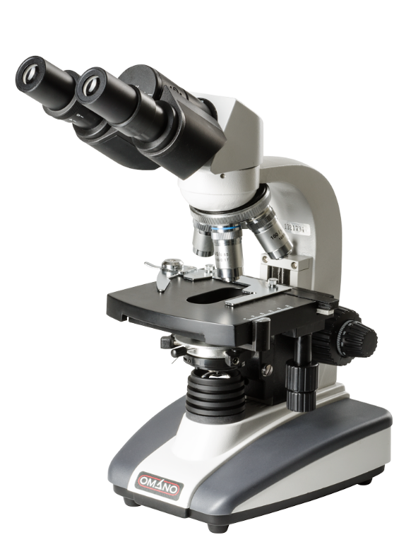

NO.

**Doctor 2021 -mercy- I medicine I MU**

……….

**DOCTOR**

……….

……….

……...

**DONE BY:**