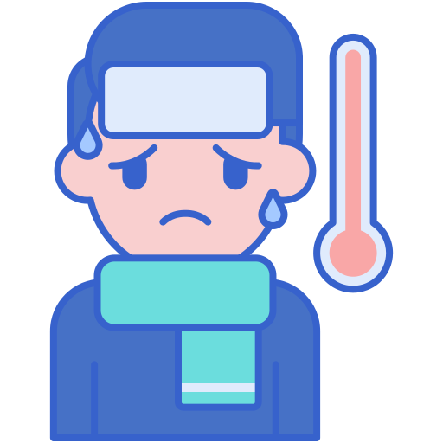

**Doctor :**

**Doctor 2021 - رَوْح - medicine - MU**

**pathology sheet**

**No.**

**DONE BY:**

**corrected BY:**