Macleod
Mini-Osce

Serotonin exam 2020
1-The confrontation test used for assess of :
A. Visual acuity .
- Visual color .
- Ophthalmoplegia
- Visual field . XXXX
- Accommodation reflex .

2-Which is damaged cranial nerve
- Right hypoglossal nerve .
- Left vagus nerve .
- Right vagus nerve .
- Left hypoglossal nerve . XXXX
- Left trigeminal nerve .

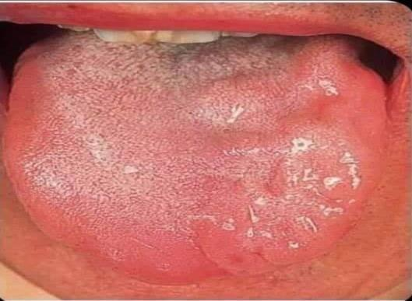

3-Which is damaged nerve ?
A. Left trochlear nerve .
- Left oculomotor nerve .
- Left optic nerve .
- Left abducent nerve . XXXX
- Right abducent nerve .

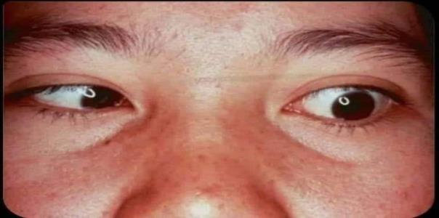
4- All of following are dxx for this sign except ?
- Right ventricular failure .
- Acute bronchitis .
- Mitral stenosis .
- Acute thrombophelibitis . XXX ???????
- Idiopathic pulmonary fibrosis .

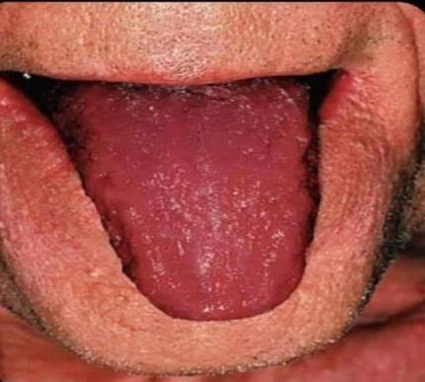

5-This patient has which of the following :
- Hypoglycemia .
- Hypocalcemia . XXXX
- Hypercalcemia .
- Hyponatremia .
- Hypernatremia .

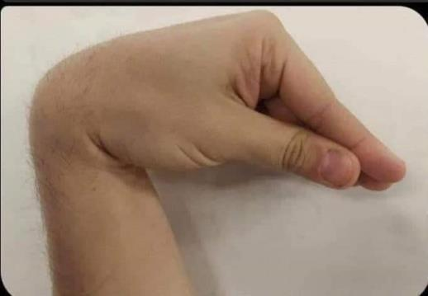

6-This examination occur for assess :
- Chest expansion . XXXX
- Vocal resonance .
- Tactile fremitus .
- Cardiac index .
- Cardiothoractic ratio .

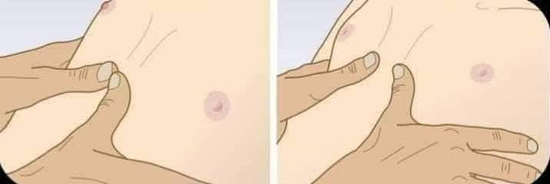

7-Which of the following is ddx for this condition ?
A. Nephrotic syndrome .
- Liver cirrhosis .
- Heart failure .
- DVT . XXXX
- Lymphedema .
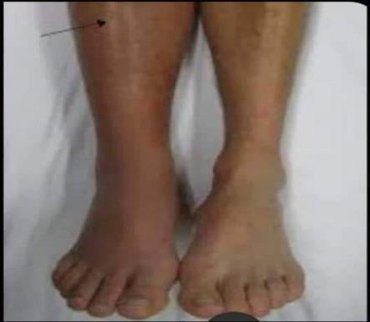

8-Which is damaged cranial nerve
- Right hypoglossal nerve .
- Left vagus nerve .
- Right trigeminal nerve .
- Left hypoglossal nerve .
- Left trigeminal nerve . XXX

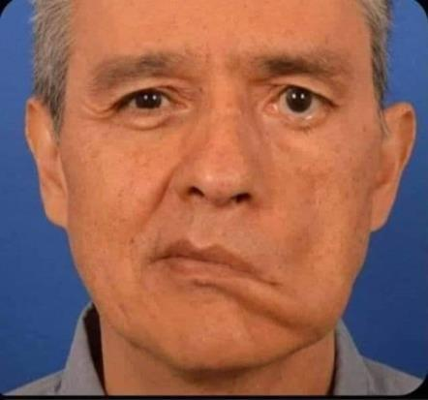

9-Which is damage nerve for this patient ?
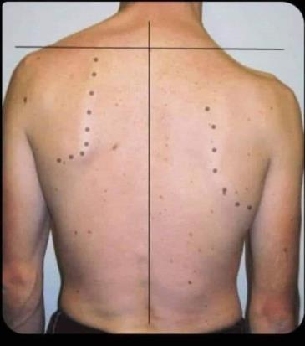
- Spinal root of accessory nerve . XXX
- Thoracodorsal nerve .
- Long thoracic nerve .
- Axillary nerve .
- Glossopharyngeal nerve
.

10-Which is damaged cranial nerve
- Right oculomotor nerve .
- Left trochlear nerve . XXXX
- Right trochlear nerve .
- Left abducent nerve .
- Left trigeminal nerve .

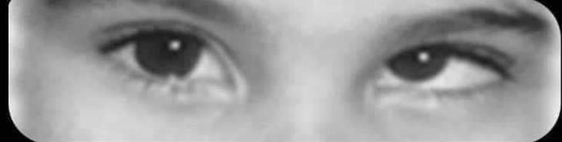

11-is a sign of . … ..................?
A- rheumatoid fever .
- - tricuspid valve reguirgitation .
- - infective endocarditis . XXX
- - acute pericarditis .
- - aortic stenosis
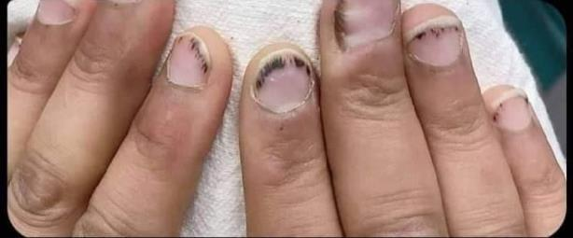
12-30 years old patient admitted to surgical clinic with neck enlargement , after eye examination shows as in picture : Which wrong about this condition ?
- Diarrhea is the common bowel habit for this patient .
- The face is wet and sweaty .
- Goiter indicated for hyperthyroidism condition . XXX
- after treatment , exophthalmus not removed .
- hyperthyroidism associated with arrhythmia , atrial fibrillation or tremor .

13-Which is damage nerve for this patient ?
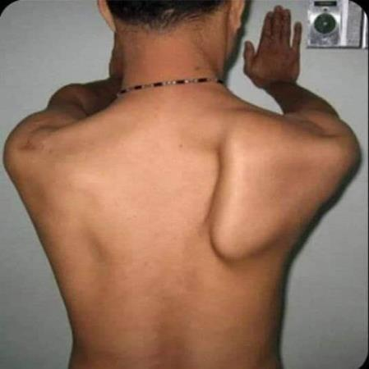
- Spinal root of accessory nerve .
- Thoracodorsal nerve .
- Long thoracic nerve . XXX
- Axillary nerve .
- Glossopharyngeal nerve .

14- Which is damaged cranial nerve
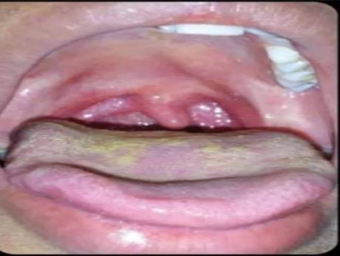
  - Right hypoglossal nerve .
  - Left vagus nerve .
  - Right vagus nerve . XXX
  - Left hypoglossal nerve .
  - Left trigeminal nerve .

15-All of the following are ddx for this condition except ?
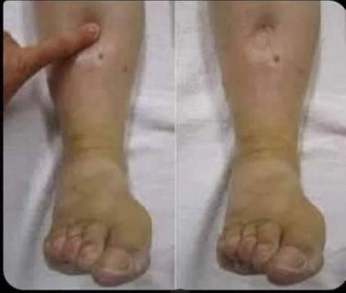
  - Nephrotic syndrome .
  - Liver cirrhosis .
  - Heart failure .
  - DVT .
  - Lymphedema XXXX

.

16-Which of the following findings is typically found on percussion over the area of the chest with massive pleural effusion ?
A. Resonant percussion .
B. Dull percussion .
C. Hyper – resonant percussion .
D. Normal percussion .
E. Stony dull percussion .
Answer:E

17-Kussumaul’s means ?
- Increases respiratory rate .
- Increases respiratory rate with sever acidosis .
- increases respiratory rate and depth with sever acidosis .
- Increases respiratory depth with sever acidosis .
- increases respiratory rate and depth with sever alkalosis .
Answer :C

18-Type of tremor of hyperthyroid patient ?
A. Resting tremor .
B. Action tremor .
C. Intention tremor .
D. Physiological tremor .
E. Essential tremor .
Answer :d

19-All of the following associated with liver cirrhosis except ?
A. Testicular atrophy .
B. Gynecomastia .
C. Spider nevae .
D. Breast atrophy .
E. Resting tremor .
Answer : e

20-Freely mobile mass like mouse in right upper quadrant breast of 25 year old female , The most Dx ?
    - Fibrocystic change .
    - Fibroadenoma .
    - Ductal infiltrating carcinoma .
    - Carcinoma in situ .
    - Lymph node enlargement .

21-What is “ secondary amenorrhea “ ?
- Cessation of menstrual cycle for two months but it was normal previously .
- Cessation of menstrual cycle for three months but it was normal previously .
- Cessation of menstrual cycle for six months but it was normal previously .
- For 16 years , but she is not menses .
- vaginal bleeding after twelfth months from last menses .

22-The wrong about this patient ?
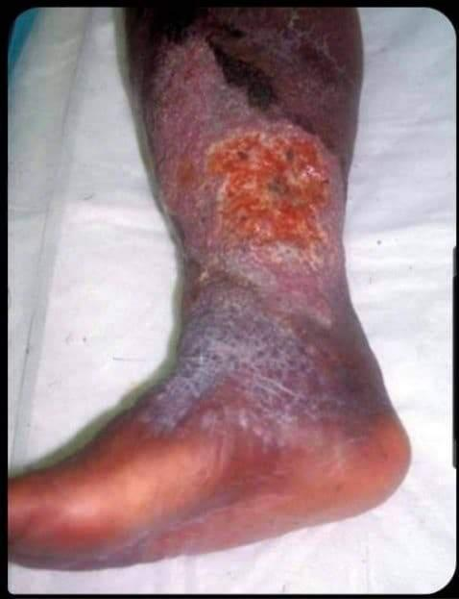
A. Associated with limb edema with exudate .
B. Sloping edges .
C. Sever painful . XXX
D. Relieved by leg elevation .
E. Lipodermatosclerosis ; hemosiderosis with blanche atrophie .

23-The most Dxx for this patient :
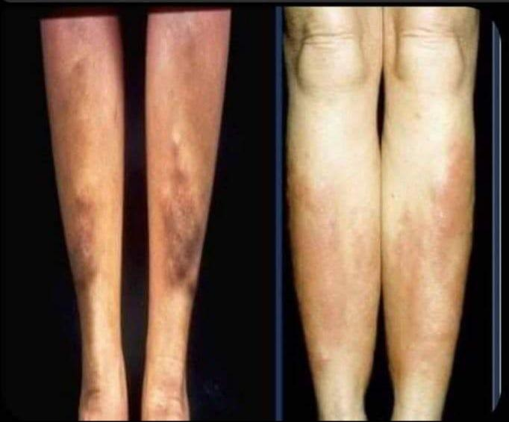
A. Deep venous thrombosis .
B. Hypothyroidism .
C. Nephrotic syndrome .
D. Graves disease . XXXX
E. Liver cirrhosis

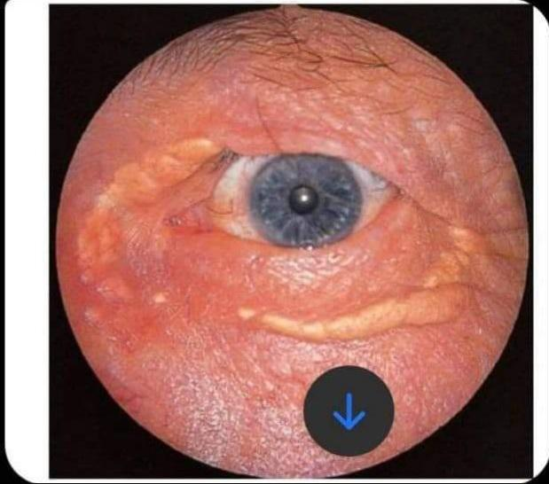
24-This sign indicates elevation of which in blood ?
A. HDL .
B. LDL .
C. Lactic acid .
D. Cholesterol . XXXX
E. Oxidative agents .

25-The most dx for this patient :
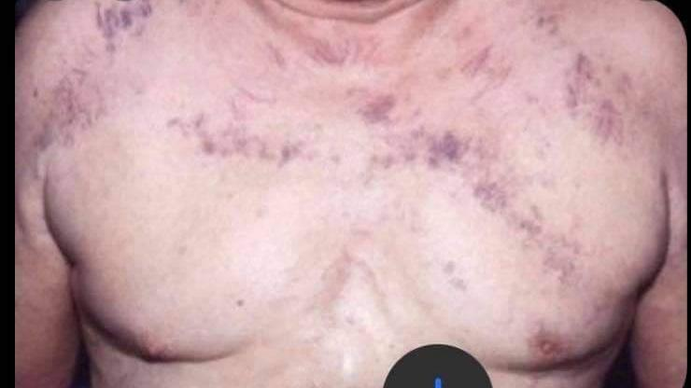
A. Portal hypertension .
B. Inferior venacava obstruction
C. Superior venacava obstruction XXX
D. Thromboephelibitis .
E. Caput medusa

26-All of the following are associated with sever ascites examination except ?
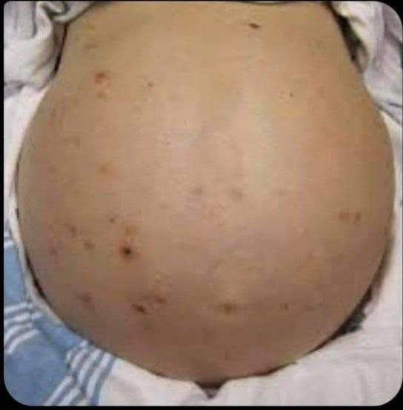
A. Increased distance btw xisosternum and umbilicus .
B. Distended flank .
C. Everted umblicus .
D. Caput medusa . XXX
E. Positive fluid thrill .

27-Which indicates ?
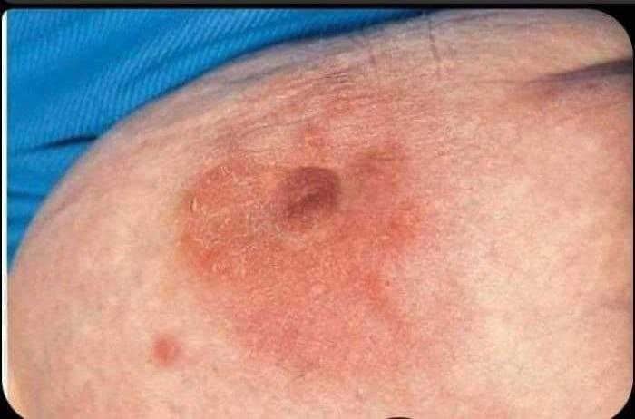
- Inflammatory breast carcinoma .
- lobar infiltrating carcinoma .
- ductal infiltrating carcinoma .
- Pagets disease of breast .
- Fibroadenoma . XXX

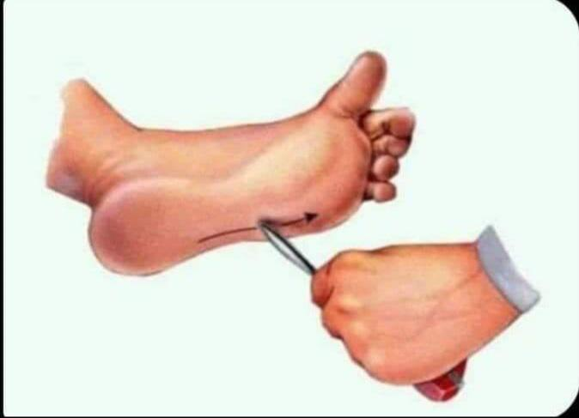
28-Which correct about this test ?
- Indicated lower neuron lesion
- associated with sensory ataxia
- Indicated upper neuron lesion XXXX
- Indicated polyneuropathy .
- Abnormal in neonate .

29-This sign is associated with :
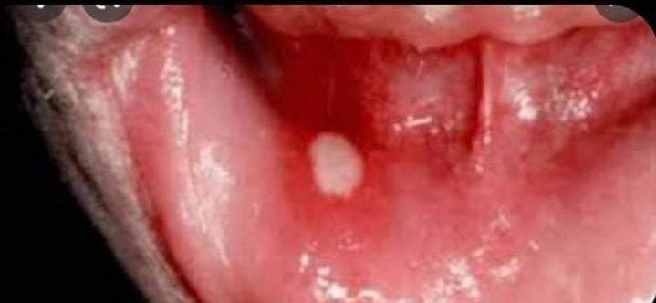
- Irritable bowel diseases .
- perihepatitis .
- inflammatory bowel diseases XXXX
- Ulcerative colitis .
- pneumothorax .

